Supplementary Information

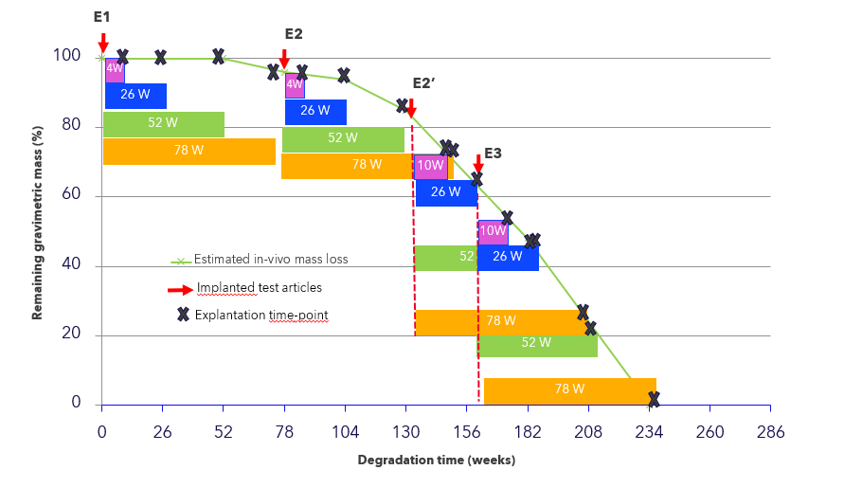
Figure S1 Equivalent degradation time of native and pre-degraded meshes, after implantation up to 78 weeks (E1, E2, E2’ and E3 represents pre-degraded implants for implantation, black crosses represent equivalent total time in-vivo at termination point)

 |  | Implanted samples
 |  | E1 | E2 | E2’ (collagen disc) | E3 (collagen disc)
SRM | SEM  picture | 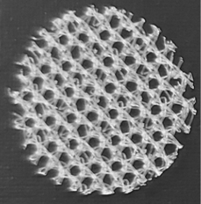 | 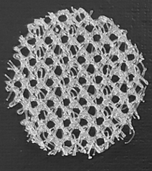 | 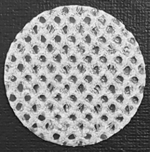 | 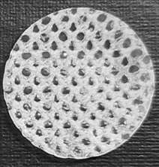
SRM | Residual gravimetric mass | 100% | 95 ± 1% | 82 ± 1% | 60 ± 2%
TIGr® | SEM  picture | 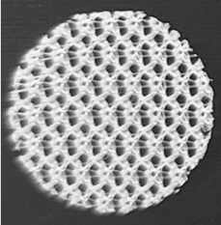 | 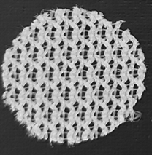 | 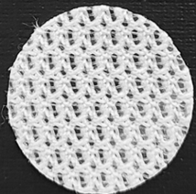 | 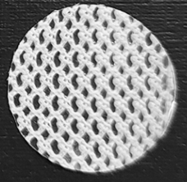
TIGr® | Residual gravimetric mass | 100% | 98 ± 2% | 76 ± 2% | 57 ± 1%

Table S1 Characteristics of native and pre-degraded SRM and TIGr® meshes

