Supplementary material
Fabrication and characterization of an anti-corrosion/ infection VAN@PLGA/HA/CMCS composite coating on magnesium alloy
Jian He ^{a, b}, Xu Cheng ^{c}, Songqiang Zhang ^{b}, Yuefeng Tao ^{b}, Hongfei Shi ^{a, d,*}
ª Department of Orthopedic Surgery, Nanjing Drum Tower Hospital Clinical College of Nanjing Medical University, Nanjing 210008, PR China
^{b} Trauma Center, Anqing municipal hospital, Anqing 246003, PR China
^{c} Anqing Normal University, Anqing 246003, PR China
^{d} Department of Orthopedic Surgery, Nanjing Drum Tower Hospital, Affiliated Hospital of Medical School, Nanjing University, Nanjing 210008, PR China

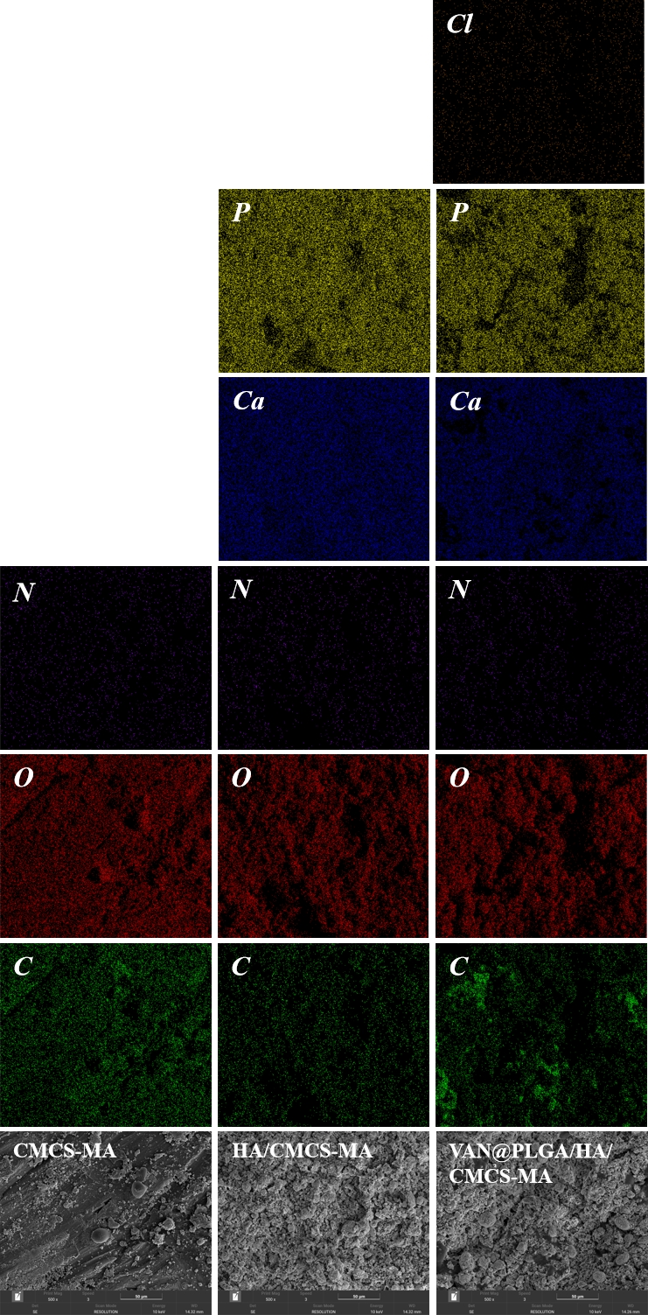
Figure S1. Surface elemental distribution of three alloy coatings

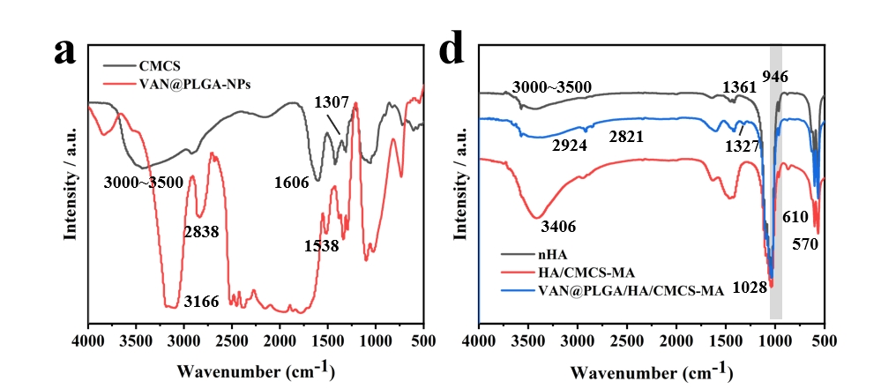
Figure S2. (a) FT-IR spectra of CMCS and VAN@PLGA-NPs; (b) FT-IR spectra of HA and alloy coating.

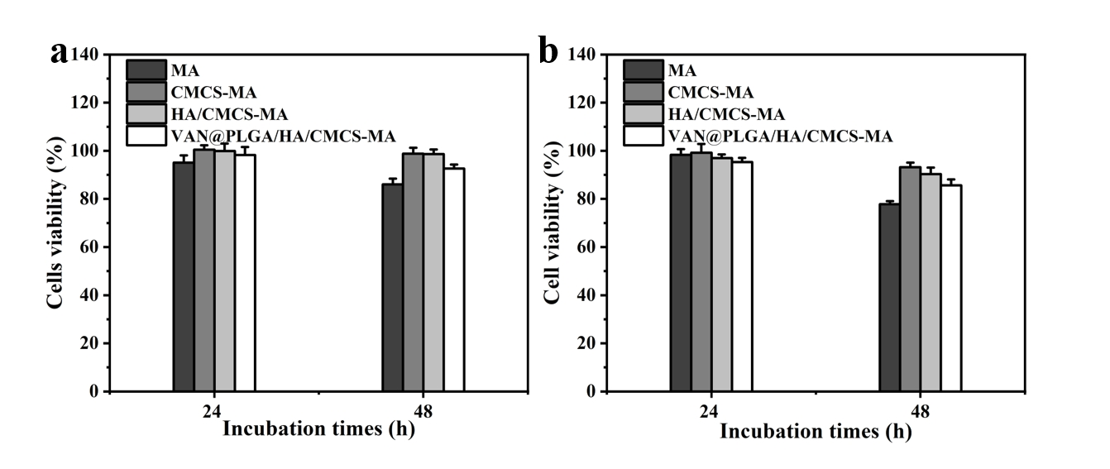
Figure S3. In vitro cells viability of Mg-Al alloy and its coating alloy in (a) 3T3 cell and (b) MC3T3-E1 cells at different times.
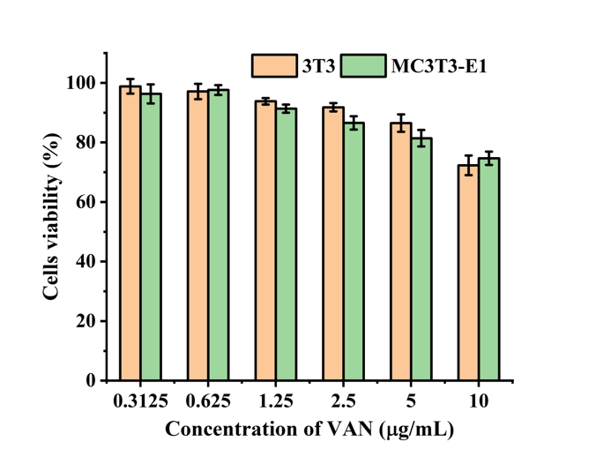
Figure S4. In vitro cells viability of VAN in 3T3 and MC3T3-E1 cells at different concentrations.

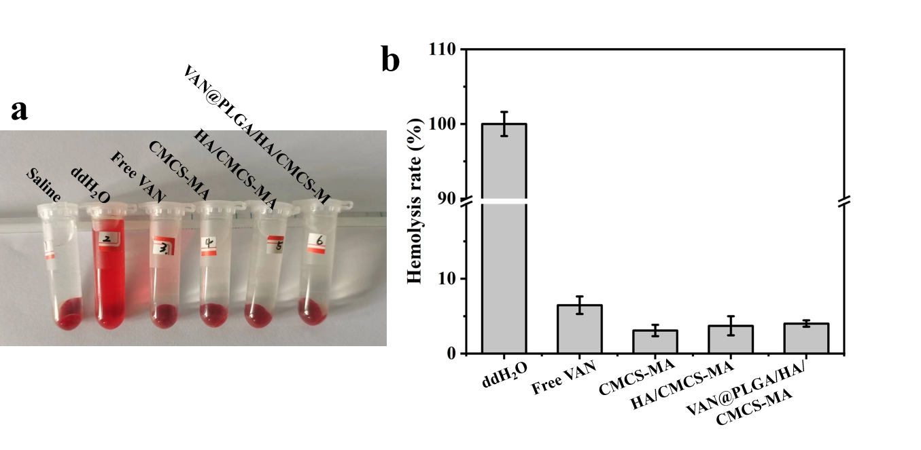
Figure S5. (a) Photos of red blood cells after treatment with different alloy samples; (b) Hemolysis rate.

Table S1. The composition of different suspension solutions
 | CMCS (mg) | HA (mg) | VAN@PLGA/NPs (mg) | H₂O (mL)
CMCS-MA | 20 | / | / | 50
HA/CMCS-MA | 20 | 300 | / | 50
VAN@PLGA/HA/CMCS-MA | 20 | 300 | 25 | 50

Table S2. Characterizing the mechanical properties of alloy coatings
 | CMCS-MA | HA/CMCS-MA | VAN@PLGA/HA/CMCS-MA
Thickness (μm) | 21.5 ± 0.65 | 49.32 ± 1.07 | 51.21 ± 1.35
Bonding strength (MPa) | 17.17 ± 1.03 | 19.32 ± 0.72 | 18.76 ± 1.15

