Multifunctional Polymer-Integrated Titanium Oxide Nanoscaffold Stimulates Bone Formation Co-Culturing Bone Marrow Mesenchymal Stem Cells to Treat Osteonecrosis

Authors List
Jiang-Li Zhang*, Jin-Hui Liu, Xi-Qing Pan, Guang-Yuan Liu, Meng-Hui Wu, Xiao Fan

Authors Affiliations
Department of Joint Surgery, Third Hospital of Shijiazhuang, Shijiazhuang 050011, China.

*Corresponding Author Mailing Address
Dr. Jiang-Li Zhang, No.15 Tiyu South Street, Shijiazhuang, Hebei, China.
E-Mail: jianglinano@outlook.com

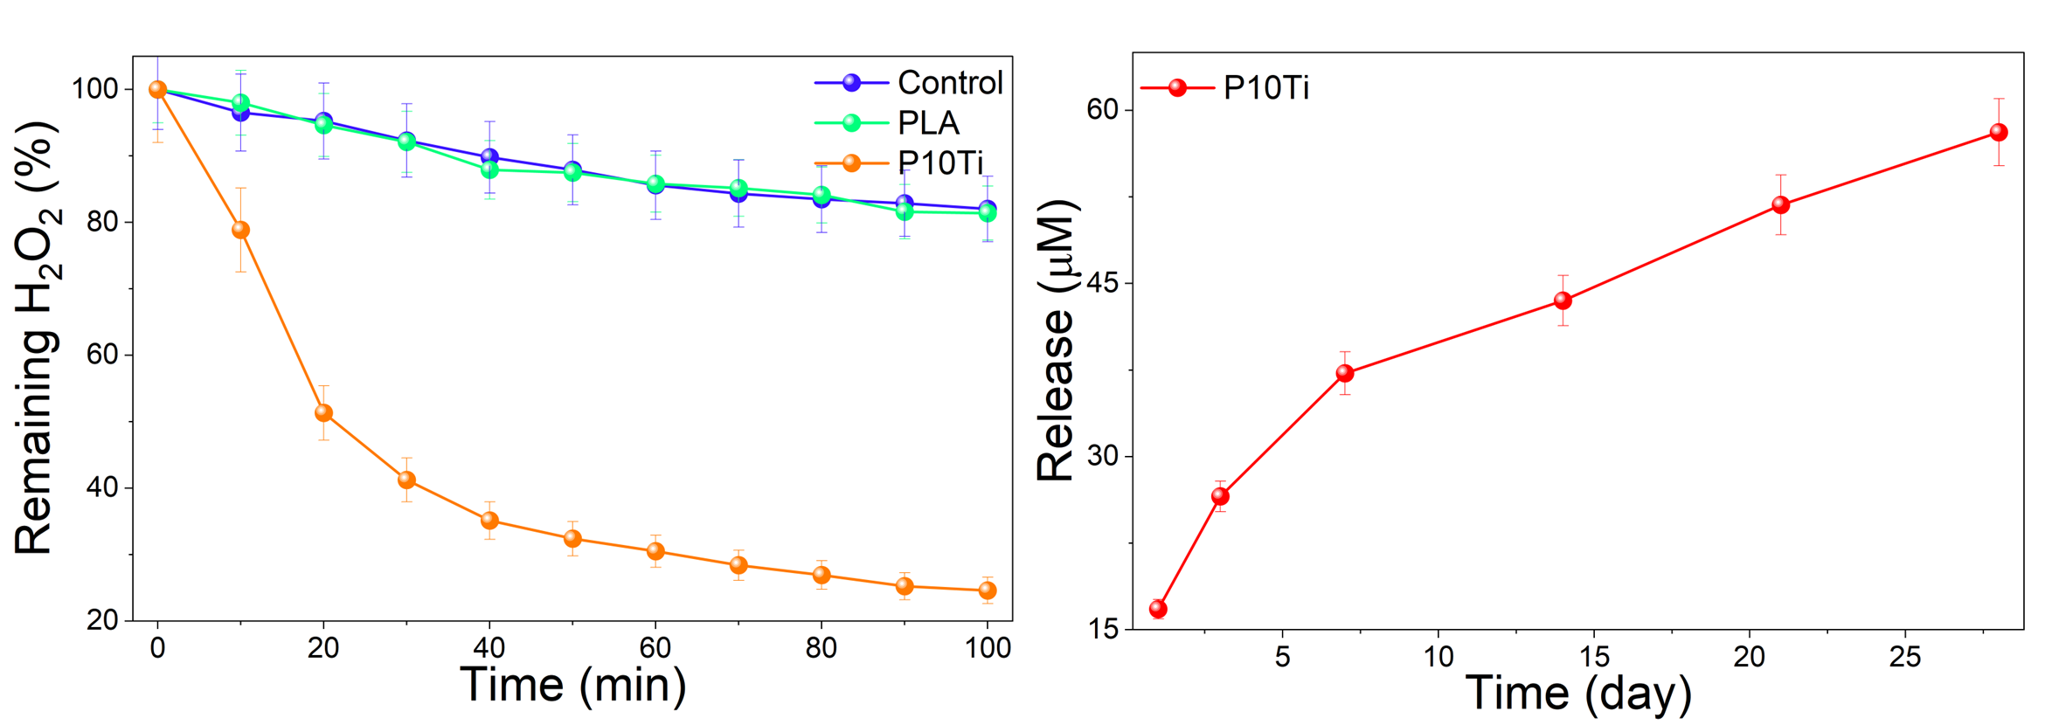
Figure S1. Characterization of PTi. (A) H₂O₂ degradation in the presence of PLA, P10Ti under 10 mM H₂O₂ solution. (B) Released Ti concentration of P10Ti under pH=6.8 solution.

Figure S2. The optical density (OD) values of BMMSC incubated with leaching solution of PLA, P2.5Ti, P5Ti, P10Ti and P20Ti.
Figure S3. Live/dead staining of BMMSC with H₂O₂ and cultured on different scaffolds was determined after 24 hours.
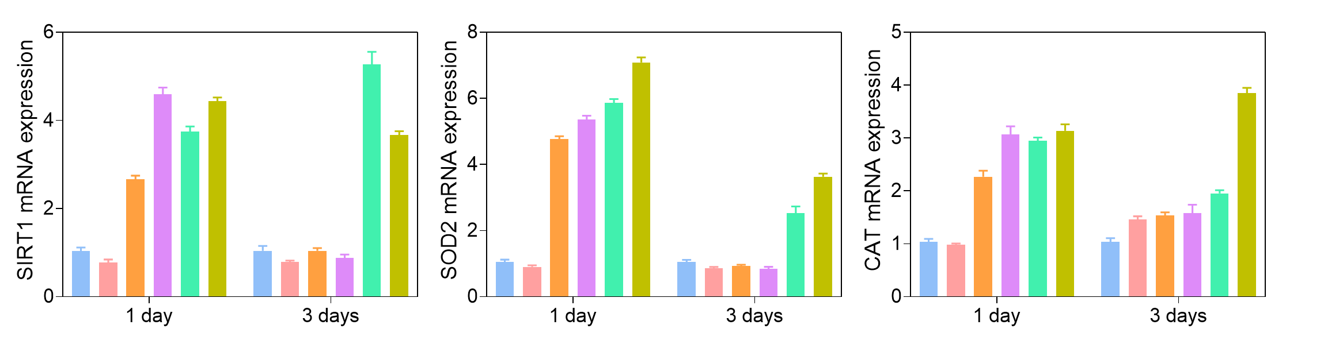
Figure S4. The expression of antioxidant genes of BMMSC.

