Supplementary information to

Methyl group reorientation under ligand binding probed by pseudocontact shifts

Mathilde Lescanne, Puneet Ahuja, Anneloes Blok, Monika Timmer, Tomas Akerud, Marcellus Ubbink

Table S1. Nuclei used to refine K_{D} and k_{OFF} with TITAN.

Mutant
50C/54C | Lu³⁺ | L107δ1, L103δ2, V186γ2, L198δ1, L29δ2
50C/54C | Yb³⁺ | L107δ1, L103δ2, V186γ2, L198δ1, L29δ2
101C/105C | Lu³⁺ | V172γ1, L48δ1, L48δ2, L29δ1, L29δ2
101C/105C | Yb³⁺ | V172γ1, L48δ1, L48δ2, L29δ1, L29δ2
149C/187C | Yb³⁺ | L103δ1, L103δ2, V186γ2, L45δ1, L29δ2
149C/187C | Lu³⁺ | L103δ1, L103δ2, V186γ2, L45δ1, L29δ2
WT | no tag | L45H^{N}, S140H^{N}, F134H^{N}, Y160H^{N}

Table S2. PCS measured on free and bound protein for the mutants 50C/54C, 101C/105C and 149C/187C.

Residue number | stereo | 50C/54C |  |  | 101C/105C |  |  | 149C/187C
 |  | Free PCS | Bound PCS | ∆PCS | Free PCS | Bound PCS | ∆PCS | Free PCS | Bound PCS | ∆PCS
17 | HG1 | 0.045 | 0.03 | -0.015 | 0.208 | 0.22 | 0.012 | 0.104 | 0.077 | -0.027
17 | HG2 | 0.045 | 0.032 | -0.013 | 0.145 | 0.124 | -0.021 | 0.05 | 0.058 | 0.008
29 | HD1 | -0.406 | -0.402 | 0.004 | 0.137 | 0.144 | 0.007 | 0.246 | 0.225 | -0.021
29 | HD2 | -0.465 | -0.483 | -0.018 | 0.217 | 0.257 | 0.04 | No data | No data | No data
32 | HD1 | -0.187 | -0.181 | 0.006 | 0.055 | 0.065 | 0.01 | 0.112 | No data | No data
32 | HD2 | -0.186 | -0.191 | -0.005 | 0.062 | 0.07 | 0.008 | No data | No data | No data
45 | HD1 | 0.329 | 0.305 | -0.024 | 0.102 | 0.097 | -0.005 | 0.319 | 0.338 | 0.019
45 | HD2 | 0.458 | 0.431 | -0.027 | 0.121 | 0.12 | -0.001 | 0.491 | 0.488 | -0.003
48 | HD1 | 0.774 | 0.717 | -0.057 | 0.23 | 0.224 | -0.006 | 1.484 | No data | No data
48 | HD2 | 0.565 | 0.519 | -0.046 | 0.284 | 0.226 | -0.058 | 0.553 | No data | No data
56 | HD1 | 1.289 | No data | No data | 0.067 | 0.033 | -0.034 | 0.165 | 0.16 | -0.005
56 | HD2 | 0.838 | 0.863 | 0.025 | 0.021 | -0.011 | -0.032 | 0.103 | 0.102 | -0.001
64 | HD1 | -0.215 | -0.183 | 0.032 | -0.114 | -0.152 | -0.038 | 0.069 | No data | No data
64 | HD2 | -0.142 | -0.113 | 0.029 | -0.101 | -0.134 | -0.033 | 0.016 | 0.019 | 0.003
70 | HD1 | 0.112 | 0.127 | 0.015 | -0.058 | -0.036 | 0.022 | -0.011 | -0.029 | -0.018
70 | HD2 | 0.197 | 0.216 | 0.019 | -0.081 | -0.125 | -0.044 | -0.008 | -0.009 | -0.001
76 | HD1 | 0.28 | 0.312 | 0.032 | -0.035 | -0.082 | -0.047 | 0.035 | 0.036 | 0.001
76 | HD2 | 0.415 | 0.434 | 0.019 | -0.023 | -0.068 | -0.045 | 0.018 | -0.026 | 0.008
80 | HD1 | 0.296 | 0.272 | -0.024 | 0.110 | 0.104 | -0.006 | No data | No data | No data
80 | HD2 | 0.265 | 0.278 | 0.013 | 0.083 | 0.065 | -0.018 | No data | 0.00 | No data
89 | HD1 | No data | No data | No data | No data | No data | No data | No data | No data | No data
89 | HD2 | 0.268 | 0.249 | -0.019 | 0.123 | 0.125 | 0.002 | 0.125 | 0.141 | 0.016
92 | HG1 | 0.409 | 0.409 | 0.00 | 0.151 | 0.136 | -0.015 | 0.035 | 0.038 | 0.003
92 | HG2 | 0.023 | 0.019 | -0.004 | 0.021 | 0.014 | -0.007 | 0.068 | 0.078 | 0.010
103 | HD1 | 0.203 | 0.171 | -0.032 | 1.491 | 1.426 | -0.065 | 0.402 | 0.477 | 0.064
103 | HD2 | 0.204 | 0.199 | -0.005 | 1.445 | 1.429 | -0.016 | 0.579 | 0.6 | 0.021
107 | HD1 | 0.215 | 0.170 | -0.045 | 0.715 | No data | No data | 0.958 | No data | No data
107 | HD2 | 0.217 | 0.120 | -0.097 | 0.998 | No data | No data | 0.849 | 0.782 | -0.067
122 | HD1 | -0.31 | -0.292 | 0.018 | 0.069 | 0.065 | -0.004 | 0.149 | 0.130 | -0.019
122 | HD2 | -0.303 | -0.280 | 0.023 | 0.057 | 0.085 | 0.028 | 0.158 | 0.112 | -0.046
136 | HG1 | -0.646 | -0.737 | -0.091 | 0.283 | 0.322 | 0.039 | 0.265 | 0.219 | -0.046
136 | HG2 | -1.501 | No data | No data | 0.187 | 0.200 | 0.013 | 0.252 | 0.256 | 0.004
143 | HD1 | -0.121 | -0.138 | -0.017 | 0.107 | 0.122 | 0.015 | 0.224 | 0.216 | -0.008
143 | HD2 | -0.129 | -0.162 | -0.033 | 0.119 | 0.124 | 0.005 | 0.292 | 0.282 | -0.010
144 | HG1 | 0.04 | 0.016 | -0.024 | 0.112 | 0.117 | 0.005 | 1.355 | 1.325 | -0.030
144 | HG2 | 0.118 | 0.083 | -0.035 | 0.150 | 0.151 | 0.001 | 1.754 | No data | No data
148 | HG1 | 0.15 | 0.122 | -0.028 | 0.298 | 0.305 | 0.007 | -0.106 | No data | No data
148 | HG2 | 0.25 | 0.224 | -0.026 | 0.383 | 0.435 | 0.052 | 0.630 | No data | No data
150 | HG1 | 0.356 | 0.321 | -0.035 | 0.655 | 0.659 | 0.004 | 0.205 | No data | No data
150 | HG2 | 0.785 | 0.849 | 0.064 | No data | No data | No data | 1.080 | No data | No data
172 | HG1 | 0.146 | 0.134 | -0.012 | 1.268 | 1.195 | -0.073 | No data | No data | No data
172 | HG2 | 0.065 | 0.043 | -0.022 | No data | No data | No data | 0.209 | 0.198 | -0.011
186 | HG1 | 0.203 | 0.162 | -0.041 | 0.119 | 0.097 | -0.022 | No data | No data | No data
186 | HG2 | 0.719 | 0.689 | -0.030 | 0.377 | 0.373 | -0.004 | 1.625 | 1.614 | -0.011

Table S3. Δχ tensor parameters calculated with PCS from the free and bound states of ntd-HSP90, using the 3T0Z structure. Errors are given between brackets.

Tensor | χ_{ax} | χ_{rh} | x | y | z | α | β | γ | Qa
50C/54C free | 8.3 (0.5) | 2.4 (1.3) | 12.6 (0.8) | 0.4 (0.7) | 25.2 (0.6) | 164 (6) | 154 (5) | 146 (10) | 0.072
50C/54C bound | 7.9 (0.3) | 1.5 (0.9) | 12.8 (0.7) | -0.1 (0.6) | 24.9 (0.4) | 157 (4) | 150 (4) | 136 (7) | 0.046
101C/105C free | 7.6 (0.3) | 2.9 (0.8) | 24.9 (0.3) | -10.1 (0.4) | 6.5 (0.5) | 176 (3) | 85 (3) | 160 (8) | 0.022
101C/105C bound | 8.5 (0.5) | 3.0 (1.0) | 25.8 (0.3) | -8.3 (0.7) | 6.1 (0.7) | 5 (5) | 98 (4) | 35 (12) | 0.026
149C/187C free | 9.7 (1.8) | 4.0 (2.9) | -1.1 (1.2) | -4.4 (1.5) | -2.2 (1.2) | 160 (21) | 156 (5) | 42 (16) | 0.115
149C/187C bound | 7.9 (1.5) | 2.9 (1.5) | 1.3 (1.3) | -6.1 (1.7) | -2.0 (1.0) | 150 (18) | 157 (7) | 31 (14) | 0.139

188 | HD1 | 0.27 | 0.231 | -0.039 | 0.223 | 0.228 | 0.005 | 0.302 | 0.338 | 0.036
188 | HD2 | 0.314 | 0.295 | -0.019 | 0.191 | 0.199 | 0.008 | 0.265 | no data | no data
190 | HD1 | 0.131 | 0.109 | -0.022 | 0.130 | 0.135 | 0.005 | 0.292 | 0.302 | 0.010
190 | HD2 | 0.123 | 0.102 | -0.021 | 0.112 | 0.104 | -0.008 | -0.187 | -0.192 | -0.005
198 | HD1 | 0.138 | no data | no data | 0.081 | 0.088 | 0.007 | -0.111 | -0.114 | -0.003
198 | HD2 | 0.094 | 0.076 | -0.018 | 0.097 | 0.093 | -0.004 | -0.047 | -0.054 | -0.007
207 | HG1 | 0.262 | 0.257 | -0.005 | 0.055 | 0.053 | -0.002 | 0.132 | 0.136 | 0.004
207 | HG2 | 0.191 | 0.199 | 0.008 | 0.069 | 0.070 | 0.001 | 0.320 | 0.271 | -0.049
220 | HD1 | 0.143 | 0.138 | -0.005 | 0.059 | no data | no data | 0.094 | 0.107 | 0.013
220 | HD2 | 0.181 | 0.175 | -0.006 | 0.069 | 0.062 | -0.007 | -0.769 | no data | no data
222 | HG1 | 0.092 | 0.090 | -0.002 | 0.006 | 0.014 | 0.008 | -0.175 | no data | no data
222 | HG2 | 0.96 | 0.088 | -0.008 | 0.050 | 0.050 | 0.000 | -0.230 | no data | no data

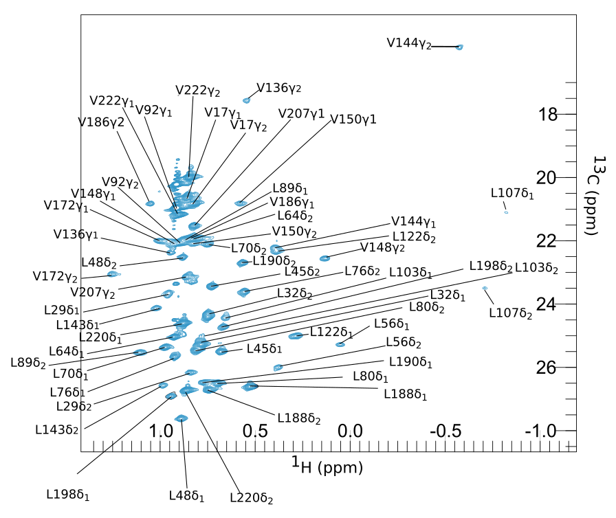
Figure S1 ¹³C Leu/Val methyl group spectrum of the 101C/105C CLaP5-Lu³⁺ tagged ntd-HSP90.

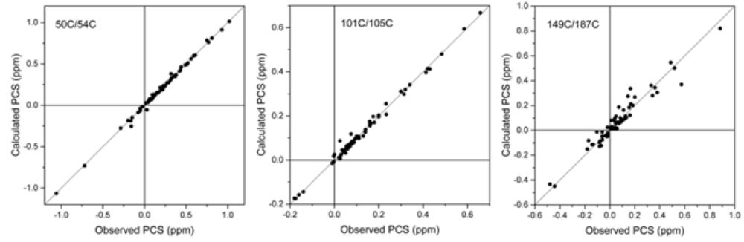

Figure S2 Quality of Δχ fits based on amide PCS [Lescanne et al. (2017) J. Biomol. NMR 69, 183]. The calculated PCS are plotted against the observed PCS of amide groups of ntd-HSP90 tagged with Yb³⁺-CLaNP-5 at the indicated positions. The solid lines represent a perfect correlation (x=y). Q/Q_{a} values, 0.056/0.028 (50/54C), 0.068/0.034 (101C/105C), 0.26/012 (149C/187C).
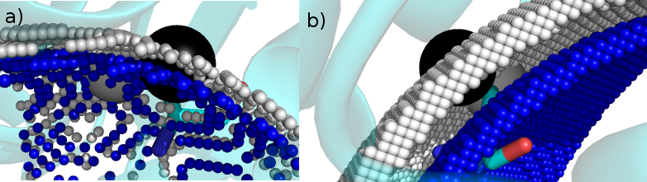

Figure S3. PCS gradient effects. In light grey are the iso-surfaces of the predicted PCS, in blue are the iso-surfaces of the experimental PCS, for Val136 γ2, represented as a black sphere. All iso-surfaces were calculated with an uncertainty of 0.01 ppm, for clarity. a) Iso-surfaces for mutant 50C/54C, the difference between the two surfaces (0.6 Å) represents a PCS difference of 0.16 ppm. b) Iso-surfaces for mutant 149C/187C, the difference between the two surfaces (1.5 Å) represents a PCS difference of 0.05 ppm.

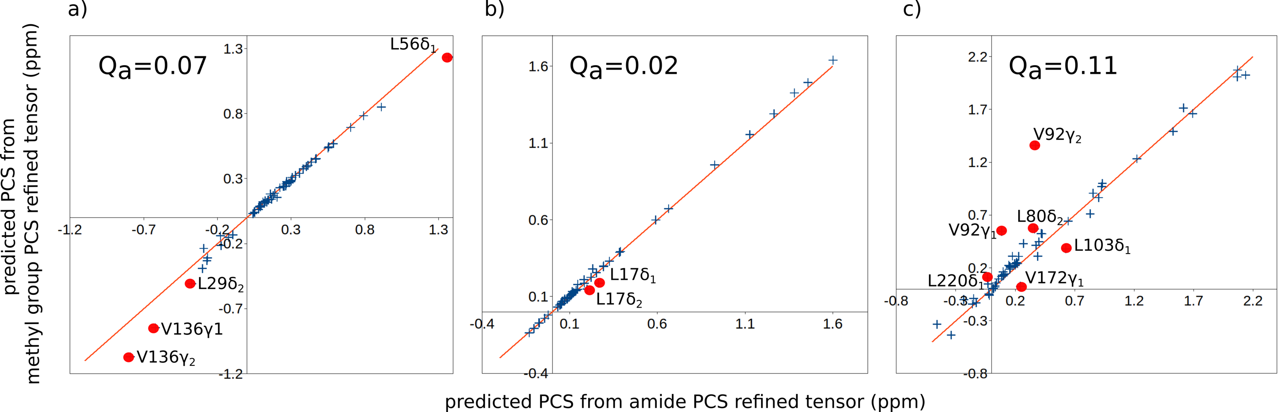

Figure S4. Plot of the predicted PCS calculated with the amide based tensor versus the predicted PCS calculated with the methyl PCS based Δχ tensor for mutant 50C/54C (a), mutant 101C/105C (b) and mutant 149C/187C (c).

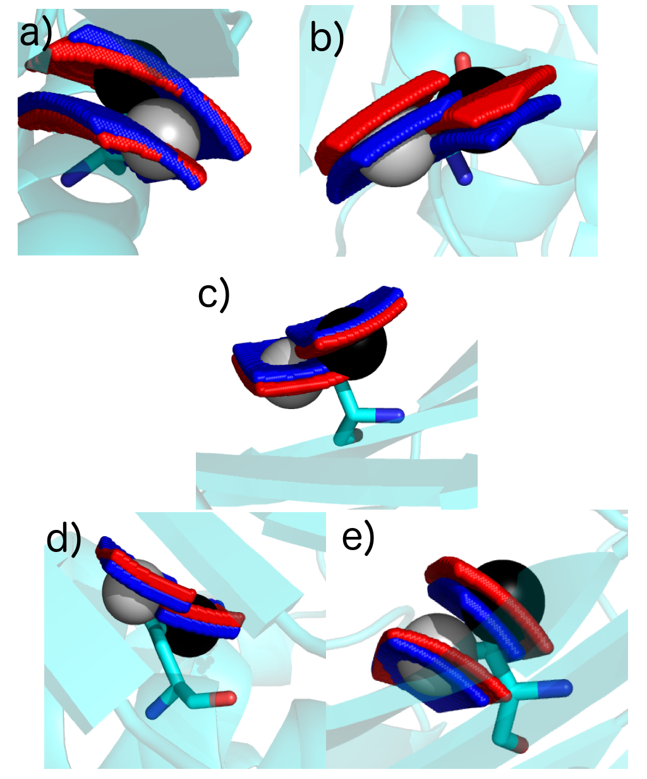

Figure S5. Influence of Δχ tensor variation on the iso-surface. Grey and black spheres represent the free carbon δ₁/γ₁ and δ₂/γ₂ methyl groups (PDB: 3t0h), respectively. The iso-surfaces predicted on the basis of the amide and methyl PCS based Δχ tensors are shown in red and blue, respectively. a) L56 methyl groups, for mutant 50C/54C; b) V136 methyl groups, for mutant 50C/54C; c) V172 methyl groups, for mutant 101C/105C; d) L48 methyl groups, for mutant 149C/187C; e) V148 methyl groups, for mutant 149C/187C.

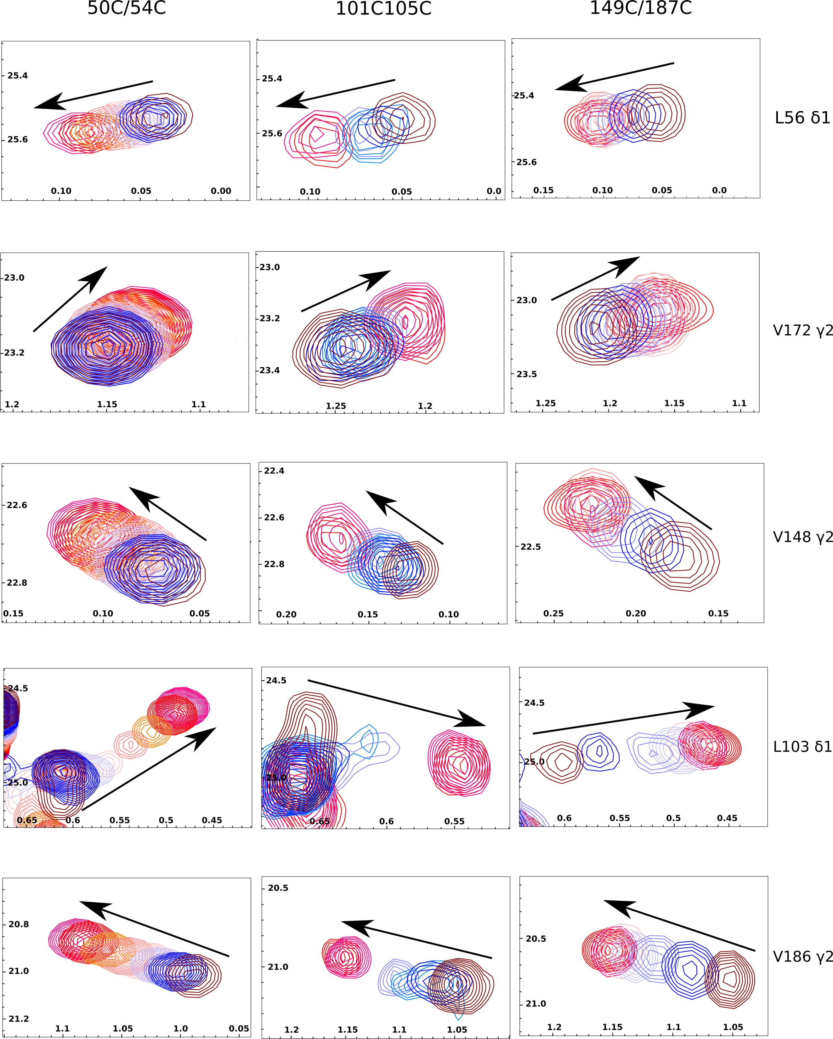

Figure S6. CSP patterns. Details of the overlay of the HSQC spectra of ntd-HSP90 titrations with 1 are shown for 5 methyl group resonances. The arrows indicate the direction of shifts. Except for methyl group L103 δ1, the CSP patterns are similar for the three mutants.

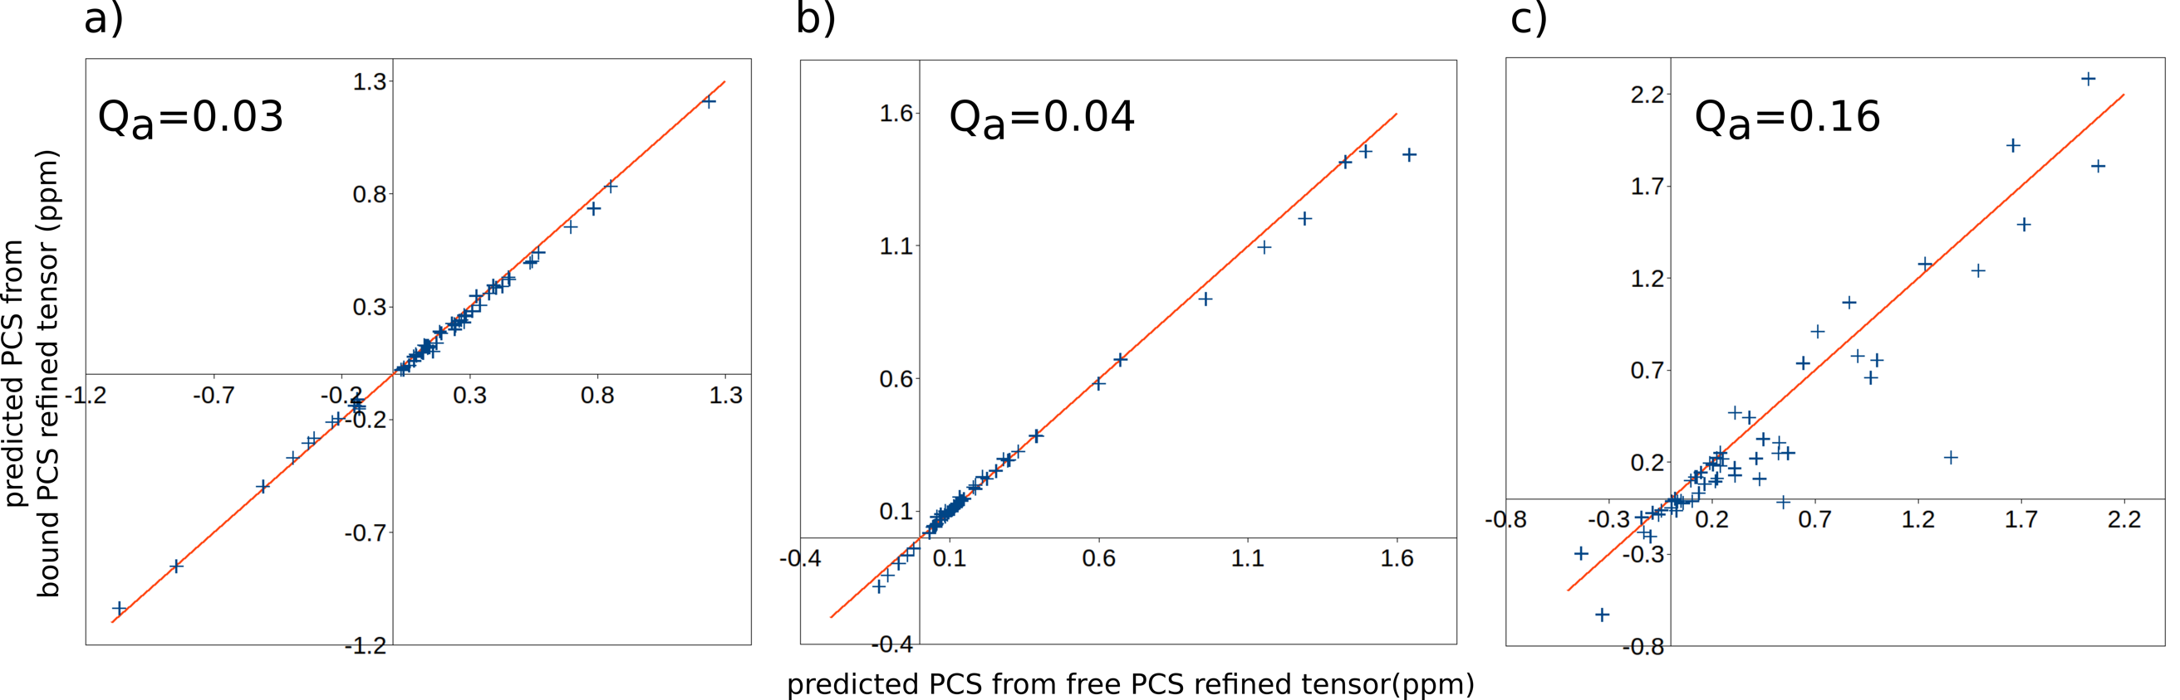

Figure S7. Plot of the predicted methyl PCS calculated with Δχ tensors based on the PCS observed of the free (horizontal axis) and bound states (vertical axis), for 50C/54C (a), 101C/105C (b) and 149C/187C (c). The tensor parameters are shown in Table S3.

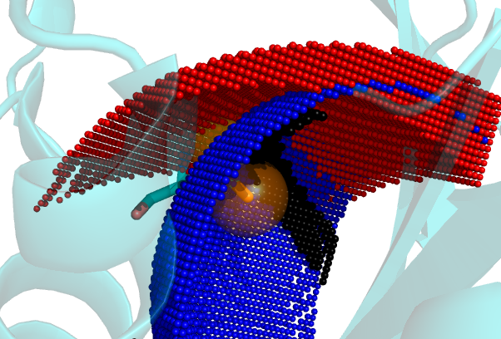

Figure S8. Leu107 δ2 methyl group. The blue and red spheres represent the δ2 iso-surfaces for the experimental PCS of the bound state for mutants 50C/54C and 149C/187C, respectively. The cross-section between these two iso-surfaces is obtained using an uncertainty of 0.03 ppm. In the free state, the cross-section between 50C/54C and 149C/187C, in small black spheres, is at a minimum distance of 0.6 Å from the crystal state methyl carbon.

