Supplementary Materials
Dynamics of a type 2 secretion system pseudopilus unraveled by complementary approaches

Benjamin Bardiaux,¹ Florence Cordier,^{1,2} Sébastien Brier,² Aracelys López-Castilla,¹ Nadia Izadi-Pruneyre,^{1*} Michael Nilges^{1*}

1: Structural Bioinformatics Unit, Department of Structural Biology and Chemistry, C3BI, Institut Pasteur; CNRS UMR3528; CNRS USR3756; Paris, France
2: Biological NMR Technological Platform, Center for Technological Resources and Research, Department of Structural Biology and Chemistry, Institut Pasteur; CNRS UMR3528; Paris, France
correspondance to: nadia.izadi@pasteur.fr, michael.nilges@pasteur.fr

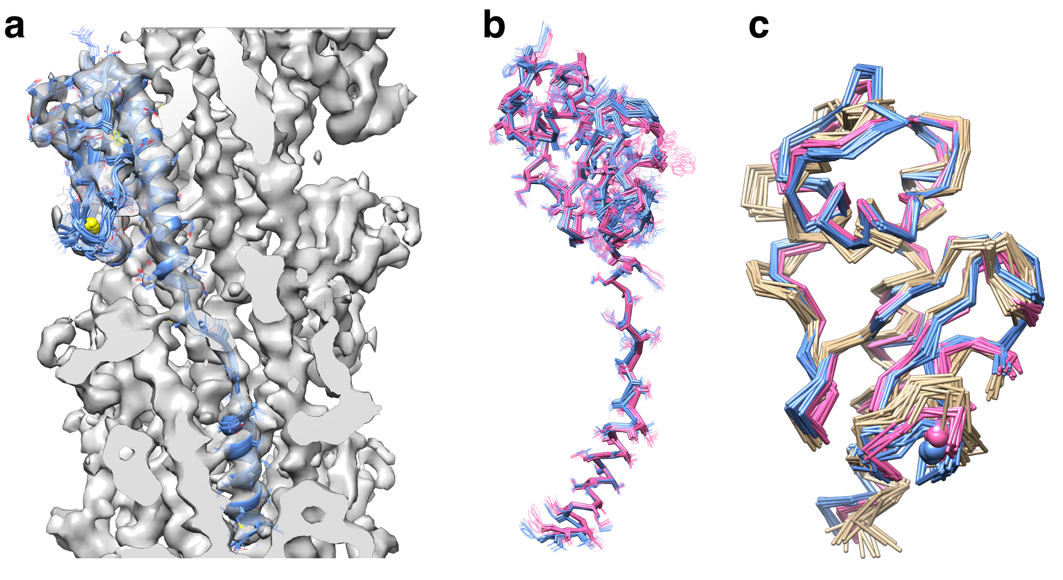
Figure S1: Superimposed structures of soluble PulG_{WT} and refined PulG_{WT} and PulG_{CC} pili. (a) Cross-section of PulG_{CC} cryo-EM reconstruction at 5 Å, with a single PulG subunit from the refined ensembles. (b) Superimposition of PulG_{WT} (pink) and PulG_{CC} (blue) refined models. (c) Superimposition of solution NMR PulG_{WT} structure (beige), PulG_{WT} pili (pink) and PulG_{CC} pili (blue) models.
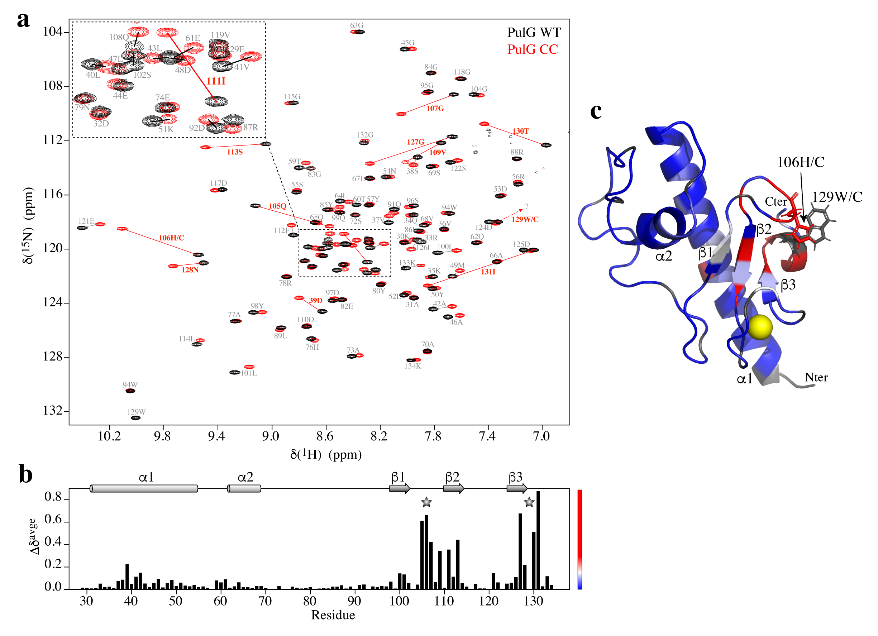
Figure S2: Local effect of the H106C-W129C mutation on PulG monomer structure. (A) Superimposed ¹H-¹⁵N HSQC spectra of PulG_{WT} (black) and PulG_{CC} (red). The largest chemical shift differences are highlighted in red. (B) Weighted average ¹H-¹⁵N chemical shift differences (Δδ^{avge}) between PulG_{WT} and PulG_{CC}. The mutation positions H106C and W129C are indicated by gray stars. Secondary structure elements are indicated on the top. (C) Mapping of mutation-induced chemical shift perturbations on PulG monomer structure, from blue to red with increasing Δδ^{avge}. The calcium atom is displayed in yellow.
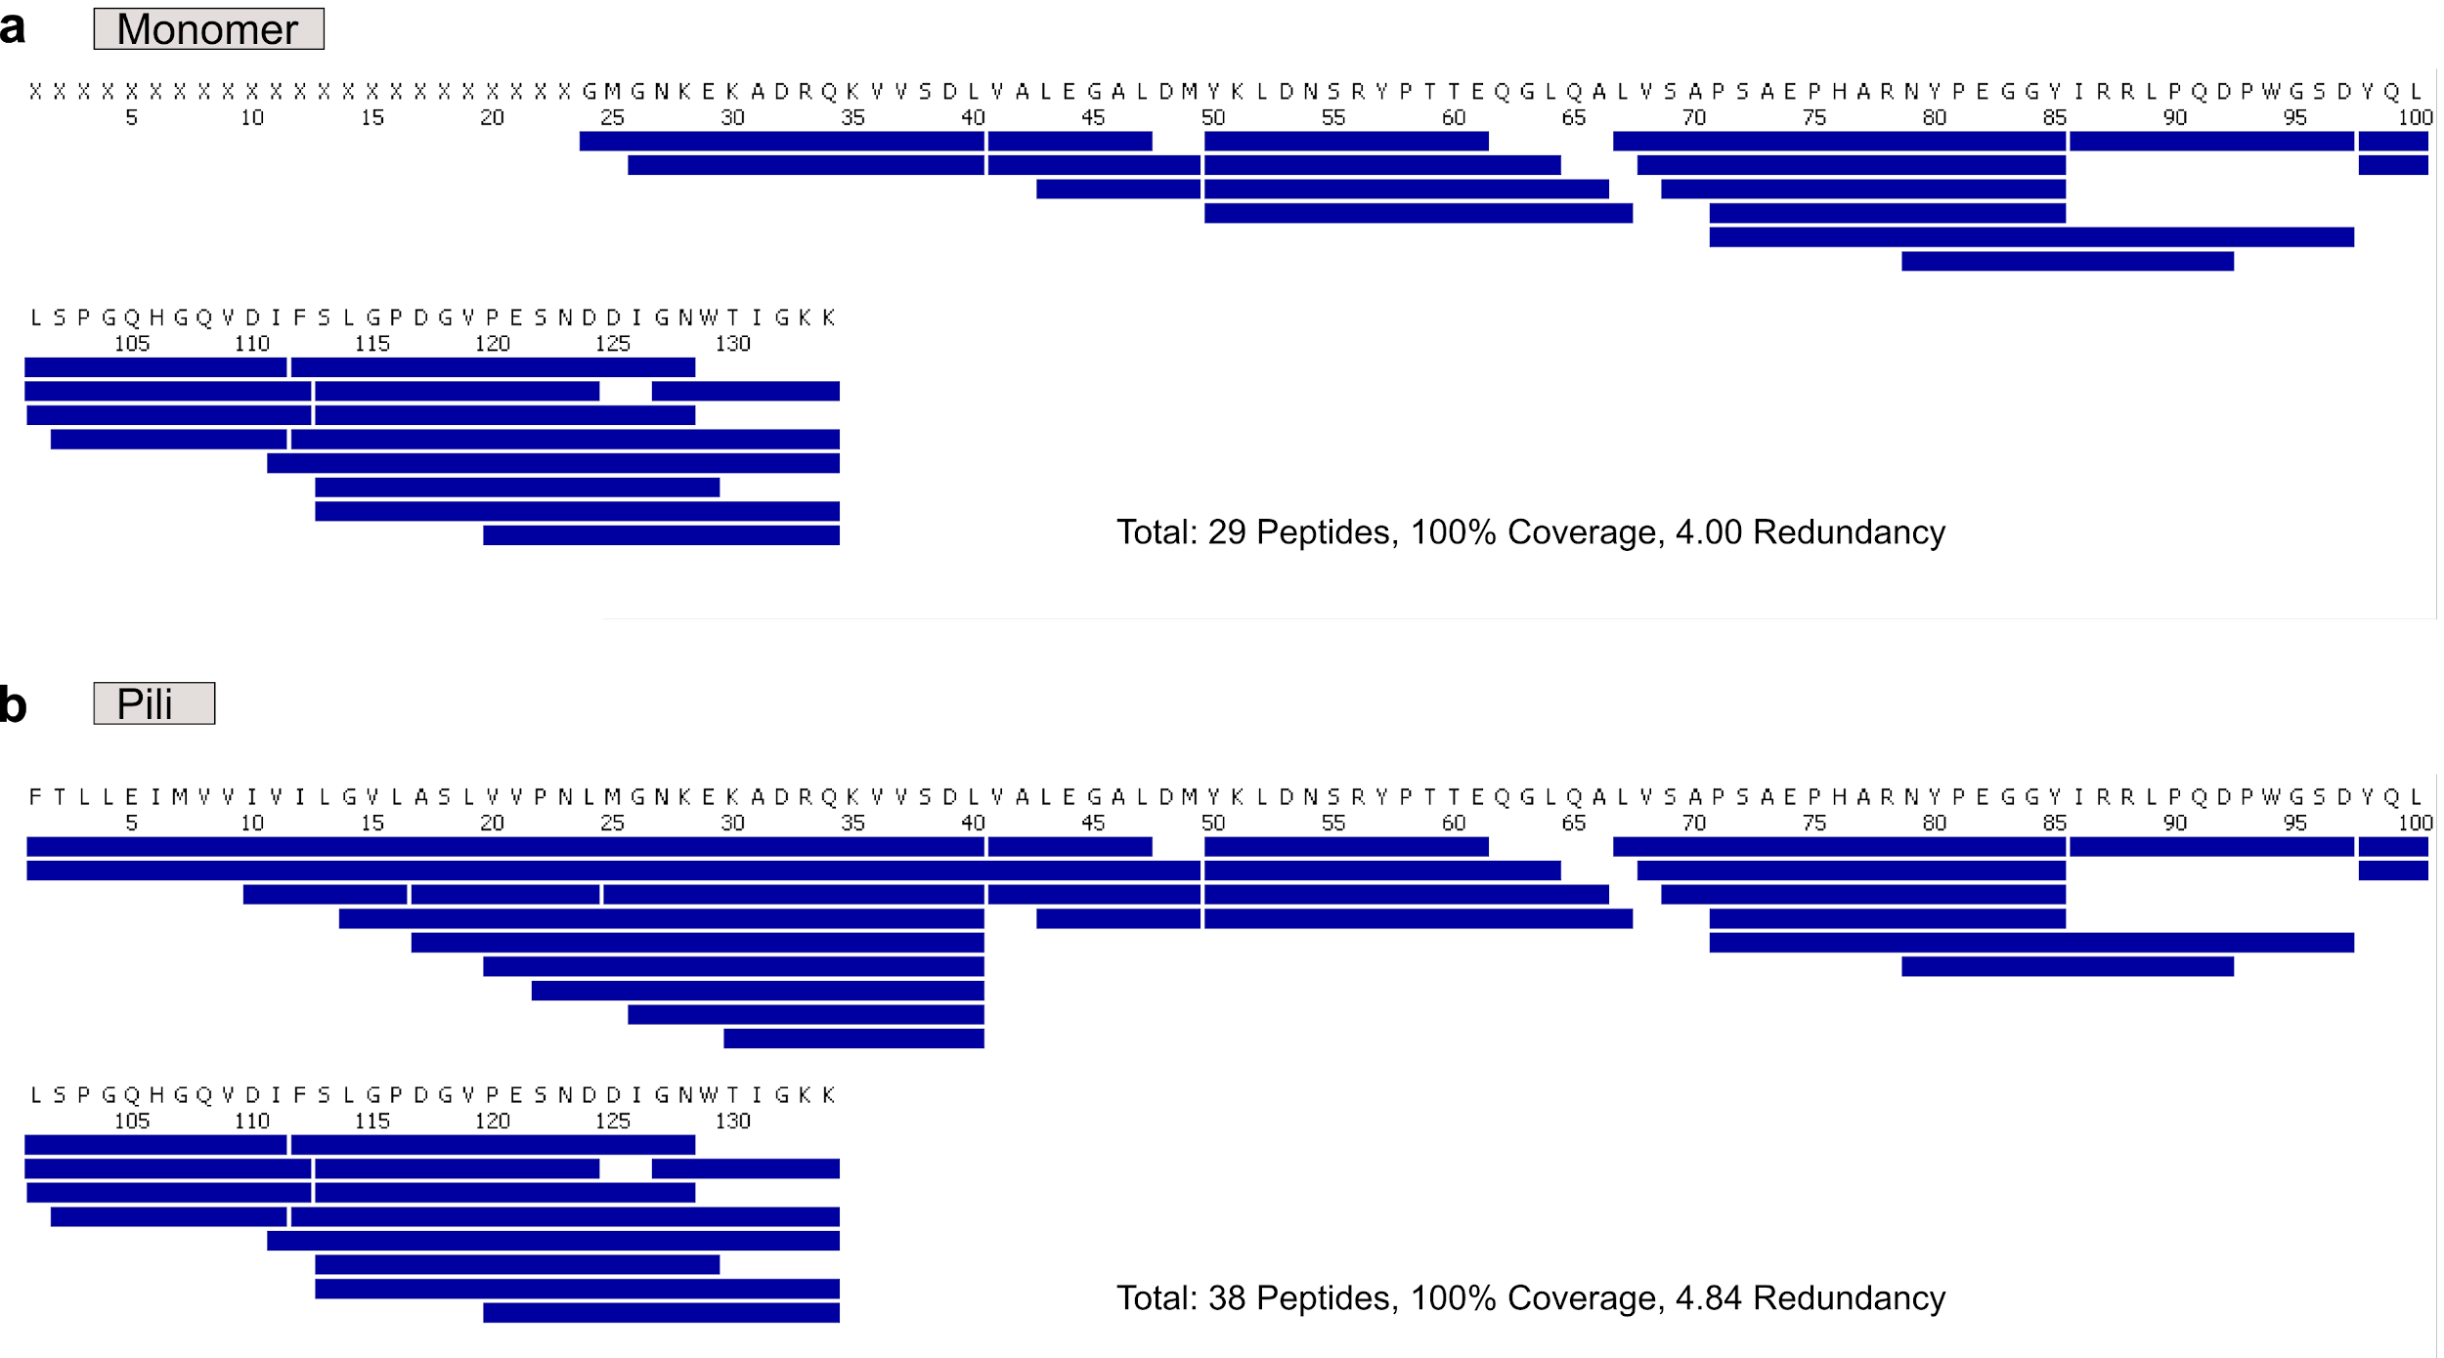

Figure S3: Peptide maps of PulG_{WT} monomer (a) and PulG_{WT} pilus (b) generated after 2 min pepsin digestion at 20ºC and pH 2.5. Each blue bar corresponds to a unique peptide. A 100% sequence coverage was achieved for both proteins. Missing residues in the N-terminal region of the PulG_{WT} monomer have been replaced by “X”.

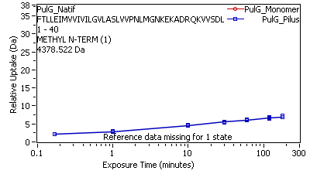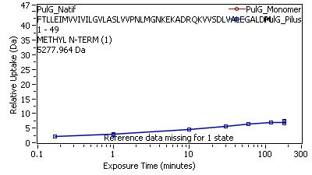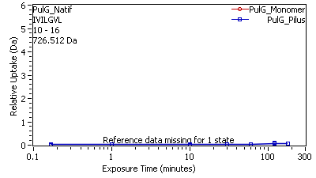
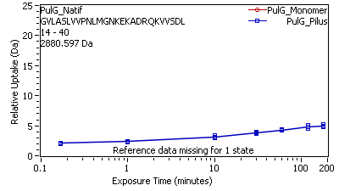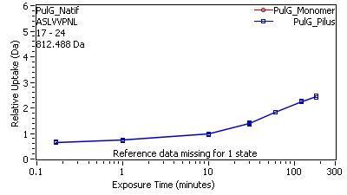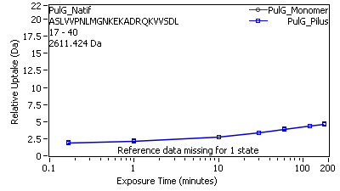
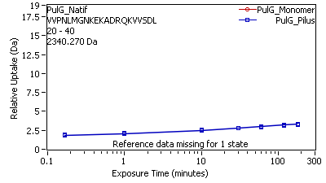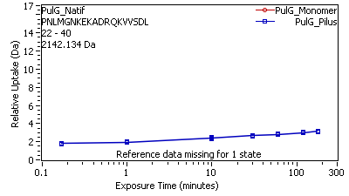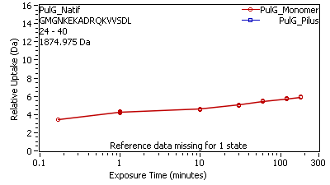
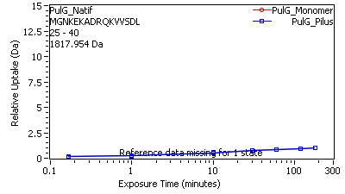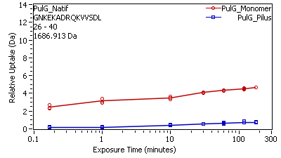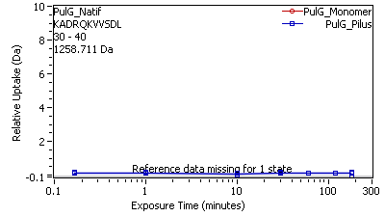
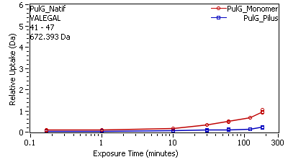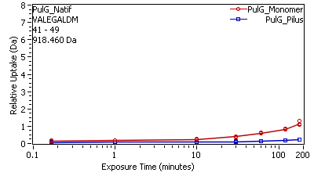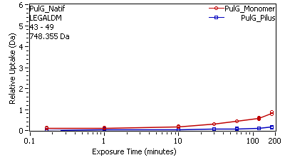
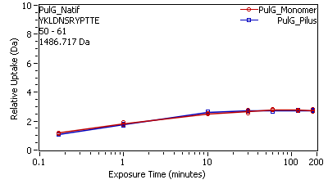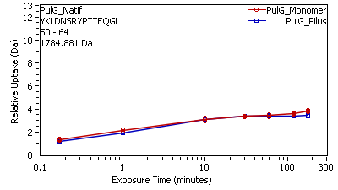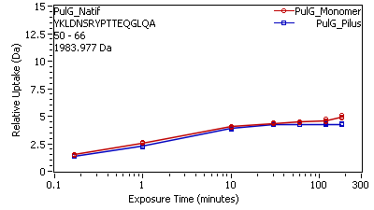
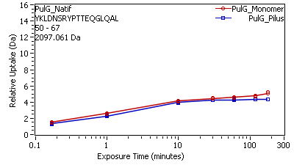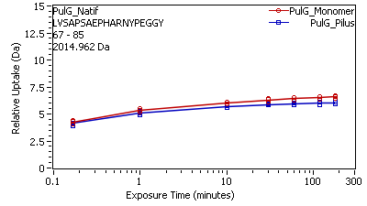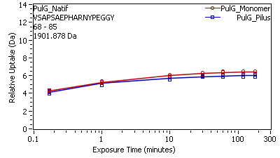
Figure S4: Deuterium uptake curves for all peptides of PulG_{WT} analyzed in the monomer (red dots) and in the pilus (blue squares).

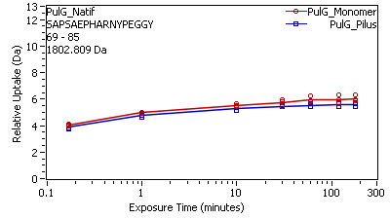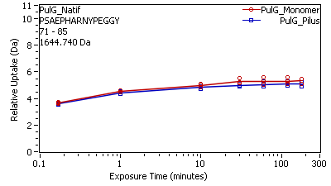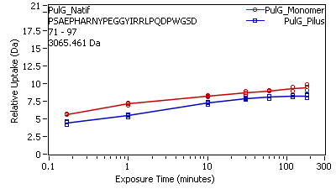
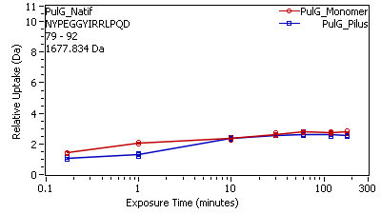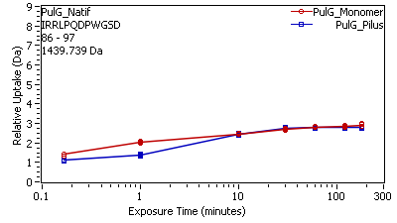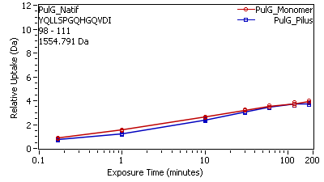
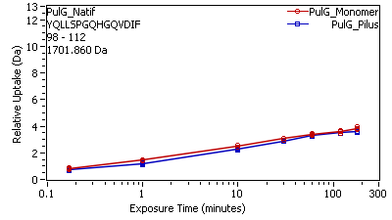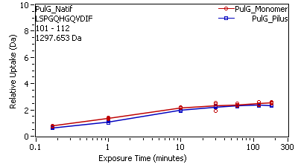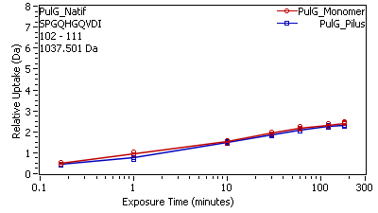
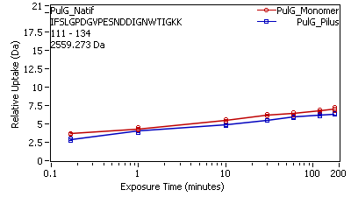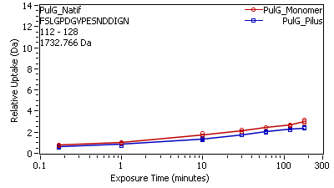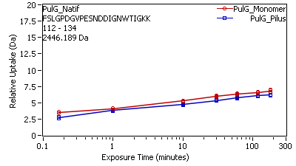
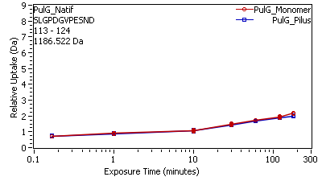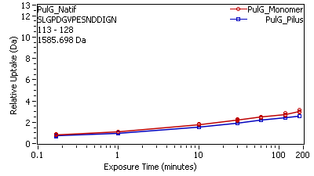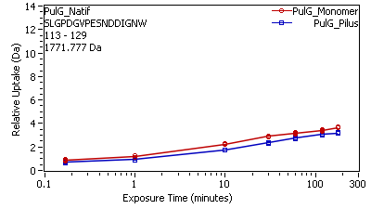
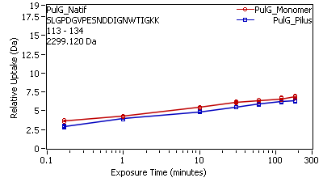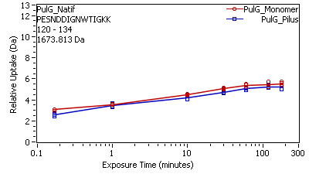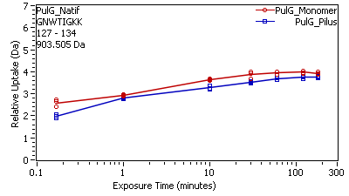

Fig. S4: continued

Table S1: Summary of the Hydrogen/Deuterium eXchange – Mass Spectrometry (HDX-MS) experiments

EXPERIMENT | PulG_{WT} monomer | PulG_{WT} pili
HDX reaction details  pD:  T°C:  Excess deuterium: | 7.4  20°C  78.6% | 7.4  20°C  78.6%
HDX time course analyzed (min) | 0.16, 1, 10, 30, 60, 120, 180 | 0.16, 1, 10, 30, 60, 120, 180
HDX control samples | Fully-labeled control | Fully-labeled control
Number of peptides analyzed after labeling | 29 | 38
Final sequence coverage after labeling | 100% | 100%
Average peptide length | 15.3 | 17.1
Redundancy | 4.00 | 4.84
Replicates | 3 (Technical) | 3 (Technical)
Repeatability (pooled standard deviation) * | 0.052 Da | 0.046 Da
Significant difference between state $ | Wald test, p < 0.01

* One unique charge state was used per peptide
$ MEMHDX (www. memhdx.c3bi.pasteur.fr)

Table S2: Cross-correlation coefficients for PulG pili models before and after real-space refinement
3D density/model | initial | refined
PulG_{WT} | 0.765 ± 0.017 | 0.781 ± 0.004
PulG_{CC} | 0.737 ± 0.009 | 0.738 ± 0.005
PulG_{CC}* | 0.781 ± 0.014 | 0.785 ± 0.005
* in low-pass filtered density at 7.5Å

