Supplementary Information
¹H-detected characterization of carbon-carbon networks in highly flexible protonated biomolecules using MAS NMR

Salima Bahri*, Adil Safeer, Agnes Adler, Haneke Smedes, Hugo van Ingen, and Marc Baldus*

- Scheme 1
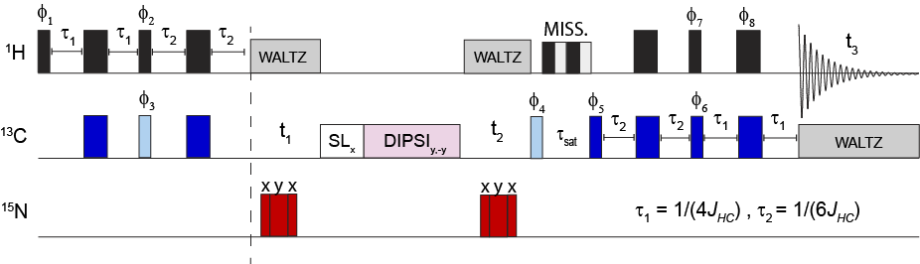
- Scheme 2
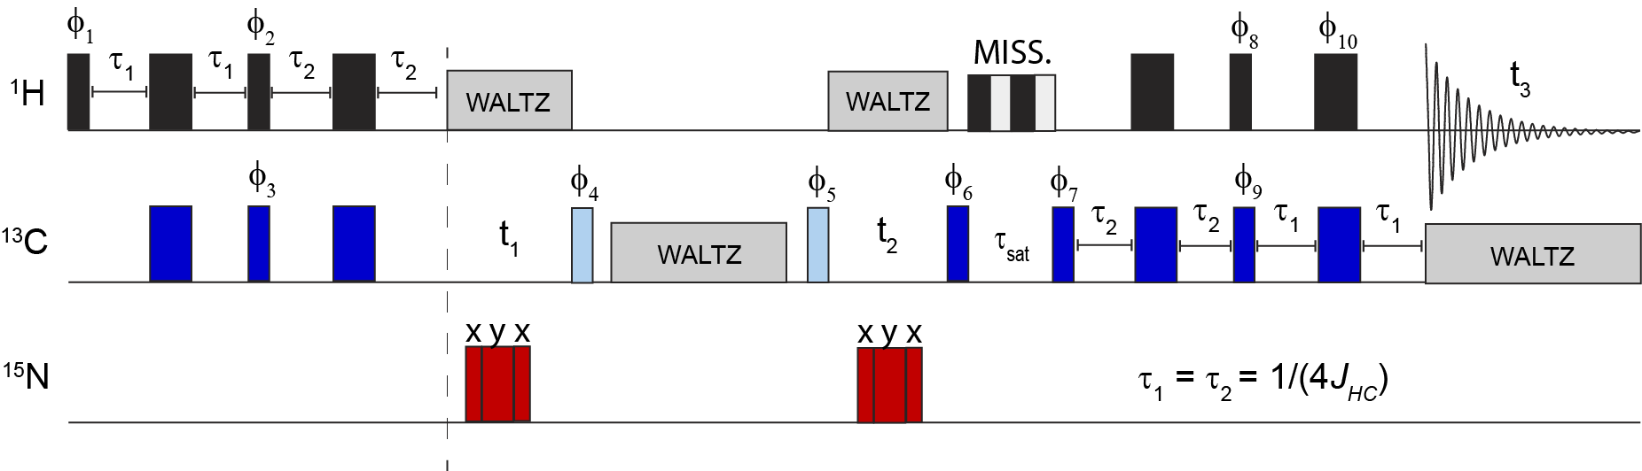
Fig. S1 (a) The phase cycle was set as follows: φ₁= x, φ₂ = -y, φ₃ = x -x, φ₄ = y, φ₅ = -y -y y y, φ6 = -x, φ₇ = x*4 -x*4, φ₈ = x -x, φ_{rec} = x -x -x x -x x x -x. The phases of the ¹⁵N pulse were x y x as indicated. Unless otherwise stated, the pulse phase was set to x. In light blue we show the pulses that are independently phase-shifted for quadrature detection. (b) The phase cycle was set as follows: ; φ₁= x -x, φ₂ = -y*8 y*8, φ₃ = x*16 -x*16, φ₄ = y, φ₅ = -y*32 y*32, φ₆ = y*4 -y*4, φ₇ = y, φ₈ = x x -x -x, φ₉ = -x, φ₁₀ = x -x, φ_{rec} = x -x -x x -x x x -x -x x x -x x -x -x x -x x x -x x -x -x x x -x -x x-x x x -x. In light blue we show incremented pulses for States-TPPI

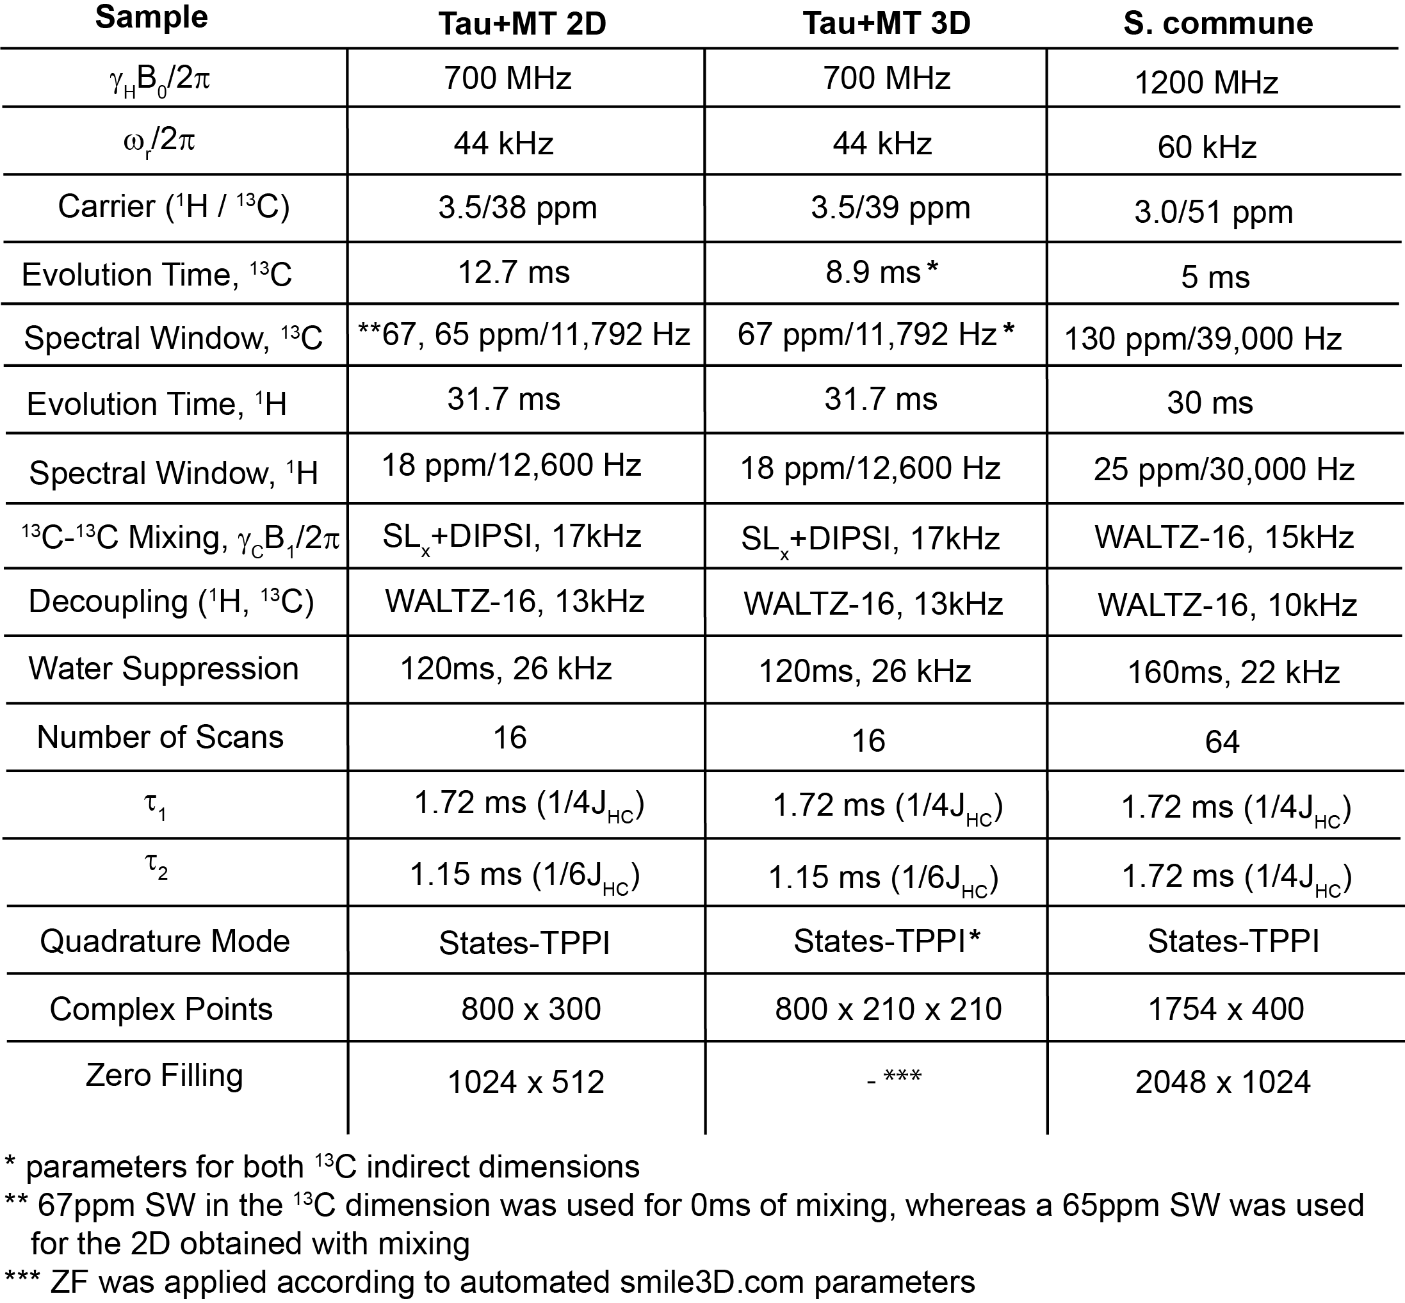
Table S1 Acquisition/processing parameters for the Tau+MT mixture and S. commune.

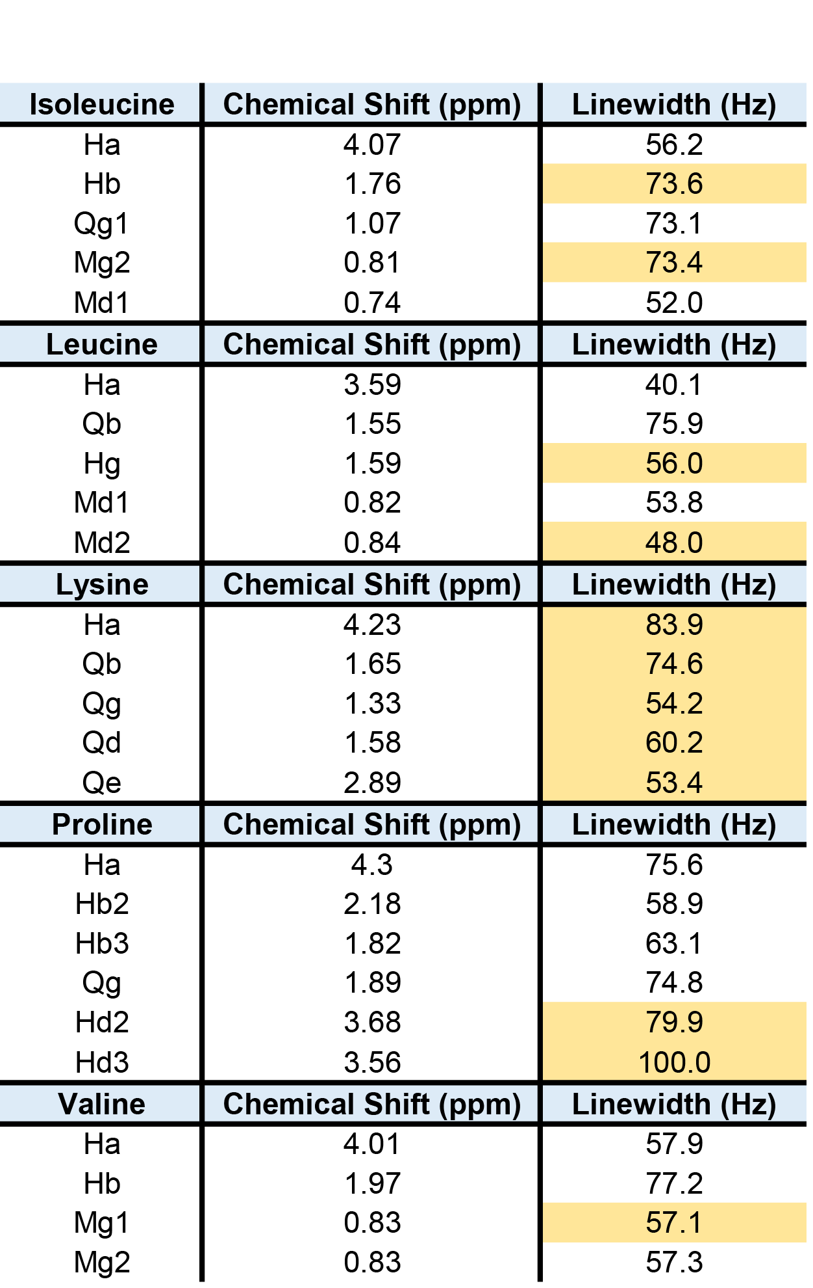
Table S2 ¹H chemical shifts and linewidths of tau resonances (Fig. 3 as determined in Sparky. Unresolved peaks are highlighted in yellow. Linewidths were measured in the directly bonded CH plane, in the 3D slice corresponding to the diagonal CC peak.

Pulse Sequence, Bruker Format

;$COMMENT= hCCH 3D, arbitrary contact and decoupling schemes
;$CLASS=Solids
;$DIM=3D
;$TYPE=INEPT
;$OWNER=Bruker

;p1 : H90 pulse length
;p2 : C90 pulse length
;p3 : N90 pulse length
;p20 : MISSISSIPPI pulse length
;p9 : f2 channel - 90 degree low power pulse (DIPSI)

;pl1 : H90 pulse power
;pl2 : C90 pulse power
;pl3 : N90 pulse power
;pl13 : H WALTZ decoupling
;pl29 : C WALTZ decoupling
;pl14 : C DIPSI3 power

;cnst2 : H-C J-coupling
;cnst24 : frequency hop for water suppression
;cnst3 : relection for echo, 6 to select all 13C

;l1 : to set length of DIPSI mixing
;l2 : MISSISSIPPI loops

define delay JCH1
define delay JCH2
define delay JCH2t
define delay mix

"d0 = 0"
"l0 = 0"
"d10 = 0"
"l10 = 0"

"in0 = inf1"
"in10 = inf2"

"p5 = 2000u"
"d16 = 0.636*p1"
"mix=(p9*54.33*4)*l1"
"JCH1 = 1/(4*cnst2)"
"JCH2 = 1/(cnst3*cnst2)"
"JCH2t = JCH2 - 0.636*p2"

1 ze
2 d1 do:f2 do:f1
(p1 pl1 ph1):f1
JCH1
(center (p1*2 pl1 ph0):f1 (p2*2 pl2 ph0):f2)
JCH1
(center (p1 pl1 ph2):f1 (p2 pl2 ph3):f2)
JCH2t
(center (p1*2 pl1 ph0):f1 (p2*2 pl2 ph0):f2)
JCH2 pl13:f1 pl3:f3

if "l0 == 1" {
"d0 = in0 - 0.3u"
}
if "l0 > 0" {
(center (d0 cpds1):f1 (p3 ph20 p3*2 ph21 p3 ph20):f3)
0.3u do:f1
}

#ifdef tocsy ; note for no mixing, remove tocsy flag
(p5 pl5 ph0):f2
0.3u pl14:f2
9 (p9*2.722 ph21):f2
(p9*4.389 ph23):f2
(p9*2.778 ph21):f2
(p9*3.056 ph23):f2
(p9*0.333 ph21):f2
(p9*2.556 ph23):f2
(p9*4.000 ph21):f2
(p9*2.722 ph23):f2
(p9*4.111 ph21):f2
(p9*3.778 ph23):f2
(p9*3.889 ph21):f2
(p9*2.889 ph23):f2
(p9*3.000 ph21):f2
(p9*0.333 ph23):f2
(p9*2.500 ph21):f2
(p9*4.050 ph23):f2
(p9*2.830 ph21):f2
(p9*4.389 ph23):f2
(p9*2.722 ph23):f2
(p9*4.389 ph21):f2
(p9*2.778 ph23):f2
(p9*3.056 ph21):f2
(p9*0.333 ph23):f2
(p9*2.556 ph21):f2
(p9*4.000 ph23):f2
(p9*2.722 ph21):f2
(p9*4.111 ph23):f2
(p9*3.778 ph21):f2
(p9*3.889 ph23):f2
(p9*2.889 ph21):f2
(p9*3.000 ph23):f2
(p9*0.333 ph21):f2
(p9*2.500 ph23):f2
(p9*4.050 ph21):f2
(p9*2.830 ph23):f2
(p9*4.389 ph21):f2
(p9*2.722 ph23):f2
(p9*4.389 ph21):f2
(p9*2.778 ph23):f2
(p9*3.056 ph21):f2
(p9*0.333 ph23):f2
(p9*2.556 ph21):f2
(p9*4.000 ph23):f2
(p9*2.722 ph21):f2
(p9*4.111 ph23):f2
(p9*3.778 ph21):f2
(p9*3.889 ph23):f2
(p9*2.889 ph21):f2
(p9*3.000 ph23):f2
(p9*0.333 ph21):f2
(p9*2.500 ph23):f2
(p9*4.050 ph21):f2
(p9*2.830 ph23):f2
(p9*4.389 ph21):f2
(p9*2.722 ph21):f2
(p9*4.389 ph23):f2
(p9*2.778 ph21):f2
(p9*3.056 ph23):f2
(p9*0.333 ph21):f2
(p9*2.556 ph23):f2
(p9*4.000 ph21):f2
(p9*2.722 ph23):f2
(p9*4.111 ph21):f2
(p9*3.778 ph23):f2
(p9*3.889 ph21):f2
(p9*2.889 ph23):f2
(p9*3.000 ph21):f2
(p9*0.333 ph23):f2
(p9*2.500 ph21):f2
(p9*4.050 ph23):f2
(p9*2.830 ph21):f2
(p9*4.389 ph23):f2
lo to 9 times l1
;end DIPSI3
0.3u
#endif

if "l10 == 1" {
"d10 = in10 - 0.3u"
}
if "l10 > 0" {
(center (d10 cpds1):f1 (p3 ph20 p3*2 ph21 p3 ph20):f3)
0.3u do:f1
}

(p2 pl2 ph6):f2 (0.3u fq=cnst24):f1
;========water saturation=======================
4 (p20 pl20 ph20):f1
(p20 pl20 ph21):f1
(p20 pl20 ph22):f1
(p20 pl20 ph23):f1
(p20 pl20 ph23):f1
(p20 pl20 ph22):f1
(p20 pl20 ph21):f1
(p20 pl20 ph20):f1
lo to 4 times l2
;========end water saturation=======================

(p2 pl2 ph7):f2 (0.3u fq=0):f1
JCH2
(center (p1*2 pl1 ph0):f1 (p2*2 pl2 ph0):f2)
JCH2
(center (p1 pl1 ph8):f1 (p2 pl2 ph9):f2)
JCH1
(center (p1*2 pl1 ph10):f1 (p2*2 pl2 ph0):f2)
JCH1 pl29:f2

d16
go=2 ph31 cpds2:f2 finally do:f2 do:f1
1m do:f2 do:f1
10m mc #0 to 2
F1PH(calph(ph3, +90), caldel(d0, +in0) & calclc(l0,1))
F2PH(calph(ph6, -90), caldel(d10, +in10) & calclc(l10,1))

HaltAcqu, 1m
exit

ph0 = 0
ph1 = 0
ph2 = 3
ph3 = 0 2
ph6 = 1
ph7 = 3 3 1 1
ph8 = 0 0 0 0 2 2 2 2
ph9 = 2
ph10 = 0 2
ph11 = 2 0
ph20 = 0
ph21 = 1
ph22 = 2
ph23 = 3
ph31 = 0 2 2 0 2 0 0 2

