Online Supplementary Materials

Identifying Symptoms of ADHD and Disruptive Behavior Disorders Most Strongly Associated with Functional Impairment in Children: A Symptom-Level Approach

Published in: Journal of Psychopathology and Behavioral Assessment

Ann-Kathrin Thöne*, Christina Dose, Michaela Junghänel, Christopher Hautmann, Lea Teresa Jendreizik, Anne-Katrin Treier, Paula Vetter, Elena von Wirth, Tobias Banaschewski, Katja Becker, Daniel Brandeis, Ute Dürrwächter, Julia Geissler, Johannes Hebebrand, Sarah Hohmann, Martin Holtmann, Michael Huss, Thomas Jans, Anna Kaiser, Johanna Ketter, Tanja Legenbauer, Sabina Millenet, Luise Poustka, Tobias Renner, Marcel Romanos, Henrik Uebel-von Sandersleben, Priska S. Schneider, Jasmin Wenning, Mirjam Ziegler, Anja Görtz-Dorten & Manfred Döpfner

* Corresponding author: Ann-Kathrin Thöne
ann-kathrin.thoene@uk-koeln.de
Pohligstraße 9, 50969 Cologne, Germany.
Corresponding author: Ann-Kathrin Thöne

Table S1
Scale Characteristics: Cronbach’s Alpha, Item-Total Correlations, and Scale Correlations
Scale | Number of Items | Cronbach’s α | Range of Item-Total Correlations | Mean (SD) | n | Scale Correlations
ADHD Scales |  |  |  |  |  | 1 | 2 | 3 | 4 | 5 | 6 | 7
1 Inattention | 9 | .71 | .29 - .49 | 1.95 (0.48) | 474 |  | .35 | .42 | .30 | .21 | .30 | .24
2 Hyperactivity-Impulsivity | 9 | .87 | 50 - .68 | 1.64 (0.73) | 474 |  | - | .45 | .42 | .32 | .25 | .31
3 ADHD-Related Functional Impairment | 5 | .62 | .24 - .48 | 1.61 (0.59) | 472 |  |  | - | .46 | .35 | .26 | .53
ODD/CD/CU Scales
4 Oppositionality with  Chronic Irritability / Anger | 10 | .86 | .43 - .66 | 1.05 (0.62) | 452 |  |  |  | - | .57 | .47 | .61
5 Conduct Disorder Symptoms | 5 | .60 | .22 - .47 | 0.40 (0.43) | 450 |  |  |  |  | - | .39 | .56
6 Callous-Unemotional Symptoms | 11 | .77 | .23 - .58 | 0.50 (0.42) | 446 |  |  |  |  |  | - | .43
7 ODD/CD/CU-Related Functional Impairment | 5 | .86 | .61 - .71 | 0.93 (0.78) | 442 |  |  |  |  |  |  | -
Note. Symptoms of ADHD, ODD, CD, and CU were assessed using the semi-structured Clinical Parent Interview for Externalizing Disorders in Children and Adolescents (ILF-EXTERNAL) conducted with the parents. ADHD = attention-deficit/hyperactivity disorder; ODD = oppositional defiant disorder; CD = conduct disorder; CU = callous-unemotional. All Pearson correlation coefficients significant (p < .001, not adjusted).
Table S2
Item Characteristics: Skewness, Kurtosis, and Variance Inflation Factor
Item | Mean (SD) | Skewness | Kurtosis | VIF | n
 | ADHD Symptoms
A01 Careless | 2.03 (0.77) | -0.52 | -0.00 | 1.25 | 474
A02 ﻿Difficulties Sustaining Attention | 2.23 (0.64) | -0.45 | 0.19 | 1.31 | 474
A03 Does not Listen | 1.96 (0.93) | -0.56 | -0.56 | 1.25 | 474
A04 ﻿Does not Finish Work | 2.09 (0.80) | -0.73 | 0.25 | 1.38 | 474
A05 Organizational Skills | 2.07 (0.86) | -0.75 | 0.02 | 1.43 | 474
﻿A06 Concentration | 1.85 (0.87) | -0.47 | -0.39 | 1.20 | 474
﻿A07 Loses Things | 1.39 (1.11) | 0.10 | -1.34 | 1.34 | 474
﻿A08 Easily Distracted | 2.48 (0.63) | -1.03 | 0.91 | 1.40 | 474
A09 Forgetful | 1.49 (1.03) | -0.10 | -1.15 | 1.35 | 474
B01 Fidgets | 2.08 (0.99) | -0.78 | -0.51 | 2.05 | 474
﻿B02 Leaves Seat | 1.72 (1.01) | -0.34 | -0.97 | 1.87 | 474
﻿B03 Runs, Climbs | 1.51 (1.08) | -0.08 | -1.25 | 2.12 | 474
﻿B04 Playing Quietly | 1.14 (1.01) | 0.32 | -1.12 | 1.51 | 474
B05 Driven, on the go | 1.51 (1.14) | -0.07 | -1.41 | 2.00 | 474
B06 Blurts out Answers | 1.72 (1.08) | -0.35 | -1.14 | 1.54 | 474
﻿B07 Waits for Turn | 1.46 (1.06) | -0.05 | -1.23 | 1.56 | 474
﻿B08 Interrupts, Intrudes | 1.93 (0.92) | -0.59 | -0.43 | 1.84 | 474
﻿B09 Talks Excessively | 1.69 (1.14) | -0.28 | -1.34 | 1.50 | 474
F01 Psychological Strain | 1.63 (0.90) | -0.34 | -0.62 | 1.23 | 473
F02 Functional Impairment Related to Home Life and Family Members | 1.84 (0.86) | -0.47 | -0.31 | 1.29 | 473
F03 Functional Impairment Related to Relationships with Adults | 1.26 (0.97) | 0.12 | -1.07 | 1.35 | 473
F04 Functional Impairment Related to Relationships with Children/Adolescents; Recreational Activities | 1.31 (1.05) | 0.16 | -1.20 | 1.55 | 472
F05 Functional Impairment Related to Academic Performance | 2.02 (0.85) | -0.69 | 0.00 | 1.22 | 473
 | ODD/CD/CU Symptoms
A01 Loses Temper | 1.47 (1.01) | -0.11 | -1.09 | 2.65 | 452
A02 Touchy, Easily Annoyed | 1.31 (1.01) | 0.11 | -1.14 | 2.06 | 452
A03 Angry, Resentful | 1.15 (0.93) | 0.23 | -0.99 | 1.53 | 452
A04 Argues with Adults | 1.22 (0.98) | 0.19 | -1.07 | 1.93 | 452
A05 Refuses to Comply with Requests | 1.47 (1.02) | 0.03 | -1.10 | 1.97 | 452
A06 Annoys | 0.87 (0.93) | 0.77 | -0.43 | 1.58 | 452
A07 Blames Others | 1.21 (1.01) | 0.22 | -1.15 | 1.53 | 452
A08 Spiteful, Vindictive | 0.30 (0.68) | 2.45 | 5.53 | 1.46 | 452
D01 Recurrent Temper Outbursts | 0.87 (0.95) | 0.77 | -0.49 | 2.75 | 452
D02 Persistently Irritable or Angry Mood | 0.59 (0.85) | 1.22 | 0.41 | 1.76 | 452
B01 Physical Fights | 0.47 (0.75) | 1.55 | 1.78 | 1.65 | 451
B02 Bullies, Threatens, or Intimidates | 0.34 (0.71) | 2.13 | 3.71 | 1.76 | 451
B03 Cruel to Animals | 0.09 (0.37) | 4.43 | 21.33 | 1.23 | 451
B04 Lies | 0.89 (0.93) | 0.70 | -0.54 | 1.53 | 451
B05 Steals Without Confrontation | 0.22 (0.55) | 2.59 | 6.11 | 1.25 | 450
C01a Lack of Remorse | 0.55 (0.80) | 1.27 | 0.58 | 1.86 | 447
C01b Lack of Concern | 0.68 (0.84) | 1.02 | 0.14 | 1.74 | 447
C02a Cold and Uncaring | 0.35 (0.70) | 2.03 | 3.49 | 1.79 | 446
C02b Self-Serving | 0.57 (0.81) | 1.18 | 0.37 | 1.70 | 447
C03a Indifferent to Poor Performance | 0.46 (0.77) | 1.62 | 1.84 | 1.40 | 447
C03b Avoids Effort | 0.88 (0.89) | 0.65 | -0.55 | 1.38 | 447
C03c ﻿Blames Others for Poor Performance | 0.63 (0.86) | 1.14 | 0.24 | 1.34 | 446
C04a Shallow, Deficient Affect | 0.32 (0.65) | 2.04 | 3.60 | 1.39 | 446
C04b Turns Emotions ‘On’ or ‘Off’ Quickly | 0.41 (0.72) | 1.81 | 2.74 | 1.31 | 446
C04c Manipulates | 0.41 (0.67) | 1.61 | 2.05 | 1.34 | 446
C04d Inconsistent Affect | 0.24 (0.60) | 2.75 | 7.51 | 1.31 | 447
F01 Psychological Strain | 0.96 (0.94) | 0.36 | -1.21 | 1.93 | 446
F02 Functional Impairment Related to Home Life and Family Members | 1.33 (1.04) | -0.01 | -1.27 | 2.25 | 443
F03 Functional Impairment Related to Relationships with Adults | 0.75 (0.91) | 0.86 | -0.43 | 2.49 | 444
F04 Functional Impairment Related to Relationships with Children/Adolescents; Recreational Activities | 0.85 (0.98) | 0.73 | -0.76 | 2.44 | 445
F05 Functional Impairment Related to Academic Performance | 0.76 (1.10) | 0.94 | -0.47 | 2.19 | 445
Note. Each symptom was rated by clinicians using the DSM-5 based, semi-structured Clinical Parent Interview for Externalizing Disorders in Children and Adolescents (ILF-EXTERNAL) conducted with the parents. VIF = Variance inflation factor; ADHD = attention-deficit/hyperactivity disorder; ODD = oppositional defiant disorder; CD = conduct disorder; CU = callous-unemotional.

Table S3
Multivariate Linear Regression Analysis Predicting Global Functional Impairment from Individual ADHD Symptoms
Predictors | Estimate | SE | 95% CI | t | p
A01 Careless | 0.02 | 0.03 | -.04, .09 | 0.68 | .498
A02 Difficulties Sustaining Attention | 0.11 | 0.04 | .04, .19 | 2.92** | .004
A03 Does not Listen | 0.05 | 0.03 | .00, .10 | 1.96 | .051
A04 Does not Finish Work | 0.02 | 0.03 | -.04, .09 | 0.67 | .051
A05 Organizational Skills | 0.02 | 0.03 | -.04, .08 | 0.71 | .480
A06 Concentration | 0.05 | 0.03 | .00, .11 | 1.97* | .049
A07 Loses Things | -0.02 | 0.02 | -.07, .02 | -0.90 | .367
A08 Easily Distracted | 0.18 | 0.04 | .10, .26 | 4.41*** | < .001
A09 Forgetful | 0.04 | 0.03 | -.01, .09 | 1.47 | .141
B01 Fidgets | -0.07 | 0.03 | -.14, -.01 | -2.31* | .021
B02 Leaves Seat | 0.06 | 0.03 | .00, .12 | 2.06* | .040
B03 Runs, Climbs | 0.07 | 0.03 | .01, .13 | 2.44* | .015
B04 Playing Quietly | 0.01 | 0.03 | -.04, .06 | 0.35 | .727
B05 Driven, on the go | 0.04 | 0.03 | -.01, .09 | 1.49 | .138
B06 Blurts out Answers | 0.05 | 0.03 | .00, .10 | 1.81 | .071
B07 Waits for turn | -0.02 | 0.03 | -.07, .04 | -0.60 | .550
B08 Interrupts, Intrudes | 0.10 | 0.03 | .03, .16 | 2.98** | .003
﻿B09 Talks excessively | 0.01 | 0.02 | -.04, .05 | 0.36 | .719
Age | 0.02 | 0.02 | -.01, .05 | 1.12 | .260
Gender | 0.13 | 0.06 | .02, .25 | 2.25* | .025
Note. Significant predictors are shaded in gray. F = 12.69, df = 451, p < .001, R² = .36; ADHD = attention-deficit/hyperactivity disorder.
* p < .05; ** p < .01; *** p < .001.
Table S4
Multivariate Linear Regression Analysis Predicting Global Functional Impairment from Individual ODD/CD/CU Symptoms
Predictors | Estimate | SE | 95% CI | t | p
A01 Loses Temper | 0.12 | 0.04 | .03, .20 | 2.63** | .009
A02 Touchy, Easily Annoyed | 0.02 | 0.04 | -.06, .20 | 0.41 | .679
A03 Angry, Resentful | 0.08 | 0.04 | .01, .16 | 2.31* | .022
A04 Argues with Adults | 0.13 | 0.04 | .06, .20 | 3.51*** | < .001
A05 Refuses to Comply | 0.06 | 0.04 | -.02, .13 | 1.56 | .119
A06 Annoys | 0.08 | 0.04 | .02, .15 | 2.39* | .018
A07 Blames Others | 0.06 | 0.03 | -.01, .12 | 1.74 | .082
A08 Spiteful, Vindictive | -0.15 | 0.05 | -.24, -.06 | -3.18** | .002
D01 Recurrent Temper Outbursts | -0.10 | 0.05 | -.19, -.01 | -2.16* | .032
D02 Persistently Irritable or Angry Mood | 0.07 | 0.04 | -.02, .15 | 1.49 | .134
B01 Physical Fights | 0.17 | 0.05 | .08, .26 | 3.68*** | < .001
B02 Bullies, Threatens, or Intimidates | 0.08 | 0.05 | -.13, .18 | 1.70 | .091
B03 Cruel to Animals | 0.14 | 0.08 | -.01, .30 | 1.79 | .074
B04 Lies | 0.06 | 0.04 | -.01, .13 | 1.74 | .084
B05 Steals Without Confrontation | 0.11 | 0.05 | .00, .21 | 1.99* | .047
C01a Lack of Remorse | 0.04 | 0.05 | -.05, .13 | 0.89 | .377
C01b Lack of Concern | 0.05 | 0.04 | -.03, .13 | 1.17 | .244
C02a Cold and Uncaring | -0.05 | 0.05 | -.14, .05 | -0.92 | .356
C02b Self-Serving | 0.06 | 0.04 | -.01, .15 | 1.53 | .127
C03a Indifferent to Poor Performance | -0.07 | 0.04 | -.15, .01 | -1.67 | .096
C03b Avoids Effort | 0.08 | 0.04 | .01, .14 | 2.20* | .028
C03c Blames Others for Poor Performance | 0.04 | 0.04 | -.03, .11 | 1.07 | .283
C04a Shallow, Deficient Affect | -0.06 | 0.05 | -.16, .03 | -1.31 | .189
C04b Turns Emotions ‘On’ or ‘Off’ Quickly | 0.05 | 0.04 | -.03, .14 | 1.38 | .169
C04c Manipulates | -0.02 | 0.05 | -.10, .08 | -0.19 | .853
C04d. Inconsistent Affect | 0.12 | 0.05 | .02, .22 | 2.26* | .024
Age | 0.02 | 0.02 | -.02, .05 | 0.86 | .389
Gender | -0.01 | 0.07 | -.15, .14 | -0.08 | .938
Note. Significant predictors are shaded in gray. F = 16.06, df = 411, p < .001, R² = .52; ODD = oppositional defiant disorder; CD = conduct disorder; CU = callous-unemotional. * p < .05; ** p < .01; *** p < .001.
Table S5
Multivariate Linear Regression Analysis Predicting Global Functional Impairment from all Externalizing Symptoms
Predictors | Estimate | SE | 95% CI | t | p
A01 Careless | -0.01 | 0.03 | -.06, .05 | -0.24 | .810
A02 Difficulties Sustaining Attention | 0.06 | 0.04 | -.01, .12 | 1.51 | .131
A03 Does not Listen | 0.03 | 0.03 | -.02, .08 | 1.08 | .280
A04 Does not Finish Work | 0.03 | 0.03 | -.03, .09 | 1.11 | .268
A05 Organizational Skills | 0.01 | 0.023 | -.04, .07 | 0.45 | .655
A06 Concentration | -0.01 | 0.03 | -.06, .04 | -0.28 | .776
A07 Loses Things | -0.03 | 0.02 | -.01, .01 | -1.30 | .195
A08 Easily Distracted | 0.13 | 0.04 | .06, .20 | 3.34*** | < .001
A09 Forgetful | 0.01 | 0.02 | -.04, .05 | 0.24 | .808
B01 Fidgets | -0.02 | 0.03 | -.08, .04 | -0.66 | .513
B02 Leaves Seat | 0.00 | 0.03 | -.05, .06 | 0.15 | .878
B03 Runs, Climbs | 0.06 | 0.03 | .01, .11 | 2.17* | .030
B04 Playing Quietly | 0.01 | 0.03 | -.04, .06 | 0.36 | .716
B05 Driven, on the go | 0.00 | 0.03 | -.05, .05 | 0.11 | .914
B06 Blurts out Answers | -0.03 | 0.02 | -.08, .02 | -1.18 | .241
B07 Waits for turn | -0.03 | 0.02 | -.08, .02 | -1.15 | .249
B08 Interrupts, Intrudes | 0.05 | 0.03 | -.01, .11 | 1.58 | .116
﻿B09 Talks excessively | -0.01 | 0.02 | -.05, .04 | -0.23 | .822
A01 Loses Temper | 0.07 | 0.03 | .01, .14 | 2.14* | .033
A02 Touchy, Easily Annoyed | 0.02 | 0.03 | -.04, .08 | 0.53 | .595
A03 Angry, Resentful | 0.08 | 0.03 | .03, .14 | 3.00** | .003
A04 Argues with Adults | 0.09 | 0.03 | .04, .15 | 3.23** | .001
A05 Refuses to Comply | 0.04 | 0.03 | -.02, .09 | 1.42 | .157
A06 Annoys | 0.10 | 0.03 | .05, .15 | 3.69*** | < .001
A07 Blames Others | 0.03 | 0.03 | -.02, .07 | 0.99 | .322
A08 Spiteful, Vindictive | -0.10 | 0.04 | -.17, -.03 | -2.92** | .004
D01 Recurrent Temper Outbursts | -0.07 | 0.04 | -.14, .00 | -1.86 | .064
D02 Persistently Irritable or Angry Mood | 0.05 | 0.03 | -.02, .11 | 1.37 | .172
B01 Physical Fights | 0.14 | 0.03 | .07, .20 | 3.99*** | < .001
B02 Bullies, Threatens, or Intimidates | 0.03 | 0.04 | -.04, .11 | 0.87 | .385
B03 Cruel to Animals | 0.08 | 0.06 | -.04, .20 | 1.36 | .174
B04 Lies | 0.03 | 0.03 | -.02, .09 | 1.29 | .198
B05 Steals Without Confrontation | 0.06 | 0.04 | -.02, .14 | 1.57 | .118
C01a Lack of Remorse | -0.01 | 0.04 | -.08, .06 | -0.36 | .721
C01b Lack of Concern | 0.02 | 0.03 | -.05, .08 | 0.47 | .639
C02a Cold and Uncaring | 0.03 | 0.04 | -.05, .10 | 0.70 | .485
C02b Self-Serving | 0.02 | 0.03 | -.05, .08 | 0.52 | .606
C03a Indifferent to Poor Performance | -0.03 | 0.03 | -.10, .03 | -1.08 | .283
C03b Avoids Effort | 0.08 | 0.03 | .03, .13 | 2.89** | .004
C03c Blames Others for Poor Performance | 0.02 | 0.03 | -.04, .07 | 0.61 | .543
C04a Shallow, Deficient Affect | -0.04 | 0.04 | -.12, .03 | -1.17 | .242
C04b Turns Emotions ‘On’ or ‘Off’ Quickly | 0.02 | 0.03 | -.04, .09 | 0.74 | .461
C04c Manipulates | -0.03 | 0.04 | -.10, .04 | -0.85 | .396
C04d Inconsistent Affect | 0.08 | 0.04 | .00, .16 | 1.94 | .053
Age | 0.02 | 0.02 | -.01, .05 | 1.39 | .165
Gender | 0.03 | 0.06 | -.08, .14 | 0.49 | .627
Note. Significant predictors are shaded in gray. F = 11.40, df = 397, p < .001, R² = .57.
* p < .05; ** p < .01; *** p < .001.

Table S6
Ordinal Logistic Regression Analysis Predicting Functional Impairment Domains from Individual ADHD Symptoms
Predictors | Estimate | SE | z | p | OR | 95% CI
F01 Psychological Strain
A01 Careless | 0.25 | 0.13 | 1.95 | .052 | 1.28 | 0.99, 1.65
A02 Difficulties Sustaining Attention | 0.39 | 0.16 | 2.49* | .013 | 1.48 | 1.09, 2.02
A03 Does not Listen | 0.04 | 0.11 | 0.38 | .705 | 1.04 | 0.85, 1.28
A04 Does not Finish Work | 0.12 | 0.13 | 0.93 | .350 | 1.13 | 0.88, 1.45
A05 Organizational Skills | 0.07 | 0.12 | 0.58 | .562 | 1.07 | 0.85, 1.36
A06 Concentration | -0.09 | 0.11 | -0.82 | .411 | 0.91 | 0.74, 1.13
A07 Loses Things | 0.06 | 0.09 | 0.62 | .537 | 1.06 | 0.90, 1.26
A08 Easily Distracted | 0.45 | 0.16 | 2.80** | .005 | 1.56 | 1.14, 2.14
A09 Forgetful | 0.09 | 0.10 | 0.83 | .405 | 1.09 | 0.89, 1.37
B01 Fidgets | -0.20 | 0.3 | -1.53 | .126 | 0.82 | 0.64, 1.06
B02 Leaves Seat | 0.06 | 0.12 | 0.47 | .642 | 1.06 | 0.84, 1.32
B03 Runs, Climbs | 0.35 | 0.12 | 2.96** | .003 | 1.42 | 1.12, 1.79
B04 Playing Quietly | -0.07 | 0.10 | -0.64 | .521 | 0.94 | 0.76, 1.15
B05 Driven, on the go | 0.03 | 0.11 | 0.27 | .790 | 1.03 | 0.84, 1.27
B06 Blurts out Answers | 0.04 | 0.10 | 0.41 | .683 | 1.05 | 0.85, 1.27
B07 Waits for turn | -0.09 | 0.10 | -0.88 | .381 | 0.91 | 0.75, 1.12
B08 Interrupts, Intrudes | 0.112 | 0.13 | 0.91 | .363 | 1.12 | 0.87, 1.44
﻿B09 Talks excessively | -0.03 | 0.09 | -0.32 | .752 | 0.97 | 0.81, 1.17
Age | 0.06 | 0.07 | 0.85 | .396 | 1.06 | 0.93, 1.20
Gender | -0.05 | 0.23 | -0.23 | .815 | 0.95 | 0.60, 1.49
F02 Functional Impairment Related
to Home Life and Family Members
A01 Careless | 0.09 | 0.13 | 0.68 | .498 | 1.09 | 0.84, 1.42
A02 Difficulties Sustaining Attention | 0.39 | 0.16 | 2.49* | .013 | 1.48 | 1.08, 2.02
A03 Does not Listen | 0.33 | 0.11 | 3.02** | .004 | 1.38 | 1.12, 1.71
A04 Does not Finish Work | -0.16 | 0.13 | -1.22 | .222 | 0.85 | 0.65, 1.10
A05 Organizational Skills | 0.07 | 0.13 | 0.54 | .588 | 1.07 | 0.84, 1.36
A06 Concentration | 0.28 | 0.11 | 2.44* | .015 | 1.32 | 1.06, 1.65
A07 Loses Things | -0.07 | 0.09 | -0.78 | .433 | 0.93 | 0.78, 1.11
A08 Easily Distracted | 0.13 | 0.17 | 0.79 | .428 | 1.14 | 0.82, 1.59
A09 Forgetful | 0.01 | 0.10 | 0.15 | .883 | 1.01 | 0.83, 1.23
B01 Fidgets | -0.25 | 0.13 | -1.99* | .047 | 0.78 | 0.60, 1.00
B02 Leaves Seat | 0.27 | 0.12 | 2.24* | .025 | 1.30 | 1.03, 1.66
B03 Runs, Climbs | 0.23 | 0.12 | 1.91 | .057 | 1.26 | 0.99, 1.59
B04 Playing Quietly | 0.00 | 0.11 | -0.02 | .981 | 0.99 | 0.81, 1.23
B05 Driven, on the go | 0.26 | 0.11 | 2.35* | .019 | 1.29 | 1.04, 1.60
B06 Blurts out Answers | 0.16 | 0.10 | 1.53 | .127 | 1.17 | 0.96, 1.43
B07 Waits for turn | -0.06 | 0.10 | -0.55 | .580 | 0.94 | 0.77, 1.16
B08 Interrupts, Intrudes | 0.04 | 0.13 | 0.31 | .760 | 1.04 | 0.81, 1.34
﻿B09 Talks excessively | 0.03 | 0.09 | 0.31 | .759 | 1.03 | 0.86, 1.24
Age | -0.06 | 0.07 | -0.98 | .326 | 0.94 | 0.83, 1.07
Gender | 0.20 | 0.23 | 0.87 | .383 | 1.22 | 0.78, 1.91
F03 Functional Impairment Related to Relationships with Adults
A01 Careless | -0.11 | 0.13 | -0.88 | .380 | 0.89 | 0.69, 1.14
A02 Difficulties Sustaining Attention | 0.16 | 0.16 | 1.05 | .293 | 1.17 | 0.87, 1.60
A03 Does not Listen | 0.12 | 0.10 | 1.16 | .244 | 1.13 | 0.92, 1.39
A04 Does not Finish Work | 0.03 | 0.13 | 0.24 | .808 | 1.03 | 0.81, 1.32
A05 Organizational Skills | -0.05 | 0.12 | -0.43 | .670 | 0.95 | 0.75, 1.21
A06 Concentration | 0.09 | 0.11 | 0.80 | .421 | 1.09 | 0.88, 1.35
A07 Loses Things | 0.10 | 0.09 | 1.08 | .279 | 1.10 | 0.93, 1.31
A08 Easily Distracted | 0.10 | 0.16 | 0.60 | .551 | 1.10 | 0.80, 1.50
A09 Forgetful | 0.11 | 0.10 | 1.15 | .246 | 1.12 | 0.92, 1.36
B01 Fidgets | -0.04 | 0.13 | -0.32 | .752 | 0.96 | 0.75, 1.22
B02 Leaves Seat | 0.29 | 0.12 | 2.50* | .013 | 1.34 | 1.07, 1.69
B03 Runs, Climbs | 0.07 | 0.12 | 0.57 | .571 | 1.07 | 0.85, 1.34
B04 Playing Quietly | 0.04 | 0.11 | 0.35 | .724 | 1.04 | 0.84, 1.28
B05 Driven, on the go | 0.18 | 0.11 | 1.73 | .084 | 1.20 | 0.98, 1.48
B06 Blurts out Answers | 0.06 | 0.10 | 0.63 | .527 | 1.07 | 0.87, 1.30
B07 Waits for turn | -0.01 | 0.10 | -0.10 | .923 | 0.99 | 0.81, 1.21
B08 Interrupts, Intrudes | 0.21 | 0.13 | 1.60 | .110 | 1.22 | 0.95, 1.58
﻿B09 Talks excessively | 0.014 | 0.09 | 0.15 | .882 | 1.01 | 0.85, 1.22
Age | 0.16 | 0.06 | 2.49* | .013 | 1.17 | 1.03, 1.33
Gender | 0.53 | 0.23 | 2.30* | .021 | 1.69 | 1.08, 2.65
F04 Functional Impairment Related to Relationships with Children/Adolescents; Recreational Activities
A01 Careless | -0.12 | 0.13 | -0.91 | .363 | 0.89 | 0.69, 1.14
A02 Difficulties Sustaining Attention | 0.26 | 0.16 | 1.63 | .102 | 1.29 | 0.95, 1.76
A03 Does not Listen | 0.10 | 0.10 | 0.93 | .354 | 1.10 | 0.90, 1.35
A04 Does not Finish Work | -0.08 | 0.13 | -0.59 | .555 | 0.93 | 0.72, 1.19
A05 Organizational Skills | 0.17 | 0.12 | 1.40 | .161 | 1.19 | 0.93, 1.51
A06 Concentration | 0.01 | 0.11 | 0.11 | .910 | 1.01 | 0.82, 1.25
A07 Loses Things | -0.21 | 0.09 | -2.27* | .023 | 0.81 | 0.68, 0.97
A08 Easily Distracted | 0.69 | 0.16 | 4.22*** | < .001 | 1.99 | 1.45, 2.75
A09 Forgetful | 0.14 | 0.10 | 1.40 | .162 | 1.14 | 0.95, 1.39
B01 Fidgets | -0.19 | 0.13 | -1.47 | .142 | 0.83 | 0.65, 1.06
B02 Leaves Seat | 0.11 | 0.12 | 0.90 | .366 | 1.11 | 0.88, 1.40
B03 Runs, Climbs | 0.05 | 0.11 | 0.43 | .660 | 1.05 | 0.84, 1.32
B04 Playing Quietly | -0.07 | 0.11 | -0.70 | .482 | 0.93 | 0.75, 1.14
B05 Driven, on the go | 0.12 | 0.10 | 1.18 | .238 | 1.13 | 0.92, 1.39
B06 Blurts out Answers | 0.23 | 0.10 | 2.26* | .024 | 1.25 | 1.03, 1.53
B07 Waits for turn | 0.10 | 0.10 | 1.01 | .315 | 1.10 | 0.91, 1.36
B08 Interrupts, Intrudes | 0.48 | 0.13 | 3.63*** | < .001 | 1.65 | 1.25, 2.10
﻿B09 Talks excessively | 0.17 | 0.09 | 1.80 | .072 | 1.19 | 0.99, 1.43
Age | -0.07 | 0.07 | -1.07 | .286 | 0.93 | 0.82, 1.06
Gender | 0.82 | 0.23 | 3.37*** | < .001 | 2.26 | 1.44, 3.60
F05 Functional Impairment Related to Academic Performance
A01 Careless | 0.22 | 0.13 | 1.63 | .103 | 1.24 | 0.96, 1.61
A02 Difficulties Sustaining Attention | 0.29 | 0.16 | 1.82 | .069 | 1.34 | 0.98, 1.85
A03 Does not Listen | 0.07 | 0.11 | 0.61 | .540 | 1.07 | 0.87, 1.32
A04 Does not Finish Work | 0.32 | 0.13 | 2.49* | .013 | 1.38 | 1.07, 1.78
A05 Organizational Skills | -0.05 | 0.15 | -0.44 | .663 | 0.95 | 0.74, 1.21
A06 Concentration | 0.28 | 0.11 | 2.50* | .012 | 1.32 | 1.06, 1.64
A07 Loses Things | -0.20 | 0.09 | -2.10* | .036 | 0.82 | 0.68, 0.99
A08 Easily Distracted | 0.50 | 0.17 | 2.96** | .003 | 1.65 | 1.19, 2.23
A09 Forgetful | 0.09 | 0.10 | 0.88 | .378 | 1.09 | 0.90, 1.33
B01 Fidgets | -0.17 | 0.13 | -1.35 | .177 | 0.84 | 0.66, 1.08
B02 Leaves Seat | 0.08 | 0.12 | 0.65 | .513 | 1.08 | 0.86, 1.36
B03 Runs, Climbs | 0.18 | 0.12 | 1.47 | .143 | 1.19 | 0.94, 1.51
B04 Playing Quietly | 0.17 | 0.11 | 1.57 | .118 | 1.19 | 0.96, 1.47
B05 Driven, on the go | -0.15 | 0.11 | -1.36 | .174 | 0.86 | 0.69, 1.07
B06 Blurts out Answers | 0.11 | 0.10 | 1.10 | .271 | 1.12 | 0.91, 1.37
B07 Waits for turn | -0.17 | 0.11 | -1.65 | .099 | 0.84 | 0.68, 1.03
B08 Interrupts, Intrudes | 0.20 | 0.13 | 1.54 | .123 | 1.22 | 0.95, 1.58
﻿B09 Talks excessively | -0.10 | 0.09 | -1.05 | .293 | 0.91 | 0.75, 1.09
Age | 0.15 | 0.07 | 2.28* | .023 | 1.16 | 1.02, 1.33
Gender | 0.00 | 0.23 | -0.02 | .986 | 1.00 | 0.63, 1.67
Note. Significant predictors are shaded in light gray and the response variables are shaded in dark gray. McFadden’s Pseudo R² = .06 (F01); .09 (F02); .07 (F03); .12 (F04); .08 (F05). ADHD = attention-deficit/hyperactivity disorder, OR = odds ratio.
* p < .05; ** p < .01; *** p < .001.
Table S7
Ordinal Logistic Regression Analysis Predicting Functional Impairment Domains from Individual ODD/CD/CU Symptoms
Predictors | Estimate | SE | z | p | OR | 95% CI
F01 Psychological Strain
A01 Loses Temper | 0.43 | 0.16 | 2.71** | .007 | 1.54 | 1.13, 2.11
A02 Touchy, Easily Annoyed | 0.07 | 0.14 | 0.47 | .640 | 1.07 | 0.81, 1.40
A03 Angry, Resentful | 0.38 | 0.13 | 2.86** | .004 | 1.46 | 1.12, 1.84
A04 Argues with Adults | 0.25 | 0.13 | 1.92 | .055 | 1.28 | 0.99, 1.65
A05 Refuses to Comply with Requests | -0.03 | 0.13 | -0.21 | .835 | 0.97 | 0.75, 1.26
A06 Annoys | 0.06 | 0.12 | 0.48 | .634 | 1.06 | 0.83, 1.35
A07 Blames Others | 0.15 | 0.11 | 1.30 | .195 | 1.16 | 0.93, 1.44
A08 Spiteful, Vindictive | -0.12 | 0.16 | -0.72 | .470 | 0.89 | 0.64, 1.26
D01 Recurrent Temper Outbursts | -0.09 | 0.16 | -0.58 | .563 | 0.91 | 0.66, 1.25
D02 Persistently Irritable or Angry Mood | 0.07 | 0.16 | 0.47 | .641 | 1.07 | 0.79, 1.56
B01 Physical Fights | 0.31 | 0.16 | 2.02* | .043 | 1.37 | 1.01, 1.86
B02 Bullies, Threatens, or Intimidates | 0.24 | 0.17 | 1.40 | .163 | 1.27 | 0.91, 1.78
B03 Cruel to Animals | -0.02 | 0.28 | -0.07 | .945 | 0.98 | 0.56, 1.72
B04. Lies | 0.35 | 0.12 | 2.79** | .005 | 1.41 | 1.10, 1.81
B05. Steals Without Confrontation | 0.05 | 0.19 | 0.28 | .777 | 1.05 | 0.73, 1.52
C01a Lack of Remorse | -0.08 | 0.16 | -0.53 | .596 | 0.92 | 0.67, 1.25
C01b Lack of Concern | 0.09 | 0.15 | 0.64 | .521 | 1.10 | 0.82, 1.46
C02a Cold and Uncaring | -0.45 | 0.18 | -2.52* | .012 | 0.64 | 0.45, 0.90
C02b Self-Serving | 0.27 | 0.15 | 1.81 | .071 | 1.31 | 0.98, 1.75
C03a Indifferent to Poor Performance | -0.32 | 0.15 | -2.08* | .038 | 0.73 | 0.54, 0.98
C03b Avoids Effort | 0.04 | 0.12 | 0.33 | .740 | 1.04 | 0.82, 1.33
C03c ﻿Blames Others for Poor Performance | -0.03 | 0.13 | -0.26 | .792 | 0.97 | 0.76, 1.24
C04a Shallow, Deficient Affect | 0.06 | 0.17 | 0.34 | .732 | 1.06 | 0.76, 1.48
C04b Turns Emotions ‘On’ or ‘Off’ Quickly | 0.06 | 0.15 | 0.42 | .676 | 1.06 | 0.80, 1.42
C04c Manipulates | -0.02 | 0.16 | -0.10 | .919 | 0.98 | 0.71, 1.35
C04d Inconsistent Affect | 0.19 | 0.18 | 1.04 | .297 | 1.21 | 0.85, 1.75
Age | 0.02 | 0.07 | 0.31 | .760 | 1.02 | 0.90, 1.16
Gender | -0.15 | 0.25 | -0.61 | .544 | 0.86 | 0.52, 1.42
F02 Functional Impairment Related
to Home Life and Family Members
A01 Loses Temper | 0.39 | 0.15 | 2.52* | .012 | 1.48 | 1.09, 2.00
A02 Touchy, Easily Annoyed | -0.09 | 0.14 | -0.68 | .496 | 0.91 | 0.69, 1.19
A03 Angry, Resentful | 0.15 | 0.13 | 1.14 | .253 | 1.16 | 0.90, 1.49
A04 Argues with Adults | 0.56 | 0.13 | 4.31*** | < .001 | 1.75 | 1.36, 2.27
A05 Refuses to Comply with Requests | 0.25 | 0.13 | 1.96* | .050 | 1.28 | 1.00, 1.65
A06 Annoys | 0.26 | 0.12 | 2.10* | .035 | 1.30 | 1.02, 1.66
A07 Blames Others | 0.12 | 0.11 | 1.03 | .305 | 1.12 | 0.90, 1.41
A08 Spiteful, Vindictive | -0.01 | 0.17 | -0.03 | .975 | 0.99 | 0.71, 1.40
D01 Recurrent Temper Outbursts | -0.30 | 0.16 | -1.80 | .072 | 0.74 | 0.54, 1.03
D02 Persistently Irritable or Angry Mood | 0.37 | 0.16 | 2.34* | .019 | 1.44 | 1.06, 1.97
B01 Physical Fights | 0.12 | 0.16 | 0.71 | .476 | 1.12 | 0.82, 1.55
B02 Bullies, Threatens, or Intimidates | 0.03 | 0.18 | 0.15 | .881 | 1.03 | 0.73, 1.45
B03 Cruel to Animals | 0.17 | 0.29 | 0.58 | .559 | 1.19 | 0.66, 2.10
B04. Lies | 0.23 | 0.12 | 1.94 | .052 | 1.26 | 1.00, 1.60
B05. Steals Without Confrontation | 0.22 | 0.18 | 1.24 | .215 | 1.25 | 0.88, 1.79
C01a Lack of Remorse | 0.12 | 0.16 | 0.79 | .430 | 1.13 | 0.83, 1.54
C01b Lack of Concern | 0.03 | 0.14 | 0.21 | .832 | 1.03 | 0.78, 1.36
C02a Cold and Uncaring | -0.03 | 0.17 | -0.18 | .858 | 0.97 | 0.69, 1.36
C02b Self-Serving | 0.23 | 0.15 | 1.56 | .119 | 1.26 | 0.94, 1.70
C03a Indifferent to Poor Performance | -0.18 | 0.15 | -1.22 | .224 | 0.83 | 0.62, 1.11
C03b Avoids Effort | 0.05 | 0.12 | 0.38 | .702 | 1.05 | 0.83, 1.33
C03c ﻿Blames Others for Poor Performance | 0.07 | 0.13 | 0.56 | .574 | 1.07 | 0.84, 1.37
C04a Shallow, Deficient Affect | -0.09 | 0.17 | -0.50 | .615 | 0.92 | 0.66, 1.28
C04b Turns Emotions ‘On’ or ‘Off’ Quickly | -0.07 | 0.15 | -0.47 | .640 | 0.93 | 0.70, 1.25
C04c Manipulates | 0.10 | 0.16 | 0.61 | .5425 | 1.10 | 0.80, 1.53
C04d Inconsistent Affect | 0.53 | 0.19 | 2.77** | .006 | 1.70 | 1.17, 2.48
Age | -0.01 | 0.07 | -0.14 | .888 | 0.99 | 0.87, 1.13
Gender | 0.04 | 0.25 | 0.15 | .884 | 1.03 | 0.64, 1.70
F03 Functional Impairment Related to Relationships with Adults
A01 Loses Temper | 0.26 | 0.17 | 1.56 | .118 | 1.30 | 0.94, 1.80
A02 Touchy, Easily Annoyed | -0.08 | 0.15 | -0.57 | .569 | 0.92 | 0.69, 1.23
A03 Angry, Resentful | 0.23 | 0.14 | 1.67 | .095 | 1.25 | 0.96, 1.64
A04 Argues with Adults | 0.37 | 0.13 | 2.77** | .006 | 1.45 | 1.12, 1.89
A05 Refuses to Comply with Requests | 0.15 | 0.14 | 1.06 | .289 | 1.16 | 0.88, 1.52
A06 Annoys | 0.36 | 0.13 | 2.86** | .004 | 1.44 | 1.12, 1.85
A07 Blames Others | 0.26 | 0.12 | 2.16* | .030 | 1.29 | 1.02, 1.63
A08 Spiteful, Vindictive | -0.36 | 0.16 | -2.26* | .024 | 0.70 | 0.51, 0.95
D01 Recurrent Temper Outbursts | -0.40 | 0.17 | -2.34* | .019 | 0.67 | 0.48, 0.94
D02 Persistently Irritable or Angry Mood | 0.18 | 0.16 | 1.14 | .254 | 1.20 | 0.88, 1.63
B01 Physical Fights | 0.45 | 0.16 | 2.81** | .005 | 1.57 | 1.15, 2.15
B02 Bullies, Threatens, or Intimidates | 0.12 | 0.17 | 0.69 | .493 | 1.12 | 0.81, 1.56
B03 Cruel to Animals | 0.30 | 0.27 | 1.12 | .262 | 1.36 | 0.80, 2.32
B04. Lies | 0.08 | 0.13 | 0.65 | .516 | 1.09 | 0.85, 1.39
B05. Steals Without Confrontation | 0.45 | 0.19 | 2.35* | .019 | 1.56 | 1.08, 2.27
C01a Lack of Remorse | 0.10 | 0.16 | 0.64 | .523 | 1.11 | 0.81, 1.52
C01b Lack of Concern | 0.31 | 0.15 | 2.13* | .033 | 1.37 | 1.03, 1.83
C02a Cold and Uncaring | -0.36 | 0.18 | -1.95 | .051 | 0.70 | 0.49, 1.00
C02b Self-Serving | 0.29 | 0.15 | 1.97* | .049 | 1.34 | 1.00, 1.79
C03a Indifferent to Poor Performance | -0.13 | 0.16 | -0.84 | .401 | 0.88 | 0.64, 1.19
C03b Avoids Effort | 0.31 | 0.13 | 2.38* | .017 | 1.36 | 1.06, 1.75
C03c ﻿Blames Others for Poor Performance | 0.29 | 0.13 | 2.25* | .024 | 1.34 | 1.04, 1.72
C04a Shallow, Deficient Affect | -0.41 | 0.18 | -2.25* | .024 | 0.66 | 0.46, 0.94
C04b Turns Emotions ‘On’ or ‘Off’ Quickly | 0.22 | 0.16 | 1.40 | .160 | 1.25 | 0.92, 1.70
C04c Manipulates | -0.05 | 0.17 | -0.31 | .757 | 0.95 | 0.67, 1.32
C04d Inconsistent Affect | 0.21 | 0.19 | 1.10 | .274 | 1.23 | 0.85, 1.78
Age | 0.05 | 0.07 | 0.65 | .516 | 1.05 | 0.91, 1.21
Gender | 0.34 | 0.29 | 1.15 | .250 | 1.40 | 0.80, 2.52
F04 Functional Impairment Related to Relationships with Children/Adolescents; Recreational Activities
A01 Loses Temper | 0.35 | 0.17 | 2.13* | .034 | 1.42 | 1.03, 1.97
A02 Touchy, Easily Annoyed | 0.33 | 0.15 | 2.26* | .024 | 1.39 | 1.05, 1.85
A03 Angry, Resentful | 0.12 | 0.14 | 0.90 | .367 | 1.13 | 0.86, 1.48
A04 Argues with Adults | 0.21 | 0.13 | 1.61 | .107 | 1.23 | 0.96, 1.59
A05 Refuses to Comply with Requests | 0.19 | 0.13 | 1.45 | .148 | 1.21 | 0.93, 1.58
A06 Annoys | 0.28 | 0.18 | 2.18* | .029 | 1.32 | 1.03, 1.69
A07 Blames Others | 0.14 | 0.12 | 1.17 | .242 | 1.15 | 0.91, 1.45
A08 Spiteful, Vindictive | -0.69 | 0.17 | -4.05*** | < .001 | 0.50 | 0.36, 0.70
D01 Recurrent Temper Outbursts | -0.30 | 0.17 | -1.77 | .077 | 0.74 | 0.53, 1.03
D02 Persistently Irritable or Angry Mood | 0.04 | 0.16 | 0.26 | .795 | 1.04 | 0.77, 1.41
B01 Physical Fights | 0.61 | 0.16 | 3.79*** | < .001 | 1.83 | 1.34, 2.52
B02 Bullies, Threatens, or Intimidates | 0.23 | 0.17 | 1.33 | .183 | 1.25 | 0.90, 1.76
B03 Cruel to Animals | 0.63 | 0.27 | 2.32* | .021 | 1.88 | 1.10, 3.23
B04. Lies | 0.21 | 0.13 | 1.69 | .091 | 1.24 | 0.97, 1.58
B05. Steals Without Confrontation | 0.21 | 0.18 | 1.17 | .241 | 1.24 | 0.86, 1.77
C01a Lack of Remorse | 0.21 | 0.16 | 1.35 | .178 | 1.24 | 0.91, 1.69
C01b Lack of Concern | -0.03 | 0.15 | -0.23 | .815 | 0.97 | 0.72, 1.29
C02a Cold and Uncaring | 0.15 | 0.17 | 0.88 | .378 | 1.17 | 0.83, 1.64
C02b Self-Serving | 0.00 | 0.15 | 0.02 | .980 | 1.00 | 0.74, 1.35
C03a Indifferent to Poor Performance | -0.19 | 0.16 | -1.18 | .238 | 0.83 | 0.61, 1.12
C03b Avoids Effort | 0.23 | 0.13 | 1.80 | .072 | 1.25 | 0.98, 1.61
C03c ﻿Blames Others for Poor Performance | -0.03 | 0.13 | -0.25 | .800 | 0.97 | 0.75, 1.25
C04a Shallow, Deficient Affect | -0.07 | 0.18 | -0.38 | .705 | 0.94 | 0.66, 1.32
C04b Turns Emotions ‘On’ or ‘Off’ Quickly | 0.08 | 0.15 | 0.56 | .573 | 1.09 | 0.81, 1.46
C04c Manipulates | 0.04 | 0.17 | 0.21 | .833 | 1.04 | 0.74, 1.44
C04d Inconsistent Affect | 0.49 | 0.19 | 2.62 | .009** | 1.63 | 1.13, 2.36
Age | 0.02 | 0.07 | 0.23 | .815 | 1.02 | 0.89, 1.17
Gender | 0.07 | 0.27 | 0.25 | .804 | 1.07 | 0.63, 1.84
F05 Functional Impairment Related to Academic Performance
A01 Loses Temper | 0.21 | 0.17 | 1.23 | .219 | 1.23 | 0.88, 1.71
A02 Touchy, Easily Annoyed | 0.05 | 0.15 | 0.38 | .708 | 1.06 | 0.79, 1.41
A03 Angry, Resentful | 0.38 | 0.14 | 2.23* | .026 | 1.36 | 1.04, 1.79
A04 Argues with Adults | 0.26 | 0.13 | 1.92 | .055 | 1.29 | 0.99, 1.68
A05 Refuses to Comply with Requests | 0.27 | 0.14 | 1.96 | .050 | 1.31 | 1.00, 1.72
A06 Annoys | 0.16 | 0.13 | 1.28 | .201 | 1.18 | 0.92, 1.51
A07 Blames Others | 0.09 | 0.12 | 0.74 | .460 | 1.09 | 0.86, 1.39
A08 Spiteful, Vindictive | -0.54 | 0.16 | -3.30*** | < .001 | 0.58 | 0.42, 0.80
D01 Recurrent Temper Outbursts | -0.15 | 0.17 | -0.86 | .393 | 0.86 | 0.62, 1.21
D02 Persistently Irritable or Angry Mood | 0.01 | 0.16 | 0.08 | .935 | 1.01 | 0.74, 1.38
B01 Physical Fights | 0.42 | 0.16 | 2.66** | .008 | 1.52 | 1.12, 2.08
B02 Bullies, Threatens, or Intimidates | 0.17 | 0.17 | 1.01 | .314 | 1.19 | 0.85, 1.67
B03 Cruel to Animals | 0.52 | 0.29 | 1.80 | .072 | 1.67 | 0.95, 2.93
B04. Lies | 0.02 | 0.13 | 0.14 | .892 | 1.02 | 0.79, 1.30
B05. Steals Without Confrontation | 0.32 | 0.19 | 1.68 | .093 | 1.37 | 0.95, 1.99
C01a Lack of Remorse | 0.10 | 0.16 | 0.60 | .552 | 1.10 | 0.80, 1.52
C01b Lack of Concern | 0.25 | 0.15 | 1.69 | .090 | 1.28 | 0.96, 1.70
C02a Cold and Uncaring | 0.13 | 0.18 | 0.69 | .491 | 1.13 | 0.79, 1.63
C02b Self-Serving | -0.08 | 0.15 | -0.54 | .591 | 0.92 | 0.68, 1.24
C03a Indifferent to Poor Performance | -0.16 | 0.16 | -0.99 | .321 | 0.85 | 0.62, 1.17
C03b Avoids Effort | 0.46 | 0.13 | 3.50*** | < .001 | 1.58 | 1.22, 2.05
C03c ﻿Blames Others for Poor Performance | 0.10 | 0.13 | 0.76 | .449 | 1.10 | 0.85, 1.43
C04a Shallow, Deficient Affect | -0.38 | 0.19 | -2.02* | .043 | 0.69 | 0.47, 0.98
C04b Turns Emotions ‘On’ or ‘Off’ Quickly | 0.19 | 0.16 | 1.21 | .225 | 1.21 | 0.89, 1.66
C04c Manipulates | -0.01 | 0.18 | -0.06 | .951 | 0.99 | 0.70, 1.40
C04d Inconsistent Affect | 0.21 | 0.19 | 1.10 | .272 | 1.24 | 0.85, 1.81
Age | 0.07 | 0.07 | 0.94 | .350 | 1.07 | 0.93, 1.23
Gender | 0.39 | 0.30 | 1.31 | .189 | 1.47 | 0.84, 2.67
Note. Significant predictors are shaded in light gray and the response variables are shaded in dark gray. McFadden’s Pseudo R² = .16 (F01); .20 (F02); .22 (F03); .21 (F04); .18 (F05). ODD = oppositional defiant disorder; CD = conduct disorder; CU = callous-unemotional, OR = odds ratio.
* p < .05; ** p < .01; *** p < .001

Figure S1
Zero-Order Correlation Matrix for ADHD and ODD/CD/CU Symptoms
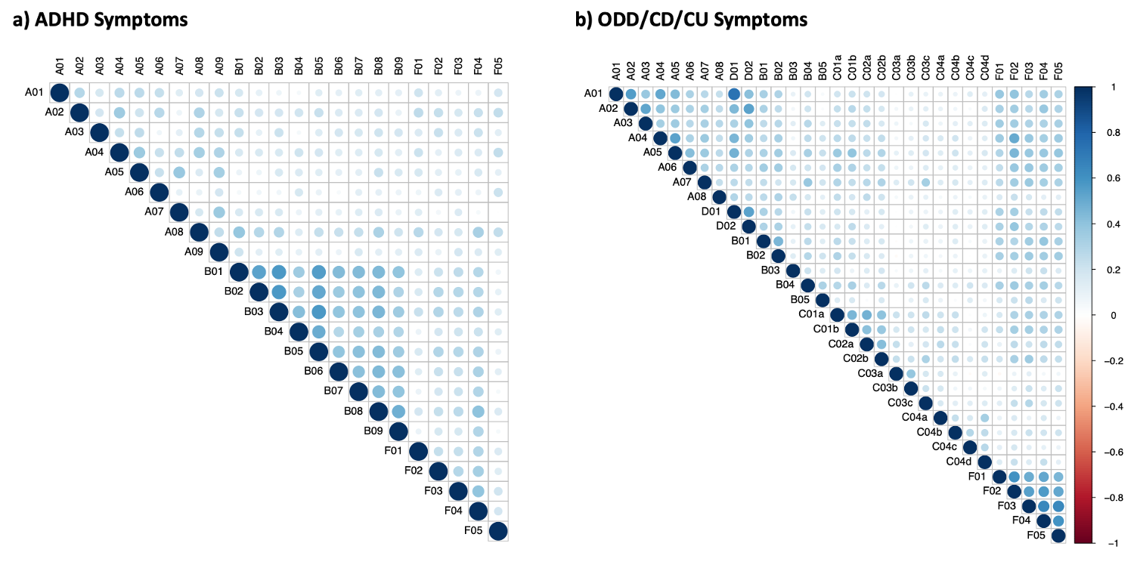
Note. Depicted are the zero-order Spearman intercorrelations between the ADHD symptoms (Figure S1a) and between the ODD/CD/CU symptoms (Figure S1b). Dark blue indicates strong positive correlations, dark red indicates strong negative correlations, and white indicates absence of correlation. The complete wording for each item can be found in Figure 1. ADHD = attention-deficit/hyperactivity disorder; ODD = oppositional defiant disorder; CD = conduct disorder; CU = callous-unemotional.

Figure S2
Simulation Studies Estimating the Correlation, Sensitivity, and Specificity of the ADHD and ODD/CD/CU Networks
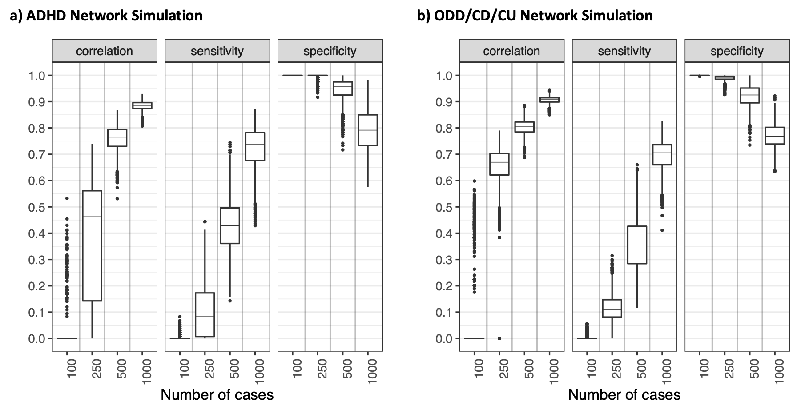
Note. Simulation results of simulated data sets for varying sample sizes (n = 100, 250, 500, 1,000). Data sets were generated using the netSimulator function from the bootnet package and were based on the EBICglasso estimation, Spearman correlations, 2,500 repetitions, and a tuning parameter of λ = 0.5. For a moderate sample size (n = 500), as in our case, we can derive a moderate correlation accuracy between the “true” and the estimated edge weights, moderate to low sensitivities (i.e. the proportion of edges in the “true” networks that were also included in the estimated networks), and moderate to high specificities (i.e. the proportion of missing edges in the “true” networks that were correctly not included in the estimated networks). These results indicate that it is highly probable that the edges we observed “truly” exist. ADHD = attention-deficit/hyperactivity disorder; ODD = oppositional defiant disorder; CD = conduct disorder; CU = callous-unemotional.
Figure S3
Edge Weight Accuracies for the ADHD and ODD/CD/CU Networks
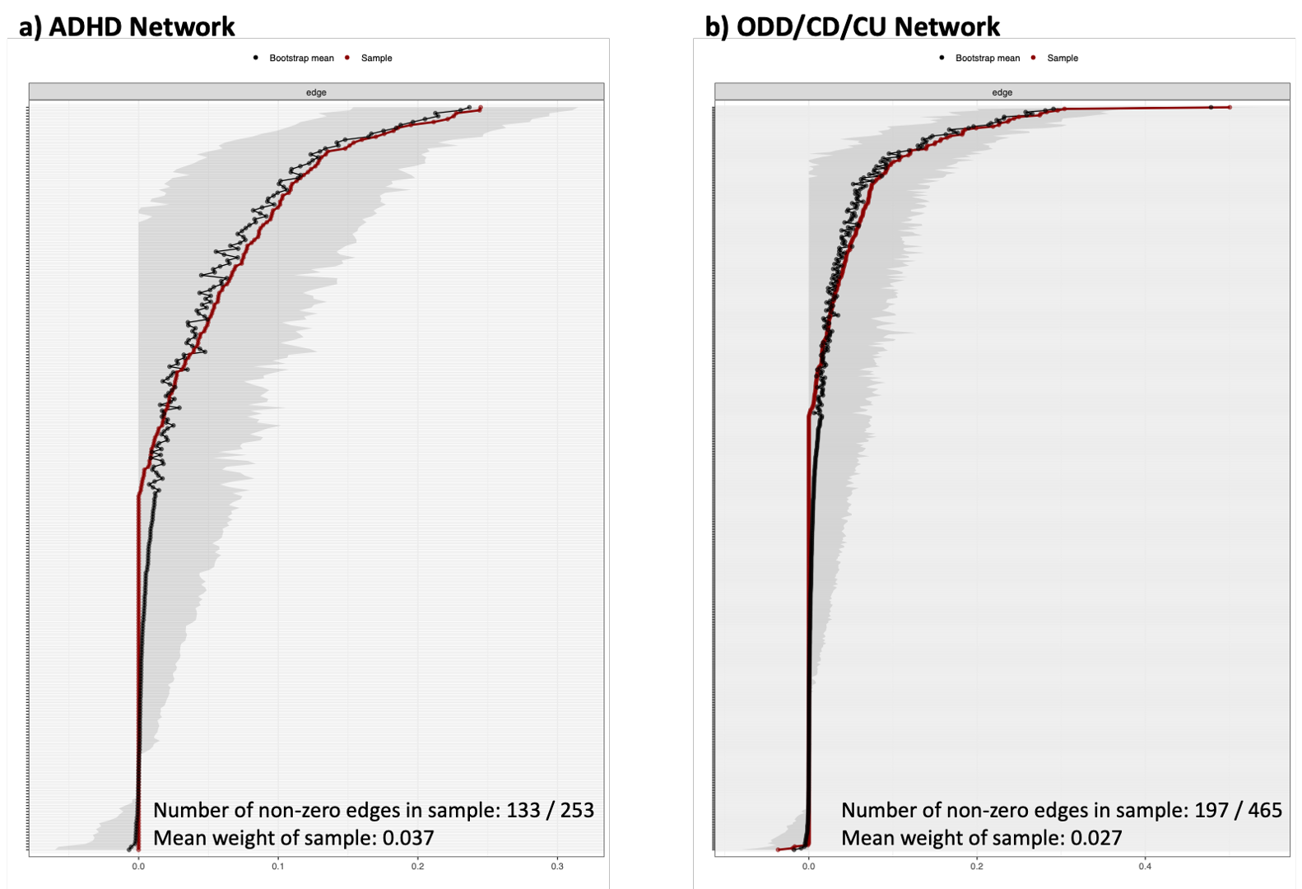
Note. The horizontal gray area represents the 95% quantile range of the parameter values based on 2,500 bootstrap samples. The red dots represent the original sample values and the black dots represent the bootstrap mean values. The y-axis shows all edges in the network (labels omitted for ease of legibility) and the x-axis shows the strength of the edge weights. ADHD = attention-deficit/hyperactivity disorder; ODD = oppositional defiant disorder; CD = conduct disorder; CU = callous-unemotional.
Figure S4
Bootstrapped Difference Test for the Edge Weights from the Attention-Deficit/Hyperactivity Disorder (ADHD) Network
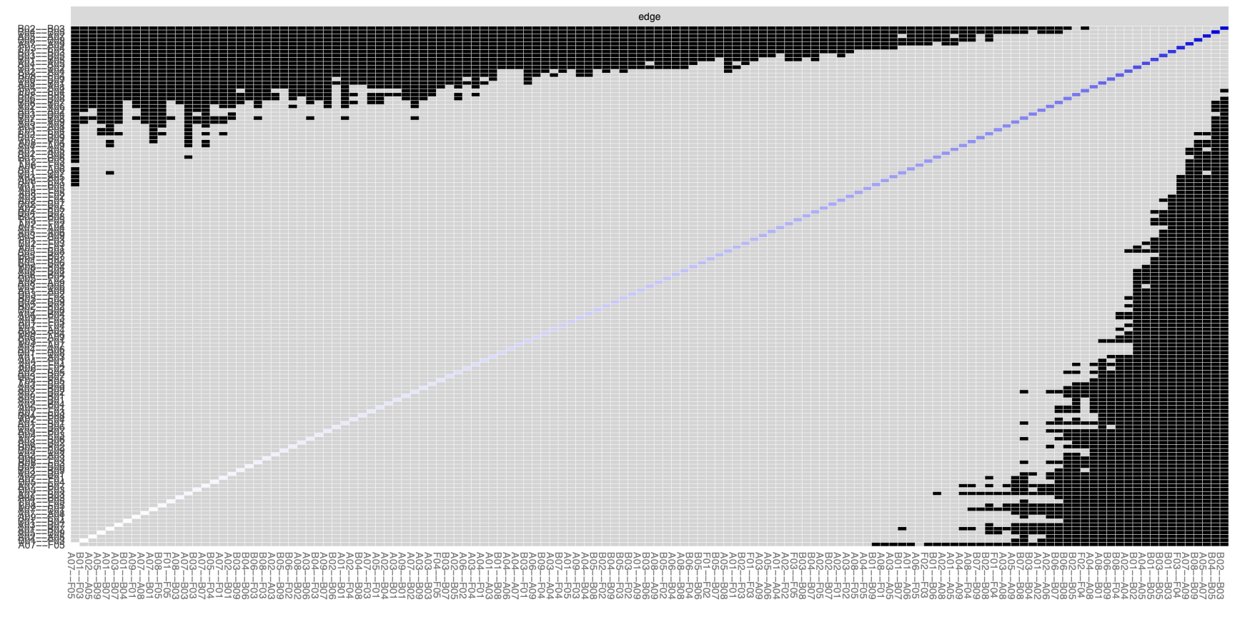
Note. The gray boxes indicate that two edge weights do not significantly differ from each other; the black boxes mark a significant difference between two edge weights (α = .05). Most of the strongest edges differ significantly from the other edges in the network.

Figure S5
Bootstrapped Difference Test for the Edge Weights from the ODD/CD/CU Network
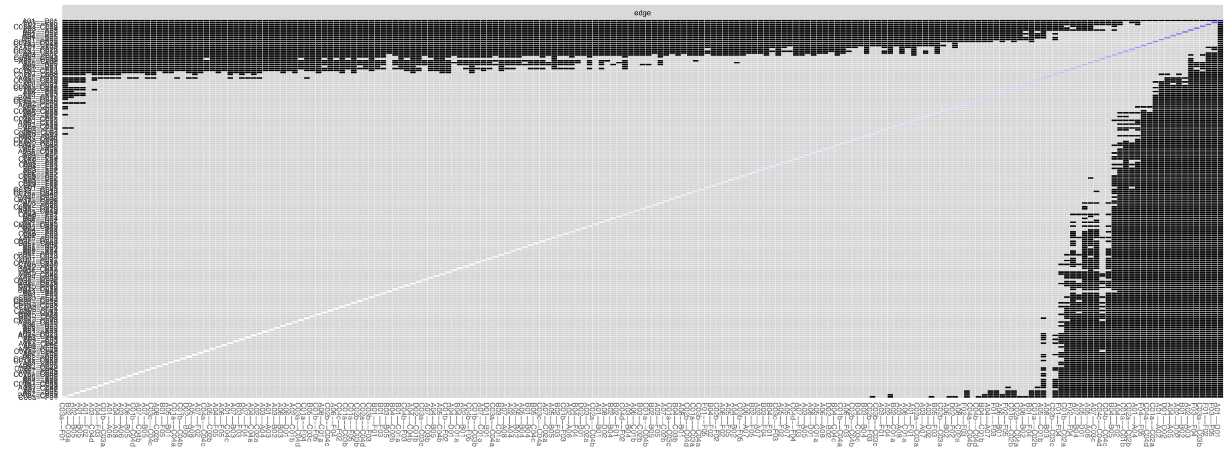
Note. The gray boxes indicate that two edge weights do not significantly differ from each other; the black boxes mark a significant difference between two edge weights (α = .05). Most of the strongest edges differ significantly from the other edges in the network. ODD = oppositional defiant disorder; CD = conduct disorder; CU = callous-unemotional.

Figure S6

Network of all Externalizing Symptoms with Associated Functional Impairment Domains
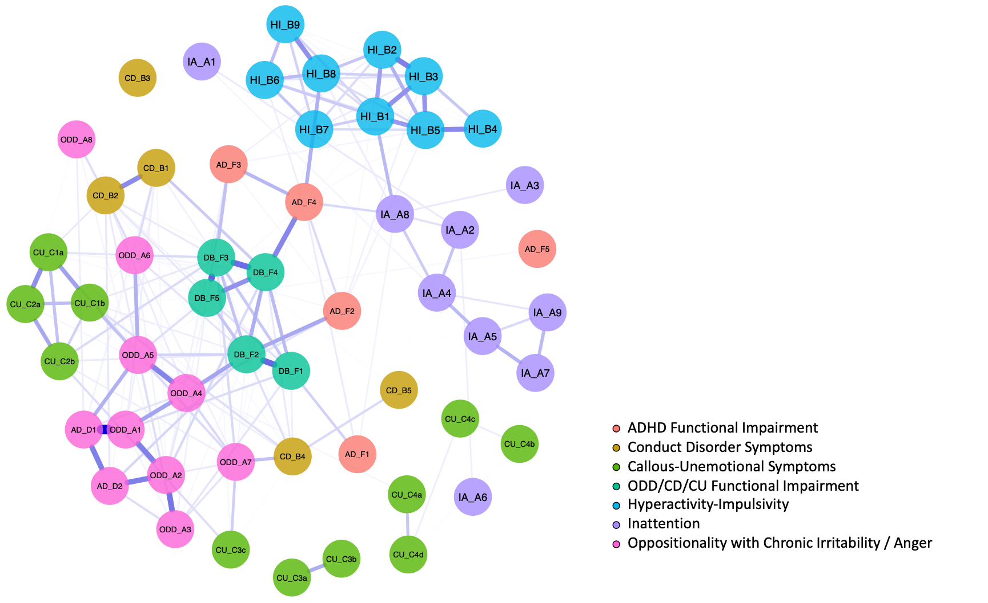
Note. The figure depicts the network structure of all externalizing symptoms and functional impairment related to psychological strain (F1) and in the domains of home life and family members (F2), relationships with adults (F3), relationships with children/adolescents and recreational activities (F4), and academic performance (F5). Item dimensions are differentiated by color. Blue edges represent positive partial correlations, and the thickness of an edge represents the strength of the partial correlation. A short description of each item is provided in Figure 1. Regarding the strongest associations of functional impairment domains with symptoms, the strongest partial correlations (i.e., the largest edge weights) were as follows: ADHD F1 and A8 Easily Distracted (ρ_{xy•z} = .02), ADHD F2 and A4 Argues with Adults (ρ_{xy•z} = .05), ADHD F3 and B2 Leaves Seat (ρ_{xy•z} = .02), ADHD F4 and B8 Interrupts, Intrudes (ρ_{xy•z} =.12), ADHD F5 showed no associations with other symptoms, DB F1 and A1 Loses Temper (ρ_{xy•z} = .06), DB F2 and A4 Argues with Adults (ρ_{xy•z} = .14), DB F3 and A7 Blames Others (ρ_{xy•z} = .06), DB F4 and B1 Physical Fights (ρ_{xy•z} = .08), and DB F5 and A5 Refuses to Comply (ρ_{xy•z} = .05). ADHD = attention-deficit/hyperactivity disorder; IA = Inattention; HI = hyperactivity-impulsivity; DB = disruptive behavior symptoms; ODD = oppositional defiant disorder; AD = affective dysregulation; CD = conduct disorder; CU = callous-unemotional.
Figure S7
Edge Weight Accuracies for the Network of Externalizing Symptoms
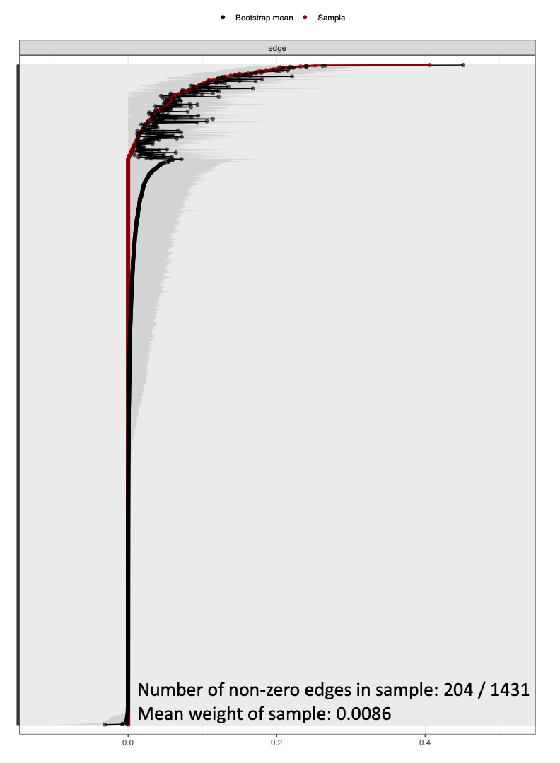
Note. The horizontal gray area represents the 95% quantile range of the parameter values based on 2,500 bootstrap samples. The red dots represent the original sample values and the black dots represent the bootstrap mean values. The y-axis shows all edges in the network (labels omitted for ease of legibility) and the x-axis shows the strength of the edge weights.

