Item Retention as a Feature Selection Task: Developing Abbreviated Measures
Using Shapley Values

Supplementary Materials

Table S1

Spearman Correlations for the 11 Positively Worded PSWQ Items

 | PSWQ_2 | PSWQ_4 | PSWQ_5 | PSWQ_6 | PSWQ_7 | PSWQ_9 | PSWQ_12 | PSWQ_13 | PSWQ_14 | PSWQ_15
PSWQ_2
PSWQ_4 | 0.489
PSWQ_5 | 0.524 | 0.581
PSWQ_6 | 0.473 | 0.573 | 0.546
PSWQ_7 | 0.424 | 0.560 | 0.496 | 0.491
PSWQ_9 | 0.375 | 0.346 | 0.386 | 0.364 | 0.353
PSWQ_12 | 0.407 | 0.563 | 0.514 | 0.485 | 0.564 | 0.304
PSWQ_13 | 0.513 | 0.517 | 0.586 | 0.497 | 0.470 | 0.383 | 0.488
PSWQ_14 | 0.419 | 0.494 | 0.489 | 0.503 | 0.525 | 0.315 | 0.528 | 0.494
PSWQ_15 | 0.462 | 0.475 | 0.501 | 0.422 | 0.535 | 0.392 | 0.517 | 0.523 | 0.545
PSWQ_16 | 0.408 | 0.373 | 0.406 | 0.440 | 0.363 | 0.447 | 0.328 | 0.484 | 0.390 | 0.410

Table S2

Item-level Skewness and Kurtosis for the 11 Positively Worded PSWQ Items

 | kurtosis | skew
PSWQ_2 | -0.19 | 0.59
PSWQ_4 | -0.37 | 0.61
PSWQ_5 | -0.85 | 0.45
PSWQ_6 | -0.76 | 0.32
PSWQ_7 | 0.08 | 0.93
PSWQ_9 | -0.07 | 0.75
PSWQ_12 | 0.22 | 1.02
PSWQ_13 | -0.64 | 0.20
PSWQ_14 | -0.12 | 0.79
PSWQ_15 | 1.03 | 1.18
PSWQ_16 | -0.73 | 0.22

Table S3

Item-level Content for PSWQ Items

Item | Question Content
PSWQ_1 | If I don't have enough time to do everything, I don't worry about it.
PSWQ_2 | My worries overwhelm me.
PSWQ_3 | I don't tend to worry about things.
PSWQ_4 | Many situations are a reason for me to start worrying.
PSWQ_5 | I know I shouldn't worry so much about things, but I just can't help it.
PSWQ_6 | When I am under pressure, I worry a lot.
PSWQ_7 | I am always worrying about something.
PSWQ_8 | I can easily dismiss worrisome thoughts.
PSWQ_9 | As soon as I finish something, I start worrying about everything else I still have to do.
PSWQ_10 | I never worry about anything.
PSWQ_11 | If I can't do anything about something, I don't worry about it anymore.
PSWQ_12 | I have been a worrier all my life.
PSWQ_13 | I notice that I worry about things.
PSWQ_14 | Once I start worrying, I can't stop.
PSWQ_15 | I am constantly worried.
PSWQ_16 | I worry about the things I still have to do until they are done.

Figure S1
Machine Learning Model Comparisons and Prediction Metrics

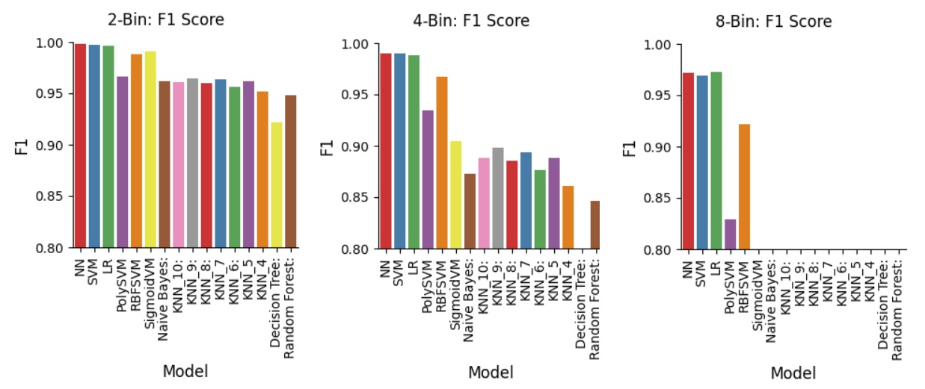

Subjects | Binsize | ModelName | Accuracy | Precision | Recall | F1
3906 | 8-Bin | NN | 0.971292 | 0.975014 | 0.971292 | 0.971386
3906 | 8-Bin | SVM | 0.96876 | 0.972507 | 0.96876 | 0.968729
3906 | 8-Bin | LR | 0.972289 | 0.976103 | 0.972289 | 0.972441
3906 | 8-Bin | PolySVM | 0.827749 | 0.848144 | 0.827749 | 0.828779
3906 | 8-Bin | RBFSVM | 0.921189 | 0.927144 | 0.921189 | 0.921475
3906 | 8-Bin | SigmoidVM | 0.669284 | 0.682158 | 0.669284 | 0.672024
3906 | 8-Bin | Naive Bayes: | 0.737596 | 0.750432 | 0.737596 | 0.73917
3906 | 8-Bin | KNN_10: | 0.731266 | 0.738153 | 0.731266 | 0.729937
3906 | 8-Bin | KNN_9: | 0.737212 | 0.742673 | 0.737212 | 0.735943
3906 | 8-Bin | KNN_8: | 0.727148 | 0.733731 | 0.727148 | 0.725778
3906 | 8-Bin | KNN_7 | 0.731317 | 0.737783 | 0.731317 | 0.730528
3906 | 8-Bin | KNN_6: | 0.706496 | 0.714677 | 0.706496 | 0.705749
3906 | 8-Bin | KNN_5 | 0.719923 | 0.724429 | 0.719923 | 0.718837
3906 | 8-Bin | KNN_4 | 0.69454 | 0.700187 | 0.69454 | 0.692884
3906 | 8-Bin | Decision Tree: | 0.60555 | 0.609727 | 0.60555 | 0.605139
3906 | 8-Bin | Random Forest: | 0.658619 | 0.662368 | 0.658619 | 0.657086

A comparison of multiple ML models that were evaluated and F1 predictions for 2-, 4-, and 8-bins. K-Nearest Neighbors (KNNs) were set to have between 4 and 10 clusters. The other models tested were set to their defaults. The NN, SVM, and LR models consistently returned >95% prediction accuracies across binning schemes and were those used in the main text.

