Supplementary Material
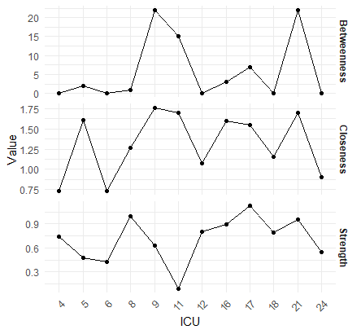
Figure S1. Z-scores for three centrality indices for the preschool age group (age 5-6)

Table S1.
Z-scores for three centrality indices for the preschool age group (age 5-6)
 | ICU 4 | ICU 5 | ICU 6 | ICU 8 | ICU 9 | ICU 11 | ICU 12 | ICU 16 | ICU 17 | ICU 18 | ICU 21 | ICU 24
Closeness | 0.73 | 1.61 | 0.73 | 1.27 | 1.76 | 1.70 | 1.07 | 1.60 | 1.55 | 1.15 | 1.70 | 0.90
Betweenness | 0 | 2 | 0 | 1 | 22 | 15 | 0 | 3 | 7 | 0 | 22 | 0
Strength | 0.74 | 0.48 | 0.43 | 1.00 | 0.63 | 0.09 | 0.8 | 0.89 | 1.13 | 0.79 | 0.95 | 0.55

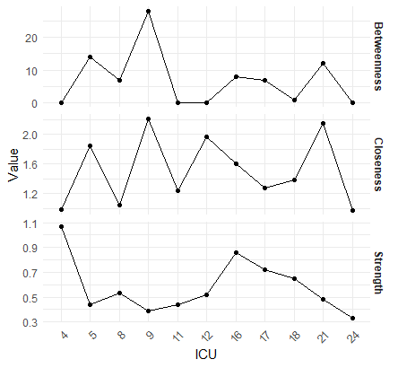
Figure S2. Z-scores for three centrality indices for the middle childhood group (age 7-10)

Table S2.
Z-scores for three centrality indices for the middle childhood group (age 7-10)
 | ICU 4 | ICU 5 | ICU 6 | ICU 8 | ICU 9 | ICU 11 | ICU 12 | ICU 16 | ICU 17 | ICU 18 | ICU 21 | ICU 24
Closeness | 0.99 | 1.85 |  | 1.04 | 2.21 | 1.24 | 1.97 | 1.62 | 1.28 | 1.38 | 2.15 | 0.97
Betweenness | 0 | 14 |  | 7 | 28 | 0 | 0 | 8 | 7 | 1 | 12 | 0
Strength | 1.07 | 0.44 |  | 0.53 | 0.39 | 0.44 | 0.52 | 0.86 | 0.72 | 0.65 | 0.48 | 0.33

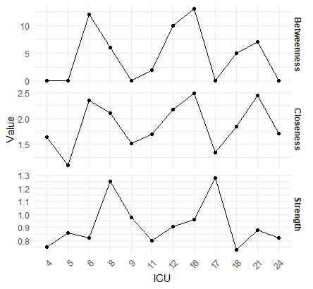
Figure S3. Z-scores for three centrality indices for the adolescents age group (age 11-19)

Table S3.
Z-scores for three centrality indices for the adolescents age group (age 11-19)
 | ICU 4 | ICU 5 | ICU 6 | ICU 8 | ICU 9 | ICU 11 | ICU 12 | ICU 16 | ICU 17 | ICU 18 | ICU 21 | ICU 24
Closeness | 1.64 | 1.09 | 2.35 | 2.11 | 1.52 | 1.69 | 2.18 | 2.49 | 1.34 | 1.85 | 2.45 | 1.71
Betweenness | 0 | 0 | 12 | 6 | 0 | 2 | 10 | 13 | 0 | 5 | 7 | 0
Strength | 0.75 | 0.86 | 0.82 | 1.25 | 0.98 | 0.80 | 0.91 | 0.96 | 1.28 | 0.73 | 0.88 | 0.82

