APPENDIX A: Student Social Validity Survey

- Do you like CW-FIT?
Yes No

- What do you like about CW-FIT?

- What didn’t you like about CW-FIT?

- Do you think other students should get to use CW-FIT in their classrooms?

Yes No

- Why or why not?

- What else would you like to tell us about CW-FIT?

Thank you for doing this survey!

- ¿Le gusta a CW-FIT?

Sí No

- ¿Qué le gusta de CW-FIT?

- ¿Qué no le gusta de CW-FIT?

- ¿Piensa que otros estudiantes deberían utilizar a CW-FIT en su salón de clases?

Sí No

- ¿Por qué?

- ¿Qué más le gustaría decirnos sobre CW-FIT?

¡Gracias por hacer esta encuesta!

APPENDIX B: Teacher Social Validity Survey

- I enjoyed being a CW-FIT MS Intervention Teacher.
Very True Mostly True Somewhat True Not True
- The CW-FIT MS program was easy to learn and implement in my classroom.
Very True Mostly True Somewhat True Not True
- The timer was manageable for use during instruction.
Very True Mostly True Somewhat True Not True
- Using teams and points for appropriate behaviors helped improve students’ behavior.
Very True Mostly True Somewhat True Not True
- The self-management component was easy for students to learn.
Very True Mostly True Somewhat True Not True
- I learned new skills to help manage students’ behavior.
Very True Mostly True Somewhat True Not True
- I will use the CW-FIT MS skills I learned in future classes.
Very True Mostly True Somewhat True Not True
- I will recommend the CW-FIT MS program to colleagues.
Very True Mostly True Somewhat True Not True
- My students enjoyed using the CW-FIT MS program.
Very True Mostly True Somewhat True Not True
- My students were more focused and engaged when we implemented CW-FIT MS.
Very True Mostly True Somewhat True Not True

Teacher Interview Questions
1. Which aspect(s) of CW-FIT MS were most helpful to you?
2. Did you experience any difficulties with the CW-FIT MS program? If so, what were they?
3. How would you modify the CW-FIT MS program for future use?

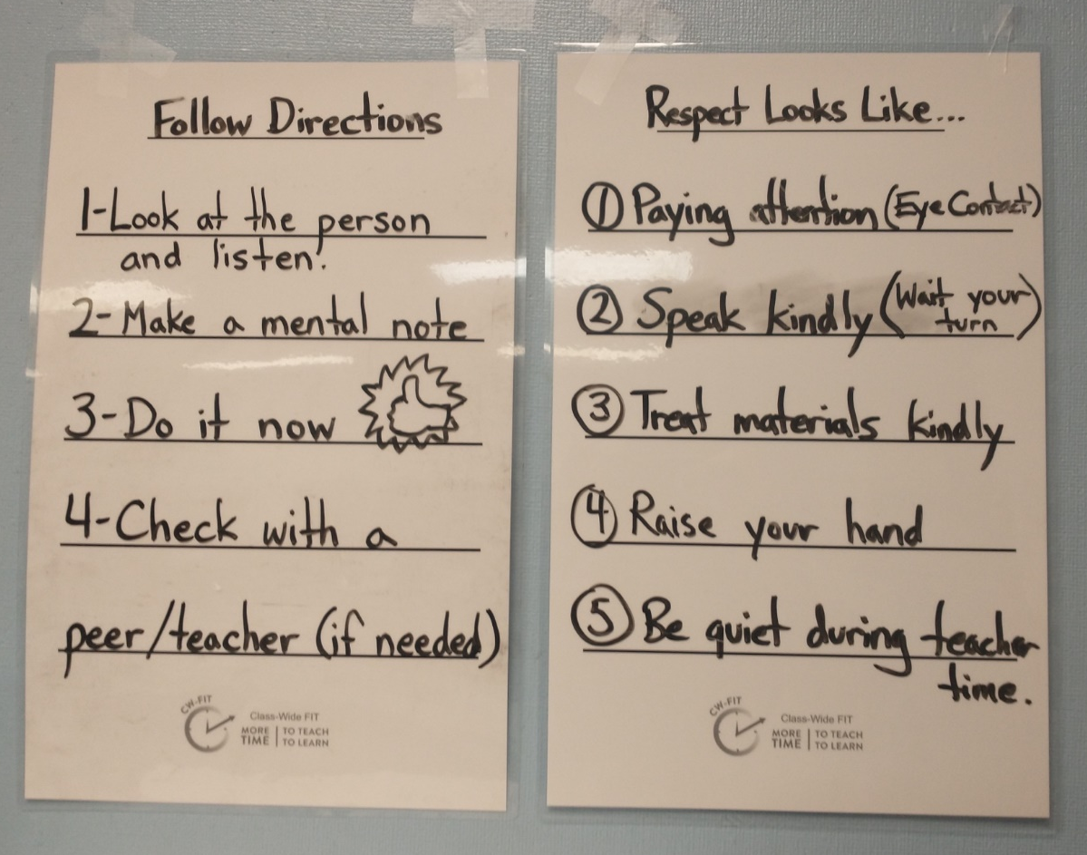
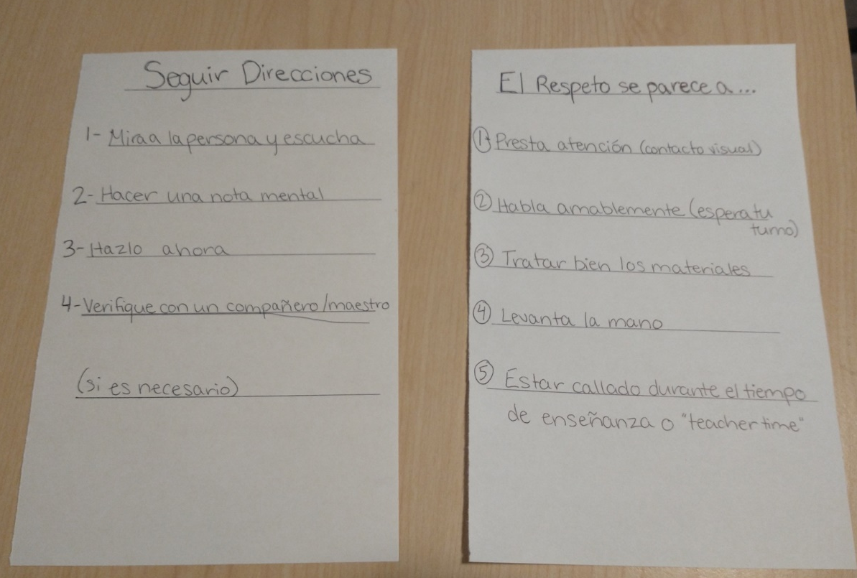
APPENDIX C: CW-FIT Posters in English and Spanish

