Supplemental Files

Table 1S. Demographics
Adolescent sex (% female) | 60.6
Adolescent Age (years) M (SD) | 13.8 (2.06)
Adolescent BMI %ile M (SD) | 97.2 (2.69)
Parent sex (% female) | 97.2
Parent Age (years) (M, SD) | 45.5 (10.3)
Parent BMI (kg/m²) (M, SD)
Marital Status (%)
Married | 19.4
Divorced | 27.8
Never Married | 36.1
Parent Education (%)
High school graduate | 8.3
Some college but no degree | 27.8
Associate degree in college | 19.4
4 Year College | 19.4
Graduate training or professional degree | 25
Parent Annual Household Income (%)
Less than $10,000 | 8.3
$10,000-$19,999 | 8.3
$20,000-$29,000 | 16.7
$30,000-$39,999 | 25.0
$40,000-$49,999 | 13.9
$50,000-$59,999 | 13.9
$70,000-$79,999 | 5.6
$90,000-$99,999 | 2.8
$100,000-$149,999 | 5.6

Table S2. Partially and Fully Integrated Curriculum Comparison
Week | Partially Integrated Cultural-Focused Curriculum  (Summer 2021-Spring 2022) | Fully Integrated Cultural-Focused Curriculum  (Fall 2022-Spring 2023)
1 | Topic: Introduction  - Provide overview of program and review stress management  - Positive communication skills  - Group ground rules  - Stress coping exercise: Deep Breathing  - Family Bonding activity: Plan family activity | Topic: Introduction & Mission Statement  - Principal Investigators meet & greet and group discussion on mission statement  - Provide overview of program and review stress management, including group discussion on African American health inequities, stress and health, cultural strengths for coping  - Positive communication skills  - Group ground rules  - Stress coping exercise: Deep Breathing  - Family Bonding activity: Plan family activity. Identify weekly stressors, including racial stress
2 | Topic: Stress and Tracking for Health Behaviors  - Identify stressors and impacts on health  - Review self-monitoring  - Stress coping exercise: Body Scan  - Family Bonding activity: Choose tracking tool | Topic: Tracking & Goal Setting for Health Behaviors  - Review self-monitoring and goal setting (SMART goals)  - Stress coping exercise: Body Scan  - Family Bonding activity: Choose tracking tool
3 | Topic: Goal Setting, Cognitive Reframing, Positive self-statement  - Review goal setting (SMART Goals)  - Exercise as a stress management  - Positive self-statement  - Stress coping exercise: Cognitive reframing  - Family Bonding activity: Set family related health behavior goal | Topic: Stress, Cognitive Reframing, Positive self-statement  - Identify stressors unique to families, including racial stress, and impacts on health  - Stress coping exercise: Cognitive reframing, including using cultural coping for racial stress  - Trailer for Hate U Give movie and discussion on racial coping  - Positive self-statement specific to one’s Black identity pride  - African dance  - Family Bonding activity: Check in on goal setting as a family, identify Black role model, family discussion on stressors
4 | Topic: Life Balance  - Lifestyle approach to health behavior changes, caloric energy in/energy out  - Barriers to life balance  - Stress coping exercise: Guided Imagery  - Family Bonding activity: Develop family routine plan/calendar | Topic: Physical Activity  - National guidelines for physical activity  - Solutions to PA barriers and how exercise can be used as a stress coping strategy  - Culturally relevant exercise (line dancing) and barriers (hairstyles)  - Parent descriptive praise, support, providing choice (“escape hatch/volition/choice”)  - Descriptive praise specific to Black identity  - Black history of yoga and spiritual practice  - Stress coping exercise: Beginner Yoga  - Family Bonding activity: Family culturally relevant physical activity (dancing)
5 | Topic: Eating Behaviors  - Portion sizes, hunger and satiety cues, mindful eating, family-based meal preparation  - Emotional eating  - Stress coping exercise: Mindful Eating  - Family Bonding activity: Prepare a healthy meal as a family | Topic: Eating Behaviors  - Portion sizes, hunger and satiety cues, mindful eating, family-based meal preparation  - Emotional eating and related cultural chronic stressors  - Cultural foods, recipes (USDA African American recipes), and traditions  - Healthy tweaks to cultural foods (cultural recipes) and cultural events (cookouts, holidays)  - Stress coping exercise: Mindful Eating  - Family Bonding activity: Prepare a healthy cultural meal as a family
6 | Topic: Physical Activity  - National guidelines for physical activity  - Solutions to PA barriers and how exercise can be used as a stress coping strategy  - Spirituality for coping  - Parent descriptive praise, support, providing choice (“escape hatch/volition/choice”)  - Stress coping exercise: Beginner Yoga  - Family Bonding activity: Family physical activity | Topic: Life Balance  - Lifestyle approach to health behavior changes, caloric energy in/energy out  - Barriers to life balance, including contextual factors (community violence)  - Cultural strategies to build life balance (spirituality, positive self-statements) and create family routines (prayer before meals)  - Stress coping exercise: Guided Imagery  - Family Bonding activity: Develop family routine plan/calendar, considering cultural routines
7 | Topic: Racial stress, health consequences, parenting, coping, support for health behaviors  - Racial discrimination and health/well-being consequences  - Parenting strategies from a cultural context (safety concerns)  - Supporting teens with health behavior goals (autonomy support strategies, “You provide, they decide”), helping teens ask for support with health behaviors  - Strategies for managing difficult family conversations  - Coping strategies specific to racial stress (journaling, community support, mental health resources, etc.)  - Stress coping exercise: 5 Senses Mindfulness Activity  - Family Bonding activity: Practice family communication tools for reaching goals | Topic: Racial stress, health consequences, parenting, coping, support for health behaviors  - Racial discrimination and health/well-being consequences  - Family conversations about racial stress and racial identity  - Parenting strategies from a cultural context (safety concerns)  - Supporting teens with health behavior goals (autonomy support strategies, “You provide, they decide”), helping teens ask for support with health behaviors  - Strategies for managing difficult family conversations, including racial stress  - Coping strategies specific to racial stress (journaling, community support, mental health resources, etc.)  - Stress coping exercise: 5 Senses Mindfulness Activity  - Family Bonding activity: Journaling for managing racial stress
8 | Topic: Sedentary Behaviors & Screens  - Health risks for sedentary behavior, screen time use among African Americans  - Substituting healthy alternatives to sedentary behavior, screen time, and junk food  - Parent skills: You provide, they decide around screen time; limit setting, monitoring  - Stress coping exercise: Progressive Muscle Relaxation  - Family Bonding activity: Make a family screen time budget | Topic: Sedentary Behaviors & Screens  - Health risks for sedentary behavior, screen time use among African Americans  - Substituting healthy alternatives to sedentary behavior, screen time, and junk food with cultural activities (African American social dancing)  - Exposure to racial stress online  - Parent skills: You provide, they decide around screen time; limit setting, monitoring  - Stress coping exercise: Progressive Muscle Relaxation  - Family Bonding activity: Make a family screen time budget, Brainstorm family alternatives to screen time, including cultural family activities
9 | Topic: Family Tree & Positive Communication  - Family Tree of racial identity beliefs, cultural traditions, stress/coping patterns  - Active listening and push-pull language, using these skills during difficult family conversations about racial stress and coping  - Stress coping exercise: Intention Setting Meditation  - Family Bonding activity: Pick family tradition from family tree, brainstorm continuing or improving family traditions | Topic: Family Tree, Positive Communication, Racial Socialization  - Family Tree of racial identity beliefs, cultural traditions, stress/coping patterns  - Active listening and push-pull language, using these skills during difficult family conversations about racial stress and coping, learning from family storytellers  - Racial socialization discussion, transgenerational messages of cultural pride  - Stress coping exercise: Intention Setting Meditation  - Family Bonding activity: Pick family tradition from family tree, tell a story of family history, brainstorm continuing or improving family traditions
10 | Topic: Review & Testimonial  - Review topics and stress coping strategies  - Relapse prevention, planning for high-risk situations (discuss future stressors)  - Create stress coping/health goal setting toolbox  - Testimonials | Topic: Review & Testimonial  - Review topics and stress coping strategies  - Relapse prevention, planning for high-risk situations (discuss future stressors)  - Create stress coping/health goal setting toolbox  - Testimonials, including curriculum on racial stress, coping, health, culture, and socialization

Table S3. Cultural Resilience Intervention Acceptability Feedback – Cohorts 1 through 3 (n =15)
 | Adolescent |  | Caregiver
 | M | SD | M | SD
Utility of Cultural Resilience Tools
Talking about racial discrimination and coping was useful for me. | 4.29 | 0.95 | 4.5 | 1.07
I enjoyed talking about family cultural traditions. | 4.14 | 0.90 | 4.62 | 0.74
Overall Program Acceptabilty
The LEADS program has been useful for me | 4.14 | 0.90 | 4.37 | 0.74
I enjoy the LEADS group sessions | 3.71 | 1.25 | 4.75 | 0.70
I learned new things in the LEADS group sessions | 4.29 | 0.75 | 4.25 | 0.70
The LEADS program has been easy for me to understand | 4.00 | 1.00 | 4.62 | 0.74
I would recommend the program to other families I know. | 4.43 | 0.53 | 4.62 | 0.74
Since the LEADS program, I am more supportive of my family. | 4.14 | 1.07 | 4.50 | 0.53
Note: Apriori goal for acceptability was >3.5 on a 1-5 scale.

Table S4. LEADS Principal Investigators Positionality Statements
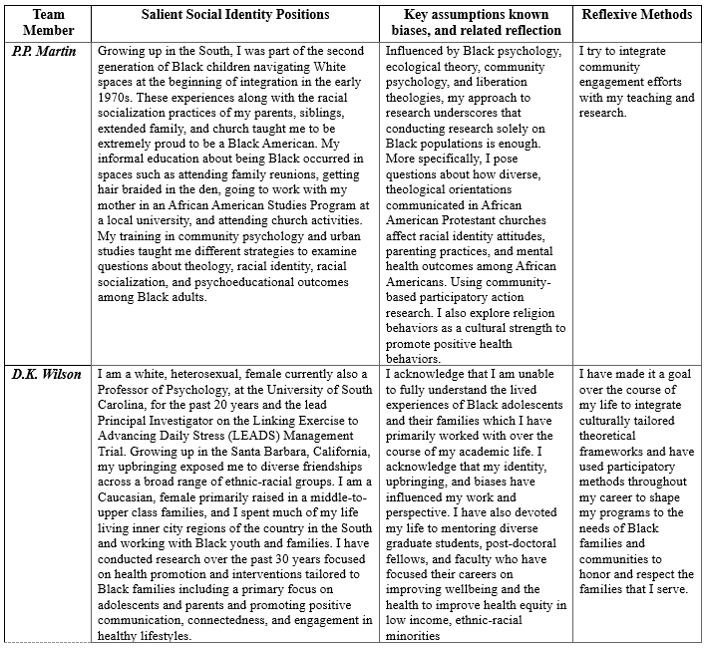

Table S5. Example Intervention Essential Elements & Program Elements
Theory | Essential Elements | Description of Program Elements
Social Cognitive Theory  & Family Systems Theory | Social Support | Use strategies for eliciting and providing social support for stress management and health behaviors from parents.
Family Systems Theory, Cultural Tailoring,  & Cultural Assets | Communication Skills & Autonomy Support | Use positive communication (reflective listening, problem-solving, shared decision-making) to increase family bonding, reduce stress, and improve health behaviors.
Social Cognitive Theory  & Resilience Theory | Goal Setting, Family Routines, & Self-Regulation | Set family goals to reduce stress and improve health behaviors. Structured daily family routines and time together to improve self-regulation (emotional, behavioral) through positive reinforcement.
Social Cognitive Theory | Group-based Behavioral Skills & Connectedness | Share anticipated or actual barriers to physical activity and problem-solve. Select a weekly collective group-based physical activity goal (e.g., Fitbit tracking).
Cultural Tailoring, Cultural Assets,  & Family Systems Theory | Cultural Assets & Strengths-Based Values | Communicate about ethnic-racial identity and foster cultural pride and self-esteem. Develop proactive coping strategies to address racism and chronic stress. Learn interactive behavioral skills to reduce stress (spirituality, meditation, mindfulness).
Cultural Tailoring, Cultural Assets, Family Systems Theory,  & Social Cognitive Theory | Cohesion & Mastery of Culture, Behavior, Emotions | Address social and cultural topics, including family cohesion, spirituality, collectivism, life balance, cultural traditions (e.g., cooking), and cognitive reframing of negative emotions.

Figure S1. LEADS Intervention Conceptual Framework
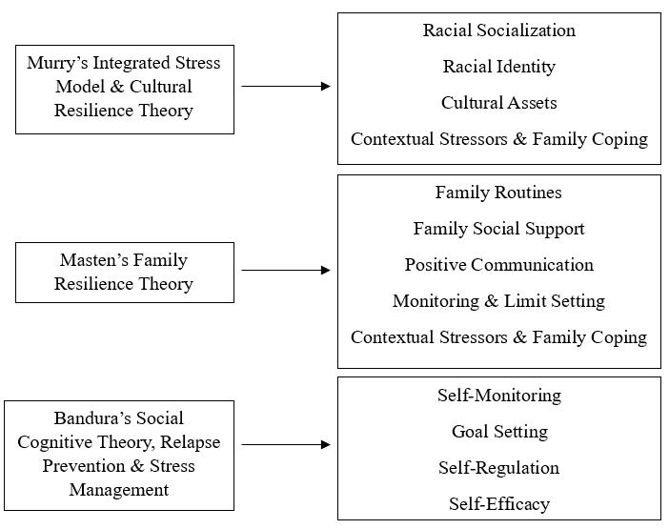

Note. Conceptual framework leans on insights from Murry et al., 2018, Masten & Monn, 2015, and Bandura, 2001

