Supplementary Information
Supplemental Material A – Description of the Goals of the Company

- Goal Customer Satisfaction: The needs of our customers are paramount, which is why our products are tailored to fit our customers. Customer satisfaction is a central goal of the company.
- Goal Innovation: The company is also committed to new technologies and innovation and thus offers customers a wide range of digital solutions.
- Goal Diversity: The company is dedicated to the Diversity Charter to promote active diversity management and gender equality. Our values define the working environment we want to create - diversity, openness, and equal opportunities

Supplemental Material B – Experimental Manipulations
Presentation of the preselection in the initial and in the final phase after the trust repair intervention. The number of male and female applicants is similar. Information for applicants are their name, age, job experience, final grades (German grades, lower means better), and strengths.

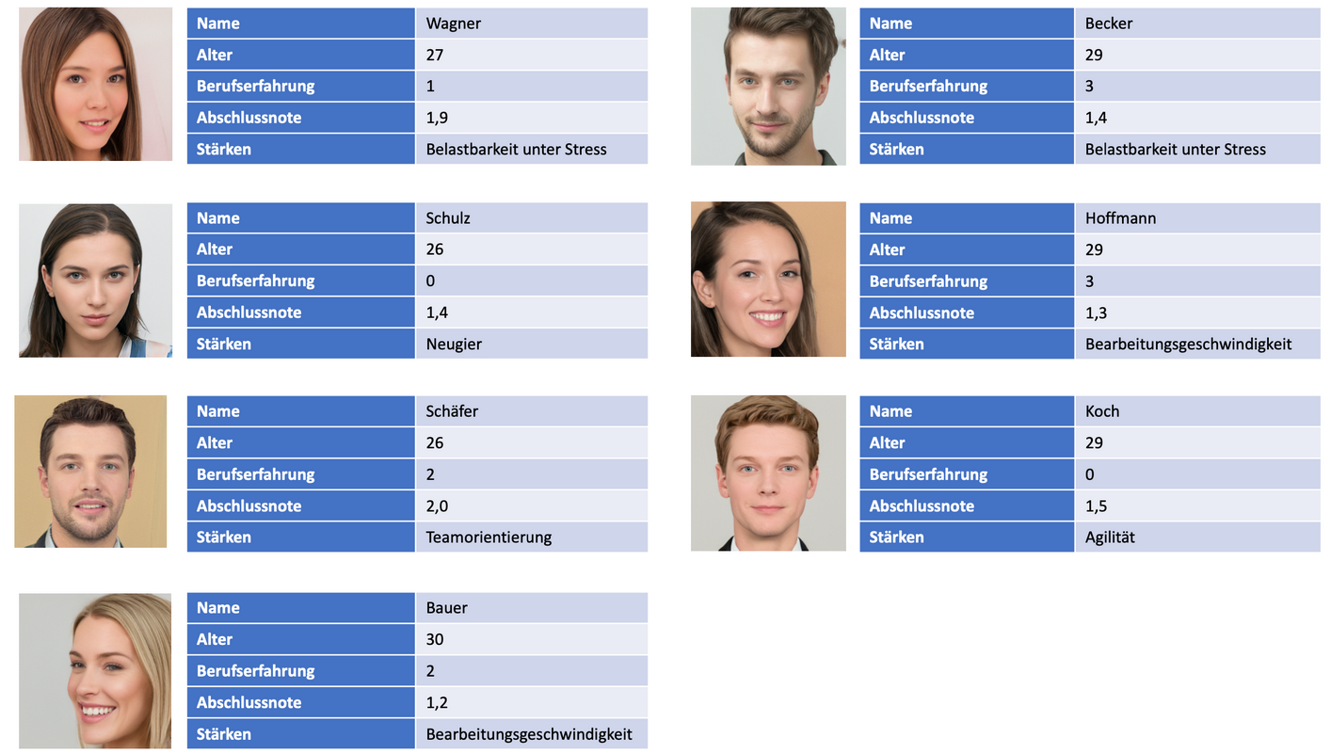
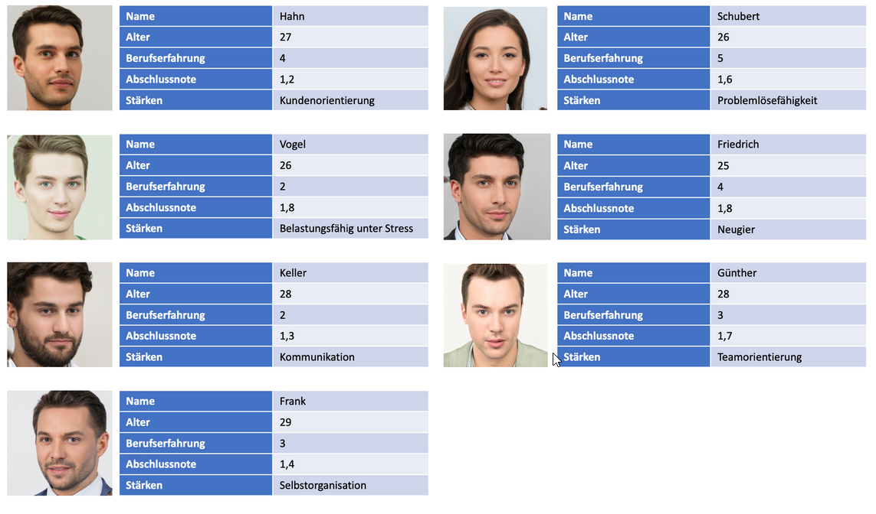
Presentation of the preselection in the trust violation phase. There are predominantly male applicants.
Supplemental Table 1
Number of Male and Female Applicants Included in the Preselection per Round
Round |  | Number of Male : Female applicants included in the preselection
1 | Gender-balanced, before trust violation | 3 : 3
2 |  | 3 : 4
3 |  | 4 : 4
4 |  | 3 : 3
5 | Male-dominant, trust violation phase | 5 : 2
6 |  | 7 : 1
7 |  | 5 : 1
8 |  | 6 : 1
9 | Gender-balanced, after trust repair intervention | 4 : 4
10 |  | 3 : 3
11 |  | 3 : 4
12 |  | 4 : 4

Supplemental Table 2.
Percentage of Participants Who Accepted the Preselection in Each Task
Initial Phase | T1
Initial Phase | H |  |  |  | S
Initial Phase | NI | I | T |  | NI | I | T
Initial Phase | 92.9 | 78.9 | 85.3 |  | 76.0 | 85.7 | 81.7
Initial Phase | T2
Initial Phase | H |  |  |  | S
Initial Phase | NI | I | T |  | NI | I | T
Initial Phase | 25.0 | 39.4 | 32.8 |  | 32.0 | 37.1 | 35.0
Initial Phase | T3
Initial Phase | H |  |  |  | S
Initial Phase | NI | I | T |  | NI | I | T
Initial Phase | 92.9 | 81.8 | 86.9 |  | 76.0 | 82.9 | 80.0
Initial Phase | T4
Initial Phase | H |  |  |  | S
Initial Phase | NI | I | T |  | NI | I | T
Initial Phase | 89.3 | 84.8 | 86.9 |  | 76.0 | 80.0 | 78.3
Trust Violation Phase | T5
Trust Violation Phase | H |  |  |  | S
Trust Violation Phase | NI | I | T |  | NI | I | T
Trust Violation Phase | 46.4 | 60.6 | 54.1 |  | 48.0 | 54.3 | 51.7
Trust Violation Phase | T6
Trust Violation Phase | H |  |  |  | S
Trust Violation Phase | NI | I | T |  | NI | I | T
Trust Violation Phase | 25.0 | 24.2 | 24.6 |  | 36.0 | 22.9 | 29.3
Trust Violation Phase | T7
Trust Violation Phase | H |  |  |  | S
Trust Violation Phase | NI | I | T |  | NI | I | T
Trust Violation Phase | 17.9 | 12.1 | 14.8 |  | 12.0 | 22.9 | 18.3
Trust Violation Phase | T8
Trust Violation Phase | H |  |  |  | S
Trust Violation Phase | NI | I | T |  | NI | I | T
Trust Violation Phase | 14.3 | 15.2 | 14.8 |  | 16.0 | 14.3 | 15.0
Trust Repair Phase | T9
Trust Repair Phase | H |  |  |  | S
Trust Repair Phase | NI | I | T |  | NI | I | T
Trust Repair Phase | 89.3 | 84.2 | 86.9 |  | 68.0 | 85.7 | 78.3
Trust Repair Phase | T10
Trust Repair Phase | H |  |  |  | S
Trust Repair Phase | NI | I | T |  | NI | I | T
Trust Repair Phase | 82.1 | 81.8 | 82.0 |  | 80.0 | 82.9 | 81.7
Trust Repair Phase | T11
Trust Repair Phase | H |  |  |  | S
Trust Repair Phase | NI | I | T |  | NI | I | T
Trust Repair Phase | 53.6 | 48.5 | 50.8 |  | 40.0 | 51.4 | 46.7
Trust Repair Phase | T12
Trust Repair Phase | H |  |  |  | S
Trust Repair Phase | NI | I | T |  | NI | I | T
Trust Repair Phase | 71.4 | 72.7 | 72.1 |  | 60.0 | 77.1 | 70.0
Notes. T = task, NI = no information, I = information about imperfection, H = human, S = system, T = total. N =121. n_{no_information_human} = 33, n_{no_information_system} = 35, n_{imperfection_human} =,28, n_{imperfection_system} = 25.
Supplemental Material C – Additional Results

