Online Supplemental Material B
for
Spoiled Rotten? LMXSC Motivates Greater Supervisor-Directed Deviance in Individuals Who Were Overindulged as Children

Online Supplemental Study
To demonstrate the replicability of the vignette experiment reported in Study 1 of the main manuscript, as well as to provide additional support for my theoretical model, I conducted a direct replication using an Australian sample.
Method
Participants and Procedure
Four hundred and twenty-two (59% female) participants located in Australia completed a vignette experiment via the online platform CloudResearch.com. Participants were on average 46.6 years old (SD = 16.7) with 28.0 years of work experience (SD = 19.0). Forty-two percent of participants reported having a university degree.
Participants were randomly assigned to one of the two experimental conditions (low vs. high LMXSC) implemented in Study 1 of the main manuscript (n_{LMXSC low} = 225, n_{LMXSC high} = 197). After reading about a hypothetical workplace scenario, participants then completed measures of hubristic pride, authentic pride, supervisor-directed deviance, parental overindulgence, and trait narcissism. At the end of the survey, participants were asked whether they answered all questions honestly.
Measures
All manipulations and measures used in this vignette study mirror those used in Study 1, reported in the main manuscript. This includes the LMXSC manipulation, as well as measures of hubristic pride (α = 0.97), parental overindulgence (α = 0.85), supervisor-directed deviance (α = 0.98), and the covariates authentic pride (α = 0.96) and trait narcissism. The means, standard deviations, and zero-order correlations of the study variables are shown in Table SB1.
--------------------------------
Insert Table SB1 about here
--------------------------------
Results
Four participants (0.9%) failed to indicate that they responded honestly to the study measures and were therefore excluded from the analyses. The final sample was comprised of 418 participants.
I conducted a series of confirmatory factor analyses (CFAs) to test whether the 34 items representing the four constructs measured with multiple items (i.e., trait narcissism was excluded) were distinguishable from one another. The 4-factor model, χ² (521) = 1949, RMSEA = 0.08, CFI = 0.91, TLI = 0.90, SRMR = 0.07, fit the data better than a 3-factor model in which hubristic pride and authentic pride loaded together, and parental overindulgence and LMXSC loaded on their own individual factors, χ² (524) = 4715, RMSEA = 0.14, CFI = 0.72, TLI = 0.70, SRMR = 0.14. Furthermore, the 4-factor model fit the data better than a single-factor model in which all variables loaded together, χ² (527) = 8482, RMSEA = 0.19, CFI = 0.48, TLI = 0.44, SRMR = 0.18. The difference between the 4-factor model and the 3-factor model were significant in terms of model fit (χ²(3) = 2766, p < .001), as was the difference between the 3-factor model and the single-factor model (χ²(3) = 3767, p < .001). These analyses demonstrate the superiority of the 4-factor model and lend support for the discriminant validity of the study’s measured variables.
All measured variables were standardized (i.e., converted to z-scores) prior to the following analysis. As conducted in Study 1 of the main manuscript, I first estimated the paths required for testing the conditional indirect effects of interest. The results of this initial analysis are summarized in Table SB2 (Model 2). As expected, LMXSC condition significantly predicted hubristic pride (b = 0.39, p < .001). Furthermore, hubristic pride interacted with parental overindulgence to predict supervisor-directed deviance intentions (β = 0.17, p < .001). Follow-up simple-slopes analysis showed that when parental overindulgence was high (+1 SD), the relationship between hubristic pride and supervisor-directed deviance was more positive (β = 0.49, p < .001) than when parental overindulgence was low (-1 SD), (β = 0.15, p = .024). See Figure SB1 for details.
--------------------------------
Insert Table SB2 and Figure SB1 here
--------------------------------
A 2nd stage moderated-mediation analysis involving 5,000 bias-corrected bootstrap samples was used to test Hypothesis 1. LMXSC was set as the independent variable, hubristic pride the mediator, parental overindulgence the 2nd stage moderator, and supervisor-directed deviance intentions the dependent variable. Authentic pride and trait narcissism were included as covariates predicting both the mediator and dependent variable. Supporting Hypothesis 1, LMXSC was associated with greater supervisor-directed deviance intentions via increases in hubristic pride when parental overindulgence was high (β = 0.19, 95% CI [0.093, 0.320]) as compared to when it was low (β = 0.06, 95% CI [0.004, 0.157]). These indirect effects were significantly different from one another (β = -0.13, 95% CI [-0.267, -0.051]).
In sum, these findings, which are derived from an Australian sample, replicate those reported in Study 1 in the main manuscript that were based on a Canadian sample and provide further support for my theory that high LMXSC motivates greater supervisor-directed deviance via increased hubristic pride in individuals who experienced more parental overindulgence as children.

Figure SB1

Hubristic Pride × Parental Indulgence Effect on Supervisor-Directed Deviance Intentions
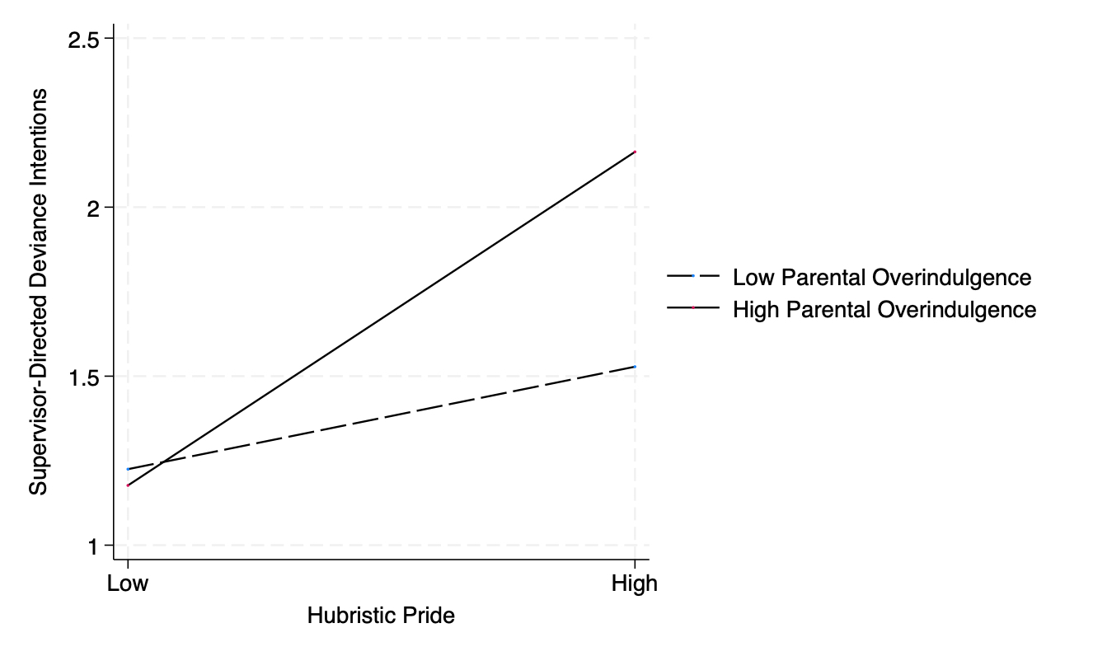
Notes. High and low levels of variables represent +1 and -1 standard deviations around the mean.

Table SB1
Means, Standard Deviations, and Zero-Order Correlations Among Variables in the Online Supplemental Study

Variable | M | SD | 1 | 2 | 3 | 4 | 5 | 6
1. LMXSC | 0.47 | 0.50 | -
2. Hubristic pride | 2.17 | 1.36 | 0.143** | -
3. Parental overindulgence | 2.46 | 0.69 | -0.091 | 0.347*** | -
4. Supervisor-directed deviance intentions | 1.58 | 1.02 | -0.021 | 0.585*** | 0.398*** | -
5. Authentic pride | 5.08 | 1.21 | -0.053 | -0.365*** | -0.043 | -0.273*** | -
6. Trait narcissism | 1.85 | 1.38 | -0.042 | 0.443*** | 0.385*** | 0.569*** | -0.115* | -
Notes. LMXSC = leader-member exchange social comparison. LMXSC was coded as 0 (low) or 1 (high) and so point-serial correlations are reported for this variable.
* p < .05, ** p < .01, *** p < .001

Table SB2

Regression Results of the Online Supplemental Study

Variables | Model 1 |  |  | Model 2
Variables | β | SE | p | β | SE | p
Hubristic Pride
Intercept | 1.98 | 0.09 | < .001 | 1.99 | 0.08 | < .001
LMXSC (0=low; 1=high) | 0.39 | 0.13 | .003 | 0.39 | 0.11 | < .001
Authentic pride |  |  |  | -0.42 | 0.06 | < .001
Trait narcissism |  |  |  | 0.56 | 0.08 | < .001
Supervisor-directed deviance intentions
Intercept | 1.58 | 0.06 | <.001 | 1.56 | 0.05 | < .001
LMXSC (0=low; 1=high) | -0.12 | 0.08 | .112 | -0.08 | 0.07 | .286
Hubristic pride | 0.49 | 0.04 | < .001 | 0.32 | 0.05 | < .001
Parental overindulgence | 0.22 | 0.04 | < .001 | 0.15 | 0.04 | <. 001
Hubristic pride ×  Parental overindulgence | 0.19 | 0.04 | < .001 | 0.17 | 0.04 | < .001
Authentic pride |  |  |  | -0.11 | 0.04 | .003
Trait narcissism |  |  |  | 0.34 | 0.04 | < .001
Notes. LMXSC = leader-member exchange social comparison.

The exclusion of covariates (i.e., authentic pride and trait narcissism) did not significantly affect the results or their interpretation (see Table SB2, Model 1 for details).

