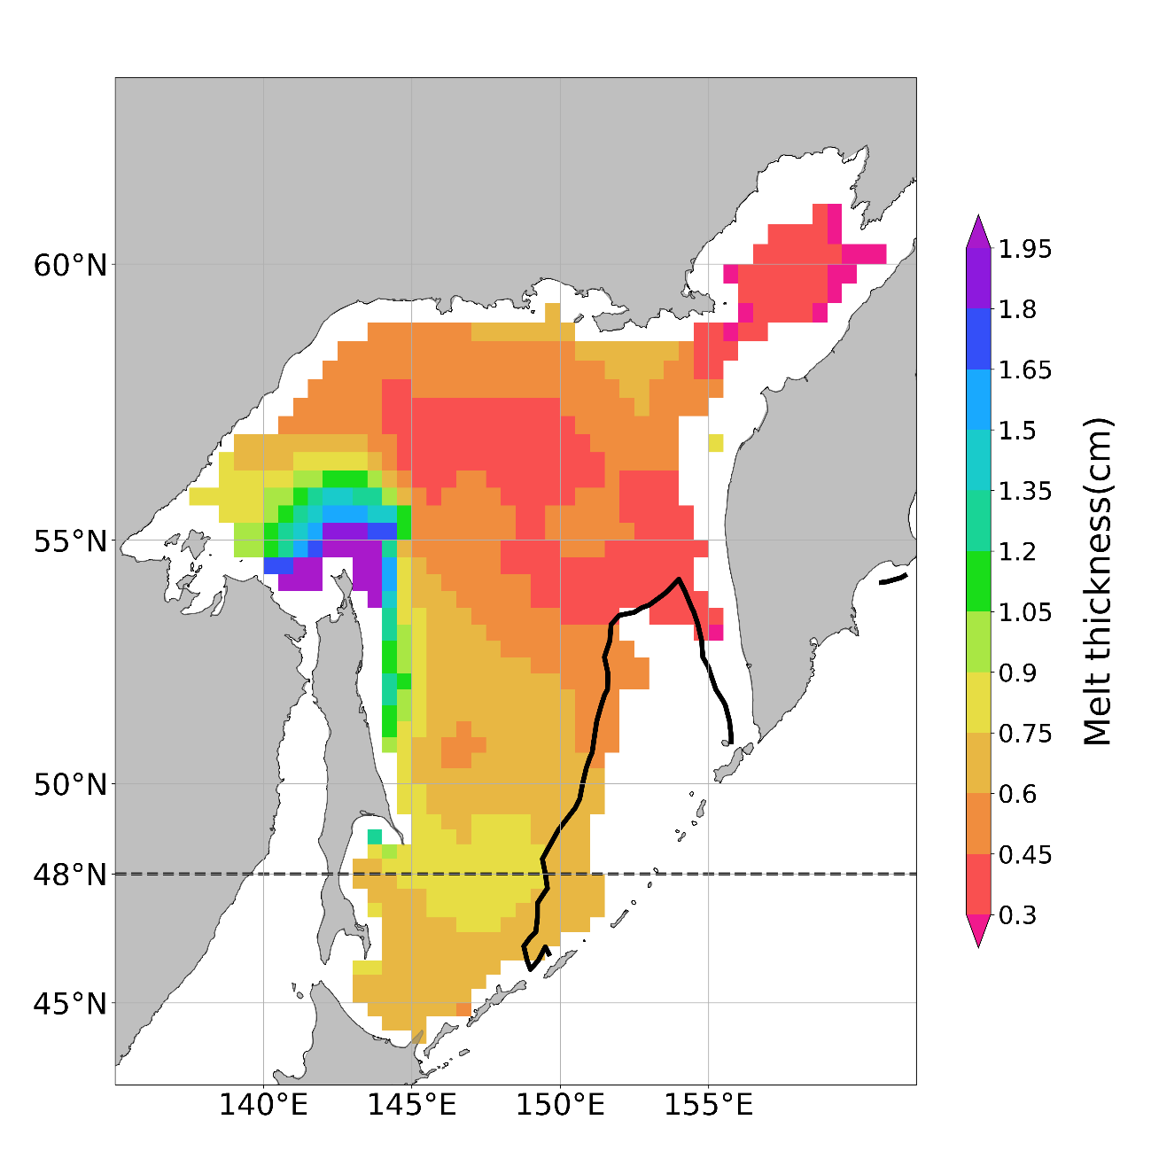
Figure S1: Climatology map of the ice-melt amount (the same as Fig. 6) with the same color scale as that of Nihashi et al. (2018). The thick solid line indicates the boundary of the average sea-ice extent, defined in Section 3.

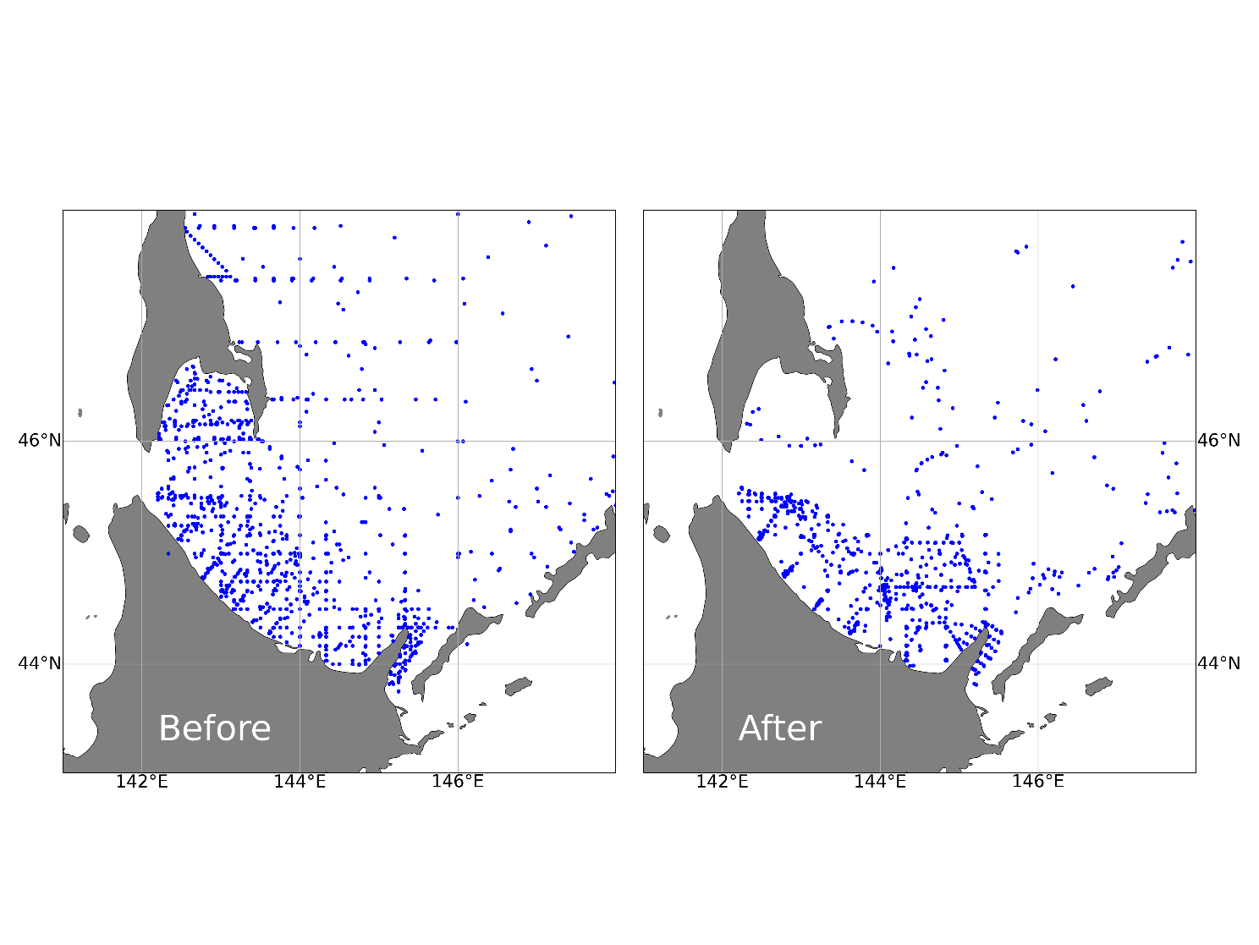
Figure S2: Locations of salinity data points at 20 m depth for two periods, before and after 1990, used in the gridded dataset.

