Supplementary material

Spatial Variability and Source Apportionment of PM_{2.5} in Rio de Janeiro: Insights from Urban, Preserved, and Biomass Burning Areas

Luis Fhernando Mendonça da Silva ª, Hellen Gonçalves Vieira ^{b}, Elizanne P. S. Justo ª, Ivan Víctor Silva Guillen ª, Vanessa A. dos Anjos ^{c}, Ricardo Henrique M. Godoi ^{c}, Maria Cristina Canela ^{b}, Cibele Maria Stivanin de Almeida ^{b}, Tatiana Dillenburg Saint’Pierre ª, Adriana Gioda ^{a,*}

ª Pontifícia Universidade Católica do Rio de Janeiro, Departamento de Química, Brazil.
^{b} Universidade Estadual do Norte Fluminense Darcy Ribeiro, Laboratório de Ciências Químicas, Brazil.
^{c} Departamento de Engenharia Ambiental, Universidade Federal do Paraná, 81531-980 Curitiba-PR, Brazil

*Corresponding author: agioda@puc-rio.br

Table S1. Period of particulate matter sampling carried out.
Date | Gávea | PARNASO | Campos dos Goytacazes
09/02/2022 | X | X | X
11/03/2022 | X | X | X
04/04/2022 |  | X | X
06/04/2022 | X
04/05/2022 | X | X | X
02/06/2022 | X
07/06/2022 |  |  | X
03/07/2022 | X |  | X
02/08/2022 | X |  | X
08/08/2022 |  | X
01/09/2022 | X | X | X
01/10/2022 |  |  | X
04/10/2022 | X | X
06/11/2022 | X | X | X
06/12/2022 | X | X | X
26/01/2023 | X
30/01/2023 |  | X | X
06/02/2023 | X |  | X
08/03/2023 | X | X
05/04/2023 | X | X | X
23/05/2023 | X | X | X
06/06/2023 | X | X | X
Total of samples (n) | 17 | 14 | 16

Table S2. Limit of detection (LOD) and limit of quantification (LOQ) of ions (µg m⁻³) and elements (µg m⁻³).
Analytes | LOD_{instrumental} | LOQ_{instrumental} | LOD_{method} | LOQ_{method}
Mn | 0.0001 | 0.0002 | 0.0001 | 0.00015
Co | 0.0001 | 0.0002 | 0.0001 | 0.00012
Ti | 0.0002 | 0.0004 | 0.0001 | 0.00011
V | 0.0001 | 0.0003 | 0.0002 | 0.0009
Pb | 0,0001 | 0.0050 | 0.0004 | 0.0010
Mo | 0.0003 | 0.0030 | 0.0005 | 0.0020
La | 0.0020 | 0.0040 | 0.0021 | 0.0040
Ce | 0.0004 | 0.0050 | 0.0007 | 0.0047
Ti | 0.00007 | 0.0001 | 0.00004 | 0.0001
Al | 0.0010 | 0.0030 | 0.0024 | 0.0099
Cu | 0.0010 | 0.0020 | 0.0009 | 0.0015
Fe | 0.00004 | 0.0009 | 0.0031 | 0.0049
Zn | 0.00007 | 0.00013 | 0.0012 | 0.0026
Li⁺ | 0.0007 | 0.0021 | 0.0012 | 0.0023
K⁺ | 0.0048 | 0.0132 | 0.0076 | 0.0155
Na⁺ | 0.0028 | 0.0085 | 0.0043 | 0.0128
NH₄⁺ | 0.0009 | 0.0026
Mg²⁺ | 0.0016 | 0.0029 | 0.0012 | 0.0023
NO₂⁻ | 0.0014 | 0.0042 | 0.0127 | 0.0285
Br⁻ | 0.0011 | 0.0033 | 0.0032 | 0.0048
NO₃⁻ | 0.0020 | 0.0060 | 0.0600 | 0.1056
PO₄³⁻ | 0.0003 | 0.0009 | 0.0055 | 0.0105
(C₂O₄)²⁻ | 0.0058 | 0.0175 | 0.0400 | 0.0777
SO₄²⁻ | 0.0060 | 0.0181 | 0.2200 | 0.5980
CH₃COO⁻ | 0.0001 | 0.0003 | 0.0700 | 0.1479
HCOO⁻ | 0.0010 | 0.0029 | 0.2500 | 0.2962
Cl⁻ | 0.0010 | 0.0029 | 0.2500 | 0.2962
Ca²⁺ | 0.0030 | 0.0091 | 0.0172 | 0.0275
F⁻ | 0.0004 | 0.0011 | 0.0320 | 0.0524
CH₂(COO)₂²⁻ | 0.0011 | 0.0033 | 0.0032 | 0.0048

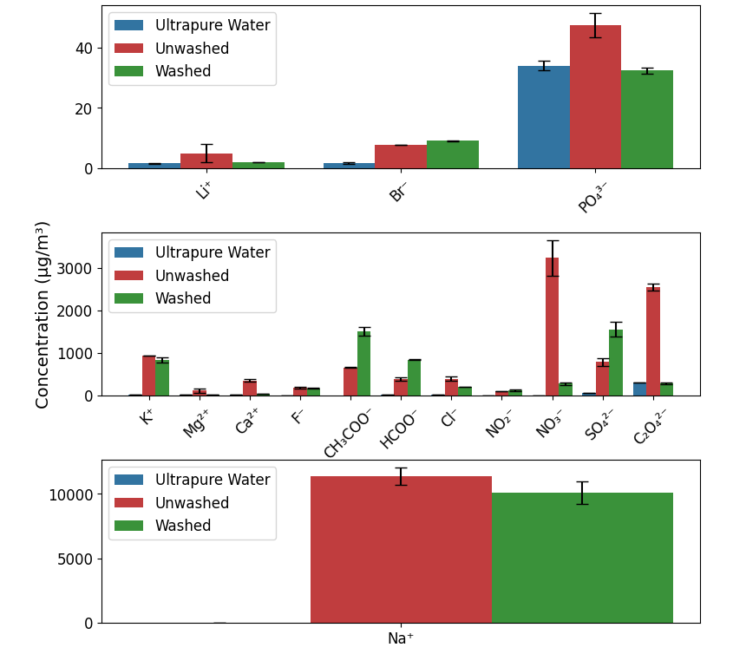
Figure S1. Concentrations of the ions present in the blank filter extracts (error bar ± SD).

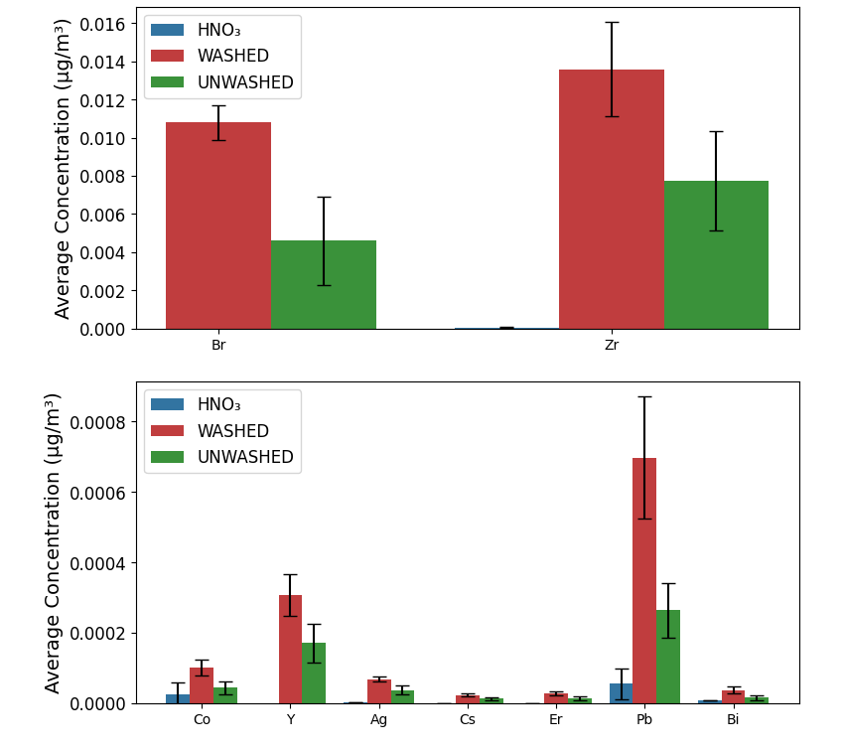
Figure S2. Concentrations of the elements present in the blank filter extracts (error bar ± SD).

Table S3. Measured concentration (average ± standard deviation) and extraction efficiencies for the analysis by ICP-MS of the standard reference material NIST-SRM 1648a.
Element | Reference (mg kg⁻¹) | Measurement (mg kg⁻¹) | Efficient of extraction (%)
Al | 34300 ± 1300 | 25646 ±1472 | 75
Ca | 58400 ± 1900 | 39846 ± 6342 | 68
Cd | 74 ± 2 | 71 ± 4 | 96
Ce | 55 ± 2 | 26 ± 3 | 47
Co | 18 ± 1 | 13 ± 2 | 72
Cr | 402 ± 17 | 104 ± 16 | 26
Cu | 610 ± 86 | 591 ± 2 | 97
Fe | 39200 ± 2100 | 33849 ± 1991 | 86
La | 39 ± 3 | 23 ± 1 | 59
Mn | 790 ± 44 | 751 ± 70 | 95
Ni | 81 ± 7 | 69 ± 4 | 85
Pb | 6550 ± 330 | 6242 ± 581 | 95
Sb | 45 ± 1 | 10 ± 1 | 22
Ti | 4021 ± 86 | 480 ± 14 | 12
V | 127 ± 11 | 98 ± 16 | 77
Zn | 4800 ± 270 | 4560 ± 294 | 95

Table S4. Concentrations (average ± standard deviations) of water-soluble ions (µg m⁻³) and ratio of ion in PM_{2.5} in the sites.
[µg m⁻³] | Gávea | PARNASO | Campos
Na⁺ | 0.82 ± 0.54 | 0.62 ± 0.47 | 1.0 ± 0.54
K⁺ | 0.14 ± 0.13 | 0.14 ± 0.11 | 0.10 ± 0.09
Mg²⁺ | 0.01 ± 0.01 | 0.02 ± 0.04 | 0.01 ± 0.01
Ca²⁺ | 0.14 ± 0.28 | 0.05 ± 0.05 | 0.11 ± 0.06
Cl⁻ | 0.51 ± 0.24 | 0.45 ± 0.31 | 0.63 ± 0.34
NO₃⁻ | 0.69 ± 0.69 | 0.48 ± 0.28 | 0.46 ± 0.25
SO₄²⁻ | 1.7 ± 0.94 | 1.2 ± 0.72 | 0.96 ± 0.68
NH₄⁺ | 0.03 ± 0.05 | 0.01 ± 0.02 | 0.06 ± 0.09
Org. Acids | 0.38 ± 0.23 | 0.29 ± 0.17 | 0.16 ± 0.13
Min. An. | 0.03 ± 0.04 | 0.05 ± 0.03 | 0.05 ± 0.12
nss-K⁺ | 0.10 ± 0.11 | 0.12 ± 0.10 | 0.07 ± 0.08
nss-Mg²⁺ | 0.004 ± 0.001
nss-Ca²⁺ | 0.12 ± 0.30 | 0.03 ± 0.04 | 0.08 ± 0.05
nss-Cl⁻ | 0.28 ± 0.26
nss-SO₄²⁻ | 1.5 ± 0.89 | 1.1 ± 0.68 | 0.72 ± 0.65
nss-K⁺/K⁺ | 0.71 | 0.86 | 0.70
nss-Ca²⁺/Ca²⁺ | 0.86 | 0.60 | 0.80
nss-SO₄²⁻ /SO₄²⁻ | 0.88 | 0.91 | 0.75
[NO₃⁻] /[SO₄²⁻] | 0.43 ± 0.27 | 0.45 ± 0.32 | 0.51 ± 0.18
ND: not detected; Org. Acids: sum of organic acids (CH₃COO⁻, HCOO⁻, CH₂(COO)₂²⁻, (C₂O₄)²⁻); Min. An.: sum of trace anions (F⁻, NO₂⁻, Br⁻, and PO₄³⁻).

Table S5. Average concentrations and standard deviation of carboxylic acid anions (µg m⁻³) in PM_{2.5} in the sites.
Ions [µg m⁻³] | Gávea | PARNASO | Campos
Oxalate | 0.41 ± 0.20 | 0.30 ± 0.15 | 0.14 ± 0.11
Malonate | 0.03 ± 0.01 | 0.05 ± 0.08 | 0.02 ± 0.02
Acetate | N.D. | 0.06 ± 0.08 | 0.03 ± 0.02
ND: not detected.
Table S6. Average concentrations and standard deviation of elements (ng m⁻³) in PM_{2.5} in the sites.
Elements (ng m⁻³) | Gávea | PARNASO | Campos
Al | 14 ± 4.2 | 23 ± 15 | 30± 125
Cu | 2.7 ± 1.5 | 0.43 ± 0.17 | 3.5 ± 51
Fe | 6.8 ± 6.9 | 29 ± 22 | 34 ± 67
Mn | 0.17 ± 0.11 | 0.56 ± 0.36 | 1.8 ± 4.0
Pb | 1.7 ± 1.1 | 1.3 ± 1.0 | 1.5 ± 1.0
Ti | 0.15 ± 0.14 | 0.50 ± 0.65 | 1.6 ± 7.0
V | 1.0 ± 1.1 | 1.3 ± 0.94 | 1.3 ± 0.90
Zn | 3.3 ± 0.78 | 2.9 ± 0.80 | 2.7 ± 2.1

Table S7. Enrichment factor (EF) for the elements presents in PM_{2.5} in the studied locations.
Enrichment Factor – Fe as C_{REF}
Element | Gávea | PARNASO | Campos
Al | 0.90 | 0.35 | 0.38
Cu | 555.88 | 20.76 | 144.12
Fe | 1.00 | 1.00 | 1.00
Mn | 0.92 | 0.71 | 1.95
Pb | 514.71 | 92.29 | 90.83
Ti | 0.18 | 0.14 | 0.37
V | 38.13 | 11.62 | 9.91
Zn | 242.65 | 50.00 | 39.71
Enrichment Factor – Al as C_{REF}
Element | Gávea | PARNASO | Campos
Al | 1.00 | 1.00 | 1.00
Cu | 620.23 | 60.13 | 375.20
Fe | 1.12 | 2.90 | 2.60
Mn | 1.03 | 2.06 | 5.08
Pb | 574.29 | 267.31 | 236.47
Ti | 0.20 | 0.40 | 0.97
V | 42.54 | 33.66 | 25.81
Zn | 270.73 | 144.82 | 103.37

