Supplementary Figures
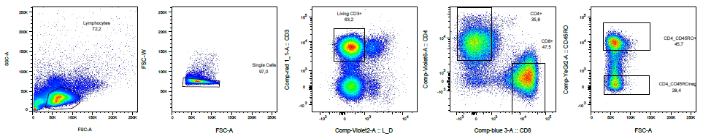
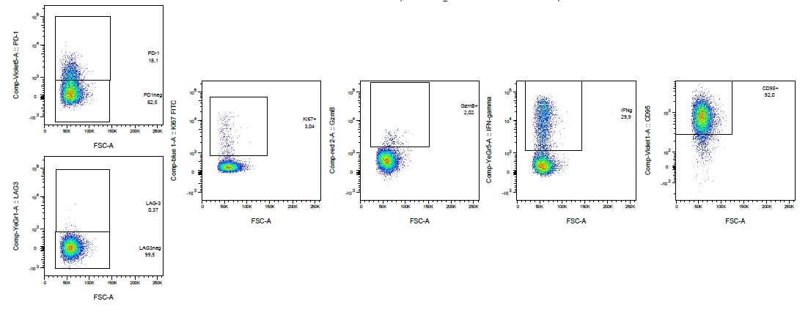
Supplementary Figure 1: Representative gating: general gating strategy and exhaustion panel
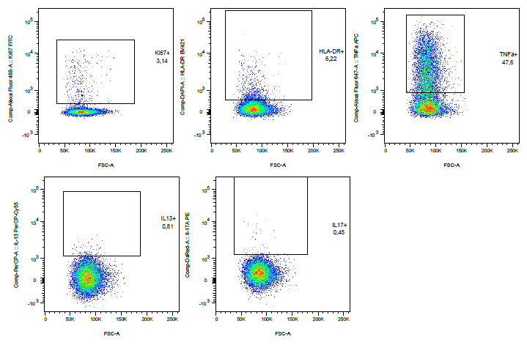
Supplementary Figure 2: Representative gating: gating strategy Th skewing panel
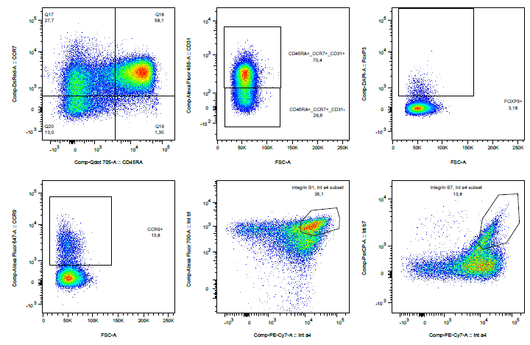
Supplementary Figure 3: Representative gating naïve / homing panel
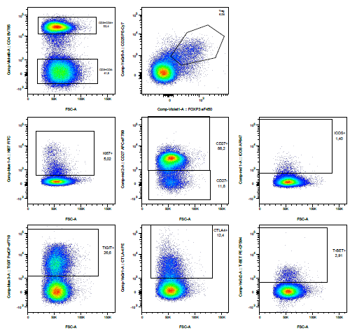
Supplementary Figure 4: Representative gating Treg panel
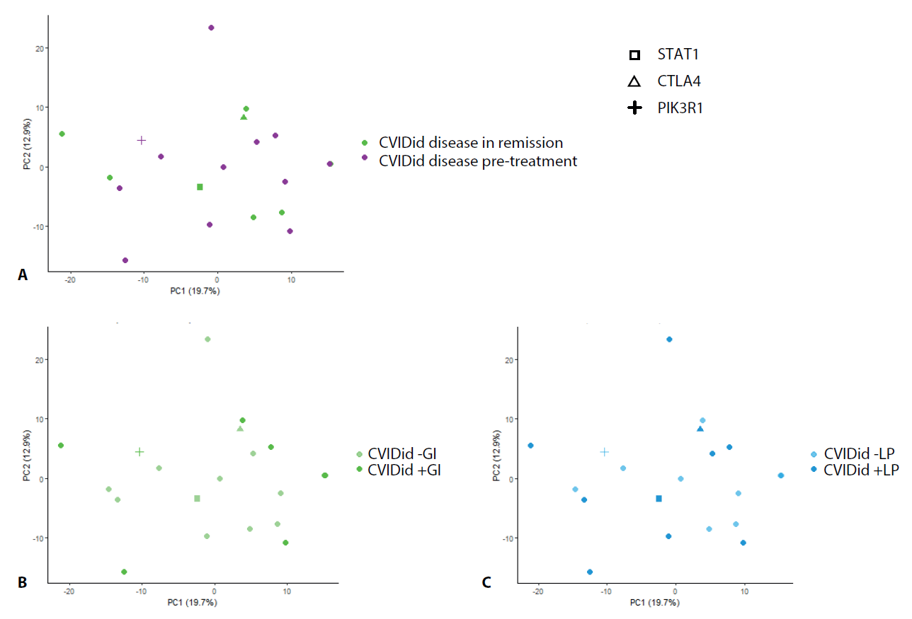
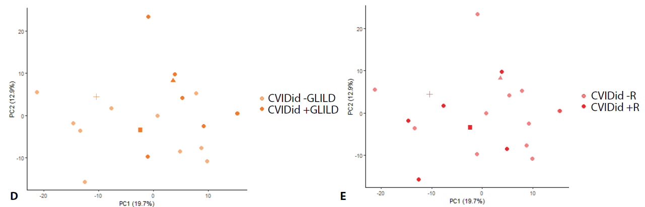
Supplementary Figure 5: Principal component analysis of FACS data (all panels combined). CVID with immune dysregulation (CVIDid, n=20) only.
A: disease status: disease in remission (n=8) versus disease pre-treatment (n=12).
B: CVIDid patients with (+GI, n=8) and without (-GI, n=12) gastrointestinal complications.
C: CVIDid patients with (+LP, n=10) and without (-LP, n=10) lymphoproliferation.
D: CVIDid patients with (+GLILD, n=8) and without (-GLILD, n=12) granulomatous-lymphocytic interstitial lung disease
E: CVIDid patients with (+R, n=6) and without (-R, n=14) rheumatological complications.

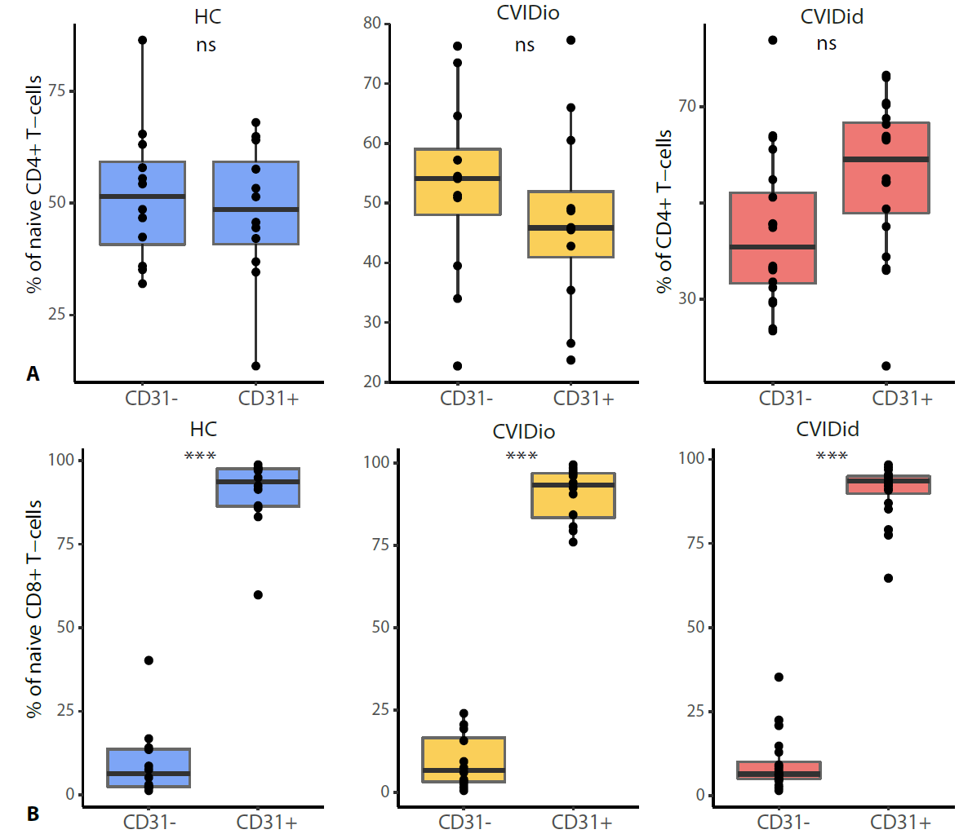
Supplementary Figure 6: CD31 expression within naïve (CD45RA+CCR7+) T-cells. CVIDid = CVID with immune dysregulation (n=20), CVIDio = CVID with infections only (n=12), HC = healthy controls (n=12). Statistics: Mann-Whitney U-test. * p<0.05, ** p<0.01, *** p<0.001.
A: naïve CD4+ T-cells
B: naïve CD8+ T-cells

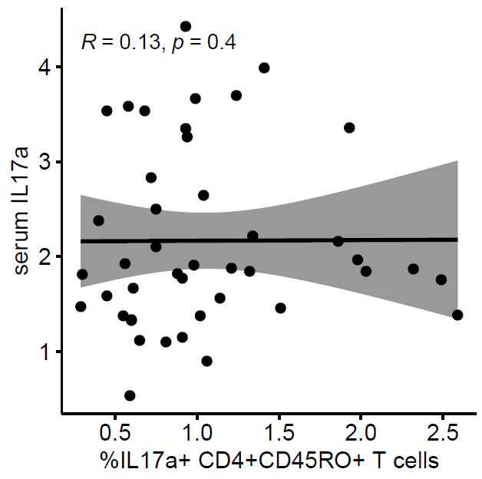
Supplementary Figure 7: Percentage of IL17+ CD4+CD45RO+ T-cells did not correlate with serum levels of IL-17A. Statistics: Spearman correlation.

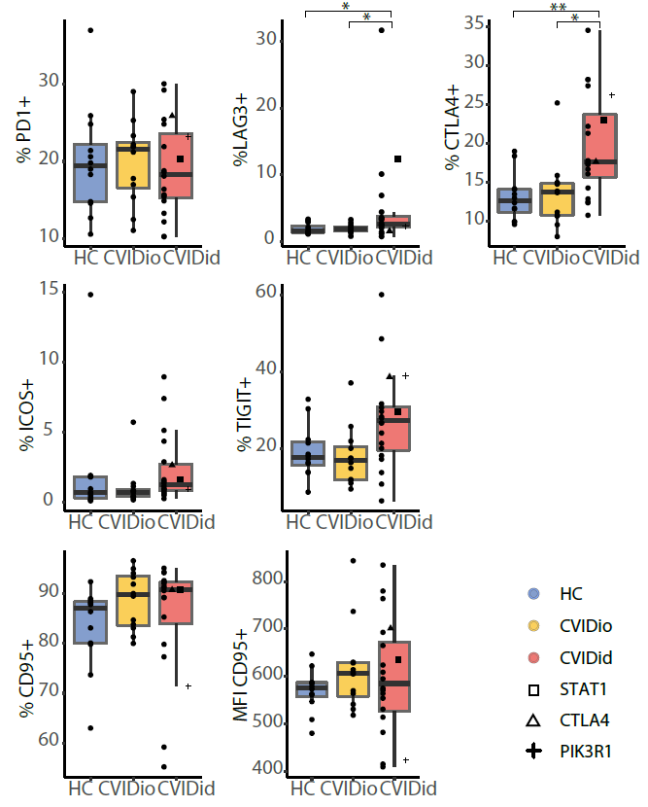
Supplementary Figure 8: Proportions of negative regulators of immune activation PD1, LAG3, CTLA4, ICOS and TIGIT, and apoptosis marker CD95 (FASL) in CD8+CD45RO+ T-cells. CVIDid = CVID with immune dysregulation (n=20), CVIDio = CVID with infections only (n=12), HC = healthy controls (n=12). MFI: median fluorescence intensity. Statistics: Mann-Whitney U-test. * p<0.05, ** p<0.01, *** p<0.001.

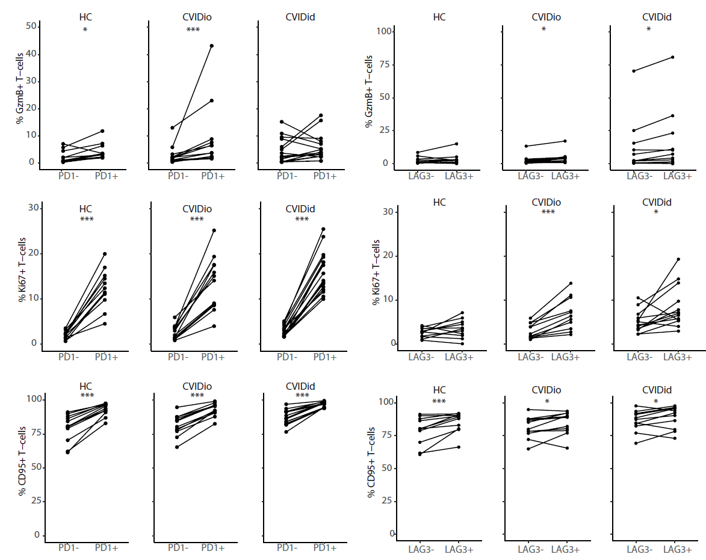

Supplementary Figure 9: Comparison of percentage of GzmB+ and CD95+ cells in PD1 and LAG3 positive and negative populations in CD4+CD45RO+ T-cells. Only samples with >50 events in the PD1/LAG3 positive and PD1/LAG3 negative populations were included. CVIDid = CVID with immune dysregulation (n=20), CVIDio = CVID with infections only (n=12), HC = healthy controls (n=12). Statistics: paired Wilcoxon-Rank test. * p<0.05, ** p<0.01, *** p<0.001.

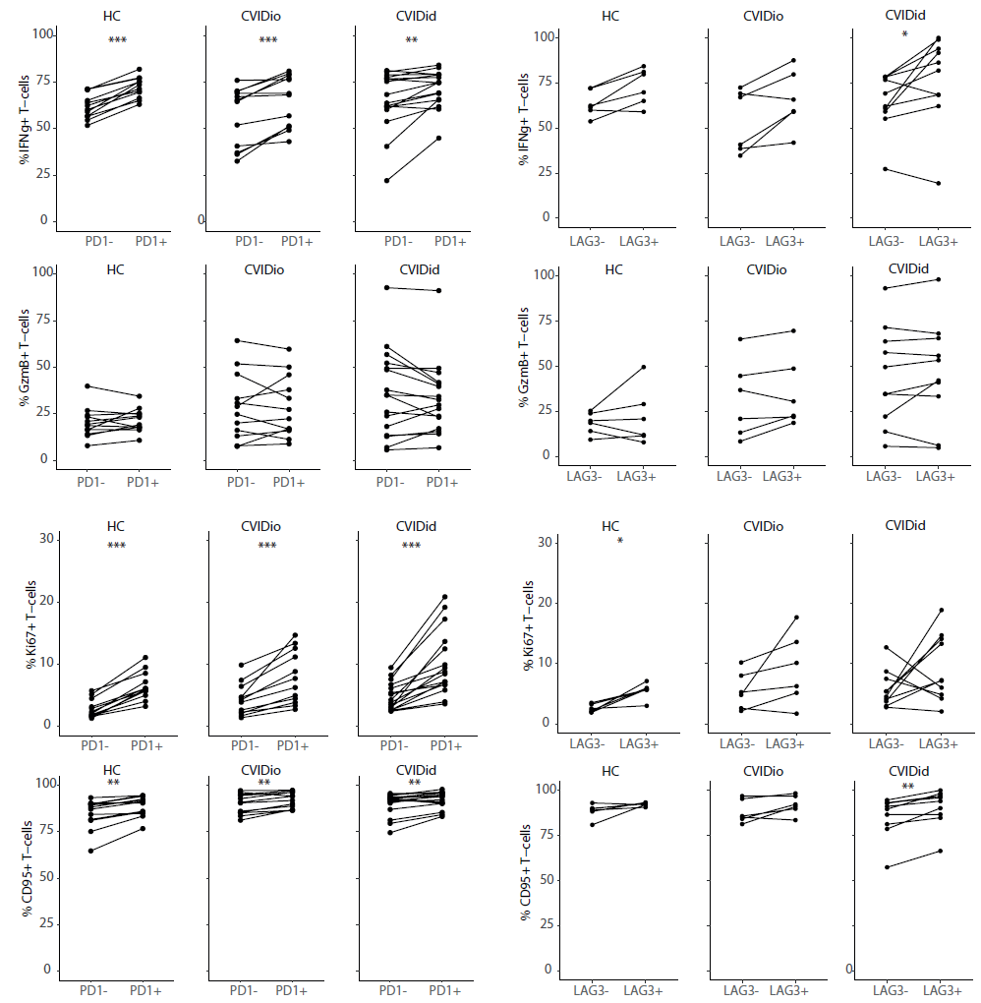
Supplementary Figure 10: Comparison of percentage of IFNγ+, GzmB+, Ki67+ and CD95+ cells in PD1 and LAG3 positive and negative populations in CD8+CD45RO+ T-cells. Only samples with >50 events in the PD1/LAG3 positive and PD1/LAG3 negative populations were included. CVIDid = CVID with immune dysregulation (n=20), CVIDio = CVID with infections only (n=12), HC = healthy controls (n=12). Statistics: paired Wilcoxon-Rank test. * p<0.05, ** p<0.01, *** p<0.001.

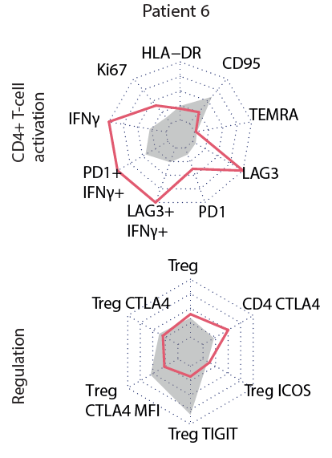
Supplementary Figure 11: Patterns of CD4+ T-cell activation and T-cell regulation in a patient with high immune activation markers but mild clinical phenotype. Coeliac disease, Sjögren-like disease, autoimmune gastritis, not requiring immunosuppressive therapy. Genetics were done but no relevant mutations were found. MFI: median fluorescence intensity.

Supplementary Table 1: FACS staining antibody list
Antibody | Fluorochrome | Company | Panel
Surface
CCR7 | PE | eBioscience | Homing/naive
CCR9 | APC | Biolegend | Homing/naive
CD137 (4-1BB) | APC | BD | Exhaustion
CD25 | PE-Cy7 | BD | Treg
CD27 | APC-eF780 | eBioscience | Treg
CD3 | AF700 | Biolegend | Exhaustion, Treg
CD3 | BV605 | Biolegend | Th skewing, Homing/Naive
CD31 | FITC | BD | Homing/naive
CD4 | BV785 | Biolegend | Exhaustion, Th skewing, Homing/Naive Treg
CD45RA | BV711 | Biolegend | Homing/naive
CD45RO | ECD | Beckman Coulter | Exhaustion, Th skewing
CD8 | APC-Cy7 | BD | Th skewing, Homing/Naive
CD8a | PerCP-Cy5.5 | Biolegend | Exhaustion
CD95 (FAS ligand) | eFluor450 | eBioscience | Exhaustion
HLA-DR | BV421 | Biolegend | Th skewing
ICOS | AF647 | eBioscience | Treg
Int α4 | PE-Cy7 | Biolegend | Homing/naive
Int β1 | AF700 | Biolegend | Homing/naive
Int β7 | PerCP-Cy5.5 | Biolegend | Homing/naive
LAG-3 | PE | R&D Systems | Exhaustion
PD-1 | BV711 | BD | Exhaustion
TIGIT | PerCP-eF710 | eBioscience | Treg
TNF | APC | Biolegend | Th skewing
Intracellular
CTLA-4 | PE | BD | Treg
FOXP3 | eF450 | eBioscience | Homing/naive, Treg
GzmB | APC-Fire750 | Biolegend | Exhaustion
IFNy | PE-Cy7 | BD | Exhaustion
IL-13 | PerCP-Cy5.5 | Sony Biotechnology | Th skewing
IL-17A | PE | eBioscience | Th skewing
Ki67 | FITC | Dako (Agilent) | Exhaustion, Th skewing, Treg
T-BET | PE-CF594 | BD | Treg

