Copy number analysis in a large cohort suggestive of inborn errors of immunity indicates a wide spectrum of relevant chromosomal losses and gains

Rensheng Wan^{1,*}, Maximilian Schieck^{1,2*}, Andrés Caballero-Oteyza³, Winfried Hofmann¹, Alexis Virgil Cochino⁴, Anna Shcherbina⁵, Roya Sherkat⁶, Clarisse Wache-Mainier⁷, Anita Fernandez⁷, Marc Sultan⁷, Thomas Illig^{1,2,8}, Bodo Grimbacher^{2,3,9,10,11#}, Michele Proietti^{2,3,12#}, Doris Steinemann^{1,2#}

¹ Department of Human Genetics, Hannover Medical School, Hannover, Germany
² RESIST-Cluster of Excellence 2155, Hannover Medical School, Hannover, Germany
³ Institute for Immunodeficiency, Center for Chronic Immunodeficiency, Medical Center, Faculty of Medicine, Albert-Ludwigs-University, Freiburg, Germany
⁴ Institute for Mother and Child Health, Bucharest, Romania
⁵ Dmitry Rogachev National Medical and Research Center for Pediatric Hematology, Oncology, Immunology, Moscow, Russia
⁶ Acquired Immunodeficiency Research Center, Isfahan University of Medical Sciences, Isfahan, Iran
⁷ Novartis Institutes for BioMedical Research, Novartis Pharma AG, Basel, Switzerland
⁸ Hannover Unified Biobank, Hannover Medical School, Hannover, Germany
⁹ Clinic for Rheumatology and Clinical Immunology, Center for Chronic Immunodeficiency (CCI), Medical Center, Faculty of Medicine, Albert-Ludwigs-University of Freiburg, Germany
¹⁰ DZIF – German Center for Infection Research, Satellite Center Freiburg, Germany
¹¹ CIBSS – Centre for Integrative Biological Signalling Studies, Albert-Ludwigs University, Freiburg, Germany
¹² Department of Rheumatology and Clinical Immunology, Hannover Medical School, Hannover, Germany
* and # equal contribution

ONLINE SUPPLEMENT
In the supplementary discussion we report and discuss CNVs and SNVs of uncertain significance (summarized in the lower part of Tab.1 “samples with uncertain molecular diagnosis”). These variants either showed less correlation to the clinical phenotype or presented a monoallelic event in a gene with a so far known autosomal recessive inheritance.

Deletions
Patient-058
The largest CNV, a heterozygous deletion of almost 9 Mb at 11q22.1q22.3, was observed in patient-058. ACMG guidelines allow classification of this CNV as pathogenic. According to the ClinGen database, this region harbors 48 protein-coding genes including ATM, previously associated with IEI. More than half of the patients with ataxia telangiectasia carrying biallelic ATM variants show a clinical history of susceptibility to infections [1]. In line with previous reports, clinical features of this patient include recurrent lower respiratory tract infections, and decreased IgA and IgG levels [2]. However, we did not detect a second variant (SNV nor CNV) on the other ATM allele. At this point it remains unclear if relevant variants, e.g. in non-coding ATM regions, are missed by our exome-based approach or if the large deletion itself has a functional effect causing the clinical presentation, including disturbed generation of adaptive immunological diversity [3].
Patient-122
Patient-122 presented a deletion of 168 kb at 16p11.2 including CD19 and LAT. For both genes an autosomal recessive inheritance in IEI has been described. Again, our analysis indicated no aberration on the second allele. The deleted region corresponds to the known chromosome 16p11.2 deletion syndrome. ClinGen reports this region as susceptible to haploinsufficiency and associated key clinical features are developmental delay and early onset obesity (dosage ID: ISCA-37486; ACMG classification “pathogenic”), which were not observed for patient-122. To what extent a possible haploinsufficiency of CD19 and LAT could explain the clinical symptoms of the patient (e.g. hypogammaglobulinemia) remains open.

Besides large deletions affecting whole genes, we identified a number of microdeletions smaller than 20 kb affecting only parts of IEI-associated genes.
Patient-047
Patient-047 carried a small 17.6 kb deletion affecting the last exon of CORO1A. This should lead to a functional inactivation due to loss of the C-terminal coiled-coil leucine zipper oligomerization domain of CORO1A (deletion of aa 428-461; NP_001180262.1). The C-terminal CORO1A domains are relevant to T-cell survival and function and some of the patient’s clinical features are in line with previously reported cases [4], including abnormal lymphocyte proliferation, increased proportion of effector memory CD8⁺ T-cells, and reduced proportion of naive CD4⁺ T-cells.
Patient-008
An intragenic deletion of TYK2 causing a potential frame-shift, is compatible with clinical symptoms observed for patient-008, including onset of symptoms in childhood, recurrent respiratory infections, and increased susceptibility to virus (MIM 611521). Additionally, this patient has evidence of autoimmune disease (e.g. positive antinuclear antibody (ANA) test), and a strong link between TYK2 variants and autoimmune diseases has been reviewed recently [5].
Patient-141
Small deletions of FANCA have been frequently reported in PID and patient-141 presented an intragenic FANCA deletion leading to a potential in-frame loss of aa 175-265 [6, 7]. This substantial loss of coding sequence is likely to impair protein function. FANCA has been suggested to play a role in primary diversification of immunoglobulins. It is therefore very well possible that the deletion of FANCA is causative for at least some of the observed clinical features in patient-141, including decreased Ig levels (IgA, IgM, IgG1, IgG4) and decreased proportions of plasmablasts and switched memory B cells [8].

Duplications
We identified a number of duplications affecting IEI-associated genes (Fig.S2). Three patients presented gains of chromosomal material affecting the entire coding region of IEI-associated genes.
Patient-083
Patient-083, with an early onset of CID at age 2.2 years, carried a large 600 kb duplication at 14q11.2 affecting more than 20 genes including TRAC, SLC7A7 and CEBPE. Dosage effects of duplicated genes might be responsible for the clinical presentation of recurrent and severe virus infections in this patient. Besides, this TD brings one copy of CEBPE in close vicinity of approx. less than 30 kb to TRAC (T cell receptor alpha chain constant) (Fig.S2). A broad influence on the inflammasome and interferome is known for the transcription factor C/EBPε encoded by CEBPE [9]. If this rearrangement leads to an altered CEBPE expression is unclear. Unfortunately, no suitable material was available to test for aberrant C/EBPε levels specifically in T cells, which might be responsible for the low T cell count observed in this patient due to pro-apoptotic features of C/EBPε [10]. A heterozygous pathogenic nonsense variant in NLRC4 adds more complexity to this case. However, the patient shows no phenotype suspective of NLRC4 inflammasomopathy, usually caused by missense variants of NLRC4, and the nonsense variant observed in our patient might lead to different phenotypic consequences [11].
Patient-090
Patient-090 carried a 103 kb TD encompassing the MEFV gene. The patient did not present typical symptoms of familial Mediterranean fever caused by defects of MEFV (MIM 608107), but variability of symptoms as well as subclinical phenotypes have been suggested [12]. The patient carried no other relevant SNVs or CNVs and further analysis on MEFV duplications in IEI could be considered. However, the ClinGen consortium reports no evidence for triplosensitivity of MEFV (dosage ID: ISCA-24503) and a genome-wide analysis beyond IEI-associated genes is considered for this specific case.
Patient-114
A 743 kb duplication of chromosome 16q24.2 in patient-114 was the largest chromosomal gain identified in this study. CYBA was part of the duplicated region, however at this point it is not clear how CYBA function might be affected by the duplication. Yet, defects of CYBA are known to cause chronic granulomatous disease 4 (MIM 608508) and in line with this the patient presented pulmonary granulomatosis at age 23 years [13].

Four patients carried duplications with breakpoints potentially located within IEI-associated genes. Duplications either affected 5’ gene regions (patient-081, patient-171, and patient-160) or the 3’ gene region (patient-149).
Patient-081
Analysis of patient-081 with OGM showed a TD, meaning that one LRBA copy is putatively left unaffected and a putative fusion of LRBA to SH3D19, consisting of the LRBA promoter region, LRBA exons 1-35 and SH3D19 exons 10-21. The putative fusion protein product would consist of the first 1882 out of 2863 LRBA amino acids (approx. 66% of the LRBA coding sequence) with a putative premature stop codon at position 1905. This would likely cause nonsense-mediated mRNA decay (NMD). However, breakpoints are not resolved at sequence-level in our study and NMD does not necessarily need to be activated.
Patient-171
In patient-171 a 9.3 kb duplication of TRIM22 exons 1 to 4 was indicated to be inserted in tandem. This TD potentially affects the region harboring the potential promoter of TRIM22 and the 5’ region of the neighboring gene TRIM5. TRIM22 has an antiviral function and is involved in activation of interferon-beta signaling and nuclear factor-κB [14, 15]. Additionally, this patient carries a rare missense VUS in NFKB2 (p.Arg261Trp). Based on this data, one can only speculate which of the two aberrations are causing the clinical phenotype (Tab.S2) or if additive effects of the TRIM22 TD and the NFKB2 VUS persist in patient-171.
Patient-160
The third 5’ gene region duplication identified in this study was a TD of BRIP1 exons 1-3. This gene is associated with Fanconi anemia (MIM 609054) and perturbed humoral immunity observed in patient-160, including hypogammaglobulinemia and decreased proportion of plasmablasts, might be explained by a defect in the Fanconi anemia pathway.
Patient-149
A TD of IKBKG exons 4-10 in patient-149 was the only duplication of a 3’ gene region of an IEI-associated gene in this study. No other variants were observed for this patient, making IKBKG a promising explanation for hypogammaglobulinemia alongside with decreased proportion of plasmablasts observed in this patient (MIM 300636).
Fig.S1: Analysis strategy for the detection and validation of CNVs and SNVs in patients with an IEI
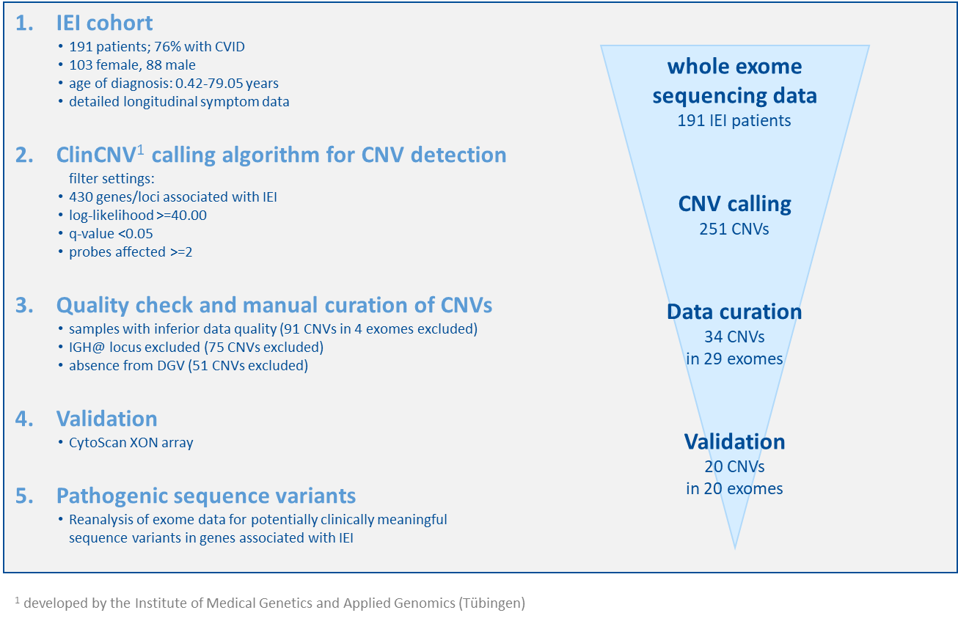
Fig.S2: Confirmation of duplications using optical genome mapping. OGM analysis showed that duplications identified from WES data were in tandem (patient-074, patient-081, patient-083, patient-090, and patient-160) or to be likely in tandem (patient-149, and patient-171).
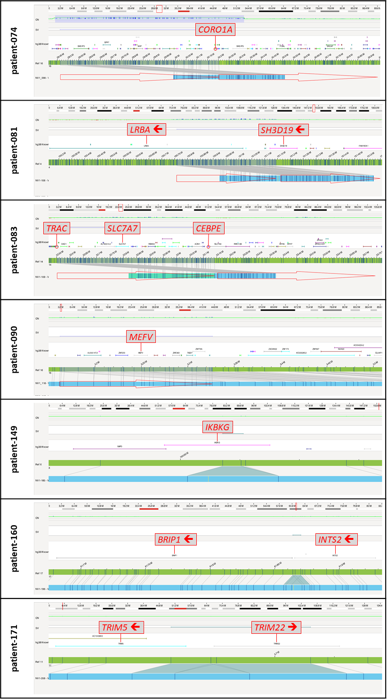
Tab.S1: Cohort of patients with a suspected IEI
Tab.S2: Clinical phenotypes of patients carrying a validated CNV affecting an IEI-associated gene.
REFERENCES
1. Staples ER, McDermott EM, Reiman A, Byrd PJ, Ritchie S, Taylor AM, et al. Immunodeficiency in ataxia telangiectasia is correlated strongly with the presence of two null mutations in the ataxia telangiectasia mutated gene. Clin Exp Immunol. 2008;153(2):214-20.
2. Bousfiha A, Jeddane L, Picard C, Al-Herz W, Ailal F, Chatila T, et al. Human Inborn Errors of Immunity: 2019 Update of the IUIS Phenotypical Classification. J Clin Immunol. 2020;40(1):66-81.
3. Weitering TJ, Takada S, Weemaes CMR, van Schouwenburg PA, van der Burg M. ATM: Translating the DNA Damage Response to Adaptive Immunity. Trends Immunol. 2021;42(4):350-65.
4. Yee CS, Massaad MJ, Bainter W, Ohsumi TK, Foger N, Chan AC, et al. Recurrent viral infections associated with a homozygous CORO1A mutation that disrupts oligomerization and cytoskeletal association. J Allergy Clin Immunol. 2016;137(3):879-88 e2.
5. Pellenz FM, Dieter C, Lemos NE, Bauer AC, Souza BM, Crispim D. Association of TYK2 polymorphisms with autoimmune diseases: A comprehensive and updated systematic review with meta-analysis. Genet Mol Biol. 2021;44(2):e20200425.
6. Stray-Pedersen A, Sorte HS, Samarakoon P, Gambin T, Chinn IK, Coban Akdemir ZH, et al. Primary immunodeficiency diseases: Genomic approaches delineate heterogeneous Mendelian disorders. J Allergy Clin Immunol. 2017;139(1):232-45.
7. Dyer L, Li X, Denton J, Jones B, Liston E, Hilton D, et al. Gene dosage defects in primary immunodeficiencies and related disorders: a pilot study. Journal of Translational Genetics and Genomics. 2017;1:23-7.
8. Nguyen TV, Pawlikowska P, Firlej V, Rosselli F, Aoufouchi S. V(D)J recombination process and the Pre-B to immature B-cells transition are altered in Fanca(-/-) mice. Sci Rep. 2016;6:36906.
9. Goos H, Fogarty CL, Sahu B, Plagnol V, Rajamaki K, Nurmi K, et al. Gain-of-function CEBPE mutation causes noncanonical autoinflammatory inflammasomopathy. J Allergy Clin Immunol. 2019;144(5):1364-76.
10. Nakajima H, Watanabe N, Shibata F, Kitamura T, Ikeda Y, Handa M. N-terminal region of CCAAT/enhancer-binding protein epsilon is critical for cell cycle arrest, apoptosis, and functional maturation during myeloid differentiation. J Biol Chem. 2006;281(20):14494-502.
11. Romberg N, Vogel TP, Canna SW. NLRC4 inflammasomopathies. Curr Opin Allergy Clin Immunol. 2017;17(6):398-404.
12. Kallinich T, Orak B, Wittkowski H. [Role of genetics in familial Mediterranean fever]. Z Rheumatol. 2017;76(4):303-12.
13. Salvator H, Mahlaoui N, Catherinot E, Rivaud E, Pilmis B, Borie R, et al. Pulmonary manifestations in adult patients with chronic granulomatous disease. Eur Respir J. 2015;45(6):1613-23.
14. Reddi TS, Merkl PE, Lim SY, Letvin NL, Knipe DM. Tripartite Motif 22 (TRIM22) protein restricts herpes simplex virus 1 by epigenetic silencing of viral immediate-early genes. PLoS Pathog. 2021;17(2):e1009281.
15. Li Q, Lee CH, Peters LA, Mastropaolo LA, Thoeni C, Elkadri A, et al. Variants in TRIM22 That Affect NOD2 Signaling Are Associated With Very-Early-Onset Inflammatory Bowel Disease. Gastroenterology. 2016;150(5):1196-207.

