Supplemental Material
Clinical and immunological features of SARS-CoV-2 breakthrough infections in vaccinated individuals requiring hospitalization
Giulia Lamacchia^{1,*}, Alessio Mazzoni^{1,*}, Michele Spinicci^{1,2}, Anna Vanni¹, Lorenzo Salvati¹, Benedetta Peruzzi³, Sara Bencini³, Manuela Capone¹, Alberto Carnasciali¹, Parham Farahvachi¹, Arianna Rocca¹, Seble Tekle Kiros¹, Lucia Graziani¹, Lorenzo Zammarchi^{1,2}, Jessica Mencarini², Maria Grazia Colao⁴, Roberto Caporale³, Francesco Liotta^{1,3,5}, Lorenzo Cosmi^{1,5}, Gian Maria Rossolini^{1,4}, Alessandro Bartoloni^{1,2}, Laura Maggi^{1,#}, Francesco Annunziato^{1,3,#}

Affiliations:
1. Department of Experimental and Clinical Medicine, University of Florence, Florence, Italy
2. Infectious and Tropical Diseases Unit, Careggi University Hospital, Florence, Italy
3. Flow cytometry diagnostic center and immunotherapy, Careggi University Hospital, Florence, Italy
4. Microbiology and Virology Unit, Careggi University Hospital, Florence, Italy
5. Immunology and Cell Therapy Unit, Careggi University Hospital, Florence, Italy

* These authors share first authorship
# These authors share last authorship

Co-Corresponding authors:
Laura Maggi, PhD
Department of Experimental and Clinical Medicine, University of Florence
Viale Pieraccini, 6
50134 – Firenze, Italy
e-mail: laura.maggi@unifi.it

Prof. Francesco Annunziato, PhD
Department of Experimental and Clinical Medicine, University of Florence
Viale Pieraccini, 6
50134 – Firenze, Italy
e-mail: francesco.annunziato@unifi.it

 |  | Age, years | Gender | Ethnicity | Comorbidity Index | Severity WHO | Pneumonia (yes/no) | PaO₂/FiO₂ (mmHg) | Drug therapy | Outcome | Time from onset of symptoms to hospital admission, days | Time from hospital admission to discharge home, days | White blood cell count (x10^9/L) | Neutrophil count (x10^9/L) | Lymphocyte count (x10^9/L) | Monocyte count (x10^9/L) | Eosinophil count (x10^9/L) | Basophil count (x10^9/L) | Red blood cell count (x10^12/L) | Platelet count (x10^9/L) | Lactate dehydrogenase (U/L) | D-dimer (ng/mL) | Serum ferritin (ng/mL) | C-reactive protein (mg/L) | IL-6 (pg/mL) | Anti-IFN-α antibodies (ng/mL) | Type of vaccine (first+second+third dose)
 | Reference Range | - | - | - | - | 0-4 | - | 400-500 | - | - | - | - | 4-10 | 1,5-7,5 | 0,5-5 | 0,3-1,2 | 0-0,7 | 0-0,2 | 4,2- 5,4 | 140-400 | 135-214 | <500 | 15-150 | <5 | <7 | - | -
 | Vaccinated COVID-19 patients
 | V1 | 77 | M | C | 4 | 2 | yes | 295 | S | H | 6 | 6 | 15,5 | 12,51 | 1,74 | 1,16 | 0,05 | 0,05 | 4,54 | 234 | 273 | 602 | 227 | 191 | 303 | 505,5 | A+A
 | V2 | 65 | F | L | 3 | 0 | no | 404 | - | H | - | 9 | 5,19 | 2,35 | 2,39 | 0,31 | 0,12 | 0,02 | 4,26 | 325 | 140 | - | 95 | 8 | - | 0 | P+P
 | V3 | 58 | F | C | 8 | 0 | no | 314 | - | H | - | 14 | 7,91 | 6,57 | 0,65 | 0,59 | 0,08 | 0,02 | 3,3 | 376 | 175 | 1316 | 381 | 71 | - | 1,9 | P+P
 | V4 | 76 | M | C | 7 | 2 | yes | 309 | S, R | H | 6 | 11 | 8,64 | 4,83 | 3,3 | 0,5 | 0 | 0,01 | 4,1 | 186 | 445 | 770 | 1295 | 15 | 19,9 | 0 | P+P
 | V5 | 82 | M | C | 5 | 3 | yes | 271 | S | H | 6 | 16 | 4,03 | 2,62 | 1,14 | 0,25 | 0,01 | 0,01 | 3,6 | 223 | 226 | 866 | 619 | 65 | 32,6 | 0 | P+P
 | V6 | 79 | M | C | 3 | 2 | yes | 283 | S | H | 10 | 6 | 8,24 | 6,86 | 0,65 | 0,59 | 0,11 | 0,03 | 3,49 | 148 | 281 | 739 | 1208 | 179 | - | 342,7 | A+A
 | V7 | 90 | F | C | 4 | 3 | yes | 223 | S | H | 6 | 25 | 5,18 | 4,35 | 0,71 | 0,11 | 0 | 0,01 | 3,98 | 279 | 272 | 1141 | 591 | 202 | - | 594,4 | P+P
 | V8 | 97 | F | C | 4 | 3 | yes | 168 | S | D | 11 | - | 6,6 | 6,01 | 0,44 | 0,14 | 0 | 0,01 | 3,71 | 442 | 265 | 940 | 2390 | 191 | 227 | 0 | P+P+P
 | V9 | 75 | F | C | 3 | 3 | yes | 285 | S, R | H | 7 | 5 | 3,4 | 1,92 | 1,17 | 0,29 | 0,01 | 0,01 | 5,02 | 174 | 240 | 1037 | 37 | 38 | 23,2 | 0 | A+A
 | V10 | 75 | F | C | 5 | 2 | no | 352 | R | H | 3 | 5 | 4,94 | 3,93 | 0,76 | 0,21 | 0,03 | 0,01 | 3,86 | 133 | 213 | 1585 | 220 | 71 | 82,5 | 0 | P+P
 | V11 | 79 | M | C | 4 | 3 | yes | 257 | S | H | 5 | 5 | 8,66 | 7,79 | 0,5 | 0,36 | 0 | 0,01 | 3,57 | 134 | 223 | 1184 | 355 | 182 | - | 0 | N+N
 | V12 | 60 | M | C | 2 | 3 | yes | 309 | S | H | 7 | 6 | 5,49 | 2,88 | 2,15 | 0,39 | 0,06 | 0,01 | 5,5 | 136 | 278 | 642 | 332 | 36 | 41,8 | 0 | A+A
 | V13 | 59 | M | C | 3 | 3 | yes | 219 | S, R, M | H | 4 | 15 | 20,7 | 2,46 | 17,41 | 0,81 | 0 | 0,02 | 4,63 | 149 | 283 | 389 | 709 | 86 | - | 0 | N+N
 | V14 | 94 | F | C | 4 | 2 | no | - | S | H | 14 | 3 | 6,81 | 4,89 | 1,16 | 0,73 | 0,02 | 0,01 | 3,81 | 212 | 210 | 1247 | 442 | 156 | 71,2 | 0 | P+P
 | V15 | 81 | F | C | 6 | 4 | yes | 233 | S | H | 10 | 24 | 9,54 | 8,45 | 0,69 | 0,38 | 0 | 0,02 | 4,34 | 182 | 265 | 611 | 1038 | 35 | 46,2 | 0,5 | P+P
 | V16 | 74 | M | C | 8 | 0 | no | - | M | H | - | 9 | 6,56 | 4,39 | 1,28 | 0,61 | 0,22 | 0,06 | 4,45 | 266 | 200 | 747 | 258 | 5 | - | 1,0 | P+P+P
 | V17 | 70 | M | C | 3 | 2 | no | 338 | S | H | 9 | 5 | 4,89 | 4,13 | 0,057 | 0,18 | 0 | 0,01 | 4,84 | 250 | 201 | 292 | 237 | 49 | 43,3 | 0 | A+A
 | V18 | 88 | F | C | 9 | 3 | yes | 280 | S, T | H | 3 | 10 | 6,78 | 5,13 | 0,77 | 0,81 | 0,05 | 0,02 | 3,7 | 172 | 235 | 1849 | 216 | 23 | - | 0 | P+P
 | V19 | 70 | F | C | 7 | 4 | yes | 233 | S, R | D | 6 | - | 5,6 | 5,15 | 0,33 | 0,11 | 0 | 0,01 | 3,38 | 111 | 333 | 474 | 265 | 208 | 230 | 0 | P+P
 | V20 | 76 | M | C | 4 | 3 | yes | 252 | S, R | H | 4 | 8 | 4,08 | 2,45 | 1,03 | 0,5 | 0,09 | 0,01 | 5,61 | 118 | 177 | 1093 | 983 | 28 | - | 0 | A+A
 | V21 | 83 | M | C | 6 | 2 | yes | 319 | S, R | H | 4 | 6 | 6,75 | 4,77 | 1,04 | 0,85 | 0,09 | 0,01 | 4,63 | 149 | 194 | 0 | - | 103 | 57,5 | 0 | P+P+P
 | V22 | 52 | M | C | 1 | 4 | yes | 271 | S, T | H | 6 | 16 | 5,91 | 5,15 | 0,63 | 0,13 | 0 | 0 | 4,82 | 147 | 310 | 229 | 888 | 158 | - | 0 | A+A
 | V23 | 77 | M | C | 2 | 2 | yes | 371 | S | H | 10 | 3 | 4,28 | 2,91 | 0,82 | 0,54 | 0 | 0,01 | 4,79 | 208 | 213 | 580 | 507 | 34 | 64,5 | 0 | A+P
 | V24 | 89 | F | C | 8 | 3 | yes | 271 | S, M | H | 6 | 4 | 4,13 | 3,09 | 0,72 | 0,29 | 0,01 | 0,02 | 3,64 | 108 | 201 | 739 | 343 | 82 | 44,9 | 0,7 | P+P+P
 | V25 | 72 | M | C | 5 | 1 | no | 258 | S, M | H | - | 8 | - | - | - | - | - | - | - | - | - | - | - | - | - | 0 | A+A
 | V26 | 64 | M | C | 2 | 3 | yes | 202 | S | H | 9 | 8 | 8,99 | 7,97 | 0,77 | 0,24 | 0 | 0,01 | 5 | 215 | 286 | 499 | 1364 | 172 | - | 0 | J
 | V27 | 76 | M | C | 6 | 0 | no | - | R, M | H | - | 8 | 9,25 | 6,23 | 1,87 | 1,08 | 0,02 | 0,06 | 5,51 | 164 | 233 | 319 | - | 74 | - | 0 | P+P
 | V28 | 89 | F | C | 5 | 3 | yes | 276 | S | D | - | - | 5,9 | 4,74 | 0,62 | 0,51 | 0,02 | 0,01 | 3,23 | 304 | 117 | 3977 | 677 | 111 | - | 0 | P+P
 | V29 | 73 | F | C | 5 | 3 | yes | 276 | S | H | 2 | 5 | 7,51 | 5,4 | 1,41 | 0,51 | 0,18 | 0,01 | 4,13 | 297 | 256 | 1731 | 527 | 89 | - | 0 | A+A
 | V30 | 83 | F | C | 4 | 2 | yes | 390 | - | H | 16 | 3 | 9,91 | 6,09 | 2,79 | 0,9 | 0,07 | 0,05 | 4,83 | 492 | 162 | 1071 | 434 | 21 | - | 0,2 | P+P
 | V31 | 60 | M | C | 2 | 2 | yes | 304 | S, R, M | H | 3 | 5 | 5,26 | 3,41 | 0,86 | 0,96 | 0,01 | 0,02 | 5,08 | 203 | 201 | 624 | 555 | 11 | 5,5 | 3,2 | P+P
 | V32 | 53 | M | C | 1 | 0 | no | 457 | - | H | - | 16 | 14,9 | 11,25 | 1,98 | 1,53 | 0,1 | 0,03 | 3,44 | 274 | 168 | 592 | 154 | 7 | - | 0 | P+P
 | V33 | 70 | F | C | 5 | 3 | yes | 271 | S | H | 10 | 11 | 4,49 | 3,48 | 0,82 | 0,18 | 0 | 0,01 | 4,09 | 173 | 200 |  | 177 | 9 | 21,1 | 0 | A+A
 | V34 | 66 | F | C | 2 | 1 | no | - | - | H | 7 | 1 | 4,03 | 0,79 | 2,43 | 0,72 | 0,08 | 0,01 | 4,39 | 147 | 189 | 572 | 209 | 7 | 4,5 | 0 | P+P
 | V35 | 30 | M | C | 0 | 1 | no | 438 | - | H | 2 | 1 | 6,49 | 3,41 | 1,87 | 1,07 | 0,11 | 0,03 | 5,55 | 189 | 202 | 490 | 236 | 10 | 5,4 | 0 | P+P
 | V36 | 73 | F | C | 3 | 4 | yes | 282 | S, T | D | 12 | - | 6,59 | 5,29 | 1,11 | 0,18 | 0 | 0,01 | 4,85 | - | 313 | 612 | 277 | 143 | - | 0 | A+A
 | Mean | 73,2 | - | - | 4,3 | 2,3 | - | 294,1 | - | - | 7,0 | 8,7 | 7,2 | 5,0 | 1,7 | 0,5 | 0,0 | 0,0 | 4,3 | 215,3 | 233,7 | 895,7 | 552,9 | 82,0 | 73,6 | 40,3 | -
 | SD | 13,3 | - | - | 2,2 | 1,2 | - | 65,2 | - | - | 3,5 | 5,9 | 3,6 | 2,5 | 2,8 | 0,4 | 0,1 | 0,0 | 0,7 | 91,6 | 62,2 | 697,8 | 482,6 | 68,8 | 86,9 | 138,1 | -

 | Unvaccinated COVID-19 patients
 | N1 | 62 | F | C | 2 | 2 | yes | 333 | S | H | 8 | 10 | 3,19 | 2,19 | 0,71 | 0,28 | 0 | 0,1 | 4,33 | 102 | 239 | 413 | 93 | 22 | 17 | 1,7 | na
 | N2 | 73 | M | C | 3 | 2 | yes | 309 | S, R, M | H | 8 | 10 | 8,9 | 7,77 | 0,62 | 0,5 | 0 | 0,01 | 4,09 | 279 | 331 | 734 | 693 | 5 | 12,6 | 0 | na
 | N3 | 63 | M | C | 2 | 4 | yes | 314 | S, R, M | D | 8 | - | 8,26 | 7,38 | 0,5 | 0,37 | 0 | 0,01 | 4,47 | 141 | 399 | 559 | 599 | 107 | 119 | 0,8 | na
 | N4 | 45 | F | C | 0 | 4 | yes | 242 | S, R, T | H | 6 | 12 | 3,72 | 3,2 | 0,38 | 0,14 | 0 | 0 | 4,4 | 146 | 455 | 937 | 167 | 150 | - | 0 | na
 | N5 | 78 | M | C | 8 | 4 | yes | 276 | S, R, M | D | 2 | - | 19,4 | 18,25 | 0,55 | 0,54 | 0 | 0,03 | 5,09 | 343 | 367 | 4786 | 679 | 271 | 243 | 593,3 | na
 | N6 | 68 | M | C | 2 | 3 | yes | 304 | S | H | - | 6 | 5,92 | 4,36 | 1,04 | 0,47 | 0,02 | 0,03 | 4,97 | 285 | 353 | 1193 | 737 | 114 | 97,6 | 0 | na
 | N7 | 54 | M | C | 1 | 2 | yes | 168 | S, R, M | H | 6 | 9 | 2,27 | 1,93 | 0,25 | 0,09 | 0 | 0 | 4,28 | 150 | 471 | 694 | 1024 | 96 | 64 | 0,9 | na
 | N8 | 90 | F | C | 5 | 3 | yes | - | S, R, M | H | 4 | 5 | 3,25 | 2,16 | 0,74 | 0,33 | 0,01 | 0,01 | 3,22 | 156 | 293 | 7118 | 760 | 10 | - | 0 | na
 | N9 | 59 | F | C | 1 | 1 | no | 314 | M | H | 5 | 2 | 3,36 | 1,37 | 1,77 | 0,21 | 0 | 0,01 | 4,58 | 115 | 280 | 432 | 324 | 10 | 20 | 0 | na
 | N10 | 88 | M | C | 6 | 3 | yes | 200 | S | D | 5 | - | 6,85 | 5,68 | 1,06 | 0,1 | 0 | 0,01 | 4,27 | 88 | 519 | 6149 | 4139 | 68 | - | 0 | na
 | N11 | 74 | M | C | 4 | 4 | yes | 252 | S, T, M | D | 12 | - | 12,8 | 11,51 | 0,79 | 0,49 | 0 | 0,01 | 5 | 234 | 406 | 718 | 480 | 102 | 51,4 | 541,6 | na
 | N12 | 50 | F | C | 1 | 1 | no | 352 | S, M | H | 7 | 2 | 5,08 | 2,69 | 1,76 | 0,62 | 0 | 0,01 | 4,74 | 198 | 188 | 233 | 429 | 5 | - | 0,2 | na
 | N13 | 83 | M | C | 6 | 2 | yes | 357 | S, R, M | H | 8 | 5 | 5,81 | 4,87 | 0,54 | 0,39 | 0 | 0,01 | 4,84 | 239 | 377 | 1224 | 1192 | 71 | 96,3 | 1,3 | na
 | N14 | 73 | F | C | 3 | 4 | yes | 261 | S, R | D | 8 | - | 6,12 | 4,62 | 1,19 | 0,31 | 0 | 0 | 3,67 | 150 | 363 | 1170 | 1879 | 52 | 44,1 | 0,5 | na
 | N15 | 46 | M | C | 0 | 4 | yes | 576 | S, R, M | H | 6 | 12 | 6,32 | 5,52 | 0,66 | 0,12 | 0 | 0,02 | 5,51 | 235 | 1149 | 2322 | 1844 | 90 | 41,8 | 0 | na
 | N16 | 74 | F | C | 4 | 3 | yes | 261 | S | H | 7 | 10 | 6,71 | 5,49 | 1,03 | 0,18 | 0 | 0,01 | 3,44 | 200 | 493 | 1434 | 1957 | 70 | 54,9 | 0,2 | na
 | N17 | 66 | M | C | 3 | 2 | yes | 309 | S | H | 7 | 11 | 2,13 | 1,43 | 0,57 | 0,12 | 0 | 0,01 | 4,78 | 216 | 343 | 612 | 784 | 89 | - | 0 | na
 | N18 | 79 | M | C | 3 | 4 | yes | 130 | S | H | - | 29 | 5,24 | 4,52 | 0,49 | 0,22 | 0 | 0,01 | 4,97 | 151 | 472 | 1151 | 1633 | 57 | - | 0 | na
 | N19 | 75 | F | C | 4 | 3 | yes | 238 | S, T | H | 9 | 9 | 4,02 | 3,19 | 0,58 | 0,25 | 0 | 0 | 5,41 | 213 | 395 | 553 | - | 150 | 60,5 | 0 | na
 | N20 | 74 | M | C | 5 | 4 | yes | 266 | S, M | D | 9 | - | 9,13 | 8,11 | 0,52 | 0,42 | 0,06 | 0,02 | 4,67 | 166 | 285 | 934 | - | 128 | - | 587,9 | na
 | N21 | 47 | M | C | 0 | 2 | yes | 352 | S | H | 13 | 2 | 7,18 | 5,11 | 0,96 | 1,08 | 0 | 0,03 | 4,78 | 342 | 236 | 1158 | - | 93 | - | 0 | na
 | N22 | 68 | F | C | 2 | 4 | yes | 117 | S | D | 9 | - | 4,59 | 3,65 | 0,64 | 0,29 | 0 | 0,01 | 4,47 | 172 | 314 | 843 | 3460 | 125 | 32,3 | 0 | na
 | N23 | 94 | F | C | 4 | 4 | yes | 147 | - | D | 11 | - | 8,46 | 7,6 | 0,57 | 0,25 | 0 | 0,04 | 4,86 | 355 | 400 | 7007 | 47 | 38 | - | 0 | na
 | N24 | 51 | M | C | 2 | 3 | yes | 261 | S | H | 14 | 15 | 6,38 | 4,7 | 1,01 | 0,64 | 0,02 | 0,02 | 4,17 | 456 | 511 | 37629 | 1177 | 106 | - | 6,4 | na
 | N25 | 49 | M | CH | 3 | 2 | yes | 338 | S, M | D | 4 | - | 4,25 | 3,71 | 0,41 | 0,12 | 0 | 0,01 | 3,05 | 81 | 324 | 526 | 17459 | 127 | 115 | 0 | na
 | N26 | 45 | M | C | 0 | 3 | yes | 295 | S, R, M | H | 4 | 13 | 7,13 | 5,64 | 1,11 | 0,36 | 0 | 0,02 | 4,59 | 117 | 414 | 458 | 1732 | 147 | 44,4 | 0 | na
 | N27 | 65 | M | C | 4 | 3 | yes | 309 | S, R | H | 5 | 5 | 2,68 | 1,75 | 0,67 | 0,22 | 0,02 | 0,02 | 5,04 | 208 | 403 | 4930 | 1173 | 144 | 59,3 | 0 | na
 | N28 | 80 | F | C | 4 | 3 | yes | 290 | S | H | 5 | 7 | 6,92 | 4,95 | 1,35 | 0,49 | 0,08 | 0,05 | 4,54 | 182 | 343 | 128000 | 517 | 128 | 94,4 | 1,7 | na
 | N29 | 59 | M | C | 1 | 3 | yes | 314 | S, M | H | 9 | 5 | 6,14 | 4,79 | 1,02 | 0,33 | 0 | 0 | 6,07 | 194 | 252 | 778 | 487 | 27 | 19,3 | 0,3 | na
 | Mean | 66,6 | - | - | 2,9 | 3,0 | - | 281,6 | - | - | 7,4 | 9,0 | 6,3 | 5,1 | 0,8 | 0,3 | 0,0 | 0,0 | 4,6 | 203,9 | 392,2 | 7403,3 | 1748,7 | 89,7 | 67,7 | 59,9 | -
 | SD | 14,3 | - | - | 2,0 | 0,9 | - | 87,7 | - | - | 2,9 | 6,1 | 3,5 | 3,4 | 0,4 | 0,2 | 0,0 | 0,0 | 0,7 | 87,8 | 168,6 | 24213,5 | 3347,7 | 58,3 | 53,7 | 178 | -
 |  | Age, years | Gender | Ethnicity | Comorbidity Index | Severity WHO | Pneumonia (yes/no) | PaO₂/FiO₂ (mmHg) | Drug therapy | Outcome (discharged home/deceased) | Time from onset of symptoms to hospital admission, days | Time from hospital admission to discharge home, days | White blood cell count (x10^9/L) | Neutrophil count (x10^9/L) | Lymphocyte count (x10^9/L) | Monocyte count (x10^9/L) | Eosinophil count (x10^9/L) | Basophil count (x10^9/L) | Red blood cell count (x10^12/L) | Platelet count (x10^9/L) | Lactate dehydrogenase (U/L) | D-dimer (ng/mL) | Serum ferritin (ng/mL) | C-reactive protein (mg/L) | IL-6 (pg/mL) | Anti-IFN-α antibodies (ng/mL) | Type of vaccine (first +second +third dose)
 | p-value | 0,0469 | 0,4522 | 0,8769 | 0,0134 | 0,0184 | 0,0178 | 0,7724 | - | 0,0459 | 0,575 | 0,7265 | 0,2147 | 0,7978 | 0,0121 | 0,026 | <0,0001 | 0,4438 | 0,1954 | 0,7511 | <0,0001 | 0,0677 | 0,004 | 0,5173 | 0,484 | 0,1328 | -

Supplemental Table 1. Demographic, clinical, and laboratory characteristics of vaccinated (n=36) and unvaccinated COVID-19 (n=29) patients at hospital admission.
A: ChAdOx1-S/nCoV-19 vaccine; C: Caucasian; CH: Chinese; D: deceased; H: discharged home; J: Ad26.COV2.S vaccine; L: Latin american; M: antiviral monoclonal antibodies; N: mRNA-1273 vaccine; na: not applicable; P: BNT162b2 vaccine; R: remdesivir; S: steroids; T: tocilizumab.
p values are calculated by Mann-Whitney U test or χ2 test, as appropriate.

Antigen | Fluorochrome | Clone | Company
CD45 | V-500 | 2D1 | BDBioscience
CD66b | V-450 | G10F5 | BDBioscience
HLA-DR | V-450 | L243 | BDBioscience
CD15 | FITC | MMAC | BDBioscience
CD14 | FITC | MɸP9 | BDBioscience
CD123 | PE | 9F5 | BDBioscience
CD64 | PerCP-5.5 | 10.1 | BDBioscience
CD13 | PE-Cy7 | L138 | BDBioscience
CD33 | PE-Cy7 | P676 | BDBioscience
CD11b | APC | D12 | BDBioscience
CD141 | APC-H7 | 1A4 | BDBioscience
CD16 | APC-H7 | 3G8 | BDBioscience
CD1c | PE | AD5-8E7 | Miltenyi

Supplemental Table 2.
List of all fluorochrome mAbs used for flow cytometric analysis of neutrophils, monocytes, plasmacytoid and classical dendritic cells.

Antigen | Fluorochrome | Clone | Company
HLA-DR | FITC | L243 | BDBioscience
CD56 | PE | NCAM16.2 | BDBioscience
CD16 | PerCP 5.5 | 3G8 | BDBioscience
CD4 | PE-Cy7 | SK3 | BDBioscience
CD19 | APC | SJ25C1 | BDBioscience
CD8 | APC-H7 | SK1 | BDBioscience
CD3 | V450 | ICHT1 | BDBioscience
CD45 | V450-C | 2D1 | BDBioscience

Supplemental Table 3.
List of all fluorochrome mAbs used for flow cytometric analysis of T cell subsets’ immunophenotyping.

Antigen | Fluorochrome | Clone | Company
CXCR3 | FITC | FAB160F | R&D Systems
CXCR5 | PE | FAB190P | R&D Systems
CCR7 | V450 | 150503 | BD Horizon
CD45RO | APC | 559865 | BD Pharmigen
CD3 | PerCP | SK7 | BDBioScience
CD8 | APC-Cy7 | SK1 | BDBioScience
CCR6 | PE-Cy7 | 130-100-381 | Miltenyi
CD4 | eFluor 506 | RPA-T4 | Invitrogen

Supplemental Table 4.
List of all fluorochrome mAbs used for flow cytometric analysis of T follicular and memory cells.

Antigen | Fluorochrome | Clone | Company
CD19 | APC-Vio770 | LT19 | Miltenyi
CD27 | VioBright FITC | M-T271 | Miltenyi
IgA | VioGreen | IS11-8E10 | Miltenyi
IgG | VioBlue | IS11-3B2.2.3 | Miltenyi
CD14 | PerCP | TÜK4 | Miltenyi
IgM | APC | PJ2-22H3 | Miltenyi
CD3 | PerCP | BW264/56 | Miltenyi
7AAD |  |  | Miltenyi
Spike | PE |  | Miltenyi
Spike | PE-Vio770 |  | Miltenyi

Supplemental Table 5.
List of all fluorochrome mAbs used for flow cytometric analysis of antigen specific B cells.

Antigen | Fluorochrome | Clone | Company
CD38 | APC-Cy7 | HB7 | BDBioScience
CD19 | APC | SJ25C1 | BDBioScience
CD27 | VioBright FITC | M-T271 | Miltenyi
CD14 | PerCP | TÜK4 | Miltenyi
CD3 | PerCP | BW264/56 | Miltenyi
7-AAD | PerCP |  | Miltenyi
CD20 | V 450 | L27 | BDBioScience
CD45 | eFluor V500 | 2D1 | BDBioScience
Spike | PE
Spike | PECy-7

Supplemental Table 6.
List of all fluorochrome mAbs used for flow cytometric analysis of antigen specific plasmablasts.

Antigen | Fluorochrome | Clone | Company
TNF-α | FITC | 6401.1111 B | BDBioscience
CD154 | PE | TRAP1 | BDBioscience
CD3 | PerCP | SK7 | BDBioscience
CD4 | PECy-7 | SK3 | Invitrogen
CD8 | SB600 | SK1 | eBioscience™
IL-2 | APC | MQ1-17H12 | BDBioscience
IFN-γ | Pacific Blue | B27 | BioLegend
L/D | Fixable Viability Stain 780 |  | BDBioscience

Supplemental Table 7.
List of all fluorochrome mAbs used for flow cytometric analysis of antigen specific and polyclonal T cells.

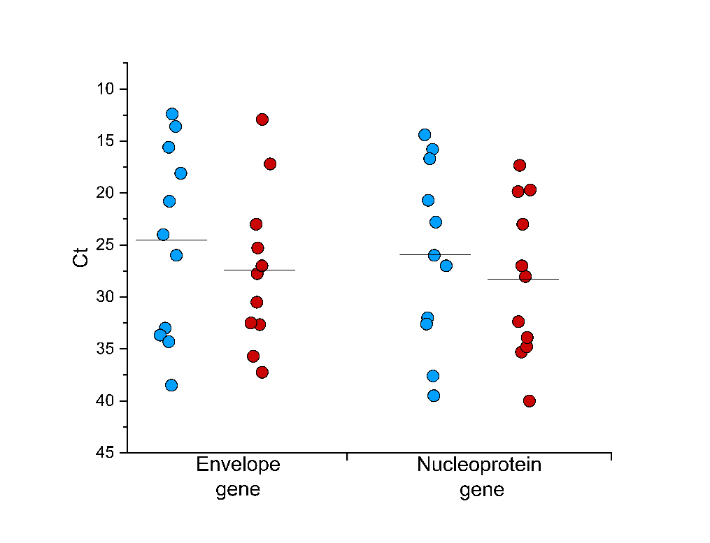
Supplemental Figure 1. Viral loads of recruited patients.
SARS-CoV2 infection of recruited subjects was confirmed by routine diagnostic PCR amplification of Envelope and Nucleoprotein viral genes from nasopharyngeal swabs. Cycle thresholds (Ct) are shown in blue dots for 11 vaccinated patients and red dots for 11 unvaccinated patients.

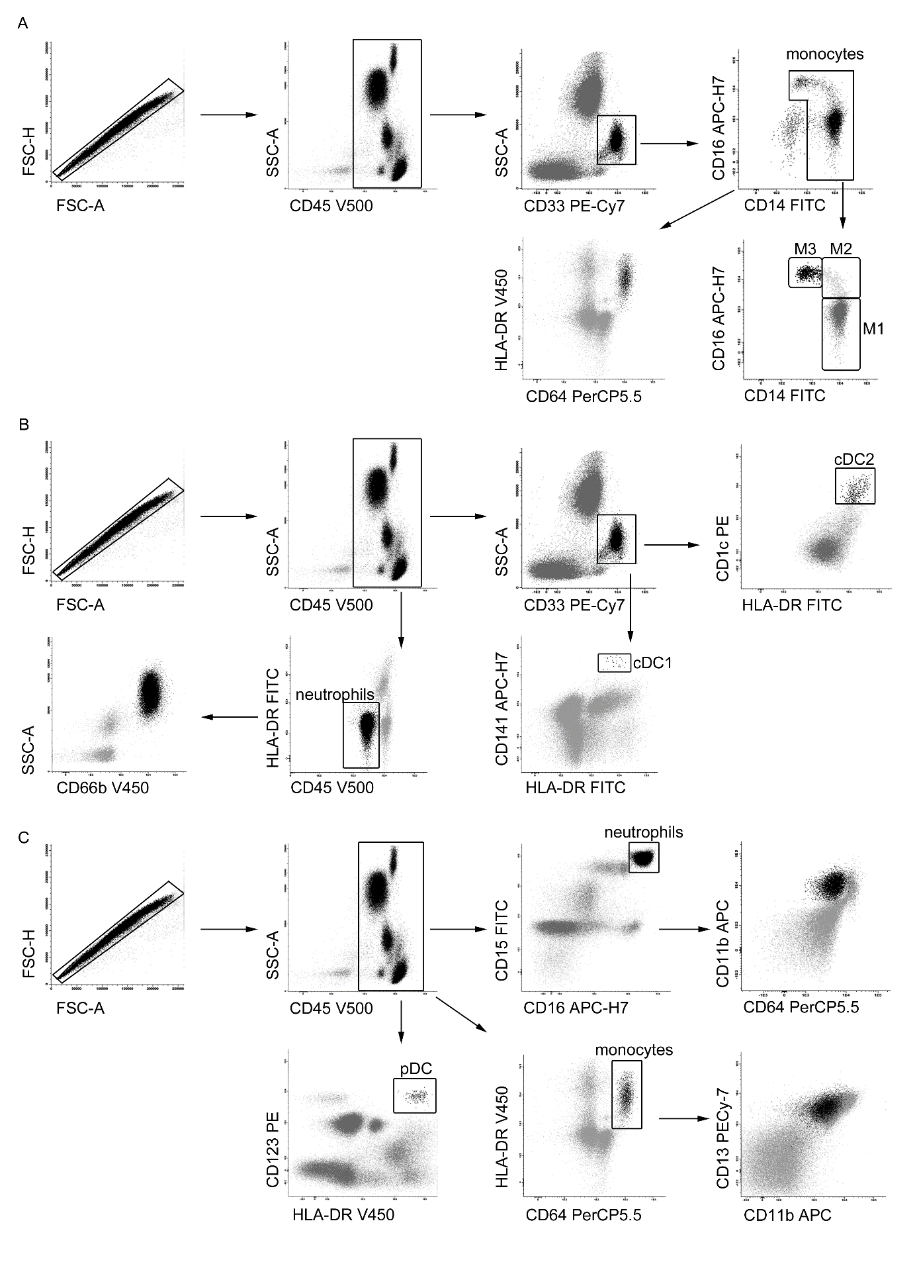
Supplemental Figure 2. Gating strategy for myeloid cells identification.
Whole blood cells were gated using physical parameters (FSC, SSC) and CD45 surface marker. (A) Monocytes were isolated from CD33+ cells as CD14+CD16+ cells. Then, they were gated basing on the expression of activation markers CD64 and HLA-DR and, in parallel, identified as CD14++(M1), CD14+CD16+ (M2) and CD16++ (M3). (B) Dendritic cells were identified through physical parameter SSC and expression of CD33, then gated into CD1c+ (cDC2) and CD141+ (cDC1). Neutrophils were identified as HLA-DR negative-CD45 dim, and then analyzed for CD66b expression. (C) Plasmacytoid Dendritic cells were isolated from CD45+ cells as CD123+ HLA-DR+ cells. Neutrophils were gated from CD45+ cells into CD15++ CD16++ cells and marked by expression of activation markers CD11b, CD64. Monocytes were identified as HLA-DR+ CD64+ and then characterized for CD13 and CD11b expression.

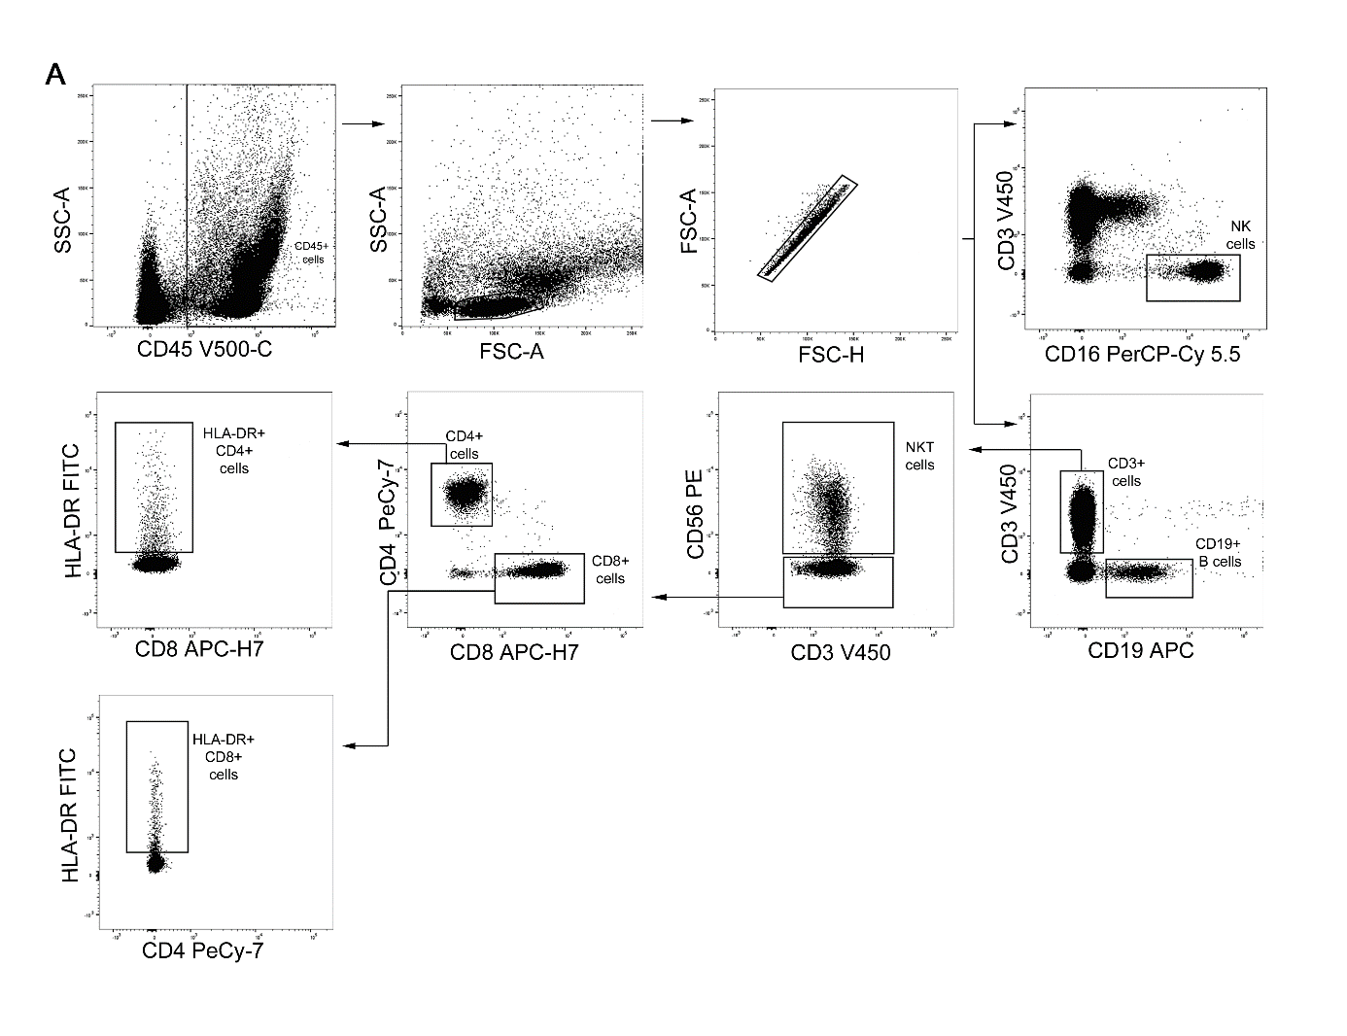
Supplemental Figure 3. Gating strategy for lymphoid cell subsets immunophenotyping.
(A) PBMCs were gated based on physical parameter SSC and CD45 surface expression, lymphocytes were then gated basing on physical parameters (SSC, FSC). Doublets were removed using FSC-A and FSC-A parameters. NK cells were isolated by CD16 expression. B cells were identified as CD19+ and T cells as CD3+. Within these, CD3+CD56+ cells were identified as NKT. We then identified CD4+ and CD8+ T cells. Among these, we identified HLA-DR expressing cells.

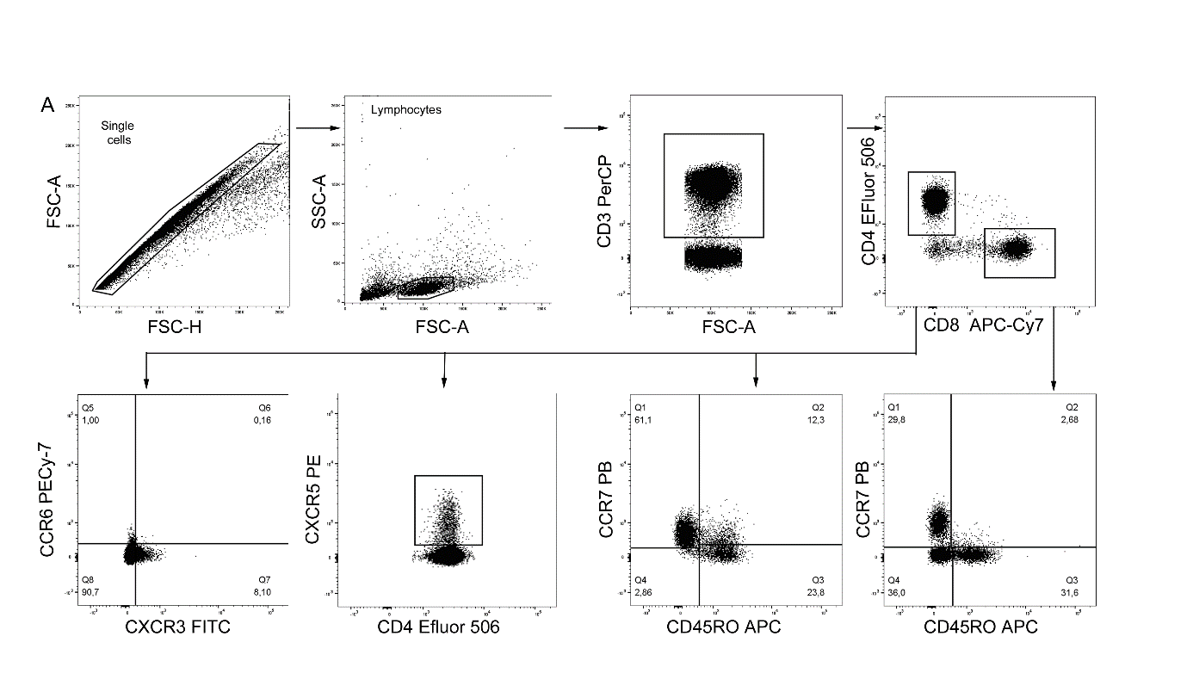

Supplemental Figure 4. Gating strategy for the identification of naive and memory T cell subsets, and T follicular helper subset.
(A) Doublets were removed using FSC-A and FSC-A parameters and lymphocytes were gated based on physical parameters (FSC-SSC). T cells were identified as CD3+. We then identified CD4+ and CD8+ T cells. Among these, we identified naive (CD45RO-CCR7+), effector memory (CD45RO+CCR7-), central memory (CD45RO+CCR7+), TEMRA (CD45RO-CCR7-). Among CD4+ T cells, we identified CXCR3+CCR6-, CXCR3+CCR6+, CXCR3+CCR6-, CXCR3-CCR6- and CXCR5+ T follicular helper cells.

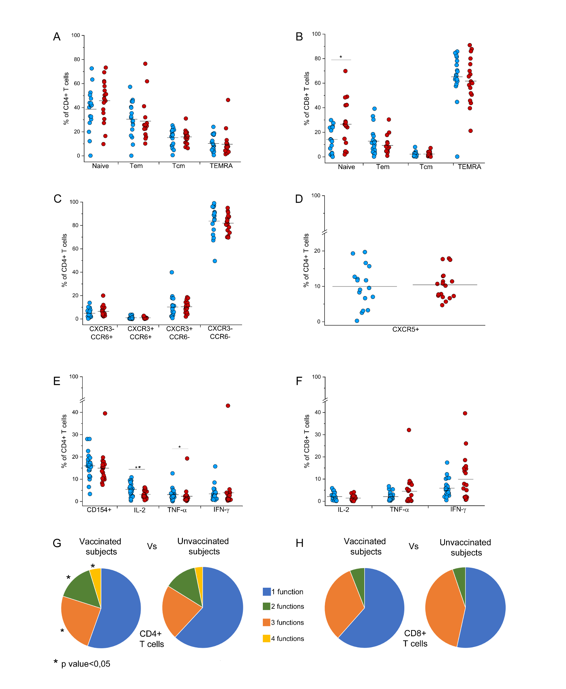

Supplemental Figure 5. Identification of CD4+ and CD8+ naive and memory T cell subsets, and T follicular helper subset.
(A) Frequency of naive (CD45RO-CCR7+), effector memory (CD45RO+CCR7-), central memory (CD45RO+CCR7+), TEMRA (CD45RO-CCR7-) among CD4+ T cells in 17 vaccinated (blue dots) and 18 unvaccinated (red dots) COVID-19 patients.(B) Frequency of naive (CD45RO-CCR7+), effector memory (CD45RO+CCR7-), central memory (CD45RO+CCR7+), TEMRA (CD45RO-CCR7-) among CD8+ T cells in vaccinated (blue dots) and unvaccinated (red dots) COVID-19 patients requiring hospitalization.(C) Frequency of CXCR3+CCR6-, CXCR3+CCR6+, CXCR3+CCR6-,CXCR3-CCR6- among CD4+ T cells in vaccinated (blue dots) and unvaccinated (red dots) COVID-19 patients requiring hospitalization.(D) Frequency of CXCR5+ T follicular helper cells among CD4+ T cells in vaccinated (blue dots) and unvaccinated (red dots) COVID-19 patients. (E) Frequency of CD154+, IL-2, TNF-α and IFN-γ producing cells among CD4+ T cells in vaccinated (blue dots) and unvaccinated (red dots) COVID-19 patients requiring hospitalization. (F) Frequency of IL-2, TNF-α and IFN-γ producing cells among CD8+ T cells in vaccinated (blue dots) and unvaccinated (red dots) COVID-19 patients requiring hospitalization. (G) Characterization CD4+ T cell polyfunctionality in vaccinated and unvaccinated COVID-19 patients. Results are shown as mean percentages from 26 vaccinated and 22 unvaccinated COVID-19 patients requiring hospitalization. (H) Characterization CD8+ T cell polyfunctionality in vaccinated and unvaccinated COVID-19 patients. Results are shown as mean percentages from 26 vaccinated and 22 unvaccinated COVID-19 patients requiring hospitalization. *P<0,05 **P>0,005 ***P<0,0005 calculated with Mann-Whitney U test.
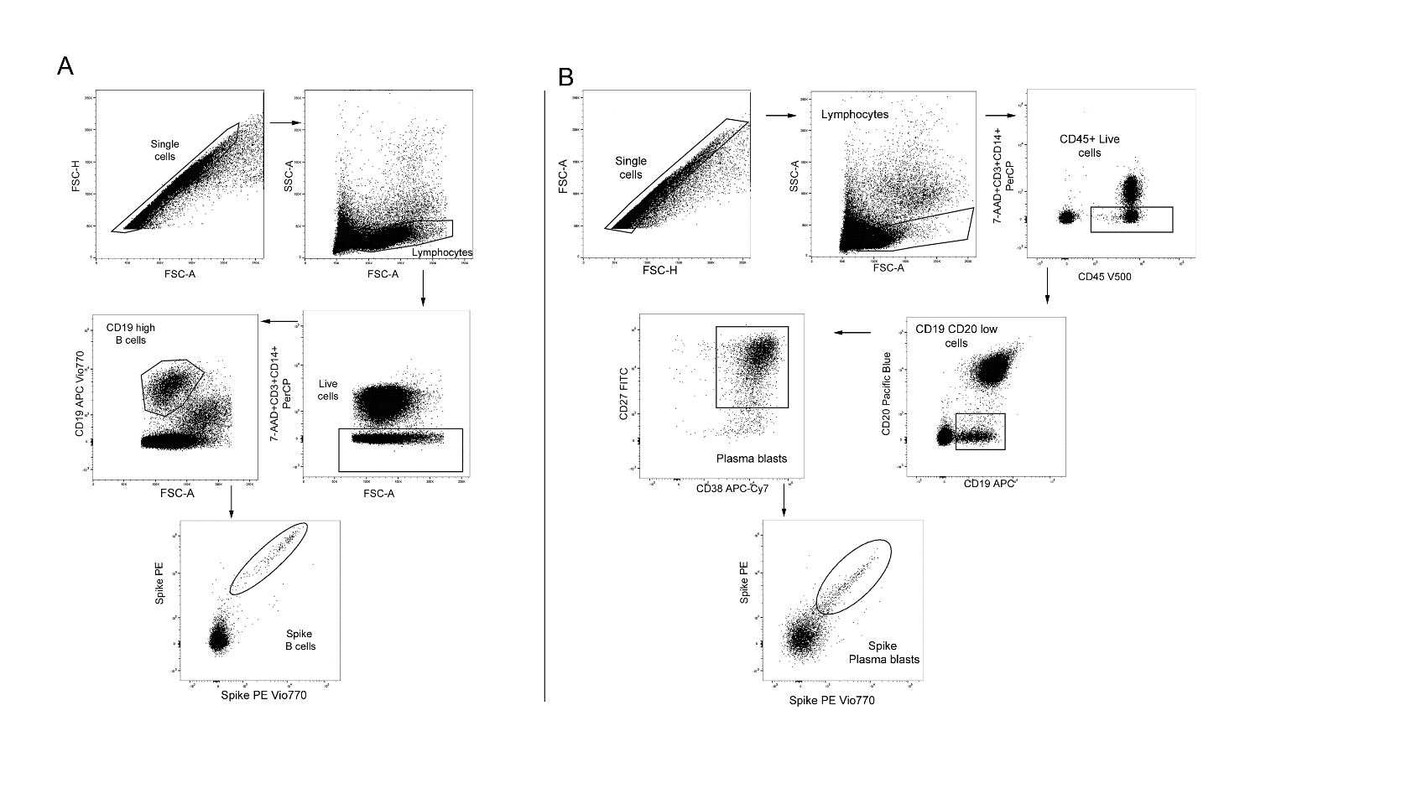
Supplemental Figure 6. Gating strategy for the identification of Spike specific B cells (A) and Plasma blasts (B).
Supplemental Figure 7. Gating strategy for the identification of polyclonal (A) and SARS-CoV2 specific (B) T cells. (A) Doublets were removed using FSC-A and FSC-A parameters and lymphocytes were gated based on physical parameters (FSC-SSC). Dead cells were excluded using viability stain 780. T cells were identified as CD3+. We then identified CD4+ T cells. Among these, we identified CD154 expressing cells. CD4+CD154+ T cells were then evaluated for IFN-γ, TNF-α and IL-2 expression. (B) Doublets were removed using FSC-A and FSC-A parameters and lymphocytes were gated based on physical parameters (FSC-SSC). Dead cells were excluded using viability stain 780. T cells were identified as CD3+. We then identified CD4+ and CD8+ T cells. CD4+ T cells were evaluated for CD154, IFN-γ, TNF-α and IL-2 expression. CD8+ T cells were evaluated for IFN-γ, TNF-α and IL-2 expression.
(A) Doublets were removed using FSC-A and FSC-A parameters and lymphocytes were gated based on physical parameters (FSC-SSC). PerCP was used as dump channel for the exclusion of dead cells (7AAD), CD3+ T cells and CD14 monocytes. B cells were identified as CD19+ high. B cells binding PE- and PE Vio770-conjugated spike protein were then identified as spike-specific. (B) Doublets were removed using FSC-A and FSC-A parameters and lymphocytes were gated based on physical parameters (FSC-SSC). PerCP was used as dump channel for the exclusion of dead cells (7AAD), CD3+ T cells and CD14 monocytes. Plasma blasts were first identified as CD19+ low, then further gated into CD27+CD38+ cells. Plasma blasts binding PE- and PE Vio770-conjugated spike protein were then identified as spike-specific.

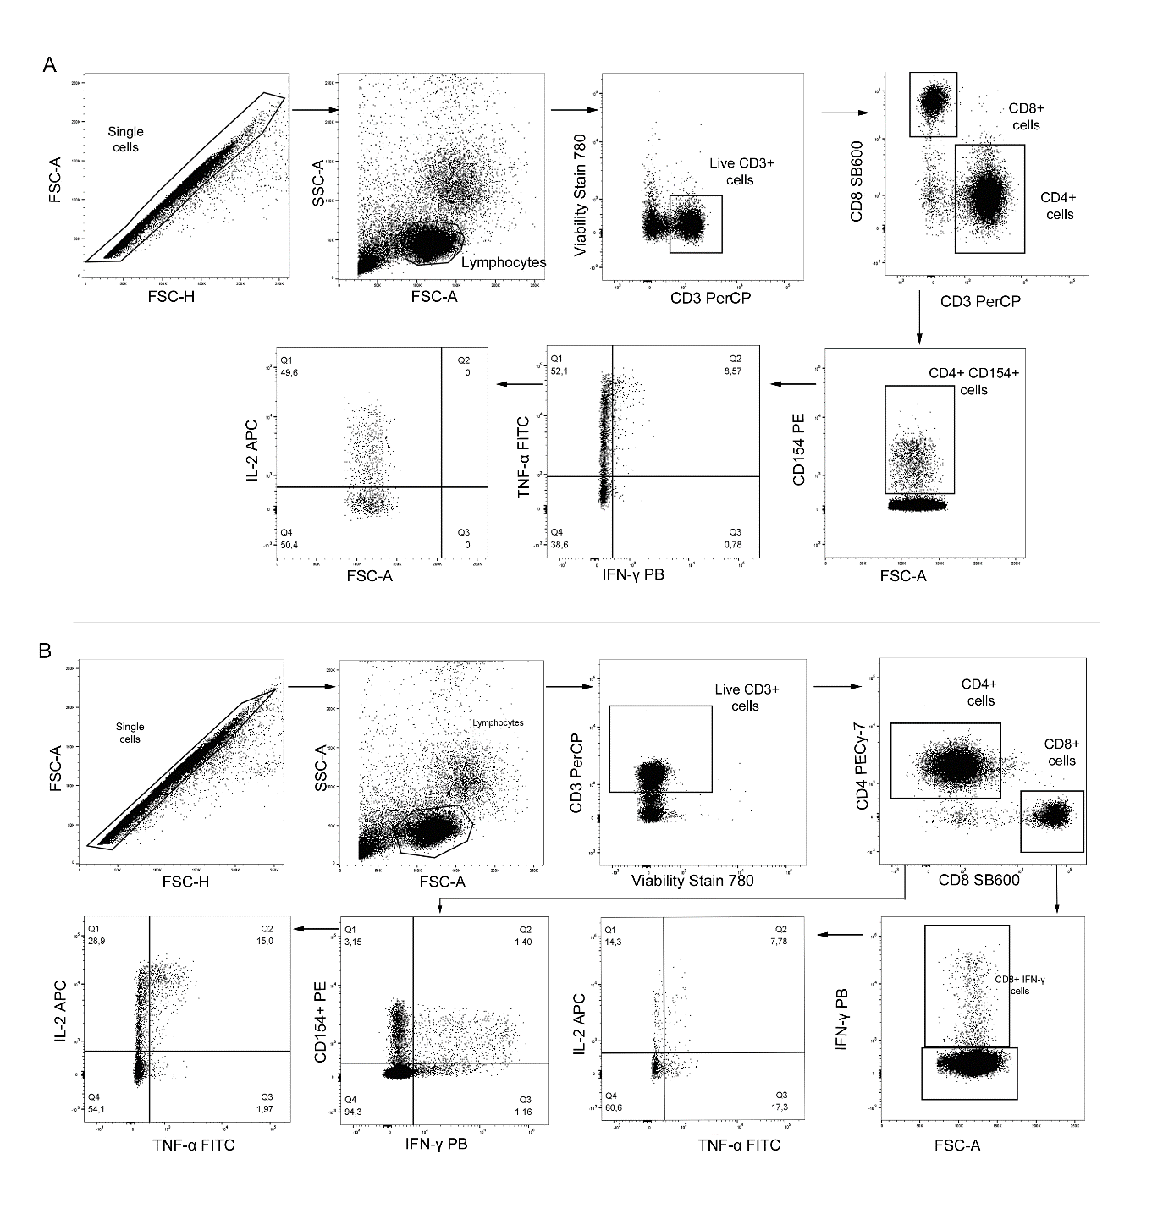Supplemental Figure 7. Gating strategy for the identification of polyclonal (panel A) and SARS-CoV-2 specific (panel B) T cells.
(A) Doublets were removed using FSC-A and FSC-A parameters and lymphocytes were gated based on physical parameters (FSC-SSC). Dead cells were excluded using viability stain 780. T cells were identified as CD3+. We then identified CD4+ T cells. Among these, we identified CD154 expressing cells. CD4+CD154+ T cells were then evaluated for IFN-γ, TNF-α and IL-2 expression. (B) Doublets were removed using FSC-A and FSC-A parameters and lymphocytes were gated based on physical parameters (FSC-SSC). Dead cells were excluded using viability stain 780. T cells were identified as CD3+. We then identified CD4+ and CD8+ T cells. CD4+ T cells were evaluated for CD154, IFN-γ, TNF-α and IL-2 expression. CD8+ T cells were evaluated for IFN-γ, TNF-α and IL-2 expression.

