Supplementary Figure 1: Responding centres
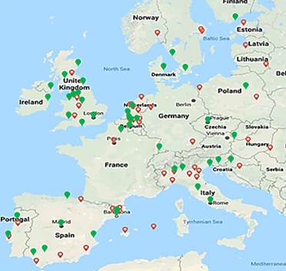
Contacted sites Response sites

Supplementary Figure 2: Distance to adult care service.

Supplementary Figure 3: Difficulties in identifying adult centre for transfer of care

Supplementary Figure 4: (a)Number of paediatric patients treated at centres transferring more or less than 10 patients per year (b) and number of patients aged twelve to eighteen treated at centres transferring more or less than 10 patients per year.

