Supplementary Information

Effect of silver-graphene oxide-cobalt oxide nanocomposite on cytotoxic levels in MRC-5 and HepG2 cell lines and molecular docking studies
Rahsan Ilikci-Sagkan¹, Erman Salih Istifli², Recep Liman³, Keziban Atacan⁴, Salih Zeki Bas⁵, Mustafa Ozmen⁵
¹ Uşak University, School of Medicine, Department of Medical Biology, 64300, Uşak, Turkey
² Çukurova University, Faculty of Science and Literature, Department of Biology, 01330, Adana, Turkey
³ Uşak University, Faculty of Engineering and Natural Sciences, Molecular Biology and Genetics Department, 64300, Uşak, Turkey
⁴ Sakarya University of Applied Sciences, Faculty of Technology, Department of Engineering Fundamental Sciences, 54050, Sakarya, Turkey
⁵ Selçuk University, Faculty of Science, Chemistry Department, 42250, Konya, Turkey

*Corresponding Author
Prof. Dr. Mustafa Ozmen
Selçuk University, Faculty of Science, Department of Chemistry, 42250, Konya, Türkiye.
E-mail: musozmen@gmail.com
Tel: 0090 332 223 38 93
Fax: 0090 332 241 24 99

Reagents and Materials

Cobalt (II) nitrate hexahydrate (Co(NO₃)₂.6H₂O), NaOH, NH₄OH, AgNO₃ and NaBH₄ were purchased from Merck (Germany). Graphite, H₂SO₄ (95.0-97.0%), P₂O₅, K₂S₂O₈ and KMnO₄ were provided from Sigma-Aldrich (USA). All materials and solutions used for analysis were washed and prepared using distilled water (Mikrotest, Ankara, Turkey).
Preparation of Nanomaterials
Firstly, the graphene oxide (GO) was prepared from graphite powder via the modified Hummers’ method [S1]. 5 g of graphite was preoxidized with 8 mL H₂SO₄, 3 g of K₂S₂O₄, and 2.5 g of P₂O₅ at 80 °C for 2 h. Then, 120 mL H₂SO₄ and 17 g of KMnO₄ were added to continue oxidation [S2]. Subsequently, the graphite oxide was exfoliated to GO via sonication for 30 min. Co₃O₄ NPs were prepared according to the procedure of Shao et al. [S3]. 2.8 g of cobalt nitrate hexahydrate was dissolved in 30 mL water under stirring at 200 rpm. Then, 60 mL of NaOH (0.33 M) and 8 mL of ammonia solution were added. The solution was placed in a stainless steel autoclave and heated at 120 °C for 12 h. Subsequently, the mixture was centrifuged, washed, and dried at 70 °C. The dried Co₃O₄ NPs were annealed at 450 °C for 3 h.
For the preparation of GO-Co₃O₄ nanocomposite, 50 mg GO was dispersed into 20 mL deionized water under sonication for 1 h. Then, 100 mg of Co₃O₄ NPs were dispersed into 20 mL deionized water for 15 min, and were added into GO suspension. The mixture was sonicated for 30 min and transferred into an autoclave for hydrothermal treatment at 180 °C for 24 h [S4]. The resultant product was separated by centrifugation and washed with deionized water, and dried in an oven at 60 °C for 12 h.
For the synthesis of Ag NPs, a stoichiometric amount of sodium borohydride was incrementally introduced into an aqueous solution of silver nitrate with a concentration of 0.05 M. This addition was carried out gradually while stirring continuously at ambient temperature, resulting in the formation of a precipitate. Following the full addition of sodium borohydride, stirring was sustained for an additional duration of 10 minutes. Finally, a certain amount of GO-Co₃O₄ was dispersed in deionized water under ultrasonication for 10 minutes to obtain the Ag-GO-Co₃O₄ nanocomposite. Then, dispersed Ag nanoparticles were added dropwise into this suspension. The solution was centrifuged at 5000 rpm for 5 min to separate the resulting Ag-GO-Co₃O₄ nanoparticles from the solution and centrifuged twice with deionized water and ethanol, then dried for 24 h at 70 °C.
S1. N.I. Kovtyukhova, Chemistry of Materials 11 (1999) 771–778.
S2. K. Atacan, Journal of Alloys and Compounds 791 (2019) 391-401.
S3. H. Shao, X. Zhao, Y. Wang, R. Mao, Y. Wang, M. Qiao, S. Zhao and Y. Zhu, Applied Catalysis B: Environmental 218 (2017) 810-818.
S4. Kolsoum Pourzare, Saeed Farhadi and Yaghoub Mansourpanah, Acta Chimica Slovenica 64 (2017) 945-958.

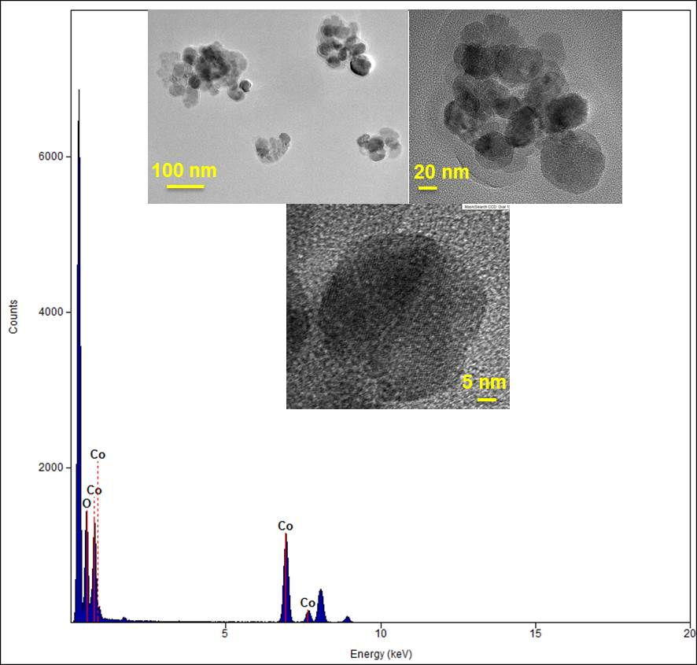
Figure S1 EDX spectrum and TEM images of Co₃O₄.

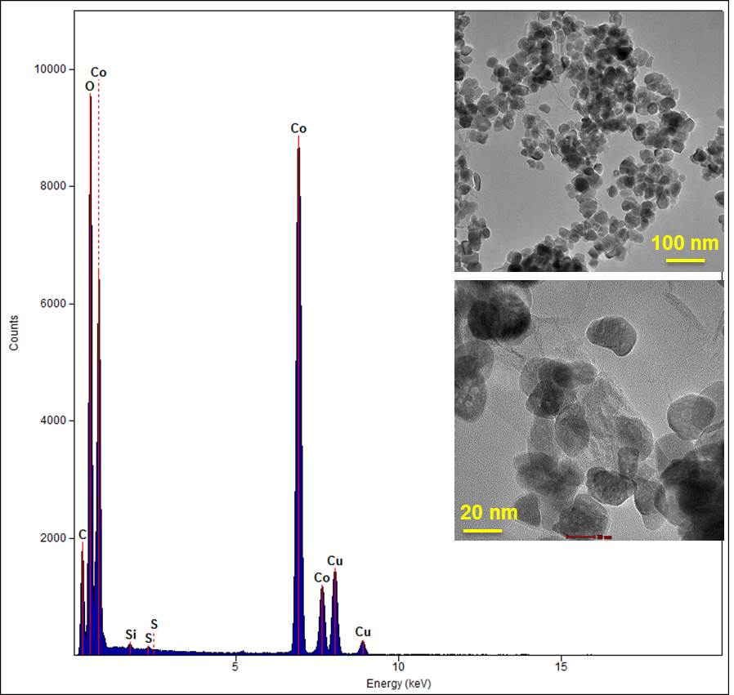

Figure S2 EDX spectrum and TEM images of GO-Co₃O₄.

Corresponding author. E-mail address: musozmen@gmail.com (M. Ozmen).

