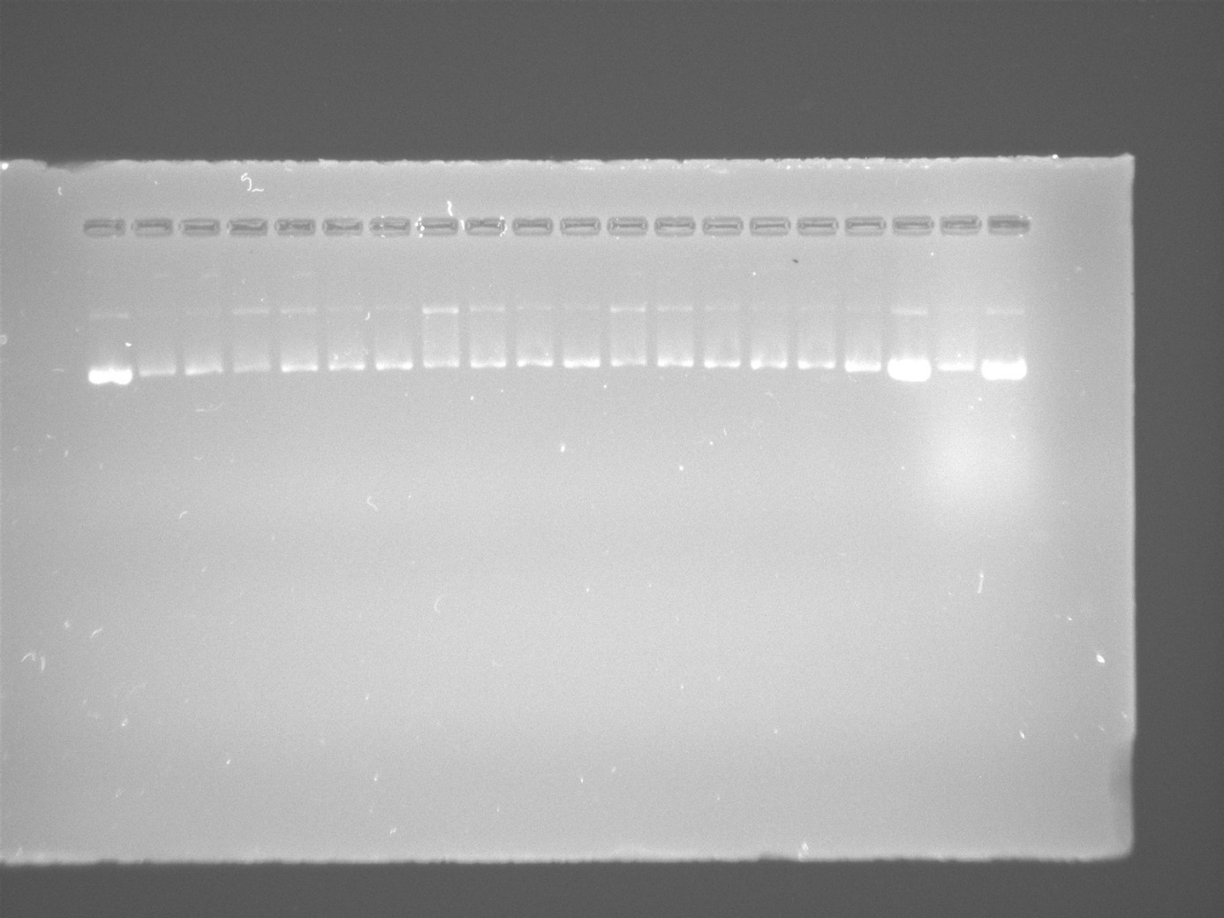
Fig. S1. Electropherograms were applied to the interaction of pBR322 plasmid DNA with decreasing concentrations (250, 125, 62.5, and 31.25 µg/mL) of Ag₂S (Line 4-7), Gemcitabine (Line 8-11), Ag₂S-Gemcitabine combination (Line 12-15), and 5-FU (Line 16). Line 1-2-17-18-19-20 represented untreated plasmid DNA at different concentrations to use as a control. Line 3 contains plasmid DNA treated with 0.9% physiological serum (to determine if there is any interaction with DNA since Gemcitabine is dissolved in 0.9% physiological serum).
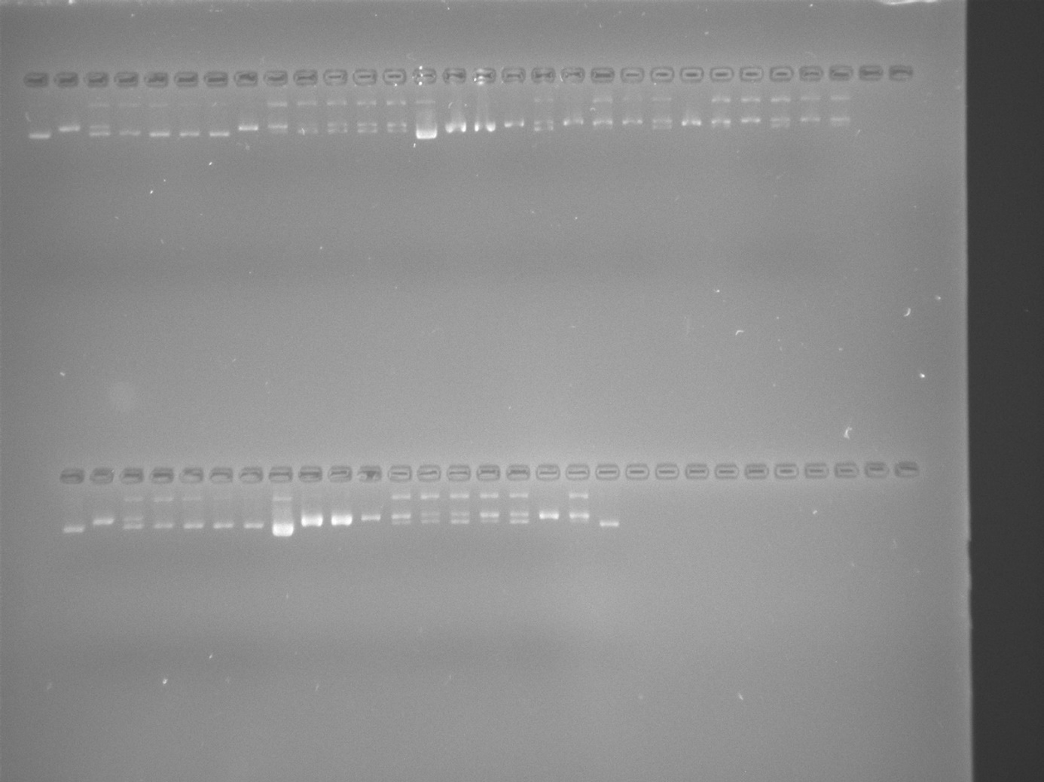
Fig. S2. An electrophoretogram was applied to incubated mixtures of plasmid DNA and Ag₂S or Gemcitabine, followed by digestion with BamHI or HindIII. Lane 1: untreated and undigested plasmid DNA. Line 2: untreated plasmid DNA digested with BamHI, Line 3: plasmid DNA treated with 0.9% physiological serum and digested with BamHI. Line 4-7: BamHI digestions of plasmid DNA treated with decreasing concentrations of Ag₂S (250, 125, 62.5, and 31.25 µg/mL). Line 8: untreated plasmid DNA digested with HindIII. Line 9: plasmid DNA treated with 0.9% physiological serum and digested with HindIII. Line 10-13: HindIII digestions of plasmid DNA treated with decreasing concentrations of Ag₂S (250, 125, 62.5, and 31.25 µg/mL). Line 14: untreated and undigested plasmid DNA. Line 15: untreated plasmid DNA digested with BamHI and Line 16: untreated plasmid DNA digested with HindIII. Line 17: untreated plasmid DNA digested with BamHI. Line 18: plasmid DNA treated with 0.9% physiological serum and digested with BamHI. Line 19-22: BamHI digestions of plasmid DNA treated with decreasing concentrations of Gemcitabine (250, 125, 62.5, and 31.25 µg/mL). Line 23: untreated plasmid DNA digested with HindIII, Line 24: plasmid DNA treated with 0.9% physiological serum and digested with HindIII. Line 25-28: HindIII digestions of plasmid DNA treated with decreasing concentrations of Gemcitabine (250, 125, 62.5, and 31.25 µg/mL).

Line 1: untreated and undigested plasmid DNA. Line 2: untreated plasmid DNA digested with BamHI, Line 3: plasmid DNA treated with 0.9% physiological serum and digested with BamHI. Line 4-7: BamHI digestions of plasmid DNA treated with decreasing concentrations of Ag₂S-Gemcitabine combination (250, 125, 62.5, and 31.25 µg/mL). Line 8: untreated and undigested plasmid DNA. Line 9: untreated plasmid DNA digested with BamHI and Line 10: untreated plasmid DNA digested with HindIII. Line 11: untreated plasmid DNA digested with HindIII. Line 12: plasmid DNA treated with 0.9% physiological serum and digested with HindIII. Line 13-16: HindIII digestions of plasmid DNA treated with decreasing concentrations of Ag₂S-Gemcitabine combination (250, 125, 62.5, and 31.25 µg/mL). Line 17: BamHI digestions of plasmid DNA treated with 5-FU. Line 18: HindIII digestions of plasmid DNA treated with 5-FU. Line 19: untreated and undigested plasmid DNA.

Note: Since Gemcitabine was initially dissolved in 0.9% physiological serum, Ag₂S nanoparticles were also prepared by dissolving in 0.9% physiological serum. Therefore, the experimental set of treated plasmid DNA with 0.9% physiological serum was included as the control group. Due to the results showing that Ag₂S and Gemcitabine clearly interact with DNA, these control groups were not included in the processed result images added to the article to prevent confusion.

