Supplementary Information

Evaluation of the cytotoxicity and molecular docking properties of the green synthesis of Ag₂S nanoparticles

Emine Arslan¹, Busra Ozcay Eksi¹, Erman Salih Istifli², Keziban Atacan³, Salih Zeki Bas⁴, Mustafa Ozmen^{4,}

¹Selçuk University, Science Faculty, Department of Biology, 42250, Konya, Türkiye
²Çukurova University, Faculty of Science and Literature, Department of Biology, 01330, Adana, Türkiye
³Sakarya University of Applied Sciences, Faculty of Technology, Department of Engineering Fundamental Sciences, 54050, Sakarya, Türkiye.
⁴Selçuk University, Science Faculty, Department of Chemistry, 42250, Konya, Türkiye

Reagents and apparatus
Sweet cherry (prunus avium L.) fruits were collected from the trees grown in Eşme district of Kocaeli (Türkiye) province and stored in the freezer at -20 °C until used. Silver nitrate (AgNO₃), sodium sulfide hydrate (Na₂S.xH₂O), and ethanol were obtained by Merck (Germany).
Ag₂S NPs were confirmed by XRD pattern Bruker D8 Discover diffractometer using Cu Kα irradiation between 2θ = 20° and 80°. The Fourier Transform Infrared Spectroscopy (FT-IR) was used for the structural characterization via a Bruker Fourier Transform Infrared FT-IR (ATR, USA). The Ag₂S NPs were characterized by scanning electron microscopy (SEM, Philips XL 30S FEG) equipped with an energy dispersive spectrum (EDX Dedector, EDAX). The morphology and structure of the ternary composite were characterized by a FEI TALOS F200S operating at a voltage of 200 keV with a transmission electron microscope (TEM) and high-resolution transmission electron microscopy (HR-TEM).
The green synthesis of Ag₂S NPs
The preparation of Ag₂S NPs was synthesized with a slight modification of the green synthesis method of Şimşir et al [S1]. Firstly, the seeds of sweet cherry fruits were removed and the fruits were crushed using a mechanical crusher. Then, the obtained mixture was first filtered through filter paper and then centrifuged to separate the solid particles. The obtained extract was used as a reducing agent. 500 mL of aqueous solution containing 0.1 M AgNO₃ was prepared. 10 mL of sweet cherry extract was added to the solution and stirred for 3 hours and then 0.2 M Na₂S.xH₂O was added and stirred for 12 hours at room temperature [S1]. Then, the mixture was centrifuged to separate Ag₂S from the medium and washed twice with distilled water and then with ethanol. Then, it was dried at 60 °C for 48 hours.

Fig. S1 The morphological changes of Ag₂S and Ag₂S + Gemcitabine on the PANC-1 cells in vitro at 24h, 48h, and 72h.
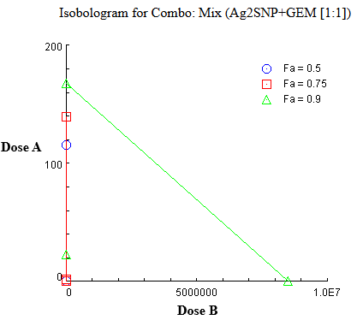
Fig. S2 Isobologram for Ag₂S and gemcitabine (GEM) combinations depicting synergistic cytotoxicity in PANC-1 cells at 72h treatment duration.

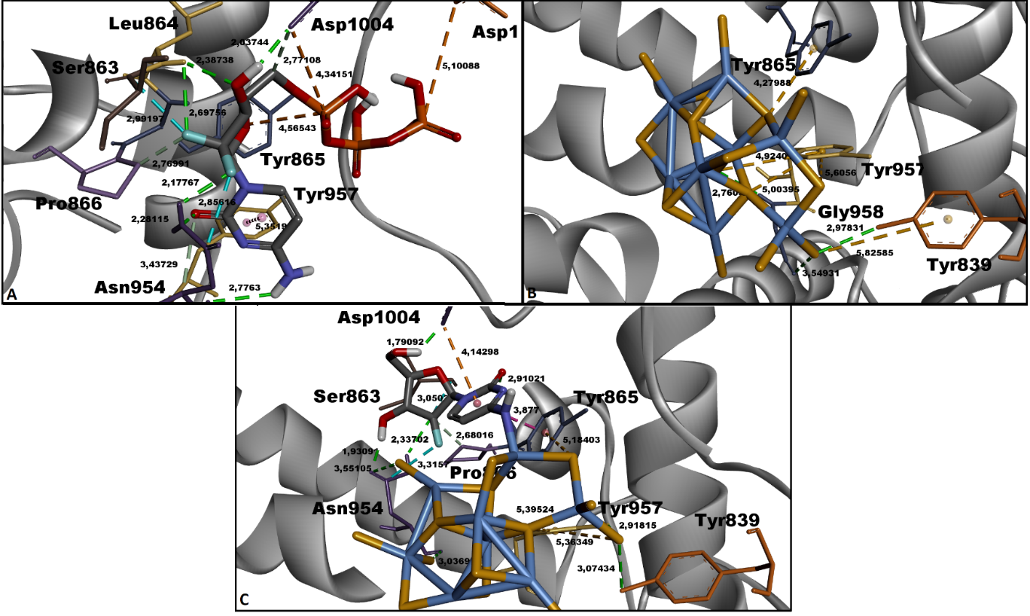
Fig. S3 Top-ranked conformations of the molecular complexes formed by GEM-TP, Ag₂S (nanoparticle), and Ag₂S—GEM ligands with human DNA polymerase alpha catalytic core (Pol α): A. GEM-TP—Pol α complex, B. Ag₂S—Pol α complex, C. Ag₂S-GEM—Pol α complex. The Pol α protein is represented in solid ribbon mode, while the ligands are depicted in stick mode. Green and light grey dashed lines represent hydrogen bonds, dark and light purple dashed lines represent hydrophobic contacts, cyan dashed lines represent halogen (fluorine) contacts, and light yellow dashed lines represent pi-sulfur interactions. 3D figure was prepared using the Discovery Studio Visualizer program.

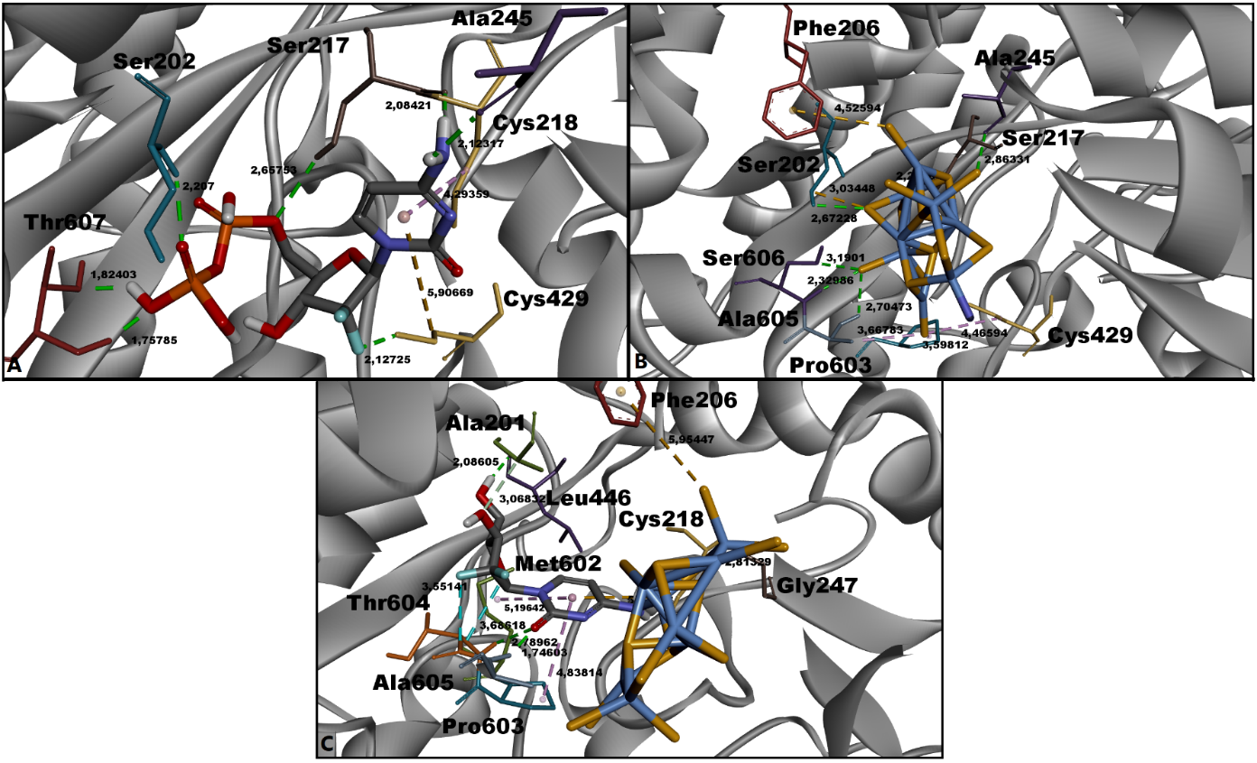
Fig. S4 Top-ranked conformations of the molecular complexes formed by GEM-DP, Ag₂S (nanoparticle), and Ag₂S-GEM ligands with human ribonucleotide reductase (RNR): A. GEM-DP—RNR complex, B. Ag₂S—RNR complex, C. Ag₂S-GEM—RNR complex. The RNR protein is represented in solid ribbon mode, while the ligands are depicted in stick mode. Green and light grey dashed lines represent hydrogen bonds, light purple dashed lines represent hydrophobic contacts, cyan dashed lines represent halogen (fluorine) contacts, and light yellow dashed lines represent pi-sulfur interactions. 3D figure was prepared using the Discovery Studio Visualizer program.

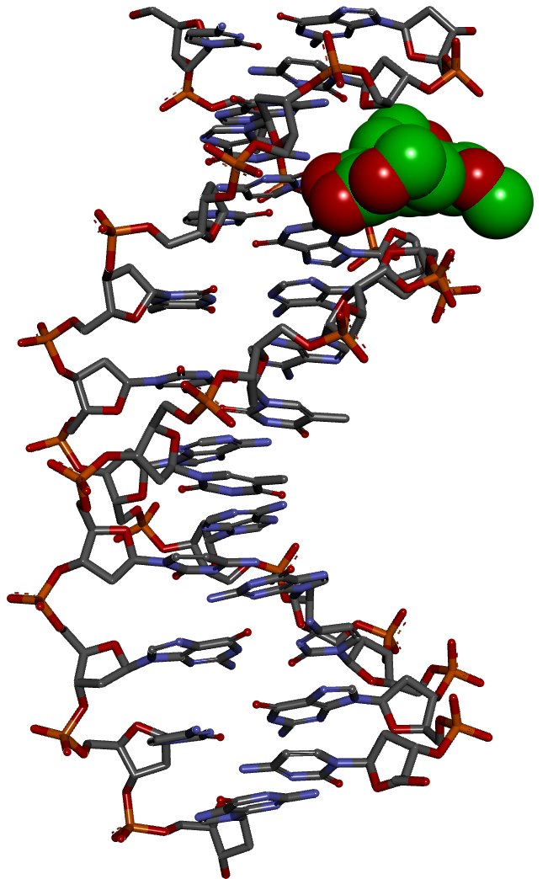
Fig. S5 Docking pose between aflatoxin (used as a positive control) and the 12-nucleotide double-stranded B-DNA dodecamer (PDB ID: 7rqt). The DNA receptor is rendered in stick mode, while the aflatoxin is depicted using the CPK (Corey-Pauling-Koltun) representation. The docking image was generated with DS Visualizer v16.

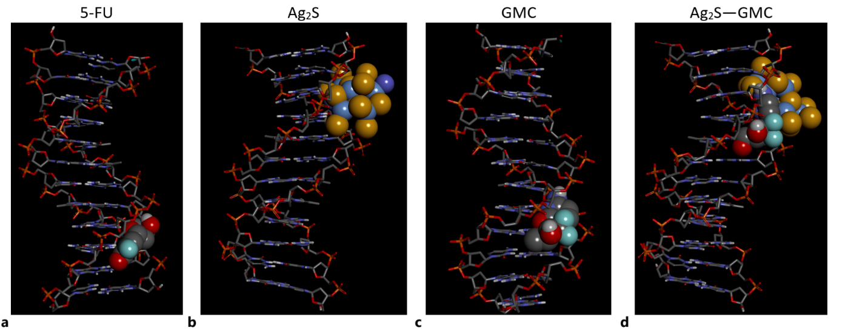Fig. S6 Molecular interactions of 5-Fluorouracil (5-FU), Ag₂S nanoparticle, gemcitabine (GEM), and the Ag₂S—GEM with the 12-nucleotide double-stranded B-DNA dodecamer (PDB ID: 7rqt). a. 5-FU-DNA interaction, b. Ag₂S-DNA interaction, c. GEM-DNA interaction, d. Ag₂S-GEM—DNA interaction. The DNA receptor is displayed in stick mode, while the ligands are represented in CPK (Corey-Pauling-Koltun) mode. The docking figures were generated using DS Visualizer v16.

Table S1 Binding free energy (kcal/mol) predicted by molecular docking for aflatoxin (AFL) used as a positive (reference) control against the 12-nucleotide double-stranded B-DNA dodecamer.
Compound | Molecular  weight  (g/mol) | Receptor | ΔG_{best}  (kcal/mol) | Binding mode | Binding sequence
AFL | 328.283 | B-DNA | -7.79 | Minor groove | 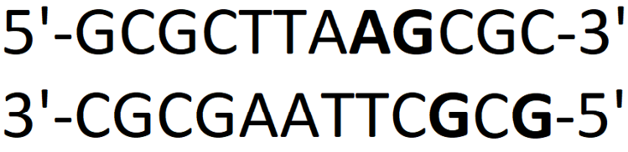
AFL: Aflatoxin (PubChem CID: 14421)
DNA: B-DNA dodecamer (PDB ID: 7rqt)
ΔG_{best}: Most favorable binding free energy (kcal/mol).

The aflatoxin (AFL, positive control) bound to B-DNA via the minor groove (Fig. S5), exhibiting a marked preference for G-enriched (bases shown in bold) regions (Table S1). AFL displayed a notably strong calculated binding affinity for B-DNA (ΔG = -7.79 kcal/mol), thereby confirming that the scoring function of AutoDock 4.2.6, employed in our docking studies, could accurately capture the DNA binding mode [S2] and relative affinity [S3] of this well-known genotoxic agent.

References
S1. A.B. Şimşir, K. Atacan, N. Güy, Green synthesis of Ag₂S nanoparticle from sweet cherry on ultrasound-assisted prepared NiMoO₄/g-C₃N₄ nanocomposite for photocatalytic H₂ production, Journal of Alloys and Compounds, 976 (2024) 172996.
S2. L. Ma, J. Wang, Y. Zhang, Probing the characterization of the interaction of aflatoxins B1 and G1 with calf thymus DNA in vitro, Toxins, 9 (2017) 209.
S3. C.G. Ricci, P.A. Netz, Docking studies on DNA-ligand interactions: building and application of a protocol to identify the binding mode, Journal of Chemical Information and Modeling, 49 (2009) 1925–1935.

Corresponding author at: Selçuk University, Science Faculty, Department of Chemistry, 42250, Konya, Türkiye E-mail address: musozmen@gmail.com(M. Ozmen)

