Supplementary Information
of
Biosynthesis of Crystalline Selenium Nanoparticles Using Rhizospheric Bacillus cereus from Mica-Rich Agricultural Soil
Saibal Ghosh^{1Δ}, Shouvik Mahanty^{2Δ}, Sristi Das³, Shreeya Purkait^{3,4}, Gopala Krishna Darbha², Raktim Pal¹*, Santanu Majumder⁵*
¹Department of Analytical Services, Tocklai Tea Research Institute, Tea Research Association, Jorhat 785008, Assam, India
²Environmental Nanoscience Laboratory, Department of Earth Sciences, Indian Institute of Science Education and Research Kolkata, Mohanpur 741246, Nadia, West Bengal, India
³Agricultural and Ecological Research Unit, Indian Statistical Institute, Giridih, 815301, Jharkhand, India
⁴School of Materials Science and Nanotechnology, Jadavpur University, Kolkata-700032, India
⁵School of Life and Environmental Sciences, Bournemouth University (Talbot Campus), Fern Barrow, Poole BH12 5BB, UK
^{Δ}Equal contributors
*Corresponding author: Dr Santanu Majumder, School of Life and Environmental Sciences, Bournemouth University (Talbot Campus), Fern Barrow, Poole BH12 5BB, UK.
Email: smajumder@bournemouth.ac.uk
Dr. Raktim Pal, Department of Analytical Services, Tocklai Tea Research Institute, Tea Research Association, Jorhat 785008, Assam, India.
Email: r.pal@tocklai.net
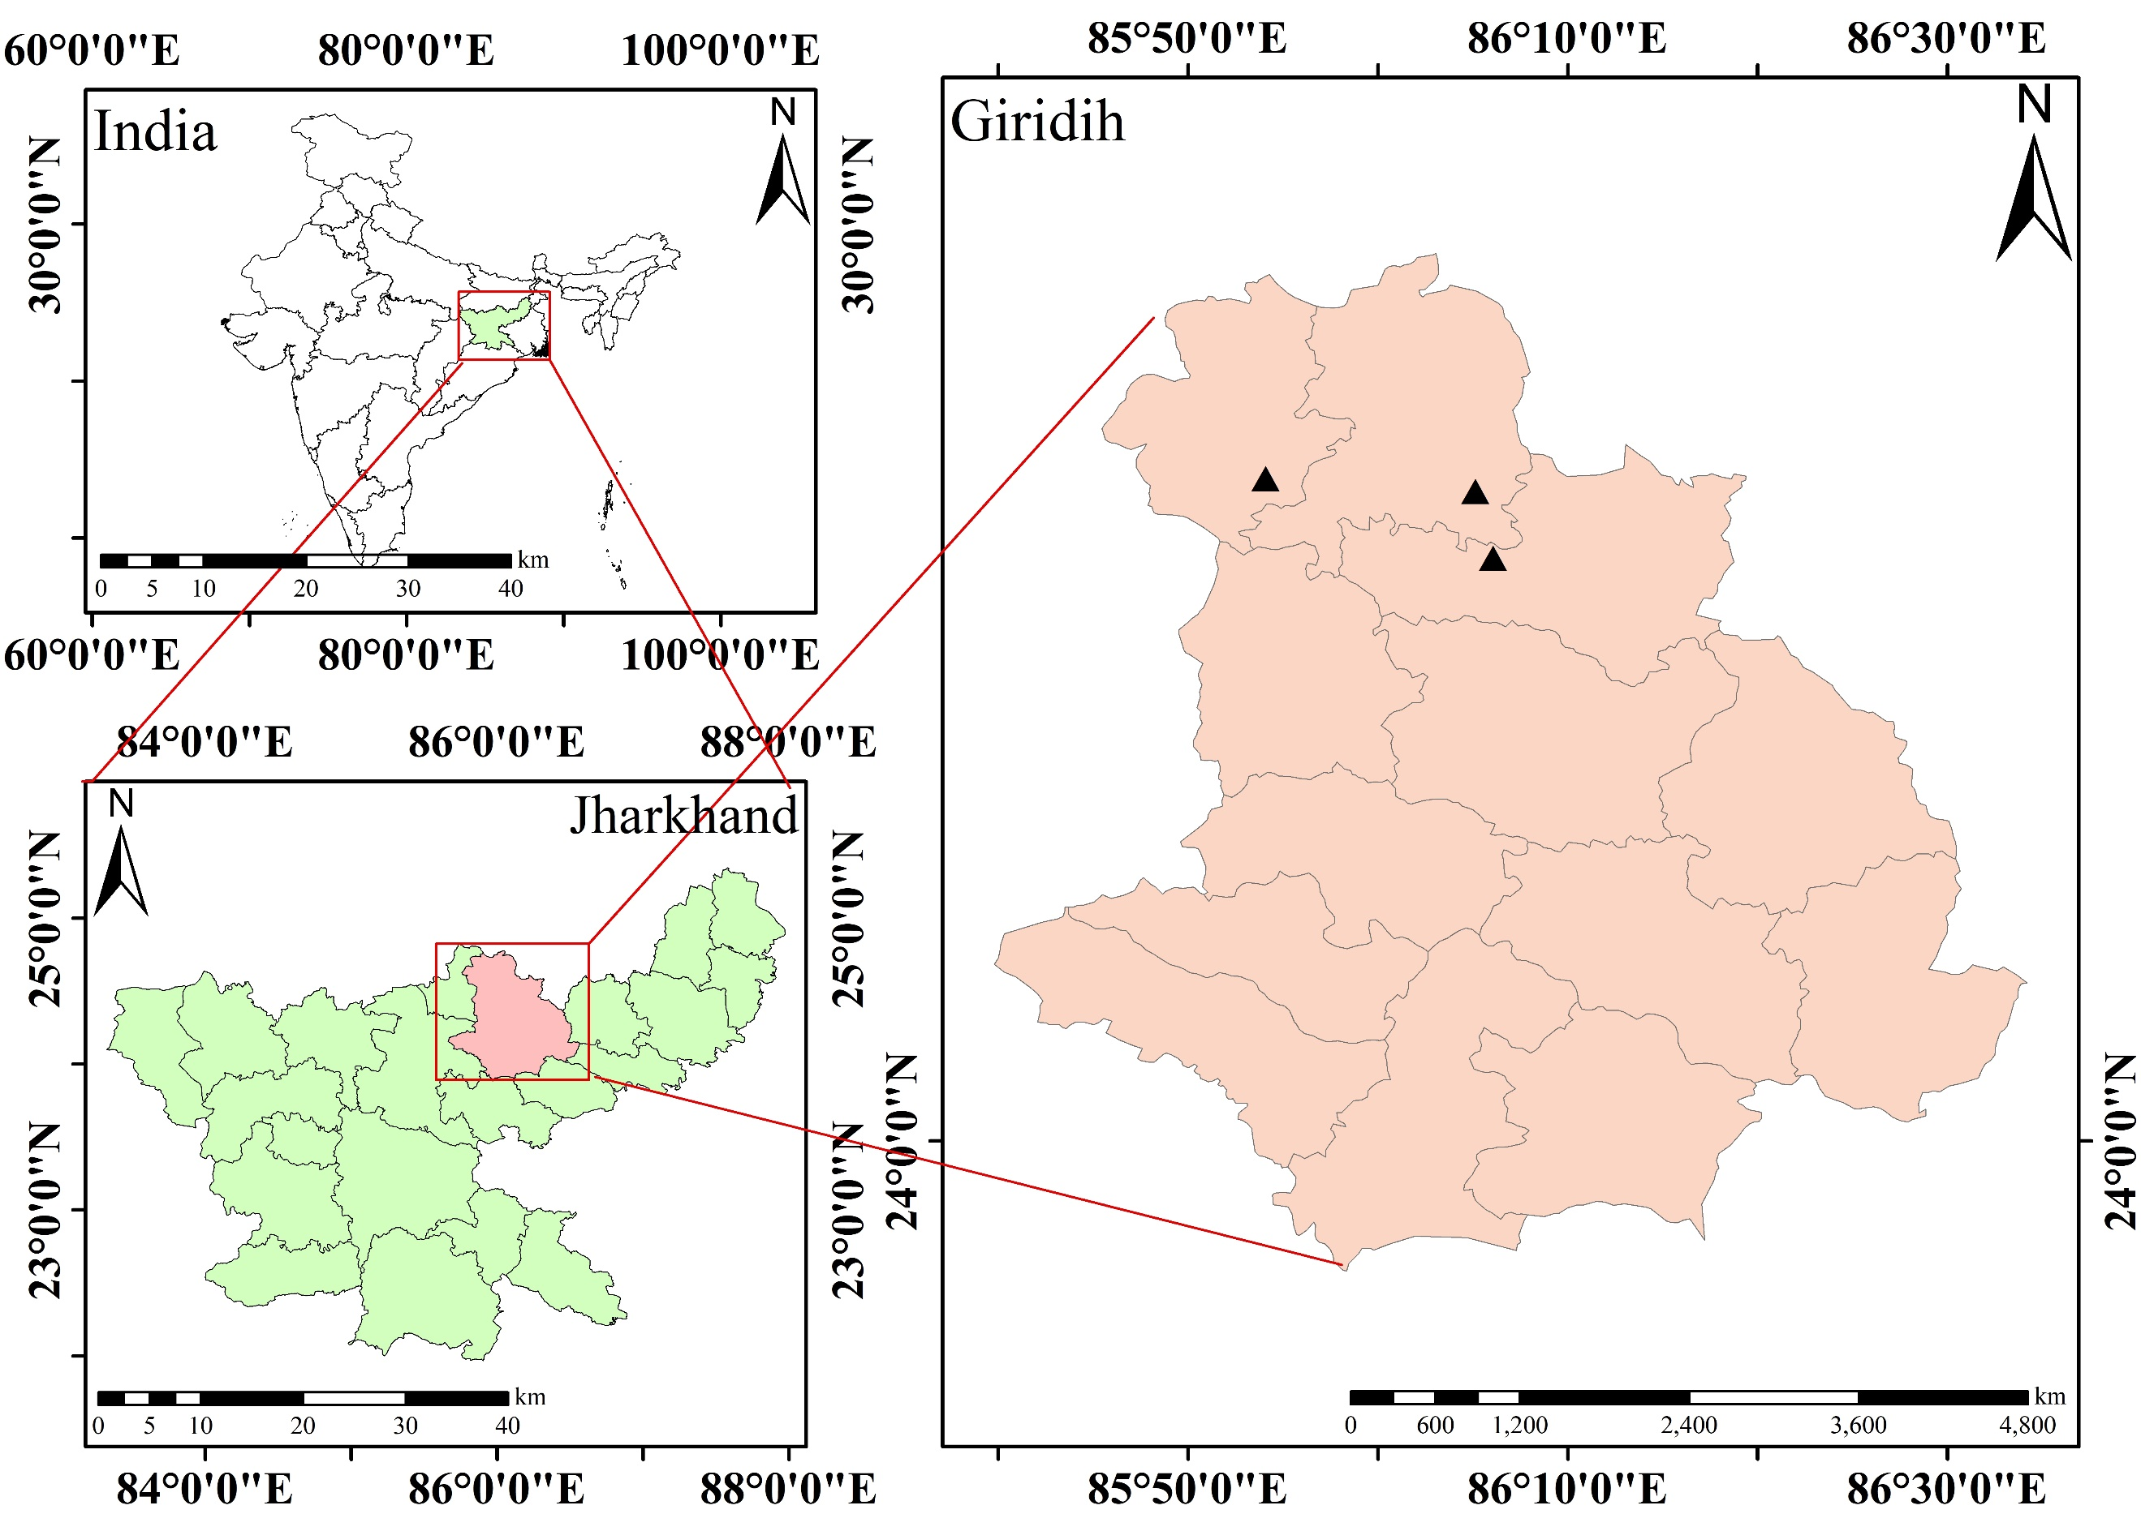
Fig. S1: Sampling locations of mica mines distributed across three blocks (Deori, Gawan, and Tisri) of Giridih district of Jharkhand, India.
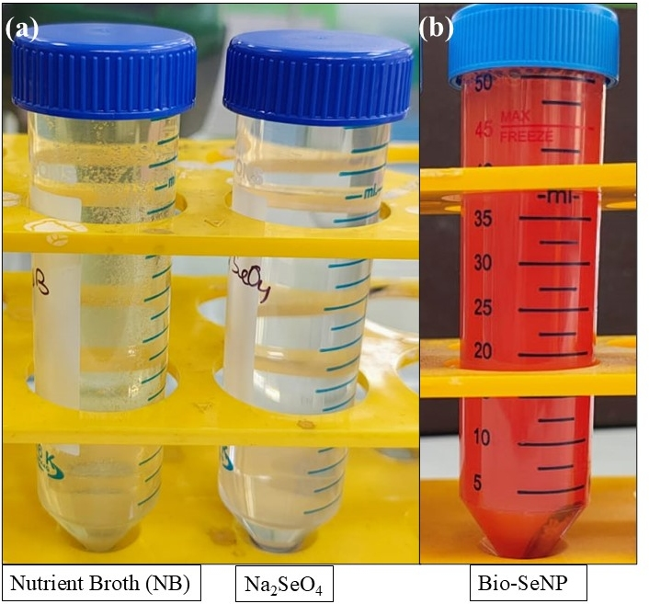
Fig. S2: Bacterial isolates of the strain Bacillus cereus showing color changes during the reaction with selenium salt solution over 48 hours of incubation: (a) positive and negative controls — nutrient broth without selenium salt and selenium salt without nutrient broth, respectively; and (b) appearance of red color due to the addition of nutrient broth with selenium salt and bacterial isolates.
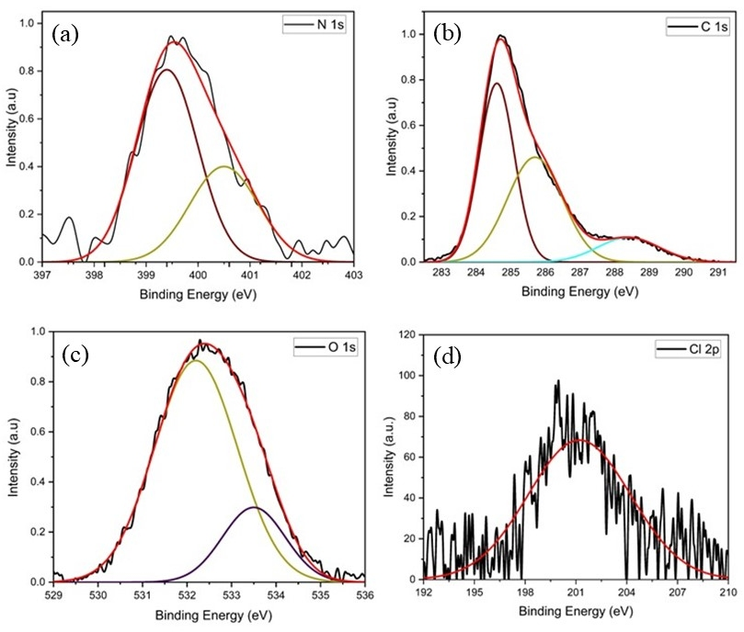
Fig S3. XPS high-resolution spectra of nitrogen (a: N 1s), carbon (b: C 1s), oxygen (c:O 1s), and (d: Cl 2p) from the purified SeNPs synthesized by bacterial isolate (Bacillus cereus).
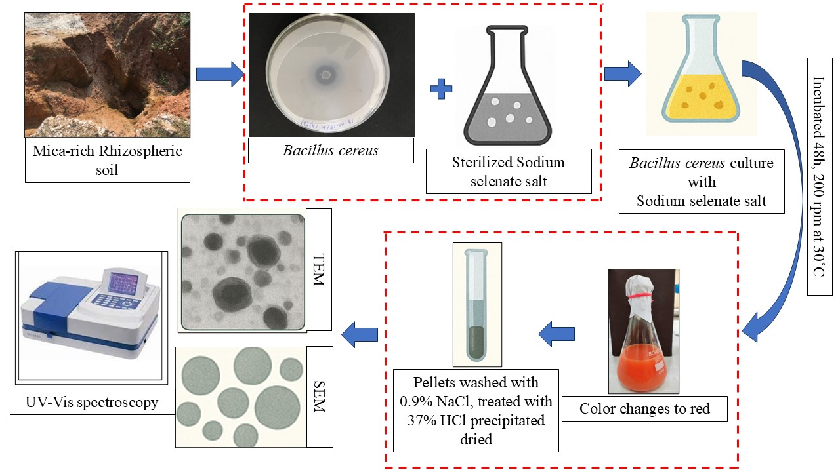
Fig. S4: Flow chart for the synthesis of bio-Selenium nanoparticles (Bio-SeNPs) using bacterial isolate (Bacillus cereus).

Table S1: Binding energies (eV) and assignment of XPS spectral bands of as-synthesized SeNPs synthesized by bacterial isolate (Bacillus cereus).

Element name | Binding Energy (eV) | Assignment
C 1s | 284.8 | C-C or C-H
C 1s | 285.7 | C-O or C-H
C 1s | 288.6 | C=O or O-C-C
O 1s | 532.2 | C=O
O 1s | 533.3 | C-O
N | 399.3 | Amine group
N | 400.5 | Protonated amine group
Cl 2p | 199.9 | 2p_{1/2}
Se 3d | 55.7 | 3d_{3/2}
Se 3d | 56.8 | 3d_{5/2}

