JavaScript packages used in Opal:

Visualization Tools
D3.js- A powerful tool that has been used for complex visualizations around the world and was featured on the New York Times website (https://www.nytimes.com/by/mike-bostock).
D3_shape.js - A component of D3 that allows for varied shapes of graph symbols.
D3_slider.js- A component of D3 that allows for a slider tool to manipulate visualization tools.
tensorflow_vis.js-neural network visualization tools

Machine Learning Tools
ML.js- includes decision tree ML, Logistic regression, unsupervised learning (k-means, PCA)
tensorflow.js- neural network tools

Customized tools built by the Opal team:
Imputation tools
Data preprocessing tools (see below)
ROC graphing tools
Lab fishbone graphing tools
Medication infusion and bolus parsing tools

Transformations by JavaScript | Transformations by PostgreSQL
Choosing which variable is the real invasive blood pressure between ART and ABP | Pivoting datasets so that time event is each row and each column has a different variable
Imputation of null values in the vitals | Grouping medications by name
Which anesthetic gas is being used defined by a different variable for each anesthetic gas | Grouping medications by bolus and by infusion
Grouping drugs by general category | Calculation of number of oral morphine equivalents from all the opioids used
Grouping laboratory values by CBC, Chemistry, and Coagulation | Parsing data by time to make sure we are gathering data preop data, intraoperative data, postoperative data
Converting infusion drug delivery data to minute by minute data | Joining multiple tables
Some measurements are not taken minute by minute so data needs to be reformatted to reflect "sparse" events
Sorting the data by time
Pivoting some data structures to reorganize for ingestion by machine learning models
Joining multiple different data sources

Variables included in the AKI model
Variables included in acute kidney injury model prediction | demographics | home medications | preoperative variables
 | age | medication name | temperature
 | gender |  | temperature source
 | weight in kilograms |  | pulse
 | bmi |  | heart rate source
 | height in centimeters |  | respiratory rate
 | race |  | blood pressure method of measurement
 | ethnicity |  | pulse oximeter oxygent saturation
 | number of anesthetic encounters in previous 3 years |  | blood glucose measure point of care
 | allergies |  | body surface area measure (mosteller formula)
 | number of allergies |  | pain assessment
 | number of "severe" reactions to allergies |  | pain level
 | past medical history (number of ICD10 codes in each category) |  | acceptable pain level for patient
 | marital status |  | pain type
 | insurance payor |  | pain location
 | how patients prefer to learn new subjects (nursing note) |  | pain character
 | patient barriers to learning |  | effect of pain on daily activities
 | primary language |  | multiple pain sites?
 | interpreter needed |  | current pain interventions being employed for patient
 | smoking status |  | thermoregulation interventions
 | alcohol use |  | assessment of attention (spell world backwards)
 |  |  | illness severity subjective from nurse (mild to severe)
 |  |  | AWOL assessment (orientation)
 |  |  | access to transportation
 |  |  | dressing
 |  |  | grooming
 |  |  | bathing
 |  |  | in and out of bed?
 |  |  | feeding?
 |  |  | weakness in hands?
 |  |  | weakness in legs?
 |  |  | bowel bladder habits
 |  |  | vision issues
 |  |  | hearing right ear
 |  |  | hearing left ear
 |  |  | mobility issues?
 |  |  | elimination?
 |  |  | history of falls
 |  |  | schmid fall risk score
 |  |  | braden score
 |  |  | stratify fall risk
 |  |  | neuro problem documented?
 |  |  | cardiac problem documented?
 |  |  | musculoskeletal problem documented?
 |  |  | GU problem documented?
 |  |  | psychosocial problem documented?
 |  |  | violence abuse assessment
 |  |  | social work consult needed
 |  |  | sucide risk
 |  |  | pain or discomfort
 |  |  | pain relieving factors
 |  |  | unplanned weight loss
 |  |  | difficulty chewing
 |  |  | difficulty swalling
 |  |  | tube feeding?
 |  |  | total parental nutrition
 |  |  | presence of pressure ulcer
 |  |  | nonhealing wound
 |  |  | dietician consult needed
 |  |  | oxygen device needed
 |  |  | braces devices and/or sensory aids
 |  |  | sleep habit details
 |  |  | glasgow coma scale score
 |  |  | arrived from
 |  |  | patient in the early recovery after surgery (ERAS) patient
 |  |  | booking case length
 |  |  | case location
 |  |  | 30 day prior admission?
 |  |  | 90 day prior admssion?
 |  |  | patient admission source
 |  |  | operating room team service primary for patient
 |  |  | emergency contact listed?
 |  |  | American Society of Anesthesiologists (ASA) class
 |  |  | American Society of Anesthesiologists (ASA) emergency?
 |  |  | case classification
Supplemental Table 2: Past Medical History ICD10 Categories
A00-B99 Certain infectious and parasitic diseases
C00-D49 Neoplasms
D50-D89 Diseases of the blood and blood-forming organs and certain disorders involving the immune mechanism
E00-E89 Endocrine, nutritional and metabolic diseases
F01-F99 Mental, Behavioral and Neurodevelopmental disorders
G00-G99 Diseases of the nervous system
H00-H59 Diseases of the eye and adnexa
H60-H95 Diseases of the ear and mastoid process
I00-I99 Diseases of the circulatory system
J00-J99 Diseases of the respiratory system
K00-K95 Diseases of the digestive system
L00-L99 Diseases of the skin and subcutaneous tissue
M00-M99 Diseases of the musculoskeletal system and connective tissue
N00-N99 Diseases of the genitourinary system
O00-O9A Pregnancy, childbirth and the puerperium
P00-P96 Certain conditions originating in the perinatal period
Q00-Q99 Congenital malformations, deformations and chromosomal abnormalities
R00-R99 Symptoms, signs and abnormal clinical and laboratory findings, not elsewhere classified
S00-T88 Injury, poisoning and certain other consequences of external causes
V00-Y99 External causes of morbidity
Z00-Z99 Factors influencing health status and contact with health services

SHAP is a machine learning “explainer” python package. This shows the top variables and their relationship within the model to the outcome of interest: acute kidney injury.

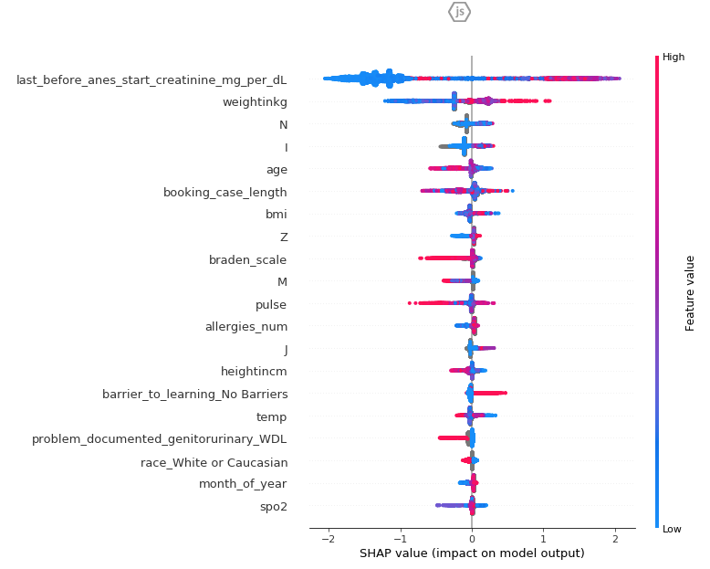

Logistic Regression reference model for predicting acute kidney injury:
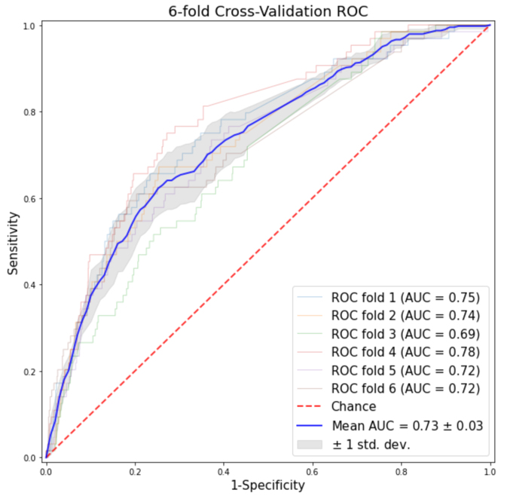

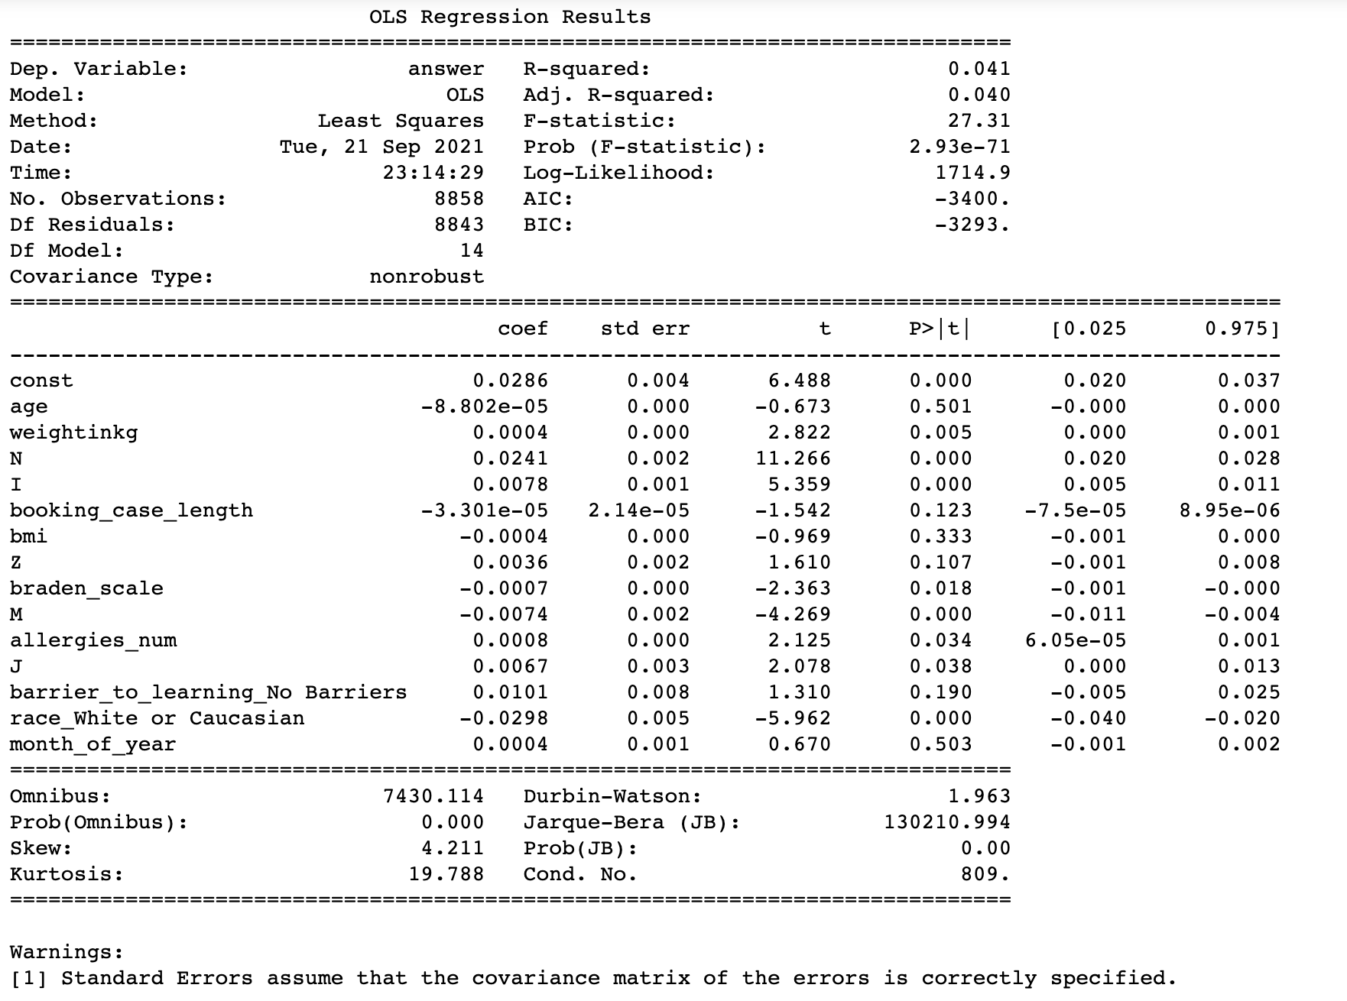

Unsupervised cluster analysis variables:
non-invasive diastolic blood pressure mean value of all minutes of case
non-invasive systolic blood pressure mean value of all minutes of case
non-invasive mean blood pressure mean value of all minutes of case
pulse oximeter heart rate value mean value of all minutes of case
respiratory rate mean value of all minutes of case
pulse oximetere oxygen saturation mean value of all minutes of case

