Supplementary file 2

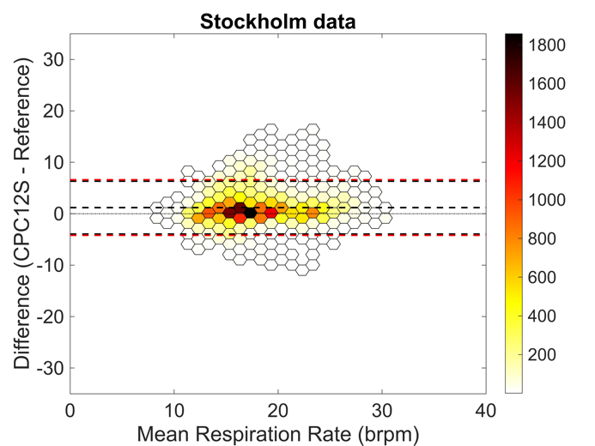
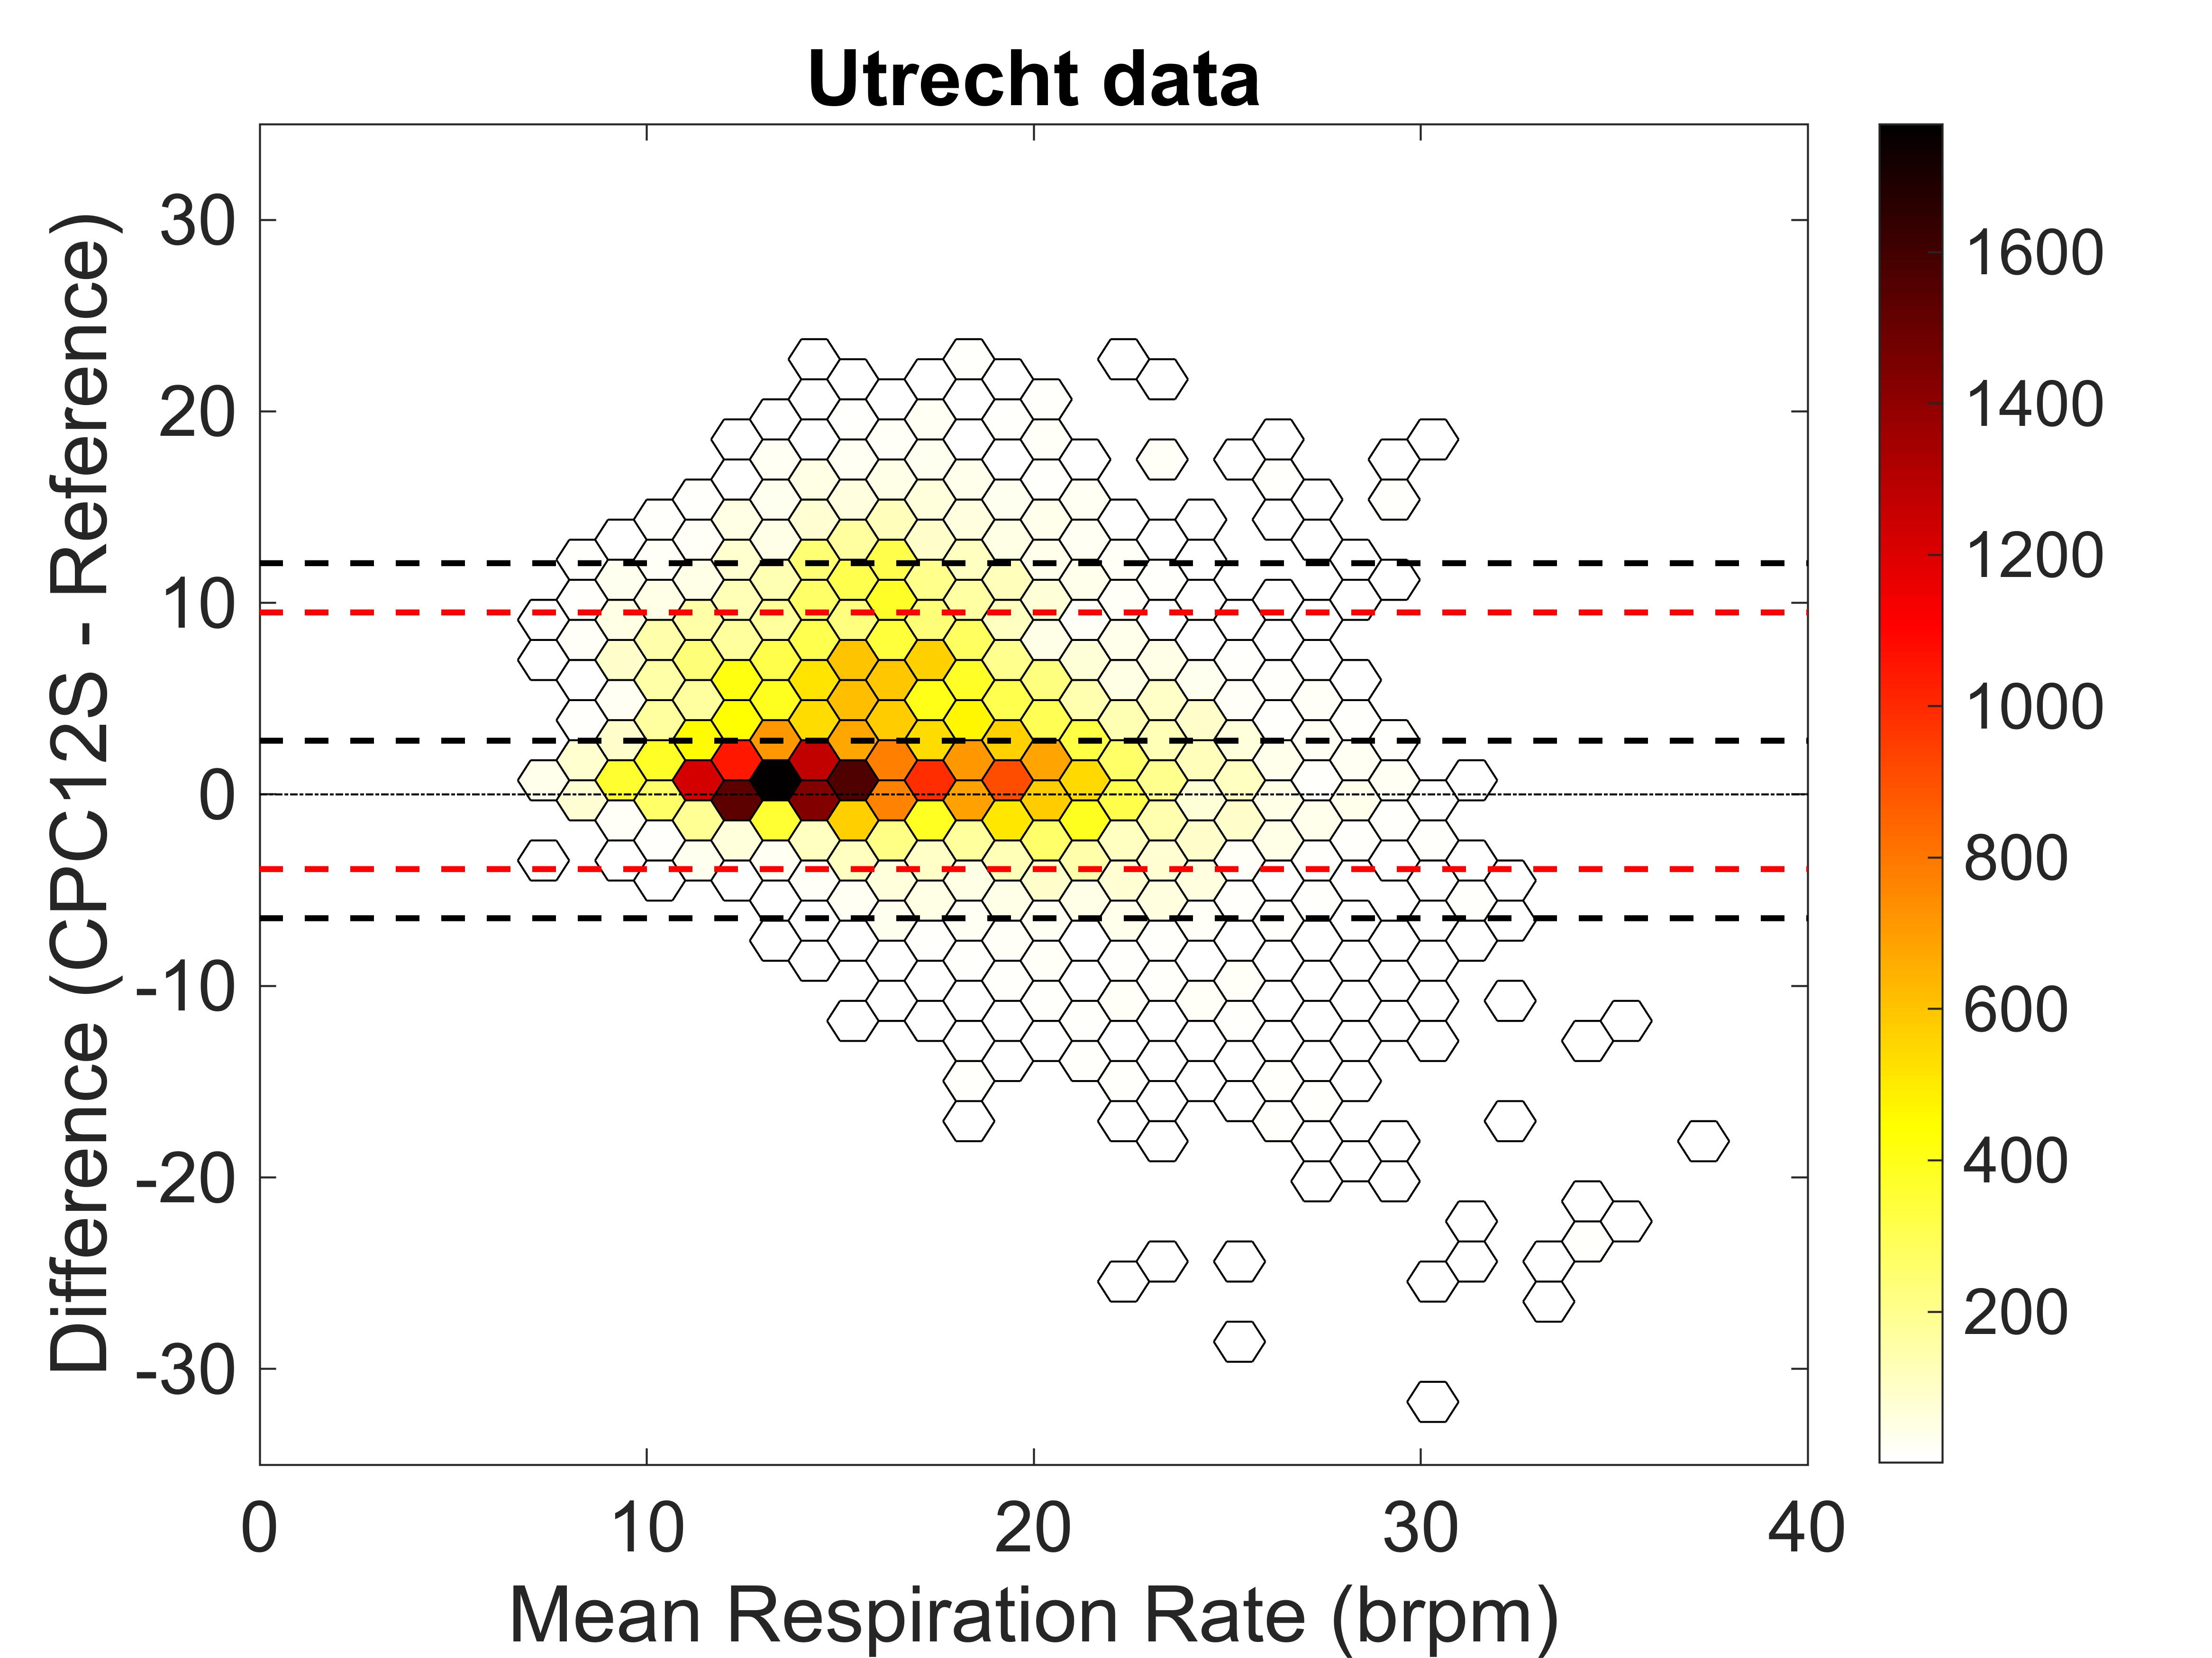
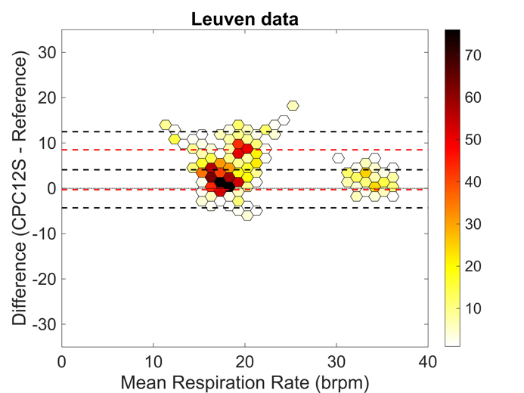

Fig. 7a-d Bland-Altman plots of respiratory rate for Utrecht, Stockholm, Aachen and Leuven respectively. Bias from the Bland-Altman method in black, and limits of agreement from mixed effects models in red.

