Supplemental Material:
Table of Contents
Supplementary Methods: Search strategy.
Supplementary Figure 1 - Leave one out sensitivity analysis: Total Fluid infused.
Supplementary Figure 2 - Leave one out sensitivity analysis: Total cristaloid infused.
Supplementary Figure 3 - Risk of Bias assessment (RoB-2).
Supplementary Figure 4 - Funnel plot: Total Fluids indufed.
Supplementary Figure 5 - Funnel plot: Total crystalloids infused.

Supplementary methods 1: Search strategy:

("Pleth Variability Index" OR “PVI” OR "Pulse Oximeter Variability" OR "Plethysmography Variability" OR "Non-Invasive Monitoring")

Supplementary Figure 1: Leave one out sensitivity analysis - Total Fluid infused:
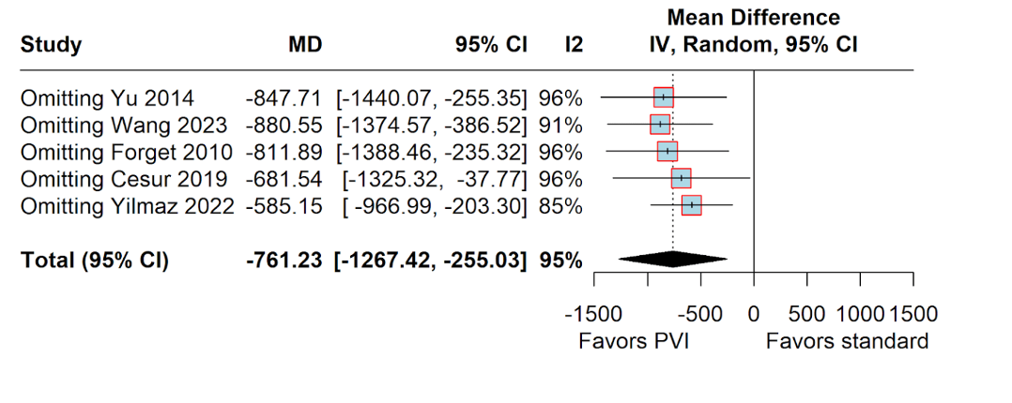

Supplementary Figure 2: Leave one out sensitivity analysis - Total crystalloid infused:
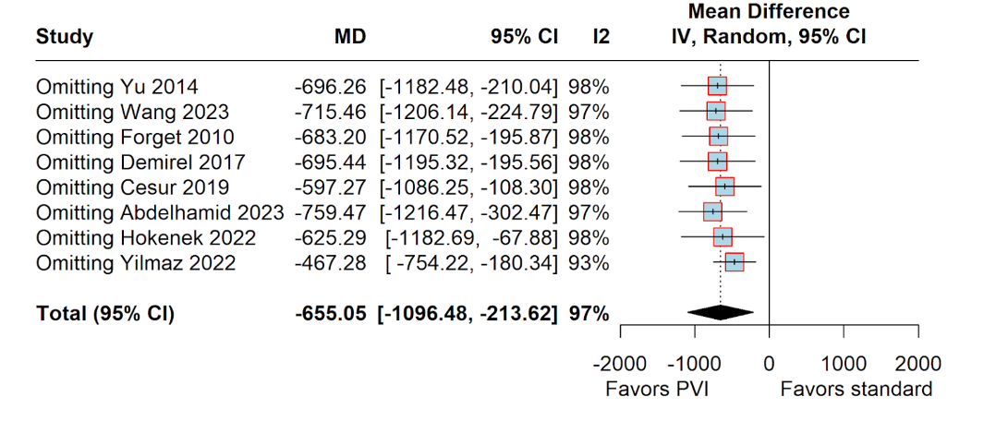

Supplementary Figure3: Risk of Bias assessment (RoB-2)

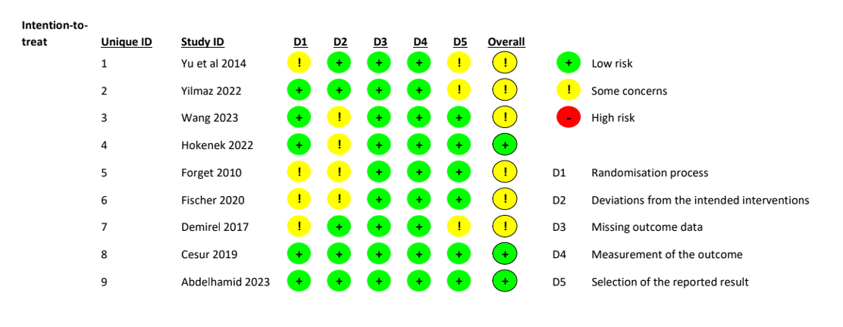

Supplementary Figure 4: Funnel plot: Total Fluids infused:
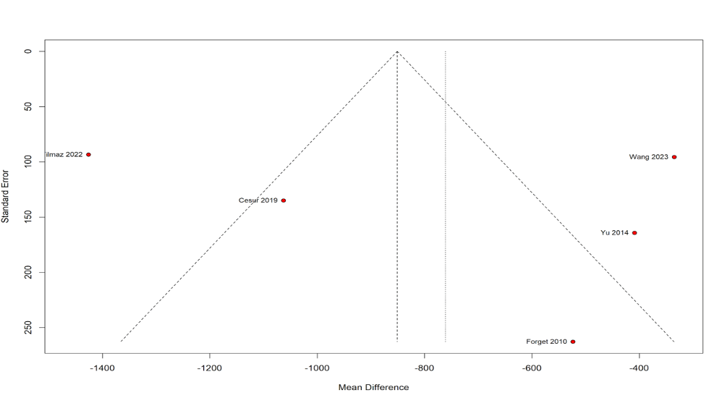

Supplementary Figure 5: Funnel plot: Total crystalloids infused:
