Supplement 3 - Example of vital sign trend data
Fig. S3 presents continuous vital sign data over a 22.3-hour period from one of the included postoperative patients, comparing the viQtor® with the reference monitor. To show the full 22-hour trends, pneumography was used as the reference for respiratory rate, as capnography was only available during the first 5 hours. The trends show a natural decline in both respiratory rate (RR) and heart rate (HR) during the initial hours following surgery, with lower values observed during the night. Notably, two sustained desaturation periods are visible in the SpO₂ trend, highlighting viQtor®’s ability to capture clinically relevant fluctuations. These episodes may have been triggered by routine nursing care activities such as washing or repositioning.
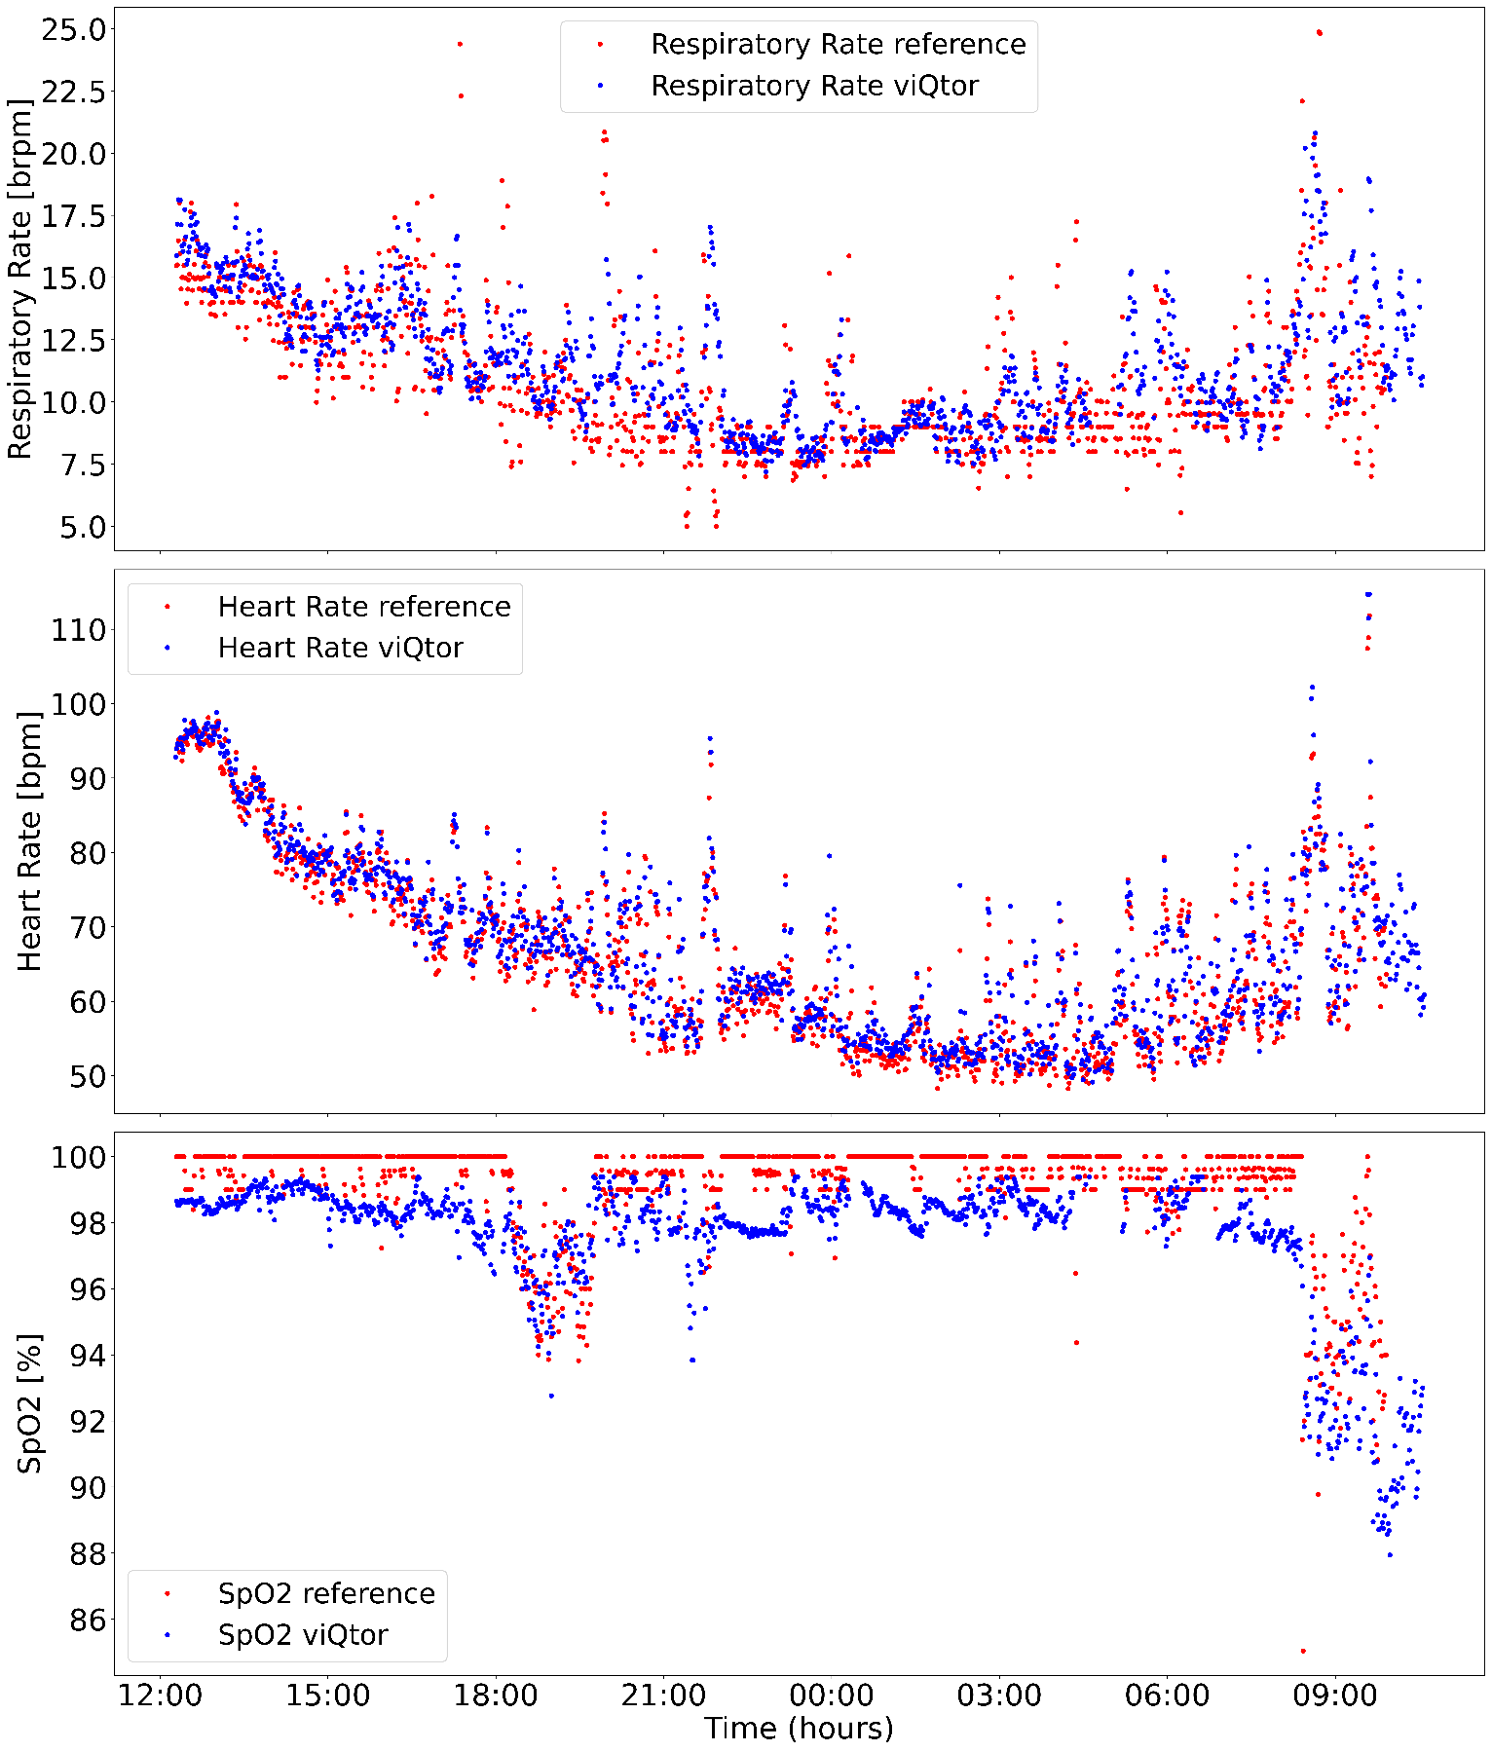

Fig. S3 Example vital sign trend data from the viQtor® (blue) and reference monitor (red) during 22.3 hours of continuous monitoring, demonstrating variability in vital sign values. From top to bottom, the graphs show respiratory rate (pneumography reference), heart rate, and SpO₂ measurements. Pneumography was used as the reference in this illustration because capnography was not available for the full monitoring period.

