Supplement A - Frequency dependent coherence and gain: linear scale*. The levels of coherence (left) and gain (right) dependent on NIRS metric and scale (0.001 – 0.5 Hz) stratified by the input signal (ABP vs. FV vs. ICP) are shown. In comparison to Figure 2 in the main manuscript, a linear scale is used which allows to focus on the higher frequency bands. The frequency band corresponding to the BPL range lies within ln1 which also displays distinctly higher coherence and gain values in comparison to higher frequency bands.
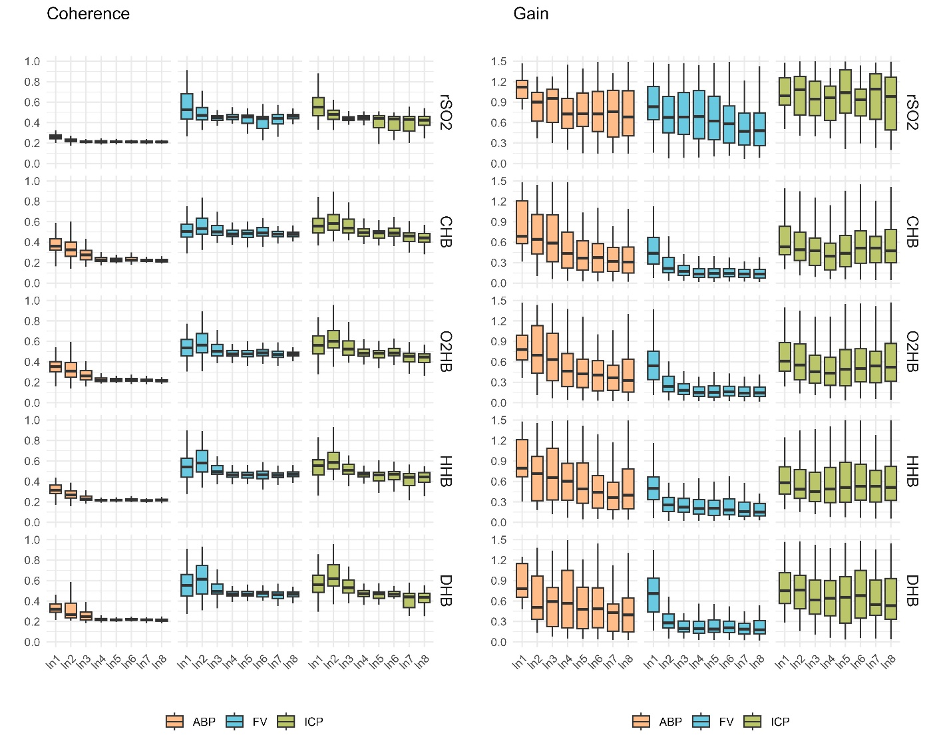
*Abbreviations: ABP: arterial blood pressure; CHB: total haemoglobin; DHB: delta haemoglobin; FV: cerebral blood flow velocity; HHB: deoxyhaemoglobin; ICP: intracranial pressure; ln – linear scale; O2HB: oxyhaemoglobin; rSO2: regional cerebral oxygen saturation;
Supplement B - Coherence and gain depending on output stratified by the different inputs. The levels of coherence and gain are compared by output (i.e. NIRS derived metrics) and stratified for the different input measures to assess which NIRS measures has highest coherence or gain associated with either input. Wilcoxon rank sum tests were used for comparison with p-values adjusted using the Bonferroni correction. Additionally, the effect size is reported.*
*Abbreviations: ABP: arterial blood pressure; CHB: total haemoglobin; DHB: delta haemoglobin; FV: cerebral blood flow velocity; HHB: Deoxyhaemoglobin; ICP: intracranial pressure; ns – not significant; O2HB: Oxyhaemoglobin; rSO2: regional cerebral oxygen saturation;
Brain Physics Lab Range (0.005 to 0.05 Hz) | Coherence: p-values (effect size)
Brain Physics Lab Range (0.005 to 0.05 Hz) |  | rSO2 vs. CHB | rSO2 vs. O2HB | rSO2 vs. HHB | rSO2 vs. DHB | CHB vs. O2HB | CHB vs. HHB | CHB vs. DHB | O2HB vs. HHB | O2HB vs. DHB | HHB vs. DHB
Brain Physics Lab Range (0.005 to 0.05 Hz) | ABP | <0.001 (0.67) | <0.001 (0.63) | <0.001 (0.51) | <0.001 (0.52) | ns | 0.001 (0.31) | ns | ns | ns | ns
Brain Physics Lab Range (0.005 to 0.05 Hz) | FV | ns | ns | ns | ns | ns | ns | ns | ns | ns | ns
Brain Physics Lab Range (0.005 to 0.05 Hz) | ICP | ns | ns | ns | ns | ns | ns | ns | ns | ns | ns
Brain Physics Lab Range (0.005 to 0.05 Hz) | Gain: p-values (effect size)
Brain Physics Lab Range (0.005 to 0.05 Hz) |  | rSO2 vs. CHB | rSO2 vs. O2HB | rSO2 vs. HHB | rSO2 vs. DHB | CHB vs. O2HB | CHB vs. HHB | CHB vs. DHB | O2HB vs. HHB | O2HB vs. DHB | HHB vs. DHB
Brain Physics Lab Range (0.005 to 0.05 Hz) | ABP | <0.001  (0.56) | <0.001  (0.47) | ns | 0.001  (0.36) | ns | <0.001  (0.67) | ns | <0.001 | ns | <0.001
Brain Physics Lab Range (0.005 to 0.05 Hz) | FV | <0.001 (0.57) | <0.001 (0.50) | <0.001 (0.61) | <0.001 (0.37) | ns | ns | ns | ns | ns | ns
Brain Physics Lab Range (0.005 to 0.05 Hz) | ICP | <0.001 (0.68) | <0.001 (0.61) | <0.001 (0.69) | <0.001 (0.48) | ns | ns | ns | ns | ns | ns

Supplement C - Coherence and gain within the CARNet ranges. Coherence and gain stratified by the CARNet ranges for the different NIRS derived metrics stratified by input (ABP vs. FV vs. ICP) are shown in panel A and B. The corresponding statistical analyses are described in the tables below. The specific frequency ranges are: Very low frequency 0.02 to 0.07 Hz; Low frequency 0.07 to 0.2 Hz; High frequency 0.2 to 0.5 Hz.
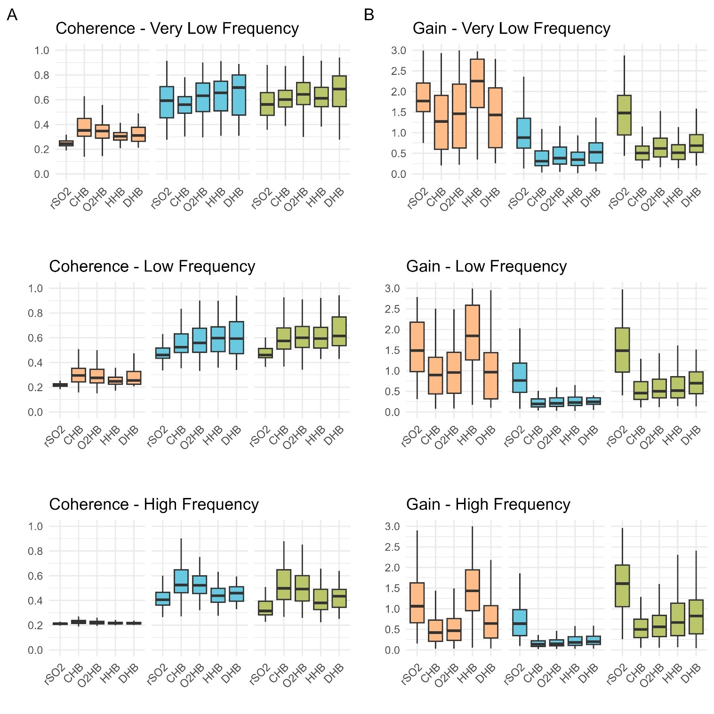
*Abbreviations: ABP: arterial blood pressure; CHB: total haemoglobin; DHB: delta haemoglobin; FV: cerebral blood flow velocity; HHB: Deoxyhaemoglobin; ICP: intracranial pressure; ns – not significant; O2HB: Oxyhaemoglobin; rSO2: regional cerebral oxygen saturation;
Table 1. Coherence and gain depending on input stratified by the different NIRS derived measures. The levels of coherence and gain are displayed stratified by the CARNet frequency ranges. Wilcoxon rank sum tests were used for comparison with p-values adjusted using the Bonferroni correction. Additionally, the effect size is reported using superscripts using “^{s}”, “^{m}”, “^{l}”, according to according to Cohen's conventional thresholds (small ≥ 0.1, moderate ≥ 0.3, large ≥ 0.5).*
* Data shown as median (interquartile range); Abbreviations: ABP: arterial blood pressure; CHB: total haemoglobin; DHB: delta haemoglobin; FV: cerebral blood flow velocity; HHB: Deoxyhaemoglobin; ICP: intracranial pressure; ns – not significant; O2HB: Oxyhaemoglobin; rSO2: regional cerebral oxygen saturation;
Very Low Frequency Range (0.02 to 0.07 Hz) |  |  |  |  |  | Coherence
 |  |  |  |  |  | Input |  |  |  |  |  | p-value (Bonferroni adjusted)
 |  |  |  |  |  | ABP |  | FV |  | ICP |  | ABP vs. FV | ABP vs. ICP | FV vs. ICP
 |  | Output |  | rSO2 |  | 0.24 (0.23, 0.27) |  | 0.59 (0.45, 0.71) |  | 0.56 (0.47, 0.66) |  | <0.001 ^{l} | <0.001 ^{l} | ns
 |  |  |  | CHB |  | 0.35 (0.31, 0.45) |  | 0.56 (0.49, 0.63) |  | 0.60 (0.54, 0.68) |  | <0.001 ^{l} | <0.001 ^{l} | ns
 |  |  |  | O2HB |  | 0.35 (0.29, 0.40) |  | 0.63 (0.50, 0.73) |  | 0.64 (0.56, 0.74) |  | <0.001 ^{l} | <0.001 ^{l} | ns
 |  |  |  | HHB |  | 0.30 (0.27, 0.34) |  | 0.66 (0.51, 0.75) |  | 0.61 (0.54, 0.70) |  | <0.001 ^{l} | <0.001 ^{l} | ns
 |  |  |  | DHB |  | 0.31 (0.26, 0.38) |  | 0.70 (0.47, 0.82) |  | 0.69 (0.54, 0.80) |  | <0.001 ^{l} | <0.001 ^{l} | ns
 |  |  |  |  |  | Gain
 |  |  |  |  |  | Input |  |  |  |  |  | p-value (Bonferroni adjusted)
 |  |  |  |  |  | ABP |  | FV |  | ICP |  | ABP vs. FV | ABP vs. ICP | FV vs. ICP
 |  | Output |  | rSO2 |  | 4.37 (2.15, 7.69) |  | 0.97 (0.64, 1.50) |  | 1.54 (1.05, 2.17) |  | <0.001 ^{l} | <0.001 ^{l} | 0.002 ^{m}
 |  |  |  | CHB |  | 1.47 (0.66, 2.51) |  | 0.31 (0.20, 0.56) |  | 0.51 (0.33, 0.69) |  | <0.001 ^{l} | <0.001 ^{l} | 0.006 ^{s}
 |  |  |  | O2HB |  | 1.91 (0.83, 2.84) |  | 0.38 (0.24, 0.66) |  | 0.62 (0.41, 0.87) |  | <0.001 ^{l} | <0.001 ^{l} | 0.01 ^{s}
 |  |  |  | HHB |  | 4.9 (3.0, 10.8) |  | 0.3 (0.2, 0.5) |  | 0.5 (0.3, 0.7) |  | <0.001 ^{l} | <0.001 ^{l} | 0.004 ^{m}
 |  |  |  | DHB |  | 2.08 (1.18, 3.51) |  | 0.53 (0.26, 0.76) |  | 0.69 (0.52, 0.96) |  | <0.001 ^{l} | <0.001 ^{l} | ns
Low Frequency Range (0.07 to 0.2 Hz) |  |  |  |  | Coherence
Low Frequency Range (0.07 to 0.2 Hz) |  |  |  |  | Input |  |  |  |  |  | p-value (Bonferroni adjusted)
Low Frequency Range (0.07 to 0.2 Hz) |  |  |  |  | ABP |  | FV |  | ICP |  | ABP vs. FV |  | ABP vs. ICP | FV vs. ICP
Low Frequency Range (0.07 to 0.2 Hz) | Output |  | rSO2 |  | 0.22 (0.21, 0.23) |  | 0.46 (0.43, 0.52) |  | 0.46 (0.44, 0.51) |  | <0.001 ^{l} |  | <0.001 ^{l} | ns
Low Frequency Range (0.07 to 0.2 Hz) |  |  | CHB |  | 0.30 (0.24, 0.35) |  | 0.52 (0.48, 0.63) |  | 0.57 (0.51, 0.68) |  | <0.001 ^{l} |  | <0.001 ^{l} | ns
Low Frequency Range (0.07 to 0.2 Hz) |  |  | O2HB |  | 0.28 (0.23, 0.34) |  | 0.56 (0.48, 0.68) |  | 0.60 (0.52, 0.69) |  | <0.001 ^{l} |  | <0.001 ^{l} | ns
Low Frequency Range (0.07 to 0.2 Hz) |  |  | HHB |  | 0.25 (0.22, 0.28) |  | 0.60 (0.49, 0.69) |  | 0.59 (0.52, 0.69) |  | <0.001 ^{l} |  | <0.001 ^{l} | ns
Low Frequency Range (0.07 to 0.2 Hz) |  |  | DHB |  | 0.25 (0.22, 0.34) |  | 0.59 (0.47, 0.74) |  | 0.61 (0.53, 0.77) |  | <0.001 ^{l} |  | <0.001 ^{l} | ns
Low Frequency Range (0.07 to 0.2 Hz) |  |  |  |  | Gain
Low Frequency Range (0.07 to 0.2 Hz) |  |  |  |  | Input |  |  |  |  |  | p-value (Bonferroni adjusted)
Low Frequency Range (0.07 to 0.2 Hz) |  |  |  |  | ABP |  | FV |  | ICP |  | ABP vs. FV |  | ABP vs. ICP | FV vs. ICP
Low Frequency Range (0.07 to 0.2 Hz) | Output |  | rSO2 |  | 4.16 (1.94, 7.84) |  | 0.77 (0.48, 1.23) |  | 1.91 (1.13, 3.01) |  | <0.001 ^{l} |  | <0.001 ^{m} | <0.001 ^{l}
Low Frequency Range (0.07 to 0.2 Hz) |  |  | CHB |  | 1.10 (0.53, 1.78) |  | 0.19 (0.12, 0.32) |  | 0.46 (0.30, 0.73) |  | <0.001 ^{l} |  | <0.001 ^{m} | <0.001 ^{l}
Low Frequency Range (0.07 to 0.2 Hz) |  |  | O2HB |  | 1.17 (0.53, 1.97) |  | 0.21 (0.13, 0.34) |  | 0.50 (0.34, 0.80) |  | <0.001 ^{l} |  | <0.001 ^{m} | <0.001 ^{l}
Low Frequency Range (0.07 to 0.2 Hz) |  |  | HHB |  | 4.3 (2.2, 10.2) |  | 0.2 (0.2, 0.4) |  | 0.5 (0.3, 0.9) |  | <0.001 ^{l} |  | <0.001 ^{l} | 0.02 ^{l}
Low Frequency Range (0.07 to 0.2 Hz) |  |  | DHB |  | 1.20 (0.50, 3.64) |  | 0.25 (0.18, 0.35) |  | 0.70 (0.44, 0.97) |  | <0.001 ^{l} |  | 0.009 ^{m} | <0.001 ^{l}
Table 1. continued.
High Frequency Range (0.2-0.5 Hz) |  |  | Coherence
High Frequency Range (0.2-0.5 Hz) |  |  | Input |  |  | p-value (Bonferroni adjusted)
High Frequency Range (0.2-0.5 Hz) |  |  | ABP | FV | ICP | ABP vs. FV | ABP vs. ICP | FV vs. ICP
High Frequency Range (0.2-0.5 Hz) | Output | rSO2 | 0.21 (0.21, 0.22) | 0.41 (0.36, 0.47) | 0.32 (0.28, 0.39) | <0.001 ^{l} | <0.001 ^{l} | <0.001 ^{m}
High Frequency Range (0.2-0.5 Hz) | Output | CHB | 0.22 (0.21, 0.24) | 0.53 (0.46, 0.65) | 0.50 (0.41, 0.65) | <0.001 ^{l} | <0.001 ^{l} | ns
High Frequency Range (0.2-0.5 Hz) | Output | O2HB | 0.22 (0.21, 0.23) | 0.52 (0.46, 0.60) | 0.49 (0.40, 0.60) | <0.001 ^{l} | <0.001 ^{l} | ns
High Frequency Range (0.2-0.5 Hz) | Output | HHB | 0.22 (0.21, 0.22) | 0.44 (0.38, 0.50) | 0.38 (0.33, 0.49) | <0.001 ^{l} | <0.001 ^{l} | ns
High Frequency Range (0.2-0.5 Hz) | Output | DHB | 0.21 (0.21, 0.22) | 0.46 (0.39, 0.51) | 0.43 (0.34, 0.50) | <0.001 ^{l} | <0.001 ^{l} | ns
High Frequency Range (0.2-0.5 Hz) |  |  | Gain
High Frequency Range (0.2-0.5 Hz) |  |  | Input |  |  | p-value (Bonferroni adjusted)
High Frequency Range (0.2-0.5 Hz) |  |  | ABP | FV | ICP | ABP vs. FV | ABP vs. ICP | FV vs. ICP
High Frequency Range (0.2-0.5 Hz) | Output | rSO2 | 2.11 (0.93, 3.78) | 0.64 (0.34, 0.98) | 2.08 (1.30, 4.04) | <0.001 ^{l} | ns | <0.001 ^{l}
High Frequency Range (0.2-0.5 Hz) | Output | CHB | 0.42 (0.21, 0.76) | 0.14 (0.08, 0.22) | 0.50 (0.30, 0.75) | <0.001 ^{l} | ns | <0.001 ^{l}
High Frequency Range (0.2-0.5 Hz) | Output | O2HB | 0.48 (0.25, 0.83) | 0.15 (0.10, 0.25) | 0.57 (0.32, 0.87) | <0.001 ^{l} | ns | <0.001 ^{l}
High Frequency Range (0.2-0.5 Hz) | Output | HHB | 1.98 (1.18, 4.07) | 0.18 (0.11, 0.32) | 0.67 (0.34, 1.15) | <0.001 ^{l} | <0.001 ^{l} | <0.001 ^{l}
High Frequency Range (0.2-0.5 Hz) | Output | DHB | 0.67 (0.29, 1.11) | 0.20 (0.13, 0.33) | 0.82 (0.38, 1.25) | <0.001 ^{m} | ns | <0.001 ^{l}

Very Low Frequency Range | Coherence: p-values (Bonferroni adjusted)
Very Low Frequency Range |  | rSO2 vs. CHB | rSO2 vs. O2HB | rSO2 vs. HHB | rSO2 vs. DHB | CHB vs. O2HB | CHB vs. HHB | CHB vs. DHB | O2HB vs. HHB | O2HB vs. DHB | HHB vs. DHB
Very Low Frequency Range | ABP | <0.001 ^{l} | <0.001 ^{l} | <0.001 ^{l} | <0.001 ^{l} | ns | <0.001 ^{m} | ns | 0.01 ^{s} | ns | ns
Very Low Frequency Range | FV | ns | ns | ns | ns | ns | ns | ns | ns | ns | ns
Very Low Frequency Range | ICP | ns | ns | ns | ns | ns | ns | ns | ns | ns | ns
Very Low Frequency Range | Gain: p-values (Bonferroni adjusted)
Very Low Frequency Range |  | rSO2 vs. CHB | rSO2 vs. O2HB | rSO2 vs. HHB | rSO2 vs. DHB | CHB vs. O2HB | CHB vs. HHB | CHB vs. DHB | O2HB vs. HHB | O2HB vs. DHB | HHB vs. DHB
Very Low Frequency Range | ABP | <0.001 ^{l} | <0.001 ^{m} | ns | 0.004 ^{m} | ns | <0.001 ^{l} | ns | <0.001 ^{l} | ns | <0.001 ^{m}
Very Low Frequency Range | FV | <0.001 ^{l} | <0.001 ^{l} | <0.001 ^{l} | <0.001 ^{m} | ns | ns | ns | ns | ns | ns
Very Low Frequency Range | ICP | <0.001 ^{l} | <0.001 ^{l} | <0.001 ^{l} | <0.001 ^{l} | ns | ns | ns | ns | ns | Ns
Low Frequency Range | Coherence: p-values (Bonferroni adjusted)
Low Frequency Range |  | rSO2 vs. CHB | rSO2 vs. O2HB | rSO2 vs. HHB | rSO2 vs. DHB | CHB vs. O2HB | CHB vs. HHB | CHB vs. DHB | O2HB vs. HHB | O2HB vs. DHB | HHB vs. DHB
Low Frequency Range | ABP | <0.001 ^{l} | <0.001 ^{l} | <0.001 ^{l} | <0.001 ^{l} | ns | 0.001 ^{m} | ns | ns | ns | ns
Low Frequency Range | FV | <0.001 ^{m} | <0.001 ^{m} | <0.001 ^{m} | <0.001 ^{m} | ns | ns | ns | ns | ns | ns
Low Frequency Range | ICP | <0.001 ^{l} | <0.001 ^{l} | <0.001 ^{l} | <0.001 ^{l} | ns | ns | ns | ns | ns | ns
Low Frequency Range | Gain: p-values (Bonferroni adjusted)
Low Frequency Range |  | rSO2 vs. CHB | rSO2 vs. O2HB | rSO2 vs. HHB | rSO2 vs. DHB | CHB vs. O2HB | CHB vs. HHB | CHB vs. DHB | O2HB vs. HHB | O2HB vs. DHB | HHB vs. DHB
Low Frequency Range | ABP | <0.001 ^{l} | <0.001 ^{l} | ns | <0.001 ^{m} | ns | <0.001 ^{l} | ns | <0.001 ^{l} | ns | <0.001 ^{m}
Low Frequency Range | FV | <0.001 ^{l} | <0.001 ^{l} | <0.001 ^{l} | <0.001 ^{l} | ns | ns | ns | ns | ns | ns
Low Frequency Range | ICP | <0.001 ^{l} | <0.001 ^{l} | <0.001 ^{l} | <0.001 ^{l} | ns | ns | ns | ns | ns | ns
High Frequency Range | Coherence: p-values (Bonferroni adjusted)
High Frequency Range |  | rSO2 vs. CHB | rSO2 vs. O2HB | rSO2 vs. HHB | rSO2 vs. DHB | CHB vs. O2HB | CHB vs. HHB | CHB vs. DHB | O2HB vs. HHB | O2HB vs. DHB | HHB vs. DHB
High Frequency Range | ABP | <0.001 ^{m} | 0.001 ^{m} | ns | ns | ns | 0.006 ^{m} | 0.03 ^{m} | ns | ns | ns
High Frequency Range | FV | ns | ns | ns | ns | ns | ns | ns | ns | ns | ns
High Frequency Range | ICP | ns | ns | ns | ns | ns | ns | ns | ns | ns | ns
High Frequency Range | Gain: p-values (Bonferroni adjusted)
High Frequency Range |  | rSO2 vs. CHB | rSO2 vs. O2HB | rSO2 vs. HHB | rSO2 vs. DHB | CHB vs. O2HB | CHB vs. HHB | CHB vs. DHB | O2HB vs. HHB | O2HB vs. DHB | HHB vs. DHB
High Frequency Range | ABP | <0.001 ^{l} | <0.001 ^{l} | ns | <0.001 ^{m} | ns | <0.001 ^{l} | ns | <0.001 ^{l} | ns | <0.001 ^{l}
High Frequency Range | FV | <0.001 ^{l} | <0.001 ^{l} | <0.001 ^{l} | <0.001 ^{l} | ns | ns | ns | ns | ns | ns
High Frequency Range | ICP | <0.001 ^{l} | <0.001 ^{l} | <0.001 ^{l} | <0.001 ^{l} | ns | ns | ns | ns | ns | ns
Table 2. Coherence and gain depending on output stratified by the different inputs. The statistical analysis stratified by the CARNet frequency ranges is shown. Wilcoxon rank sum tests were used for comparison with p-values adjusted using the Bonferroni correction. Effect size is reported using superscripts using “^{s}”, “^{m}”, “^{l}”, according to according to Cohen's conventional thresholds (small ≥ 0.1, moderate ≥ 0.3, large ≥ 0.5).*
* Data shown as median (interquartile range); Abbreviations: ABP: arterial blood pressure; CHB: total haemoglobin; DHB: delta haemoglobin; FV: cerebral blood flow velocity; HHB: Deoxyhaemoglobin; ICP: intracranial pressure; ns – not significant; O2HB: Oxyhaemoglobin; rSO2: regional cerebral oxygen saturation;

