Table S1. Microcirculation Image Quality Scores across study time points
Time point | Non-anemia group (n=27) | Anemia group  (n=22) | P value
T0 | 1.00 [0.67–1.33] | 1.00 [0.67–1.33] | 0.951
T1 | 1.00 [0.67–1.33] | 1.00 [0.75–1.58] | 0.310
T2 | 1.00 [0.67–1.33] | 1.00 [0.67–1.33] | 0.614
T3 | 1.00 [0.83–1.33] | 1.00 [0.67–1.25] | 0.171
Note: Values are presented as median [interquartile range] of the mean Microcirculation Image Quality Score obtained from the three recordings for each patient at each time point. Between-group comparisons were performed using the Mann–Whitney U test.
Table S2. Estimated marginal means and between-group comparisons for sublingual microcirculatory variables.

Outcome | Time point | Non-anemia,  estimated marginal mean | Anemia,  estimated marginal mean | Between-group difference (95% CI) | P-value
MFI | T0 | 2.82 | 2.84 | −0.015 (−0.236 to 0.205) | 0.892
MFI | T1 | 2.38 | 2.1 | 0.281 (0.061 to 0.502) | 0.013
MFI | T2 | 2.35 | 2.15 | 0.203 (−0.017 to 0.423) | 0.071
MFI | T3 | 2.4 | 2.48 | −0.082 (−0.303 to 0.138) | 0.461
PPV | T0 | 98.6 | 98.39 | 0.209 (−4.274 to 4.692) | 0.927
PPV | T1 | 94.05 | 90.69 | 3.365 (−1.118 to 7.849) | 0.140
PPV | T2 | 96.82 | 90.94 | 5.881 (1.398 to 10.365) | 0.010
PPV | T3 | 95.96 | 94.69 | 1.265 (−3.219 to 5.748) | 0.579
PVD, mm mm⁻² | T0 | 17.881 | 17.505 | 0.377 (−1.308 to 2.062) | 0.659
PVD, mm mm⁻² | T1 | 16.648 | 16.664 | −0.015 (−1.700 to 1.669) | 0.986
PVD, mm mm⁻² | T2 | 17.252 | 16.732 | 0.520 (−1.165 to 2.205) | 0.542
PVD, mm mm⁻² | T3 | 17.259 | 17.059 | 0.200 (−1.485 to 1.885) | 0.814
TVD, mm mm⁻² | T0 | 18.133 | 17.791 | 0.342 (−1.173 to 1.857) | 0.655
TVD, mm mm⁻² | T1 | 18.048 | 18.436 | −0.388 (−1.903 to 1.127) | 0.613
TVD, mm mm⁻² | T2 | 17.837 | 18.473 | −0.636 (−2.151 to 0.879) | 0.408
TVD, mm mm⁻² | T3 | 18.159 | 17.659 | 0.500 (−1.015 to 2.015) | 0.514

Note: T0: before anesthesia induction, T1: after anesthesia induction, T2: after specimen removal, T3: at the end of surgery. Abbreviations: 95%CI: 95% confidence interval, MFI: microvascular flow index, PPV: proportion of perfused vessels.

Table S3. Association between preoperative hemoglobin level and perioperative changes in sublingual microcirculation.

Outcome | Correlation coefficient | P-value | Adjusted regression coefficient (95% CI) | P-value
ΔMFI_{T1-T0} | r = 0.343 | 0.016 | 0.060 (−0.010 to 0.130) | 0.091
ΔMFI_{T2-T0} | ρ = 0.369 | 0.009 | 0.076 (0.003 to 0.149) | 0.041

Note: T0: before anesthesia induction, T1: after anesthesia induction, T2: after specimen removal. Pearson correlation was used for ΔMFI_{T1-T0}, and Spearman correlation for ΔMFI_{T2-T0}, according to data distribution. Multivariable linear regression was adjusted for age and body mass index. Abbreviations: MFI: microvascular flow index, ΔMFI_{Tx−T0}=MFI_{Tx}−MFI_{T0} (Tx=T1,T2,T3).

Table S4. Associations between maximum intraoperative reductions in sublingual microcirculatory perfusion and postoperative outcomes.
Postoperative outcome | ΔMFI_{max}, coefficient | P-value | ΔPPV_{max}, coefficient | P-value
Time to first flatus, days | ρ=0.124 | 0.394 | ρ=0.137 | 0.348
Postoperative hospital stay, days | ρ=0.159 | 0.276 | ρ=0.251 | 0.081
Postoperative lactate, mmol L⁻¹ | ρ=0.094 | 0.520 | ρ=0.057 | 0.698
Change in serum creatinine, μmol L⁻¹ | r=−0.195 | 0.179 | ρ=−0.265 | 0.066

Note: The maximum intraoperative reduction was defined as ΔMFI_{max}=MFI_{T0}−min(MFI_{T1},MFI_{T2},MFI_{T3}). The same method was used for PPV. T0: before anesthesia induction, T1: after anesthesia induction, T2: after specimen removal. Pearson correlation and Spearman correlation according to data distribution. Abbreviations: MFI: microvascular flow index, PPV: proportion of perfused vessels.

Table S5. Exploratory analyses of linear and quadratic associations between macrocirculatory and microcirculatory variables
Outcome | Predictor | Linear term P-value | Quadratic term P-value
MFI | MAP | 0.793 | 0.457
MFI | CI | 0.410 | 0.378
PPV | MAP | 0.201 | 0.357
PPV | CI | 0.961 | 0.724

Note: Linear mixed-effects models were used to examine the associations between macrocirculatory variables (MAP and CI) and microcirculatory variables (MFI and PPV). Both linear and quadratic terms were included to explore potential nonlinear relationships. Models were adjusted for time, group, age, sex, and body mass index, with patient identity included as a random effect. Abbreviations: CI: cardiac index, MFI: microvascular flow index, PPV: proportion of perfused vessels. MAP, mean arterial pressure.
Table S6. Associations between cumulative norepinephrine dose and perioperative changes in sublingual microcirculation.
Microcirculatory variable | Correlation coefficient | P-value
ΔMFI _{T1−T0} | r=−0.158 | 0.278
ΔMFI _{T2−T0} | ρ=−0.001 | 0.997
ΔMFI _{T3−T0} | r=0.024 | 0.871
ΔPPV _{T1−T0} | ρ=0.058 | 0.69
ΔPPV _{T2−T0} | ρ=0.047 | 0.751
ΔPPV _{T3−T0} | ρ=0.107 | 0.466

Note: T0: before anesthesia induction, T1: after anesthesia induction, T2: after specimen removal. Pearson correlation and Spearman correlation according to data distribution. Abbreviations: MFI: microvascular flow index, ΔMFI_{Tx−T0}=MFI_{Tx}−MFI_{T0} (Tx=T1,T2,T3).

Figure S1. Representative sublingual microcirculation images before and after induction of general anesthesia. (A) Before anesthesia induction (T0). (B) After anesthesia induction (T1).
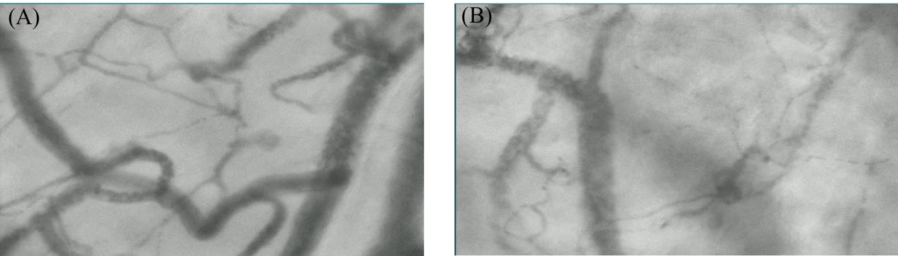

Figure S2. Scatter plot of macro- and micro-circulatory variables stratified by anemia status. CI: cardiac index, MFI: microvascular flow index, PPV: proportion of perfused vessels. MAP, mean arterial pressure.
