Supplementary Material
Table S1 Two tailed Pearson/Spearman correlation tests between slug feeding residual (SFR) and the concentrations of individual pyrrolizidine alkaloids (PAs, µg/g dw) in the 87 F2 genotypes from a cross between Jacobaea vulgaris and Jacobaea aquatica
Group | PA | r/r_{s} | P
 | senecionine | -0.201 | 0.062
 | senecionine N-oxide | -0.184 | 0.087
 | integerrimine | -0.160 | 0.139
 | integerrimine N-oxide | -0.131 | 0.227
 | retrorsine | -0.125 | 0.249
 | retrorsine N-oxide | -0.005 | 0.962
 | usaramine | -0.112 | 0.300
Senecionine-like PAs | usaramine N-oxideª | -0.041 | 0.706
 | riddelliine | 0.205 | 0.057
 | riddelliine N-oxide | -0.124 | 0.251
 | seneciphylline | -0.374 | <0.001*
 | seneciphylline N-oxide | -0.342 | 0.001*
 | spartioidine | -0.380 | <0.001**
 | spartioidine N-oxide | -0.345 | 0.001*
 | acetylseneciphylline | 0.068 | 0.531
 | acetylseneciphylline N-oxide | 0.638 | 0.265
 | senecivernine | -0.341 | 0.001*
 | jacobine | -0.113 | 0.297
 | jacobine N-oxideª | -0.171 | 0.114
 | jacoline | -0.100 | 0.356
 | jacoline N-oxideª | -0.156 | 0.149
Jacobine-like PAs | jaconine | -0.093 | 0.394
 | jaconine N-oxideª | -0.159 | 0.142
 | jacozine | -0.238 | 0.027
 | jacozine N-oxide | -0.336 | 0.001*
 | dehydrojaconine | -0.259 | 0.015
 | erucifoline | -0.095 | 0.384
Erucifoline-like PAs | erucifoline N-oxide | -0.137 | 0.204
 | acetylerucifoline | 0.045 | 0.682
 | acetylerucifoline N-oxide | 0.011 | 0.920
 | senkirkineª | -0.002 | 0.985
 | otosenine | 0.163 | 0.131
Otosenine-like PAs | onetine | 0.123 | 0.256
 | desacetyldoronine | 0.137 | 0.207
 | florosenine | 0.141 | 0.195
 | floridanine | 0.088 | 0.426
 | doronine | 0.161 | 0.142
ª Spearman correlation tests were carried out for PAs with not normally distributed concentrations
*P<0.05, **P<0.01indicates significance after the sequential Bonferroni test

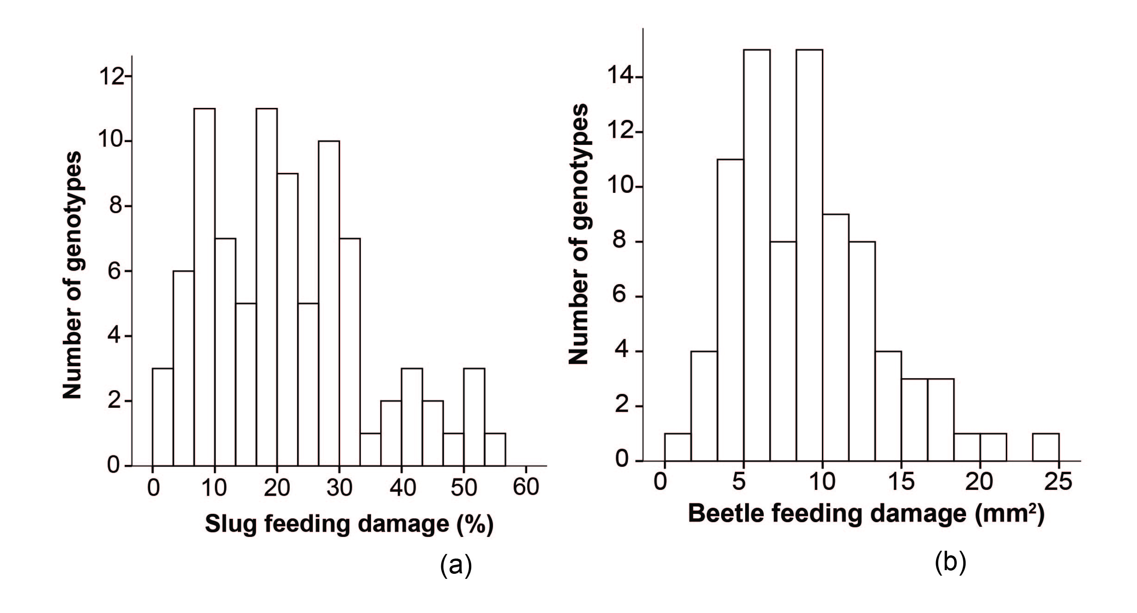
Fig.S1 (a) Frequency distribution of genotypic mean percentage of slug feeding damage of 87 F2 hybrids. Each genotype is the mean of 4-6 replicates. In total, 498 plants were used in the slug bioassay. (b) Frequency distribution of the genotypic mean square millimeter of flea beetle feeding damage of 84 F2 hybrids. Each genotype is the mean of 4-6 replicates. In total, 484 plants were used in the flea beetle bioassay
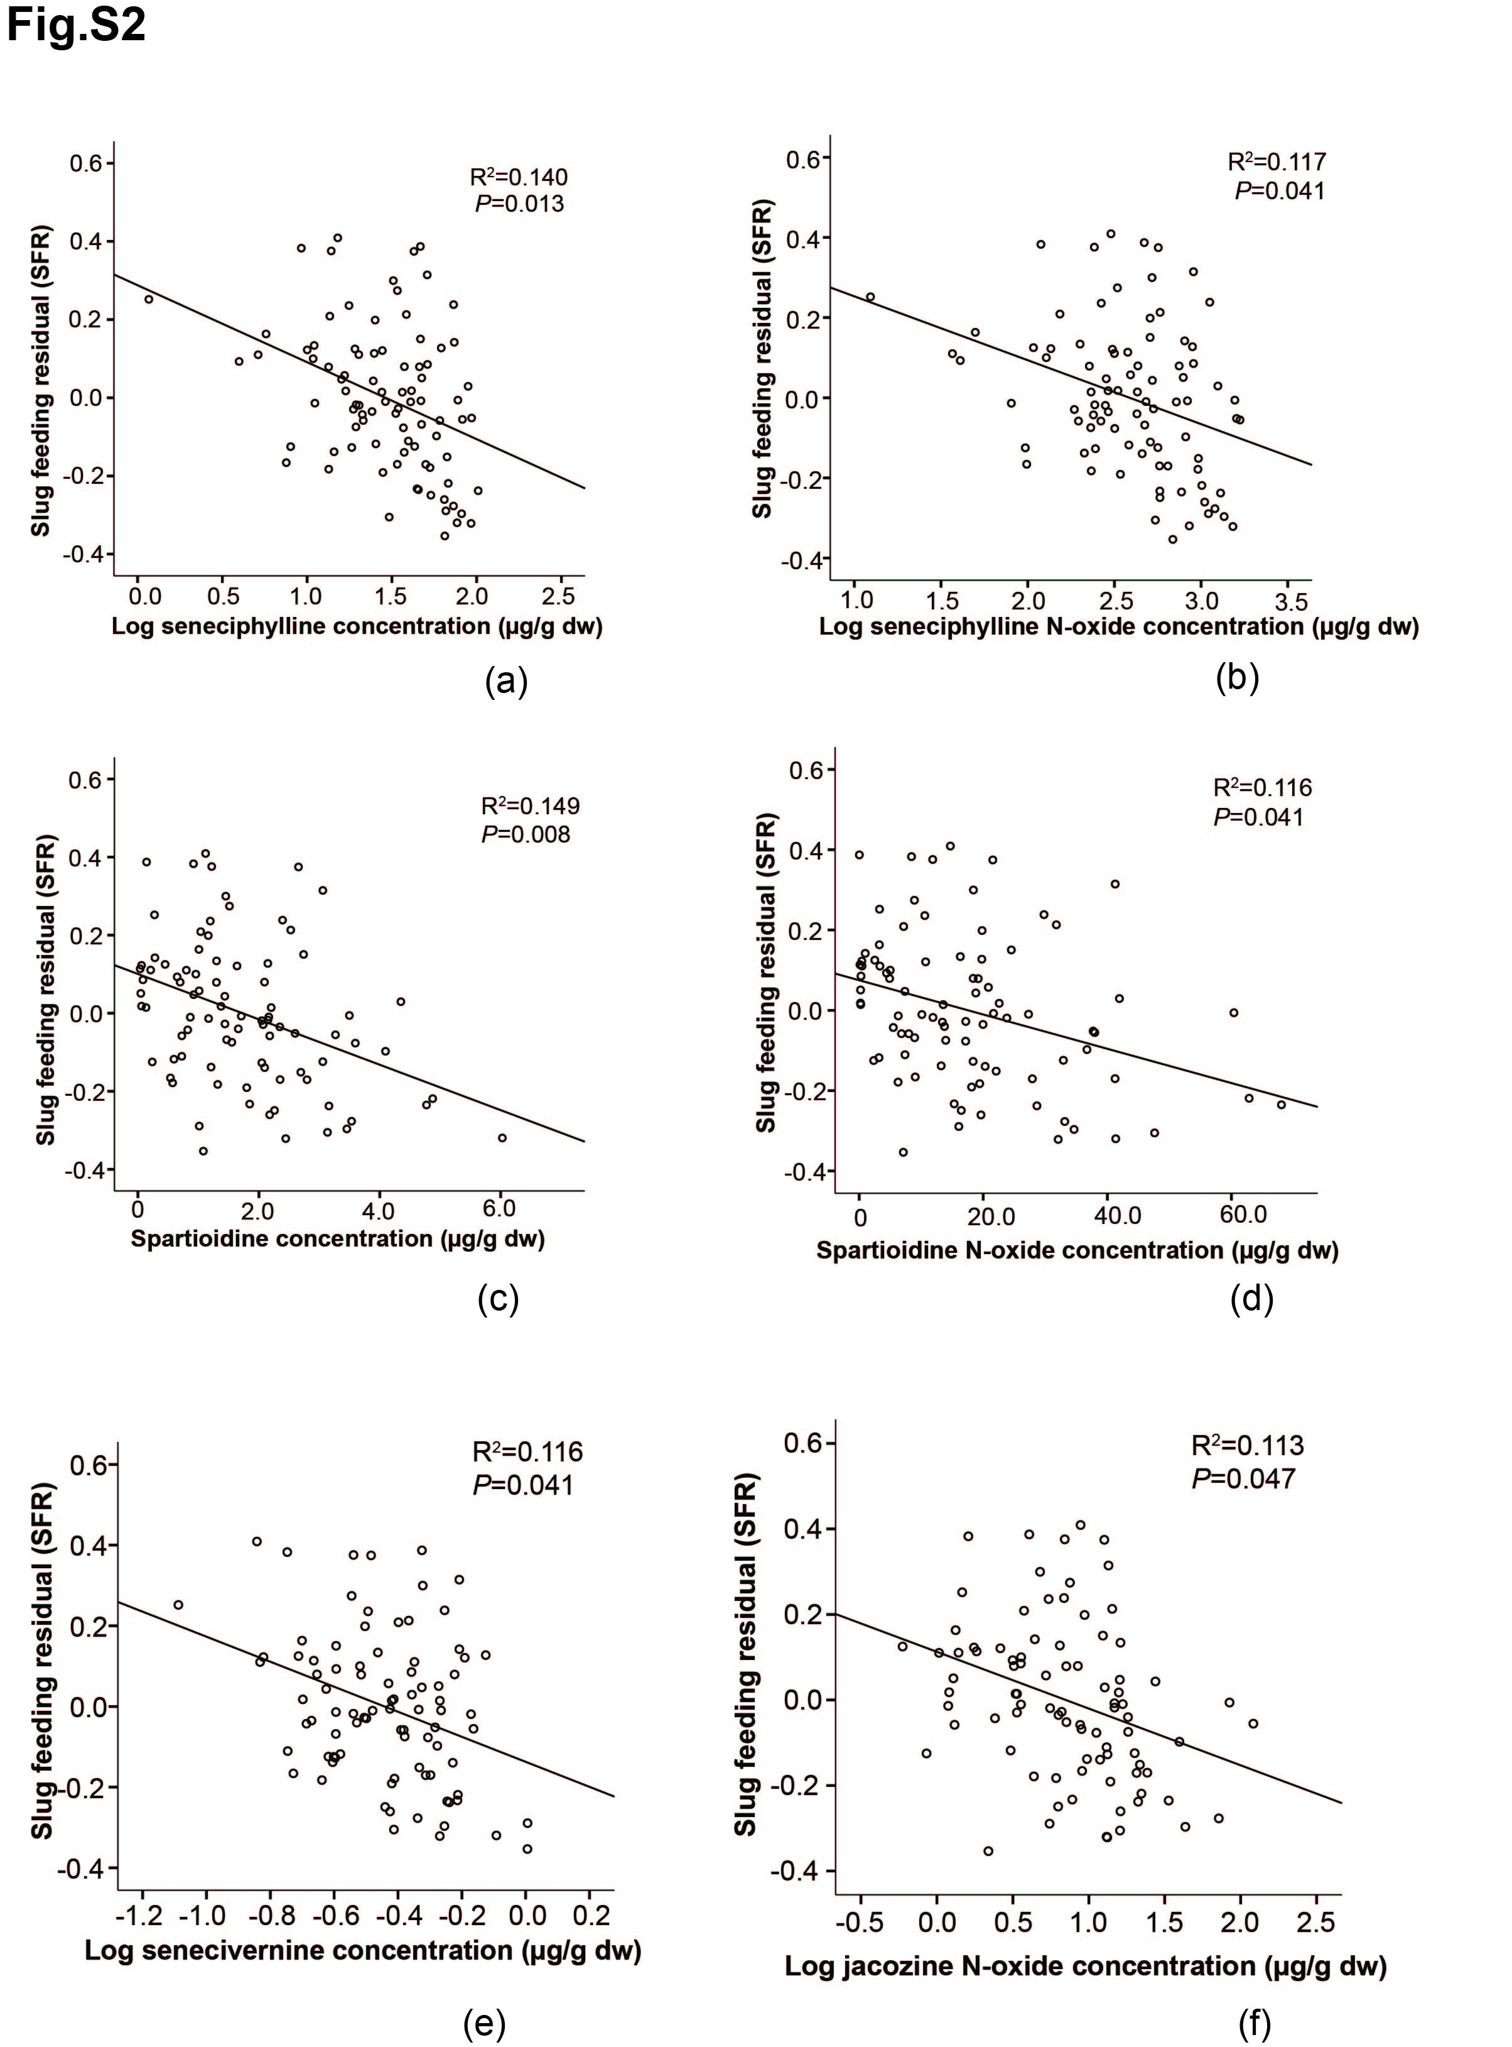
Fig.S2 Scatter plots between slug arcsine square root transformed percentage of feeding damage corrected for trial (SFR) and the concentration of individual pyrrolizidine alkaloids (PAs): seneciphylline (a), seneciphylline N-oxide (b), spartioidine (c), spartioidine N-oxide, (d), senecivernine (e), jacozine N-oxide (f) of 87 F2 hybrids of Jacobaea vulgaris and Jacobaea aquatica. The genotypic mean of PA concentrations (except for spartioidine and spartioidine N-oxide) were log transformed. Each P value was corrected by sequential Bonferroni test. Each dot represents the genotypic mean value of one of 87 F2 genotypes
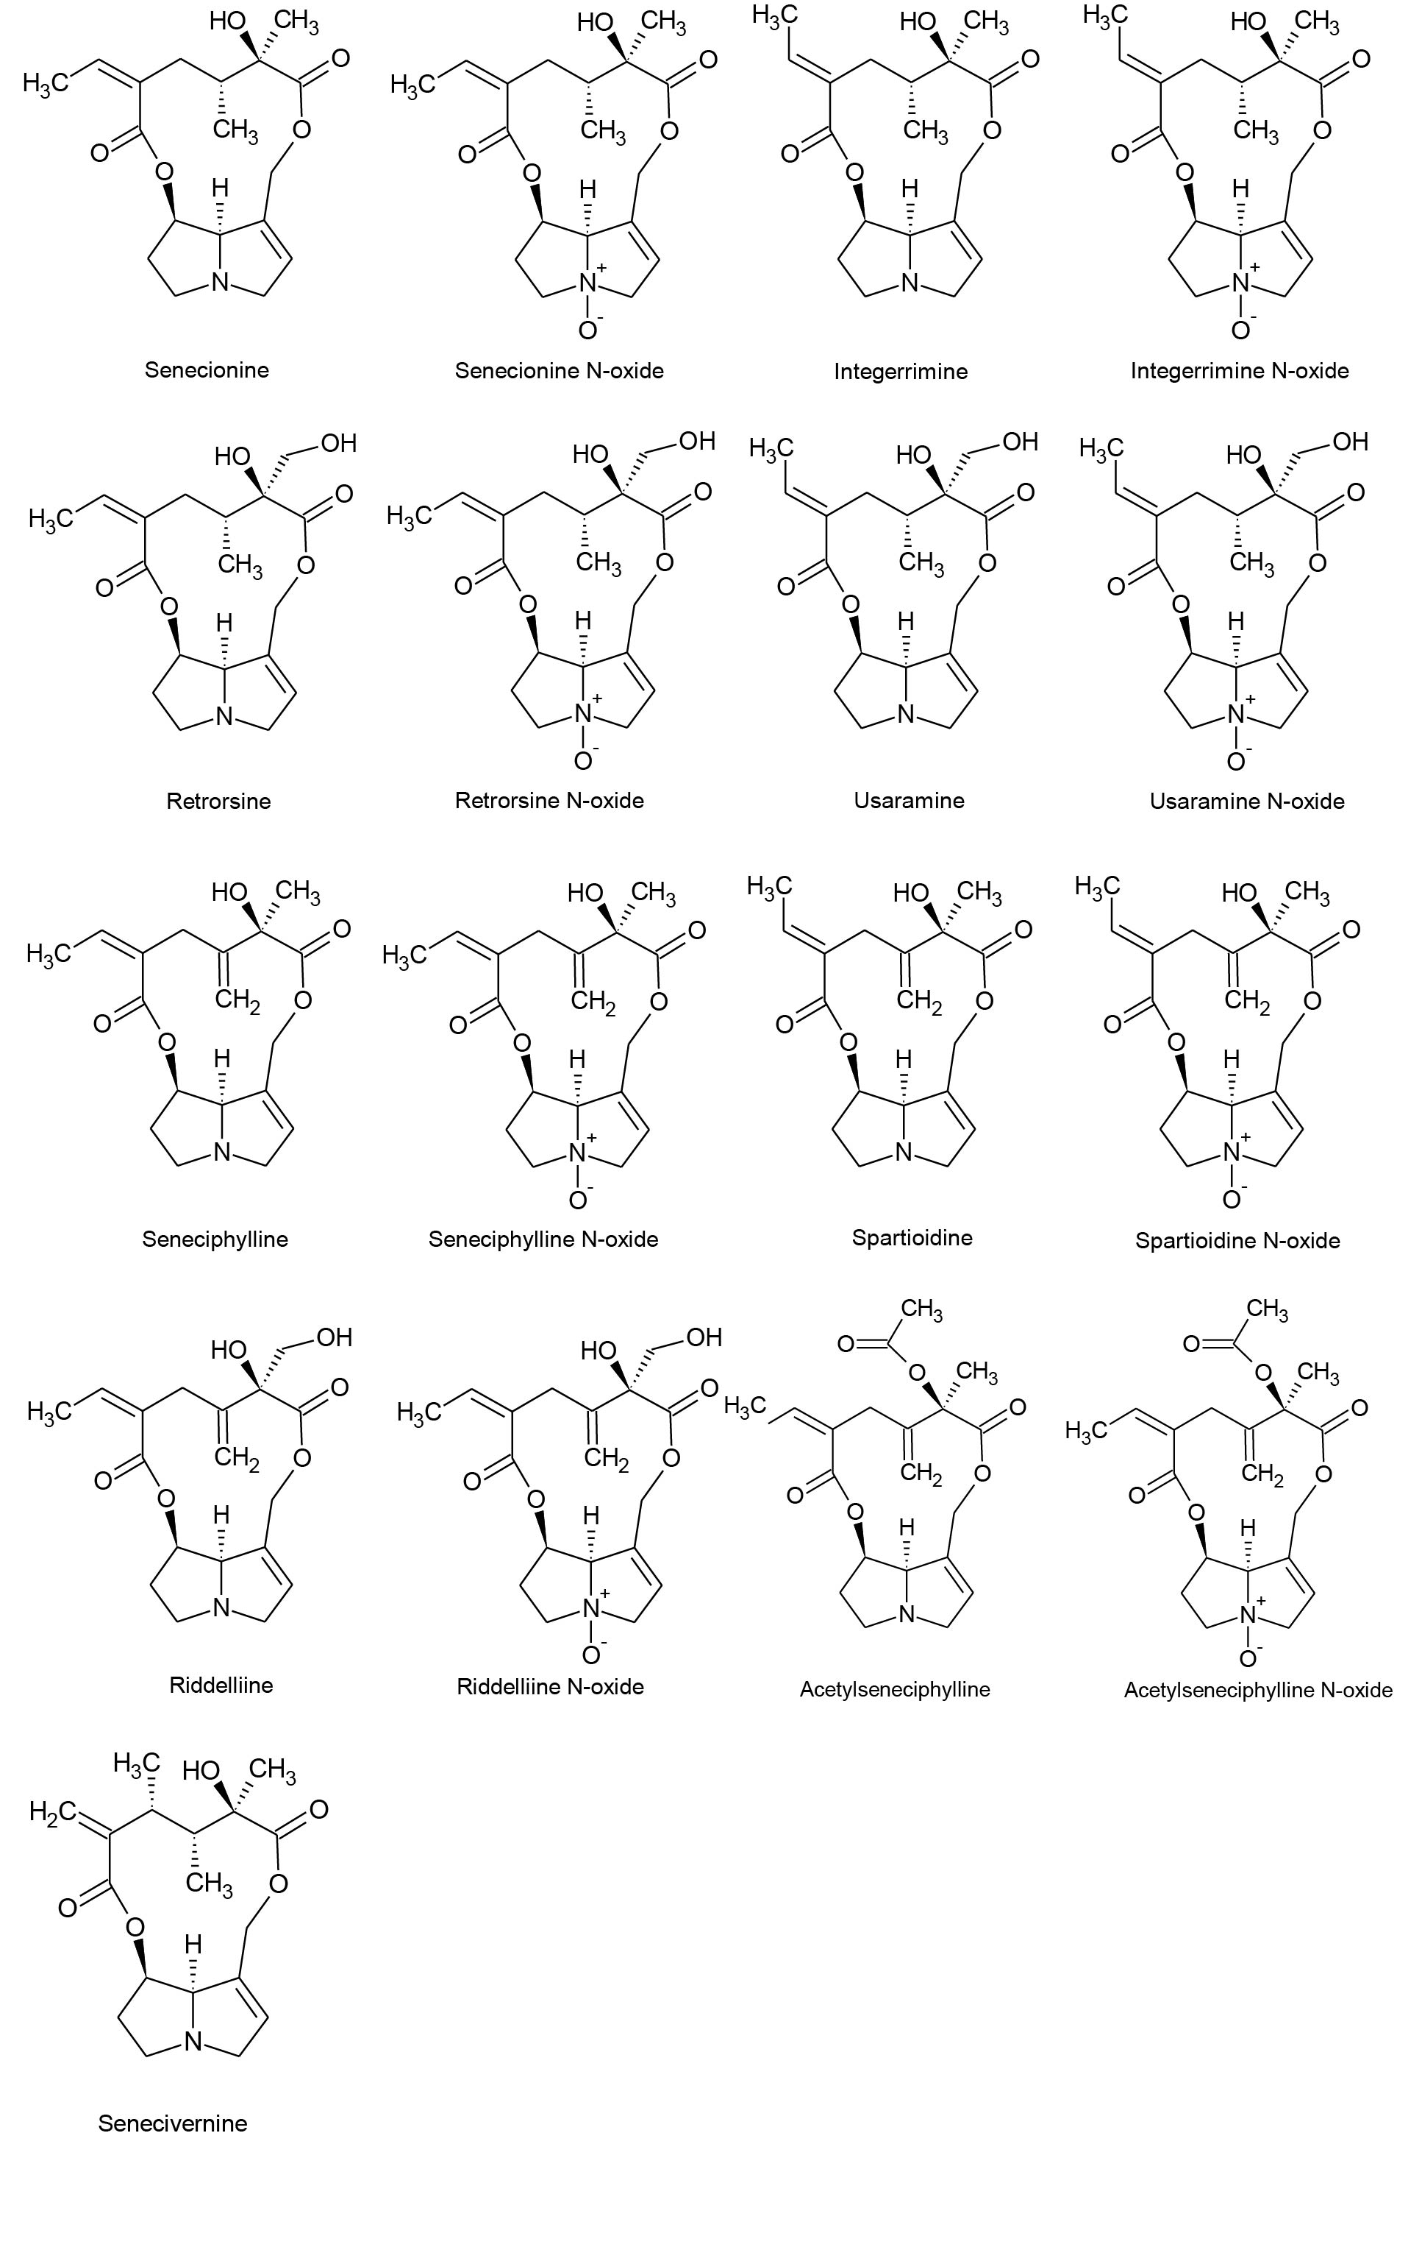
Fig.S3 Chemical structures of senecionine-like PAs

