PHYTOCHEMICAL BACKGROUND MEDIATES EFFECTS OF PYRROLIZIDINE ALKALOIDS ON WESTERN FLOWER THRIPS

XIAOJIE LIU^{1,2} *, KLAAS VRIELING¹, PETER G.L. KLINKHAMER¹

¹ Plant Ecology and Phytochemistry, Institute of Biology, Leiden University, PO Box 9505, 2300 RA Leiden, The Netherlands
² Modern Research Center for Traditional Chinese Medicine, Shanxi University, Taiyuan 030006, China

* Corresponding author. E-mail: x.liu.2@biology.leidenuniv.nl

- Supplementary figures
Figure Legend
FIG. S1. Experimental design of the in vitro thrips bioassay of one well of a 96 wells plate
FIG. S2. A schematic figure illustrating the repeation of the experiments
FIG. S3. Total PA concentration in the five fractions of Jacobaea shoots derived from the MeOH extract (mM) at the highest concentration tested. Data are based on the LC-MS/MS analysis of the fractions
FIG. S4. Log-transformed rates of 2nd instar Western flower thrips (WFT) (Frankliniella occidentalis) against the amount of Jacobaea plant mass equivalents per mL of the methanol extract (A) and the five fractions of the methanol extract: n-hexane fraction (B), CHCl₃ fraction (C), EtOAc fraction (D), n-BuOH fraction (E) and H₂O fraction (F). WFT larvae were put on an artificial diet at five concentrations for 5 days. Survival rate was corrected for differences among negative controls. For significant regressions, lines are shown (see also Table 1 for the corresponding statistical tests)
FIG. S5. Log-transformed survival of 2nd instar Western flower thrips (WFT) (Frankliniella occidentalis) against the concentrations of n-hexane fraction (open dots), CHCl₃ fraction (solid triangles), EtOAc fraction (stars), n-BuOH fraction (solid dots) and H₂O fraction (squares). Dots are averages ± SE (n = 4)
FIG. S6. Western flower thrips (WFT) survival rates of 5 fractions of a Jacobaea methanol extract, retrorsine and the combination of retrorsine with n-hexane fraction (A), CHCl₃ fraction (B), EtOAc fraction (C), n-BuOH fraction (D) and H₂O fraction (E)
FIG. S7. Survival rate of 2nd instar larvae of Western flower thrips (Frankliniella occidentalis) of individual fractions of Jacobaea plant or retrorsine N-oxide and the combination of retrorsine N-oxide with n-hexane fraction (A), CHCl₃ fraction (B), EtOAc fraction (C), n-BuOH fraction (D) and H₂O fraction (E)
FIG. S8. High-performance thin-layer chromatographs (HPTLC) of the MeOH extract of Jacobaea shoots (Track 1), five fractions derived from the MeOH extract (Track 2-6), the re-combined fraction (Track 7) and references compounds (Track 8-12). The TLC plate was detected after derivatisation with the natural products reagent (NPR) and PEG 4000 at 366 nm. Plant fractions: Track 2: the n-hexane fraction; Track 3: the CHCl₃ fraction; Track 4: the EtOAc fraction; Track 5: the n-BuOH fraction; Track 6: the H₂O fraction. Reference compounds: Track 8: rutin; Track 9: chlorogenic acid; Track 10: quercetin; Track 11: caffeic acid; Track 12: ferulic acid

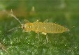
The flat cap

Test solution
Up-side down
Thrips larvae
Test solution
ParafilmTM

FIG. S1.

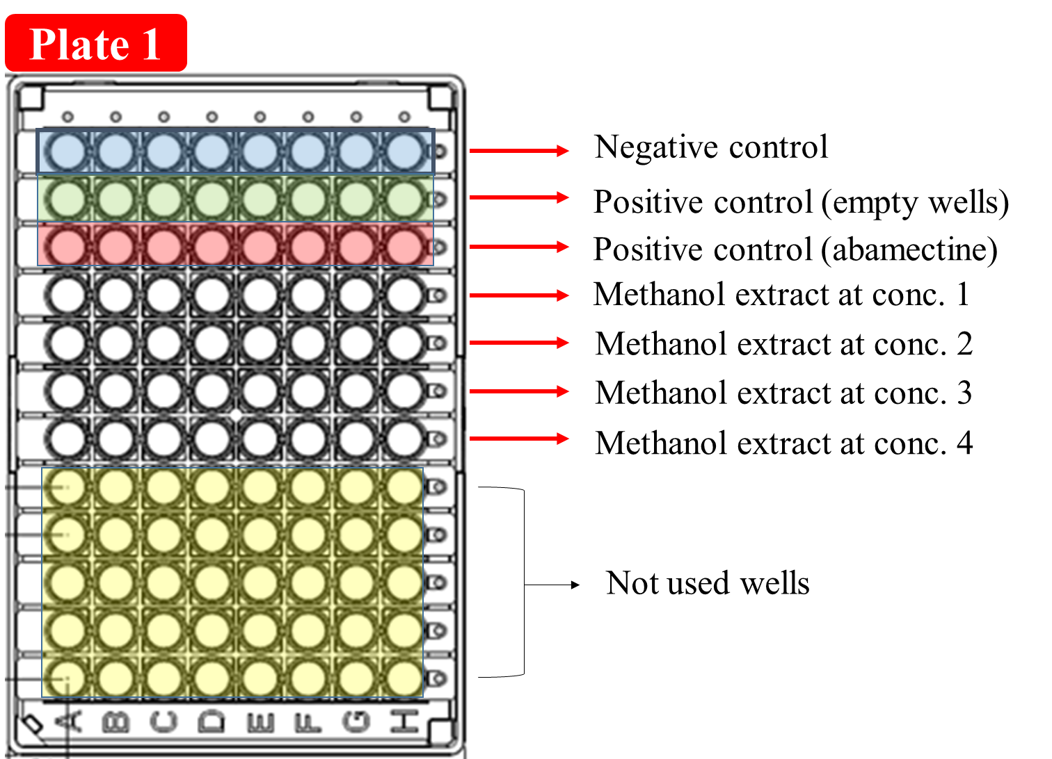
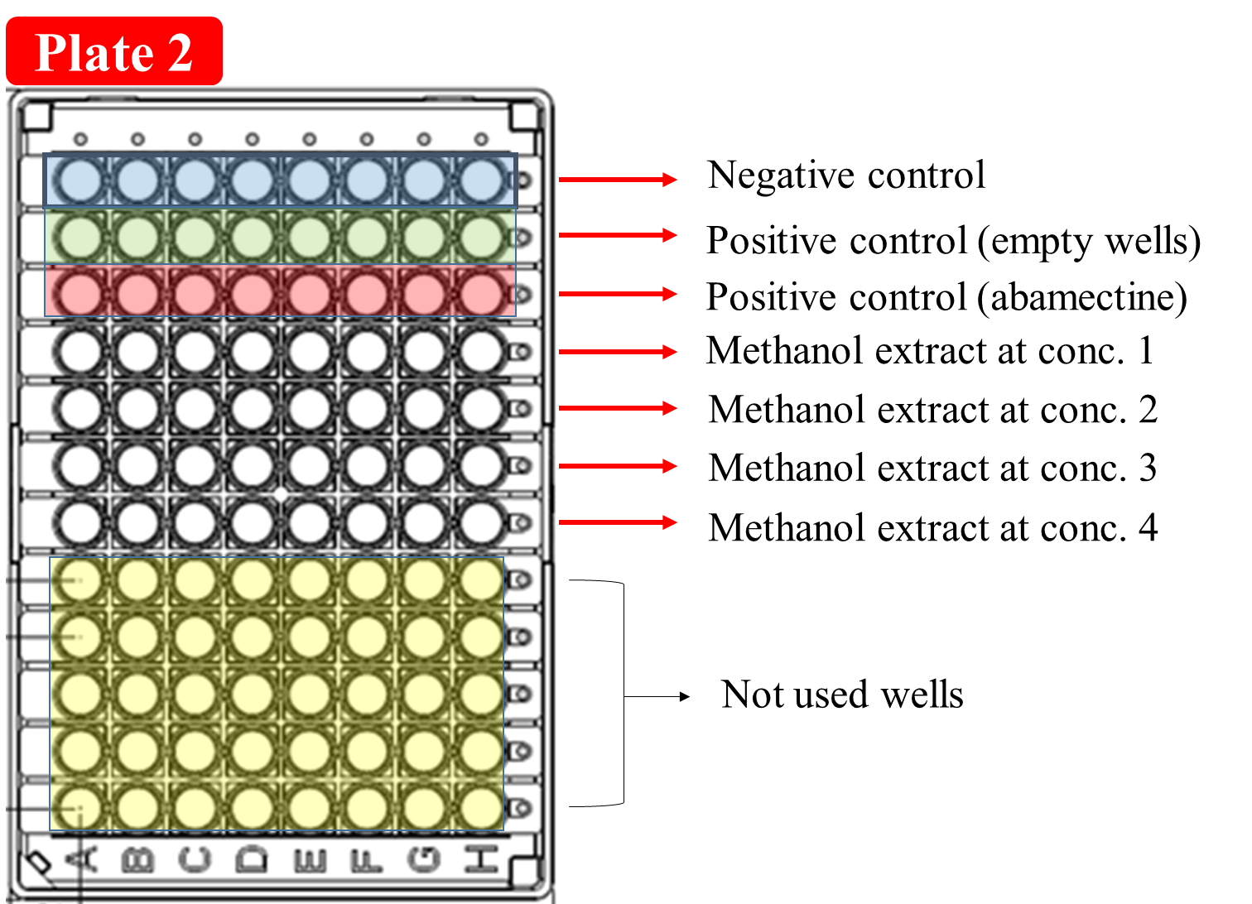
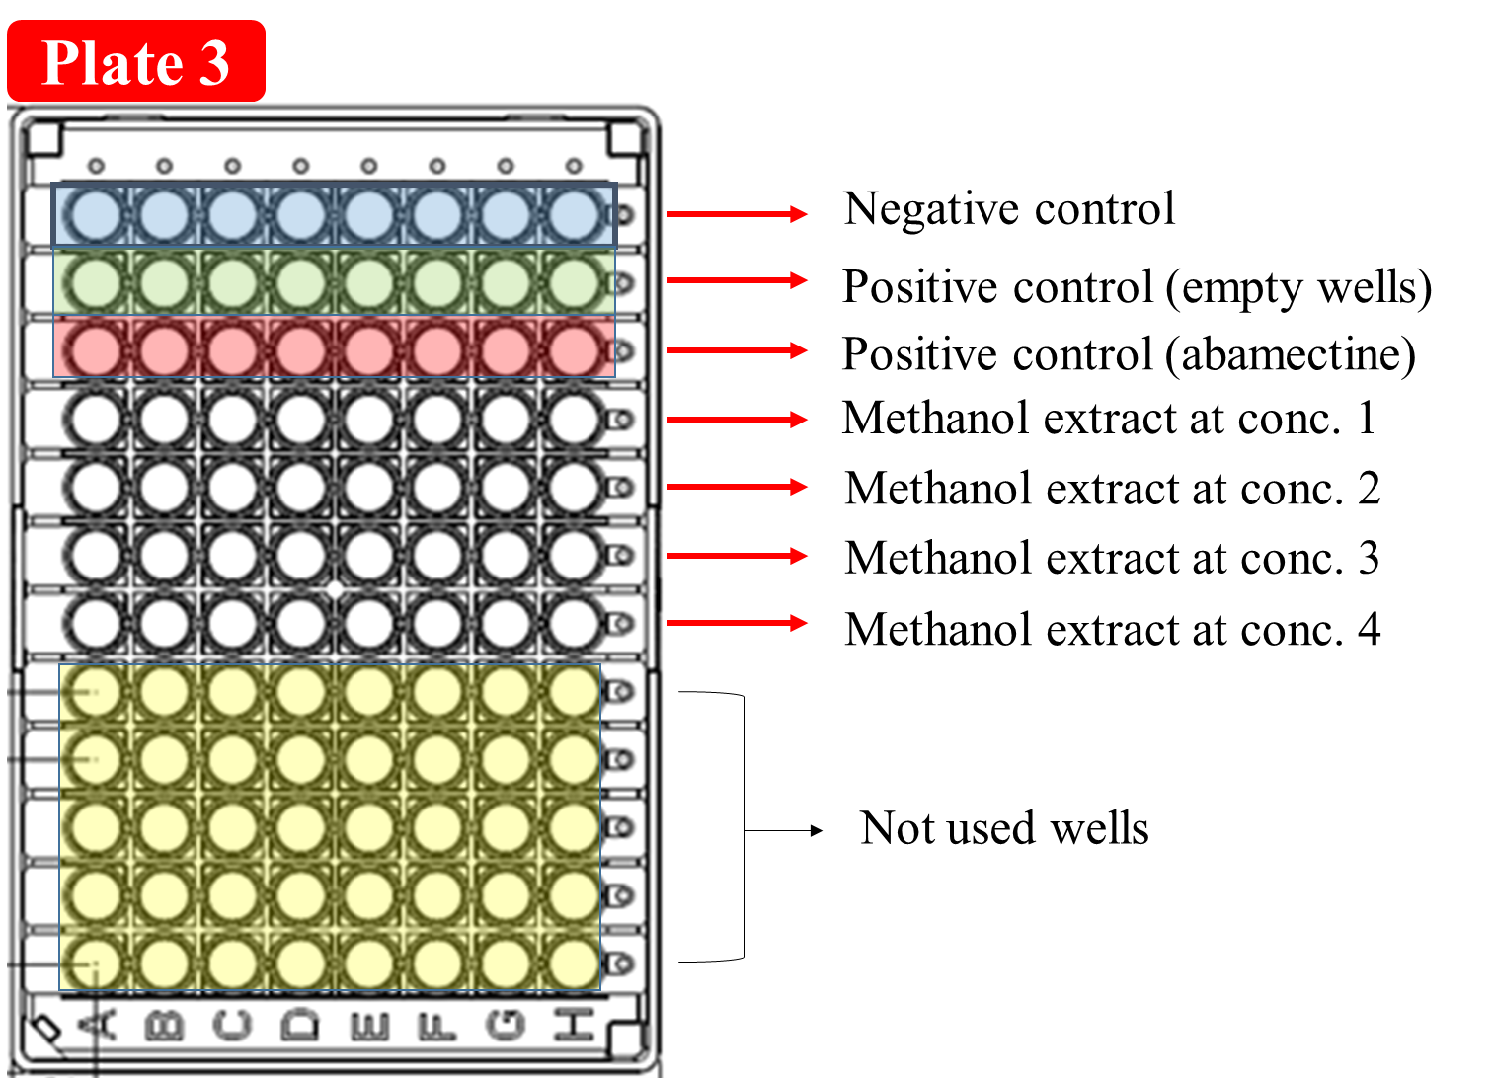
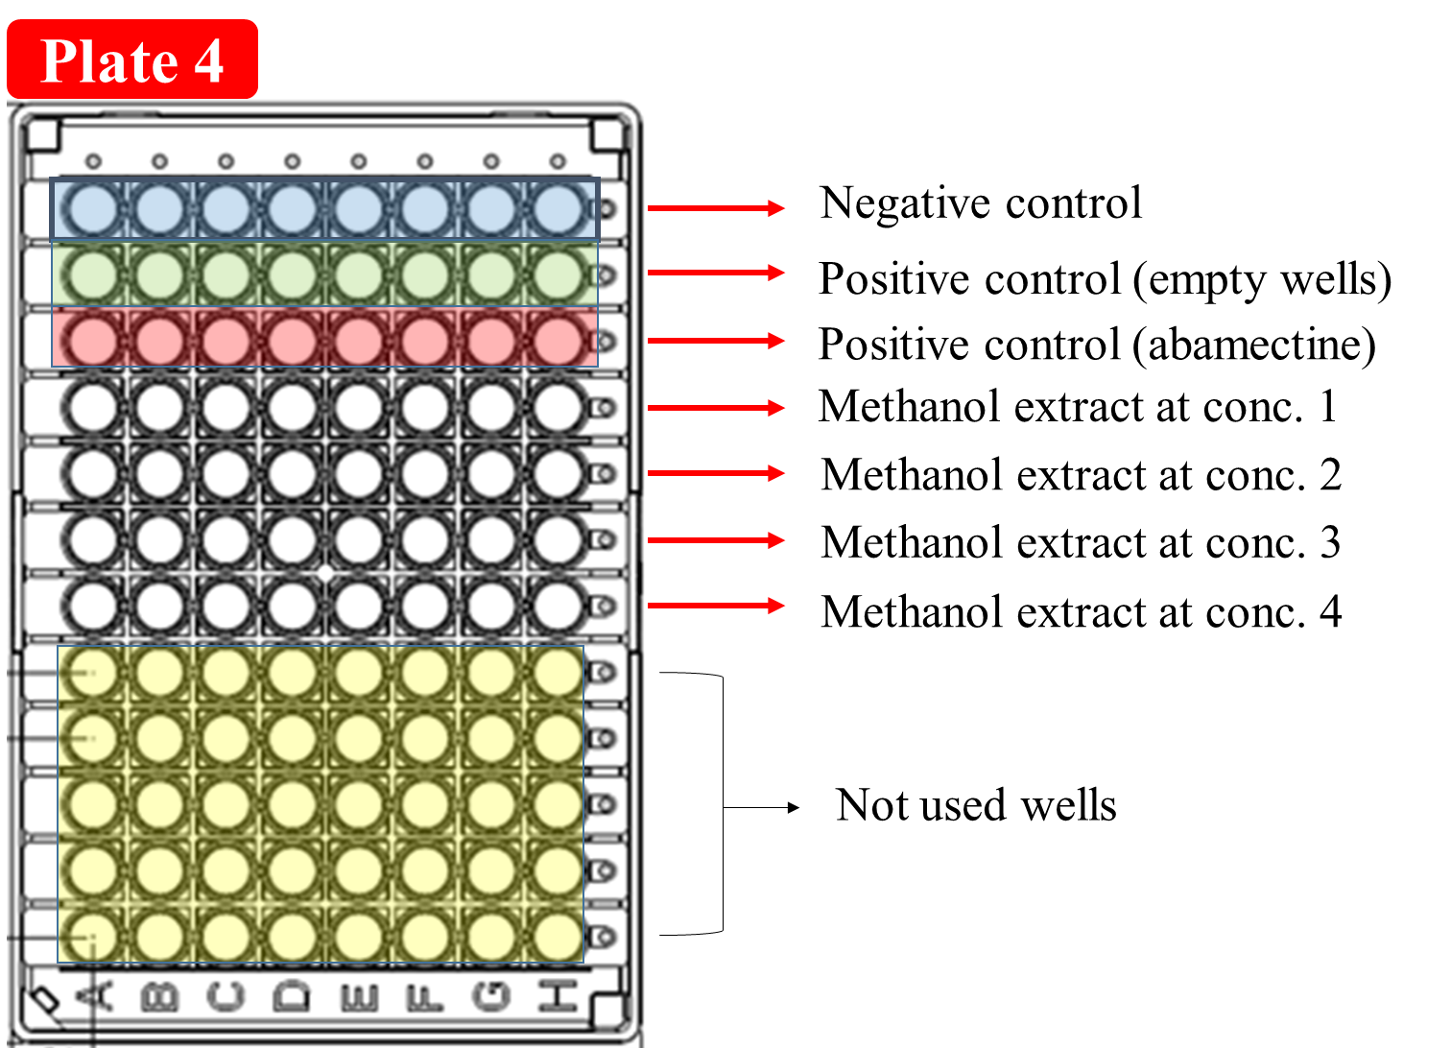
FIG. S2

FIG. S3

Mass equivalents (g/mL)
Mass equivalents (g/mL)
Log WFT survival rates
Log WFT survival rates

Log WFT survival rates
FIG. S4

FIG. S5

FIG. S6

FIG. S7

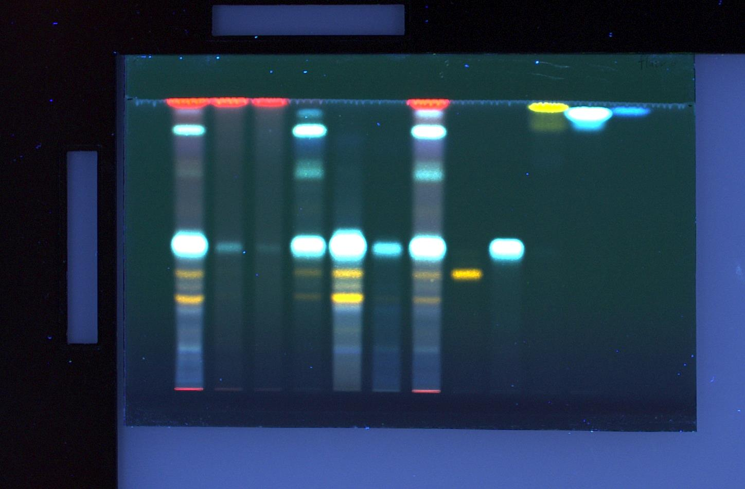
1 2 3 4 5 6 7 8 9 10 11 12

FIG. S8

- Supplementary tables
TABLE S1. Two-way analyses of variance (ANOVAs) with fraction concentration and retrorsine concentration as fixed factors and the interaction effect S_{PA*F} minus one as the dependent variable. A significant intercept indicates a synergistic or antagonistic interaction

Factors | df | F | P
Intercept | 1, 11 | 23.9 | <0.01
n-hexane fraction concentration | 2, 11 | 1.1 | NS
Retrorsine concentration | 1, 11 | 4.3 | NS
n-hexane fraction concentration * Retrorsine concentration | 2, 11 | 1.9 | NS
Intercept | 1, 11 | 3.1 | NS
CHCl₃ fraction concentration | 2, 11 | 0.9 | NS
Retrorsine concentration | 1, 11 | 7.2 | <0.05
CHCl₃ fraction concentration * Retrorsine concentration | 2, 11 | 0.5 | NS
Intercept | 1, 11 | 0.4 | NS
EtOAc fraction concentration | 2, 11 | 1.1 | NS
Retrorsine concentration | 1, 11 | 0.1 | NS
EtOAc fraction concentration * Retrorsine concentration | 2, 11 | 0.4 | NS
Intercept | 1, 10 | 37.0 | <0.01
n-BuOH fraction concentration | 2, 10 | 0.7 | =0.06
Retrorsine concentration | 1, 10 | 5.8 | NS
n-BuOH fraction concentration * Retrorsine concentration | 2, 10 | 0.7 | NS
Intercept | 1, 11 | 9.6 | <0.05
H₂O fraction concentration | 2, 11 | 7.5 | <0.05
Retrorsine concentration | 1, 11 | 0.1 | NS
H₂O fraction concentration * Retrorsine concentration | 2, 11 | 0.3 | NS

NS = Not significant

TABLE S2. Two-way analyses of variance (ANOVAs) with fraction concentration and retrorsine N-oxide concentration as fixed factors and the interaction effect S_{PA*F} minus one as a dependent variable. A significant intercept indicates a synergistic or antagonistic interaction

Factors | df | F | P
Intercept | 1, 11 | 33.9 | < 0.001
n-hexane fraction concentration | 2, 11 | 4.4 | NS
Retrorsine N-oxide (Re NO) concentration | 1, 11 | 0.03 | NS
n-hexane fraction concentration * Re NO concentration | 2, 11 | 0.3 | NS
Intercept | 1, 11 | 127.8 | < 0.001
CHCl₃ fraction concentration | 2, 11 | 3.2 | NS
Re NO concentration | 1, 11 | 15.8 | < 0.01
CHCl₃ fraction concentration * Re NO concentration | 2, 11 | 4.1 | NS
Intercept | 1, 11 | 0.5 | NS
EtOAc fraction concentration | 2, 11 | 5.3 | < 0.05
Re NO concentration | 1, 11 | 0.005 | NS
EtOAc fraction concentration * Re NO concentration | 2, 11 | 0.06 | NS
Intercept | 1, 11 | 21.5 | < 0.01
n-BuOH fraction concentration | 2, 11 | 0.3 | NS
Re NO concentration | 1, 11 | 6.4 | < 0.05
n-BuOH fraction concentration * Re NO concentration | 2, 11 | 0.4 | NS
Intercept | 1, 11 | 2.0 | NS
H₂O fraction concentration | 2, 11 | 2.6 | NS
Re NO concentration | 1, 11 | 0.2 | NS
H₂O fraction concentration * Re NO concentration | 2, 11 | 0.1 | NS

NS = Not significant

