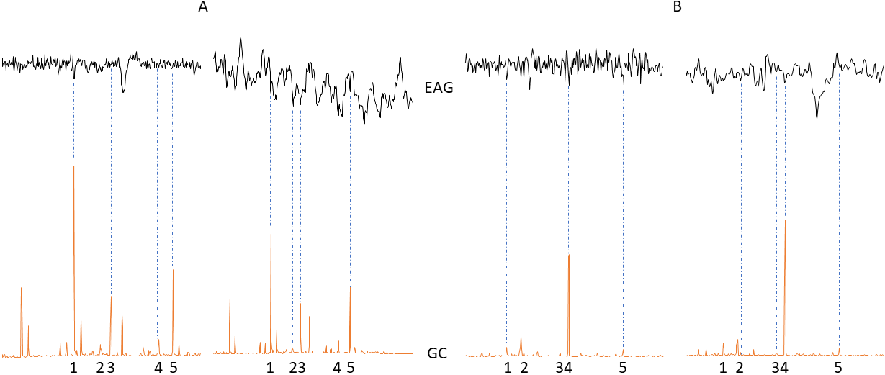

Supplementary Fig. 1. Typical coupled gas chromatography-electrophysiology (GC-EAG) recordings from the antennae of female Maruca vitrata to cowpea volatile extracts. Numbers indicate EAG-active peaks. A: floral volatile extract, 1: benzaldehyde, 2: benzylalcohol, 3: acetophenone, 4: vinylbenzaldehyde isomer, 5: (E)-cinnamaldehyde. B: HIPV extract, 1: (R or S)-1-octen-3-ol, 2: n-hexyl acetate, 3: (R or S)-linalool, 4: (E)-DMNT, 5: indole.

