Supplementary Figures
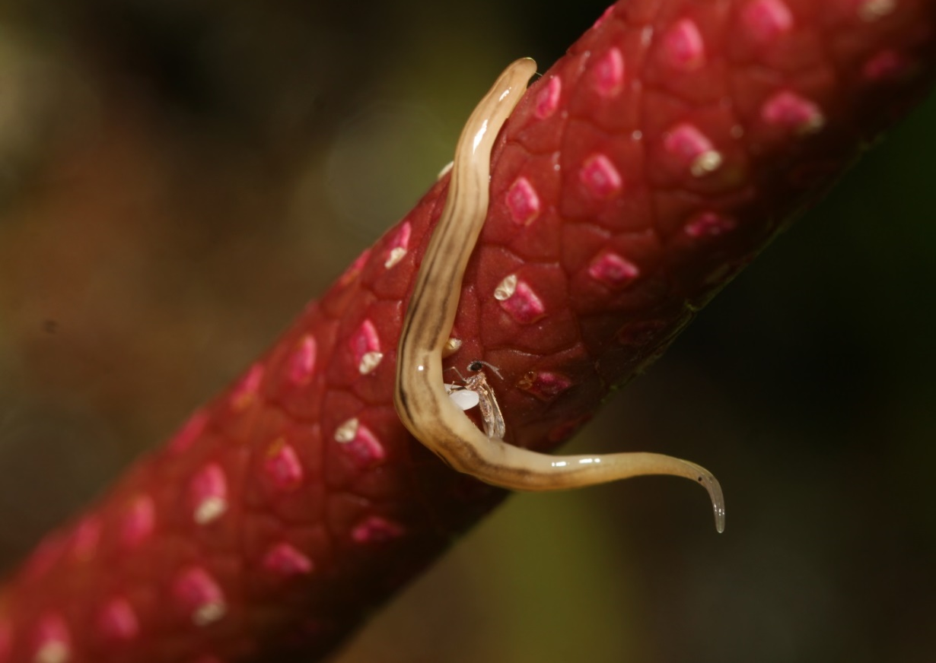
Fig. S1 A land-flatworm (Plathelminthes: Geoplanidae) feeding on a gall midge pollinator.

