Supporting Information. Journal of Chemical Ecology. Constitutive level of specialized secondary metabolites affects plant phytohormone response to above- and belowground herbivores.

Kayleigh C. Hauri^{1,*}, Anthony L. Schilmiller², Elisabeth Darling^{3,4}, Amanda D. Howland^{1,4}, David S. Douches³, and Zsofia Szendrei¹

¹Department of Entomology, Michigan State University, East Lansing, MI, USA
²Mass Spectrometry and Metabolomics Core, Michigan State University, East Lansing, MI, USA
³Department of Entomology, UC Riverside, Riverside, CA, USA
⁴Department of Plant, Soil and Microbial Sciences, Michigan State University, East Lansing, MI, USA

*Corresponding author email: haurikay@msu.edu
⁵Authors contributed equally to the manuscript.

Appendix S1

Table of Contents
Fig. S1. Components of plant chemical defense influencing spatially separated herbivores.
Fig. S2. Chaconine and Solanine LC-MS chromatograms.
Fig. S3. Mass spectra of solanine and chaconine with collision energy on showing fragmentation.
Fig. S4. Colorado potato beetle plant consumption.
Table S1. MS/MS details for targeted phytohormone method.
Table S2. Model output (F- and p-values) for plant hormones in the leaves and roots of two Solanum chacoense breeding lines that were damaged by M. hapla nematodes (RKN) and/or Colorado potato beetle (CPB).

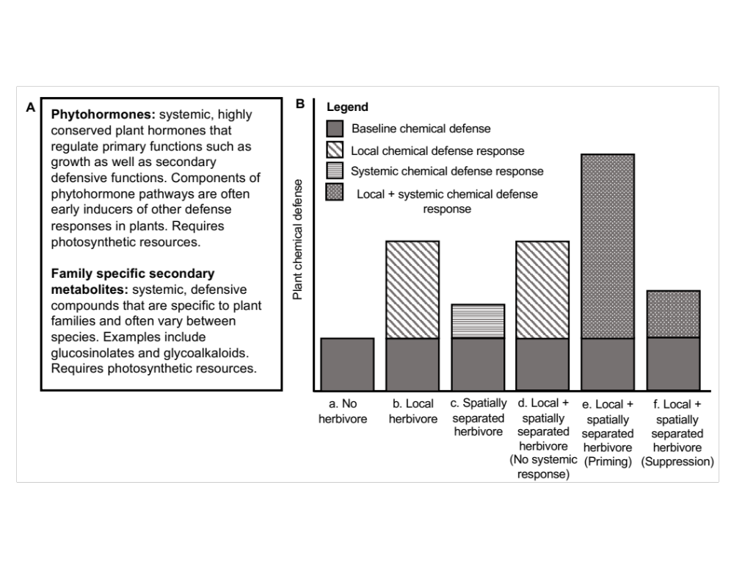
Fig. S1 Components of plant chemical defense influencing spatially separated herbivores. A) Description of phytohormone and family-specific components of plant defense. B) Possible outcomes of local and spatially separated herbivory on plant defense. Plants can respond locally or systemically, or in both ways, to herbivory. Local response is indicated by a change in plant chemical defenses in the same tissues where the herbivory is occurring compared to a plant without herbivory (a): for example, an increase in jasmonic acid in leaf tissues in response to aboveground beetle herbivory (b). Responses to spatially separated herbivores are expected to increase plant defense compared to (a), a change in glycoalkaloid composition in leaves while the roots are damaged by nematodes (c). On plants with multiple herbivores, a response that is no different from a local response (b) would indicate a lack of systemic effects (d). Systemic response is indicated by a difference between the multiple herbivore state and the local herbivore state, either enhancing the response to a single local herbivore, such as through priming (e); or a dampened response to a local herbivore, through suppression of defense pathways (f). For example, in plants with both plant-parasitic nematodes and beetles aboveground, a reduction in plant JA production in leaf tissue following beetle herbivory would indicate a systemic effect (root to shoot) of nematodes.

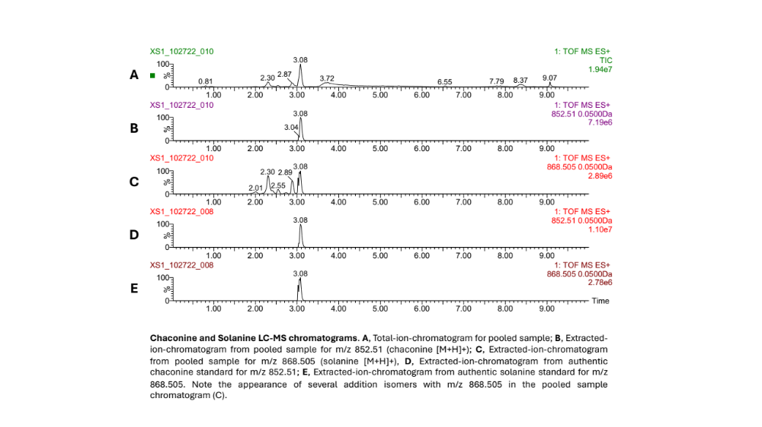
Fig. S2 Chaconine and Solanine LC-MS chromatograms. A) Total-ion-chromatogram for pooled sample; B) Extracted-ion-chromatogram from pooled sample for m/z 852.51 (chaconine [M+H]+); C) Extracted-ion-chromatogram from pooled sample for m/z 868.505 (solanine [M+H]+); D) Extracted-ion-chromatogram from authentic chaconine standard for m/z 852.51; E) Extracted-ion-chromatogram from authentic solanine standard for m/z 868.505. Note the appearance of several addition isomers with m/z 868.505 in the pooled sample chromatogram (C).

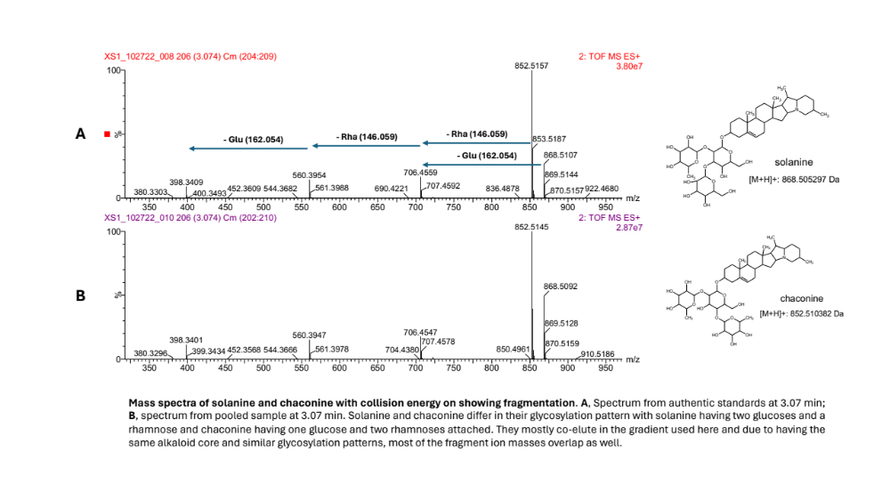
Fig. S3 Mass spectra of solanine and chaconine with collision energy on showing fragmentation. A) Spectrum from authentic standards at 3.07 min; B) spectrum from pooled sample at 3.07 min. Solanine and chaconine differ in their glycosylation pattern with solanine having two glucoses and a rhamnose and chaconine having one glucose and two rhamnoses attached. They mostly co-elute in the gradient used here and due to having the same alkaloid core and similar glycosylation patterns, most of the fragment ion masses overlap as well.

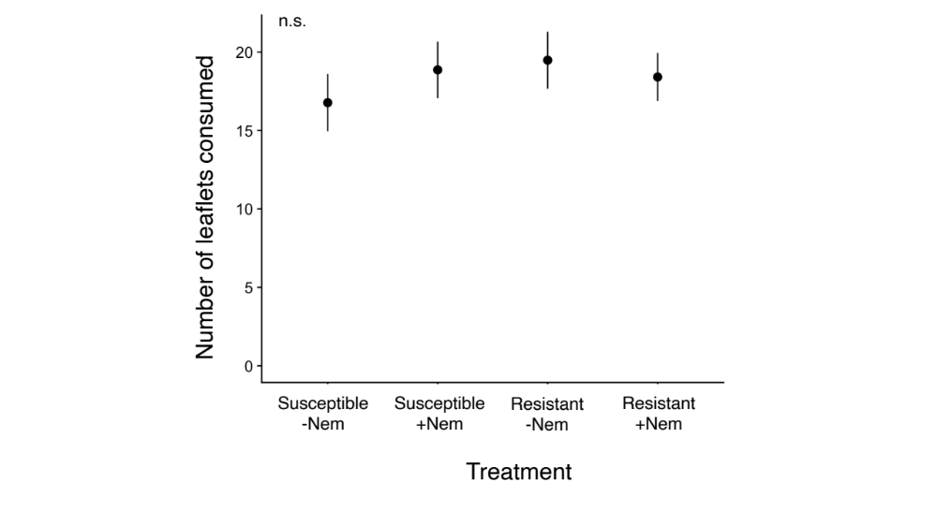
Fig. S4 Colorado potato beetle leaflet consumption does not vary by plant line or nematode presence. After five days of feeding, we visually estimated the aboveground biomass removed by herbivory to the nearest 5% and counted the total number of leaflets and the number of damaged leaflets for each plant to check our estimates. Because leaves grew in a consistent alternating pattern, we were able to estimate total number of leaflets even if a leaflet was fully consumed by a larva. The amount of leaf tissue consumed by beetles was calculated by multiplying the total number of leaflets for a plant by the percent removed by herbivory. Beetles did not consume different amounts of tissue on the two plant lines (F_{1,86.1} = 0.54, p = 0.46), nor did nematode presence affect their consumption (F_{1,86.1} = 0.04, p = 0.83).
Table S1 MS/MS details for targeted phytohormone method.
Compound | Parent Ion | Daughter Ion | Cone Voltage | Collision Energy
SA | 137.1 | 92.8 | 25 | 13
SA-13C6 | 143 | 98.9 | 25 | 13
JA | 209.2 | 58.8 | 20 | 14
JA-d5 | 214.03 | 61.9 | 20 | 14
ABA | 263.2 | 153.1 | 25 | 10
ABA-d6 | 269.2 | 159.1 | 25 | 10
JA-Ile | 322.2 | 130.1 | 34 | 22
SAG | 299.1 | 137 | 28 | 16
OPDA | 291.2 | 165.1 | 46 | 22

Table S2 Model output (F- and p-values) for plant hormones in the leaves and roots of two Solanum chacoense breeding lines that were damaged by M. hapla nematodes (RKN) and/or Colorado potato beetle (CPB). Significant p-values are bolded (α = 0.05).
 | Plant line |  | Nematode |  | CPB |  | Line × Nematode |  | Line × CPB |  | CPB × Nematode
Leaves | F | p | F | p | F | p | F | p | F | p | F | p
JA¹ | 3.69 | 0.06 | 0.26 | 0.61 | 22.85 | < 0.01 | 0.04 | 0.85 | 10.32 | < 0.01 | 0.33 | 0.57
JA-Ile² | 0.18 | 0.67 | 1.07 | 0.31 | 6.97 | 0.01 | 0.41 | 0.52 | 9.47 | < 0.01 | 0.51 | 0.48
OPDA³ | 34.38 | < 0.01 | 13.95 | < 0.01 | 27.00 | < 0.01 | 10.06 | < 0.01 | 19.87 | < 0.01 | 3.77 | 0.06
SA⁴ | 0.26 | 0.62 | 1.19 | 0.28 | 0.12 | 0.73 | 0.41 | 0.53 | 0.16 | 0.69 | 1.35 | 0.25
SAG⁵ | 4.53 | 0.04 | 0.86 | 0.36 | 3.64 | 0.06 | 0.14 | 0.71 | 0.00 | 0.95 | 0.11 | 0.74
ABA⁶ | 12.33 | < 0.01 | 0.40 | 0.53 | 1.30 | 0.26 | 0.22 | 0.64 | 1.26 | 0.27 | 0.16 | 0.69
Roots
JA | 26.69 | < 0.01 | 4.27 | 0.04 | 0.49 | 0.49 | 2.78 | 0.10 | 0.17 | 0.68 | 1.46 | 0.23
JA-Ile | 22.89 | < 0.01 | 9.06 | < 0.01 | 0.11 | 0.74 | 6.81 | 0.01 | 0.30 | 0.58 | 2.46 | 0.12
OPDA | 53.79 | < 0.01 | 1.41 | 0.24 | 6.56 | 0.01 | 1.69 | 0.20 | 1.07 | 0.31 | 0.04 | 0.85
SA | 0.12 | 0.73 | 0.34 | 0.56 | 1.33 | 0.25 | 0.10 | 0.75 | 0.01 | 0.91 | 1.98 | 0.16
SAG | 4.88 | 0.03 | 0.18 | 0.67 | 0.09 | 0.34 | 0.01 | 0.91 | 0.01 | 0.93 | 0.16 | 0.69
ABA | 1.69 | 0.20 | 0.32 | 0.57 | 0.00 | 0.98 | 0.00 | 0.95 | 1.09 | 0.30 | 3.91 | 0.053
¹Jasmonic acid; ²Jasmonic acid isoleucine; 3 12-oxo-phytodienoic acid; ⁴Salicylic acid; ⁵Salicylic acid beta-glucoside; ⁶Abscisic acid

