Table S1. Mass spectrum data presenting the m/z (mass-to-charge) fragments and their top five relative abundances (%) for all compounds identified in the defensive secretions of the millipede Coxobolellus saratani. This information emphasizes the most prominent fragmentation patterns, providing key insights into the chemical composition of each compound.
ID  No. | R. time | Compound | Mass spectrum (electron ionization) | m/z (relative abundance (%)
1 | 2.226 | Not identified  (M = 118) | 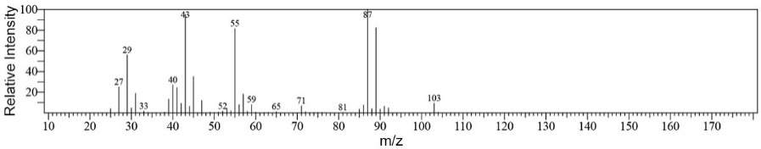 | 87 (100) | 55 (>80) | 43 (>95) | 29 (>55) | 40 (>25)
2 | 2.333 | Not identified  (M = 92) | 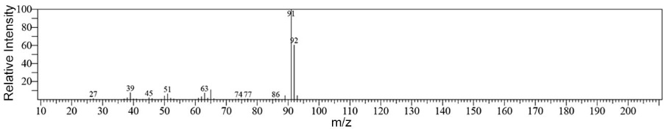 | 91 (100) | 92 (60) | 63 (>10) | 39 (<10) | 51 (<10)
3 | 6.358 | 2-Methyl-1,4-benzoquinone  (M = 122) | 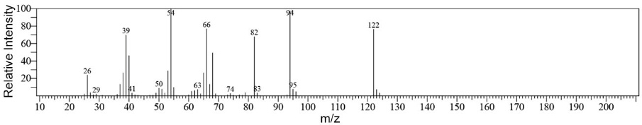 | 54 (100) | 94 (>95) | 66 (>75) | 122  (>75) | 39  (70)
4 | 21.742 | 2-Methoxy-3-methyl-1,4-benzoquinone  (M = 170) | 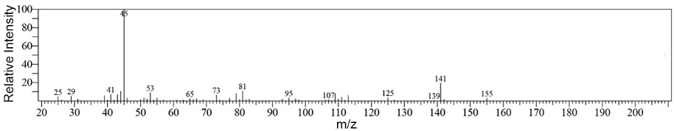 | 45 (100) | 141  (30) | 81  (>10) | 53  (10) | 73  (<10)
5 | 15.625 | 2-Methoxy-1,4-benzoquinone  (M = 124) | 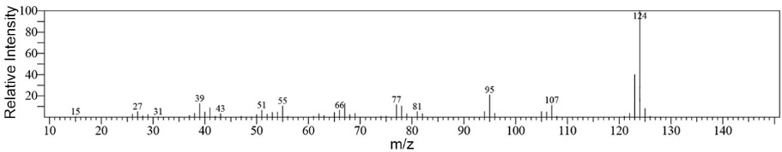 | 124  (100) | 95  (>20) | 107  (>10) | 77  (>10) | 66  (>10)
6 | 17.033 | 3,4-Dimethoxyphenol  (M = 154) | 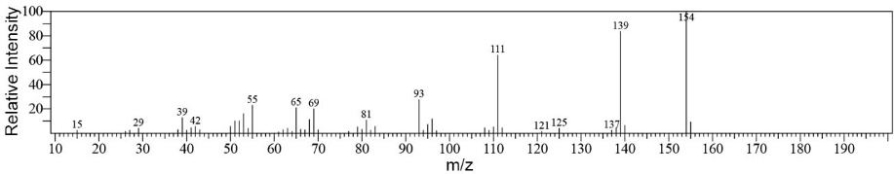 | 154  (100) | 139  (>80) | 111  (>60) | 93  (>25) | 65  (20)

7 | 10.392 | 2,3-Dimethoxy-1,4-benzoquinone  (M = 152) | 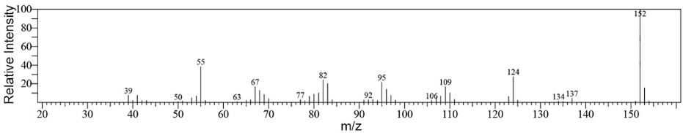 | 152  (100) | 55  (>35) | 124  (>25) | 82  (>20) | 95  (>20)
8 | 15.175 | 2-Methoxy-5-methylhydroquinone  (M = 180) | 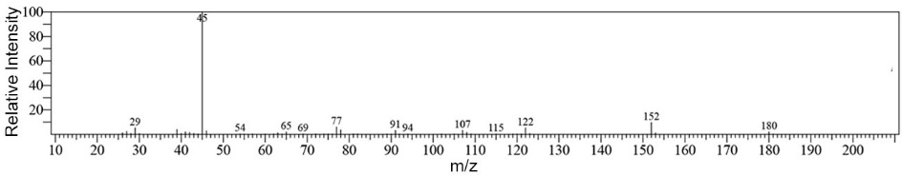 | 45  (100) | 152  (10) | 77  (<10) | 29  (<10) | 122  (<10)
9 | 15.783 | 2,3-Dimethoxyhydroquinone  (M = 170) | 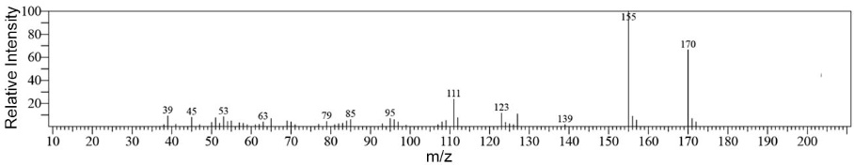 | 155  (100) | 170  (>65) | 111  (>20) | 123  (>10) | 39  (10)
10 | 18.950 | 2-Methyl-3,4-methylenedioxyphenol  (M = 182) | 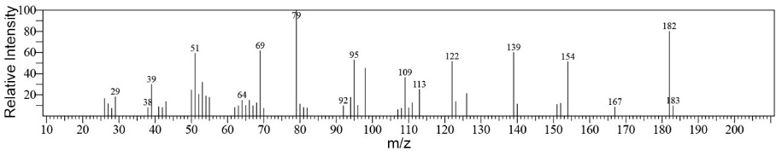 | 79  (100) | 182  (80) | 69  (>60) | 139  (>60) | 51  (>60)
11 | 19.600 | Not identified  (M = 184) | 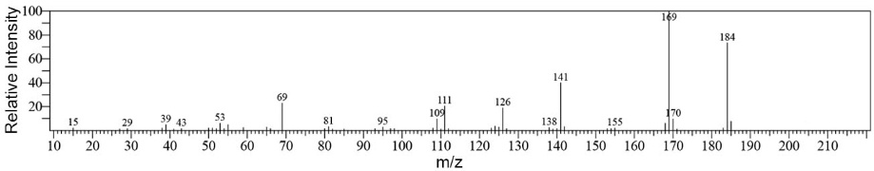 | 169  (100) | 184  (70) | 141  (>40) | 69  (>20) | 111  (20)
12 | 42.642 | Not identified  (M = 268) | 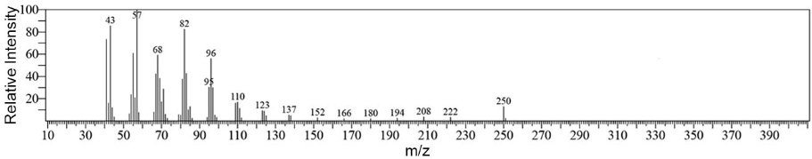 | 57  (100) | 43  (>85) | 82  (>80) | 68  (60) | 96  (>55)
13 | 36.233 | Hexyl pentadecanoate  (M = 281) | 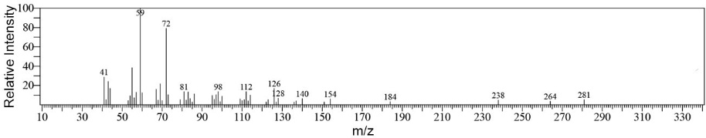 | 59  (100) | 72  (70) | 41  (30) | 126  (>15) | 112  (>10)
14 | 19.100 | Hexyl hexadecanoate  (M = 299) | 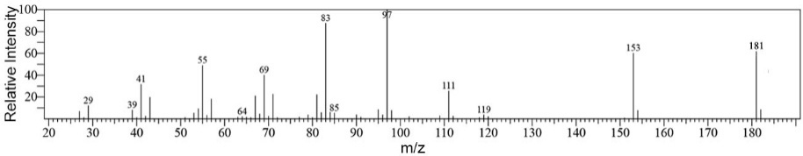 | 97  (100) | 83  (>85) | 181  (>60) | 153  (60) | 55  (50)
15 | 47.250 | Not identified (M = 400) | 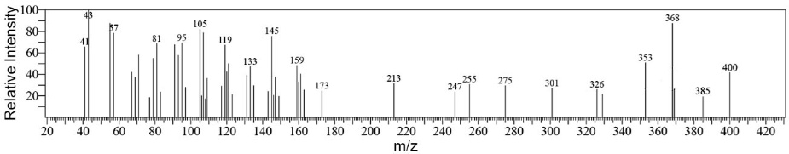 | 43  (100) | 368  (>85) | 57  (>85) | 105  (>80) | 95  (70)
16 | 45.258 | Hexyl octadecanoate  (M = 352) | 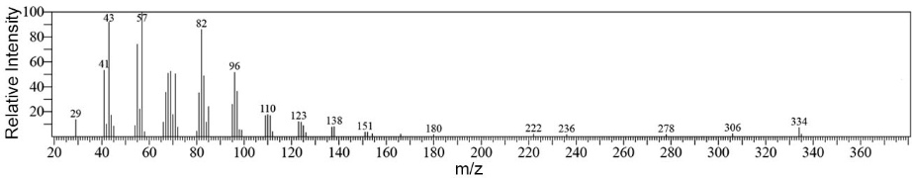 | 57  (100) | 43  (>90) | 82  (>85) | 41  (>50) | 96  (>50)
17 | 41.592 | Octyl heptadecanoate  (M = 380) | 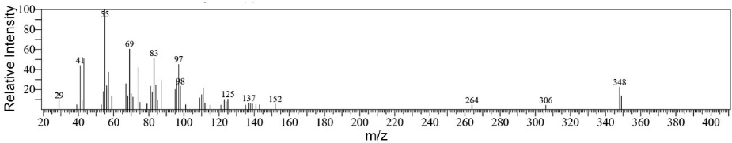 | 55  (100) | 69  (60) | 83  (>50) | 97  (>45) | 41  (>40)

