Journal of Chemical Ecology
Ultra-violet induced biochemical changes in an invasive weed and their implications for plant-biocontrol agent interactions.
D. Paul Barrett¹, Arvind K. Subbaraj², Jason J. Wargent¹, Maria A. Minor¹, Paul Peterson³, David J. Lun¹ and Andrea Clavijo McCormick¹.
¹ College of Sciences,
Massey University, PB 11 222,
Palmerston North, 4410, New Zealand.
² AgResearch, 1365 Springs Rd.
Lincoln 7674, New Zealand.
³ Manaaki Whenua – Landcare Research,
PB 11 052, Palmerston North 4442, New Zealand.

Corresponding Author: d.p.barrett@massey.ac.nz

SUPPLEMENTAL INFORMATION DOC 2.⎯Annotated compound confirmations. All annotation confirmation data composes of screen images from 1: ThermoFisher ― Excalibur “Freestyle”. In the top chromatogram is retention time (rt.). The spectrum beneath provides the m/z value and below that the chemical formula and mass error (Delta [ppm]). 2: The bottom field shows the mass spectral graphic in the online “MassBank” mass spectral library from which parent and fragment ion m/z abundance values have been derived and the chemical structure is also displayed. Compounds are ordered by ascending m/z value. Zooming in on each will reveal finer detail.

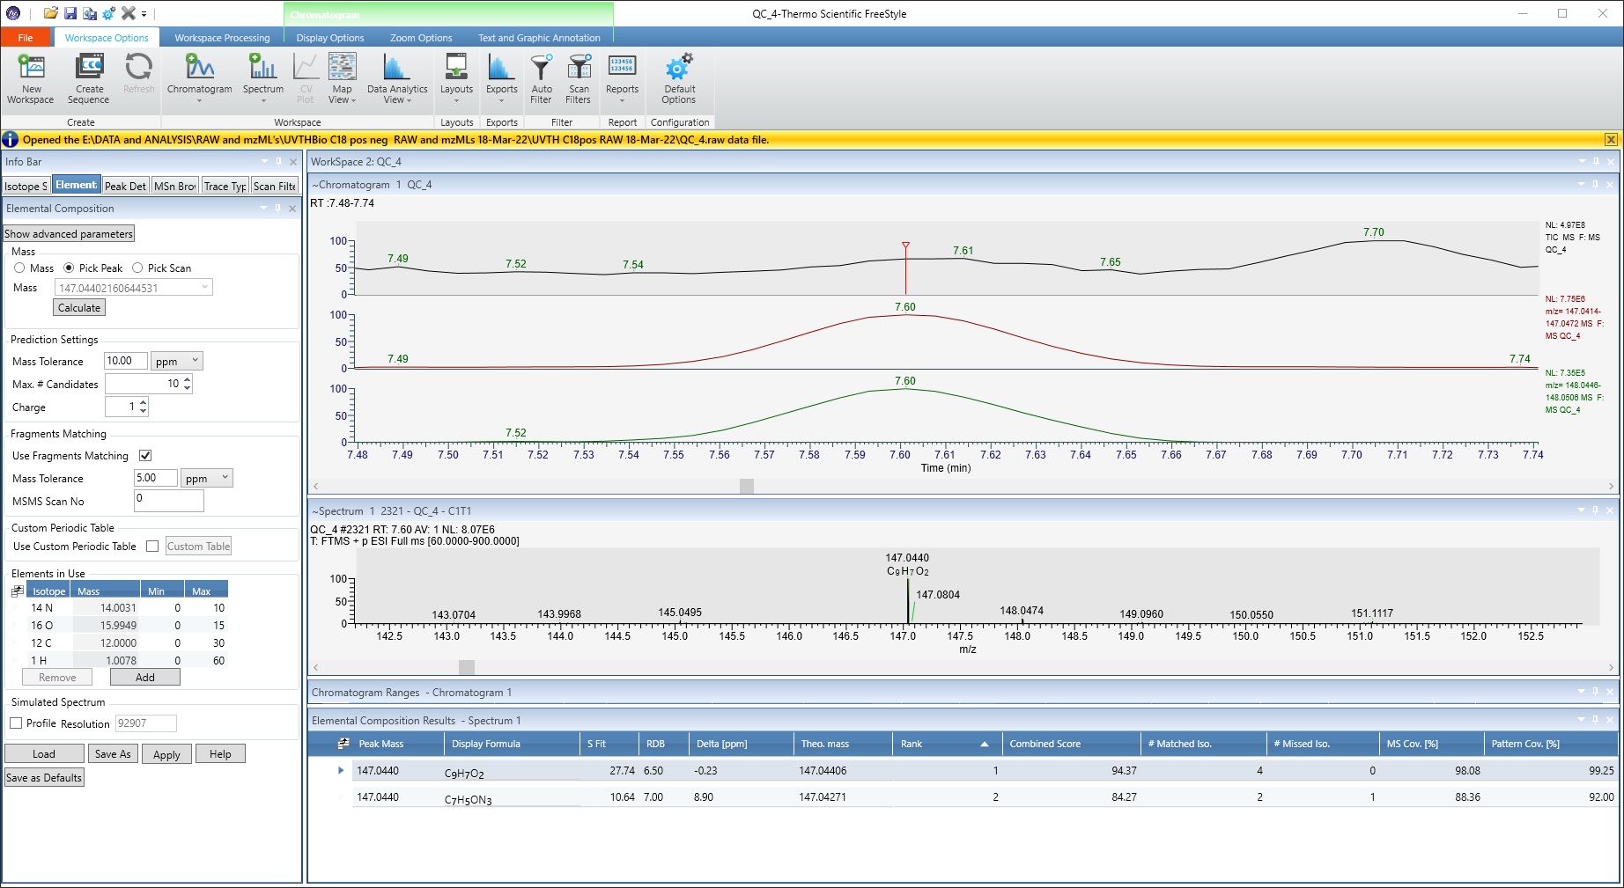
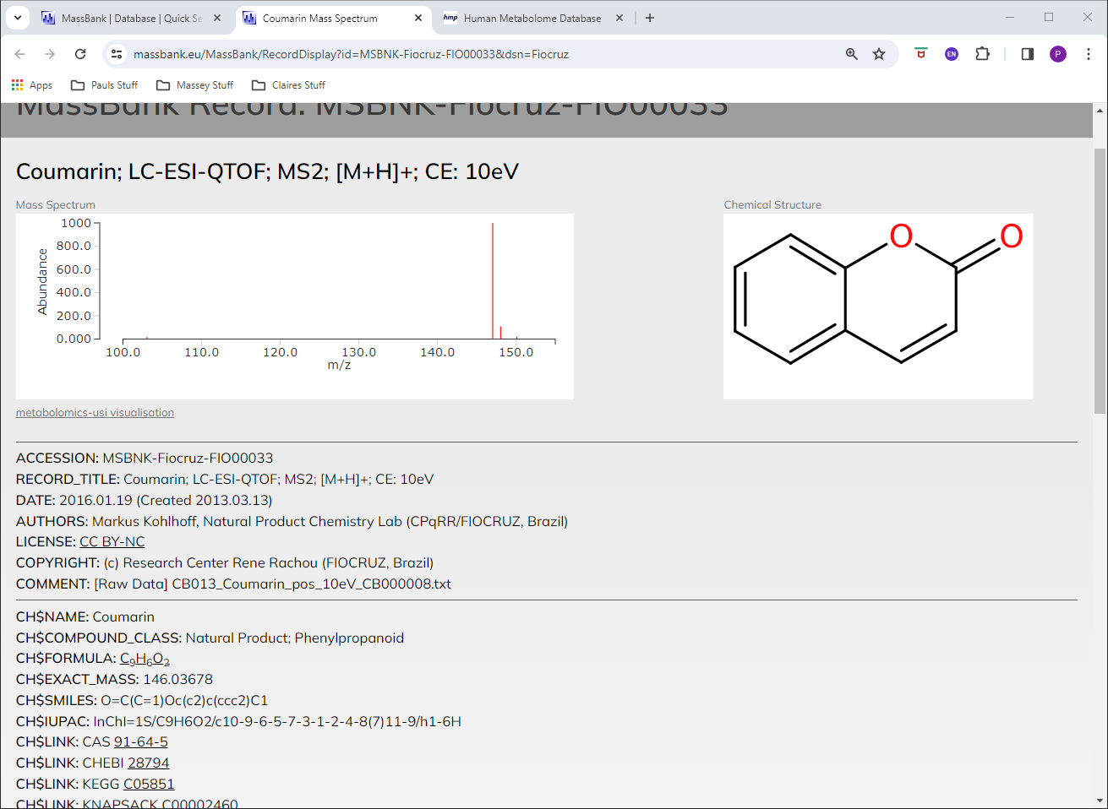
147.044 / 7.6 Coumarin

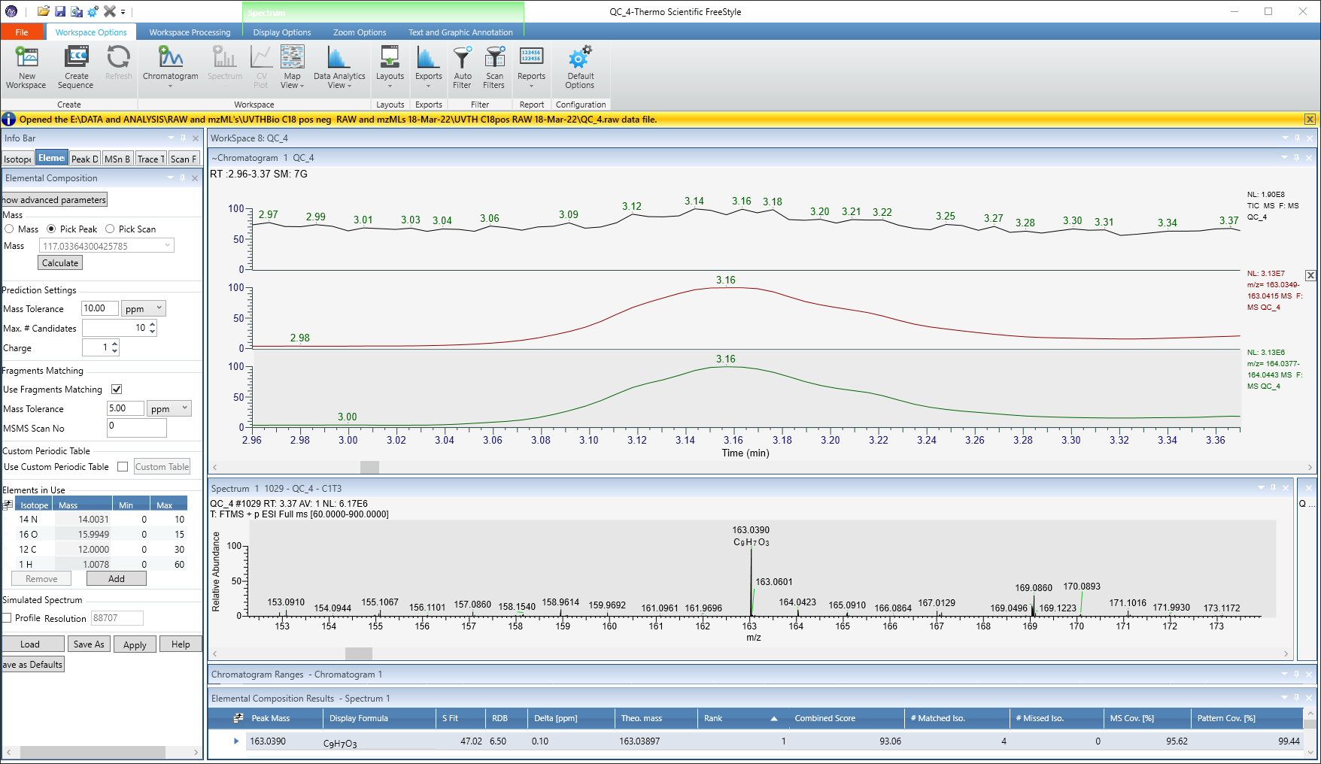
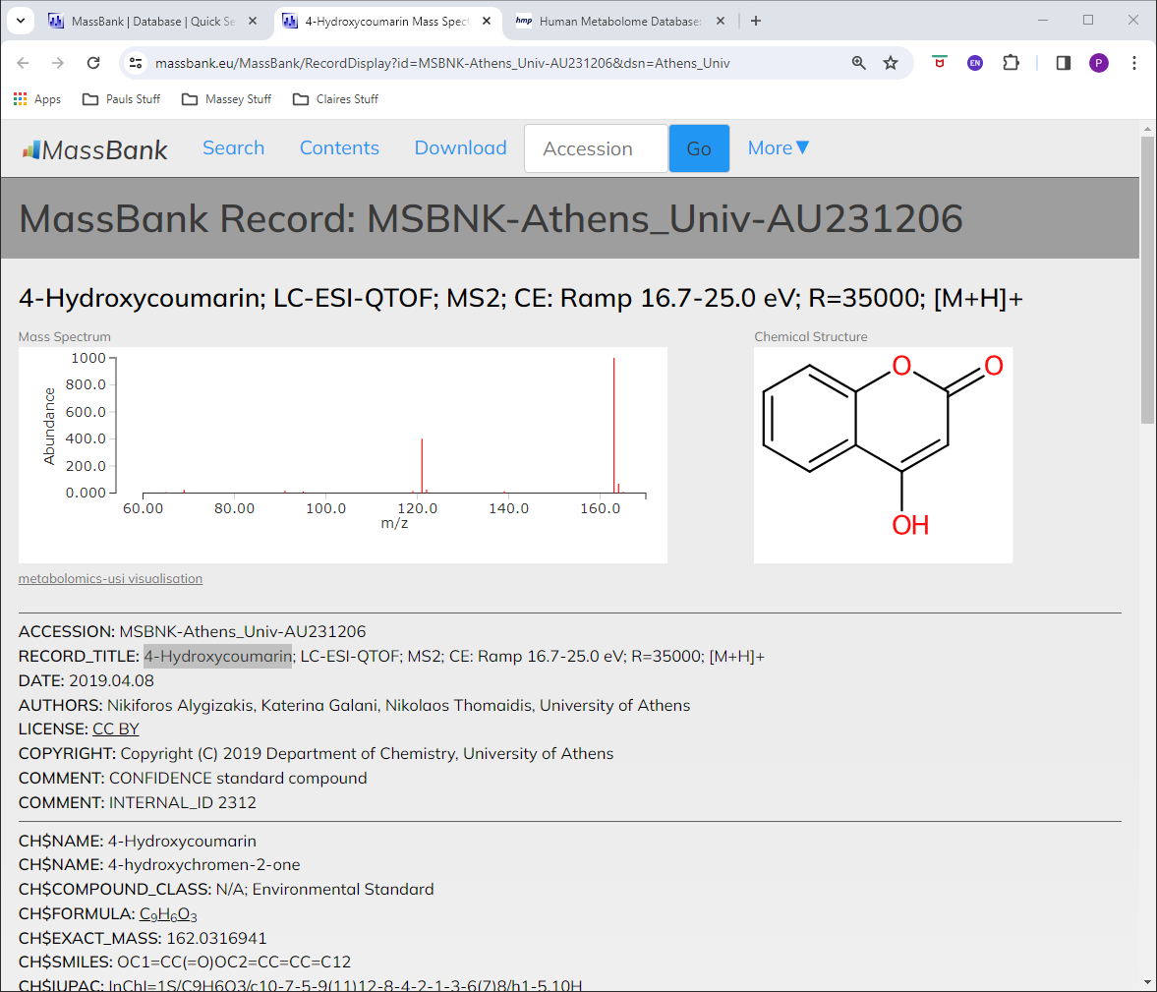
163.0389 / 3.16 4-Hydroxycoumarin

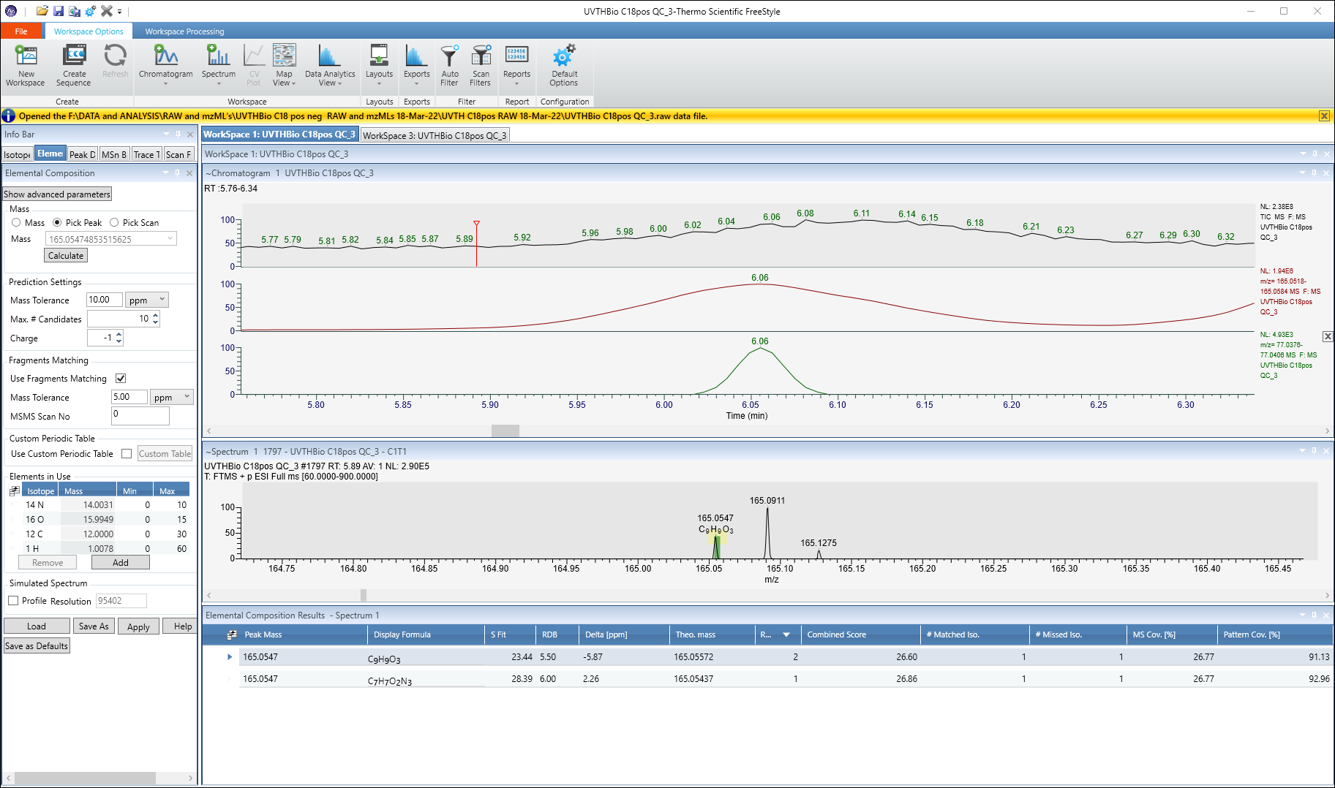
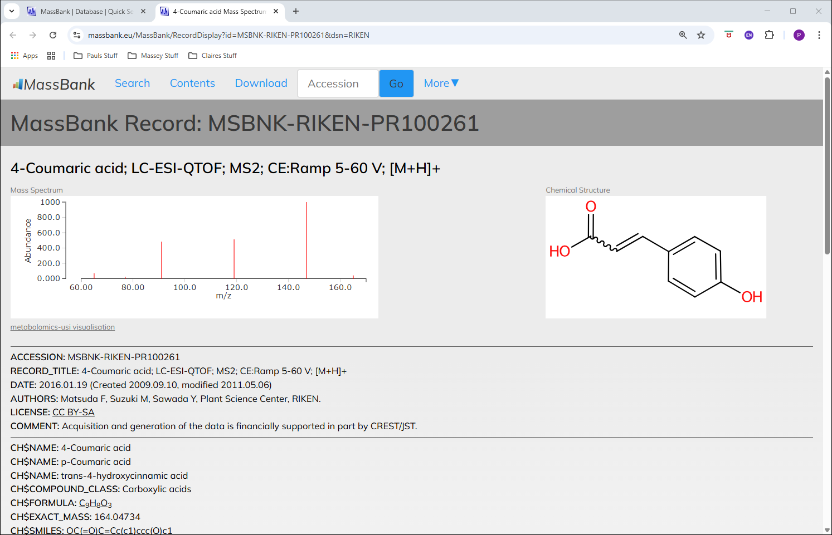
165.0546 / 6.05 p-coumaric acid

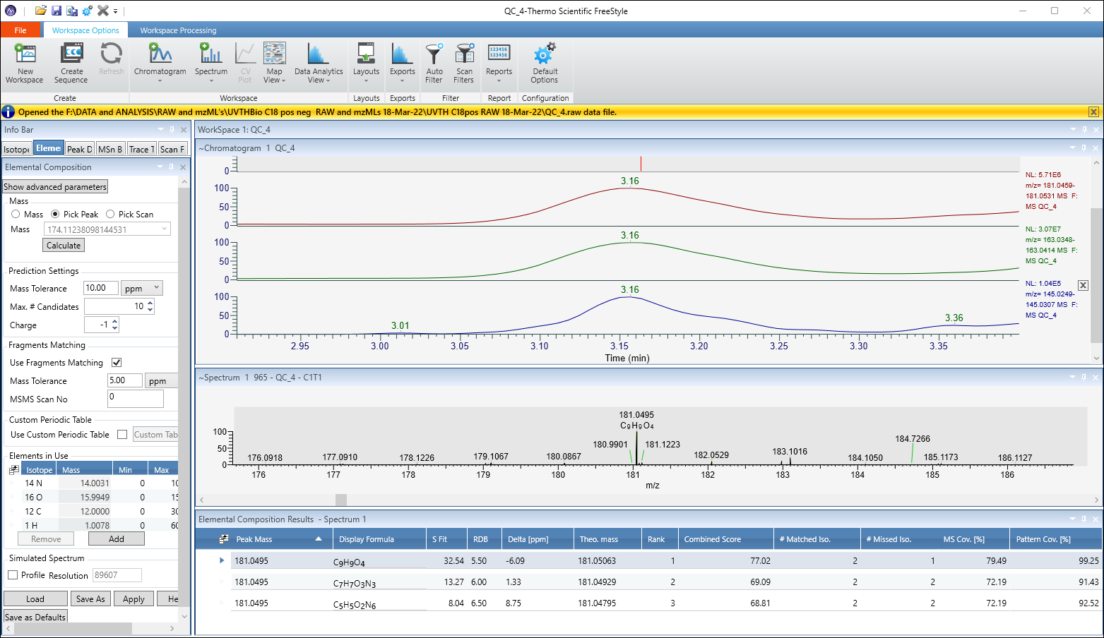
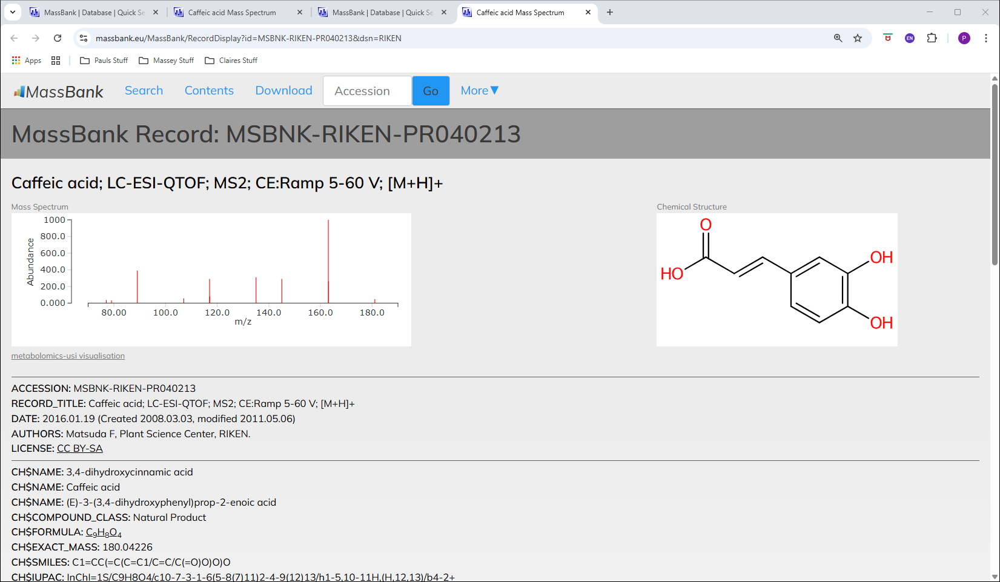
181.0495 / 3.16 Caffeic acid

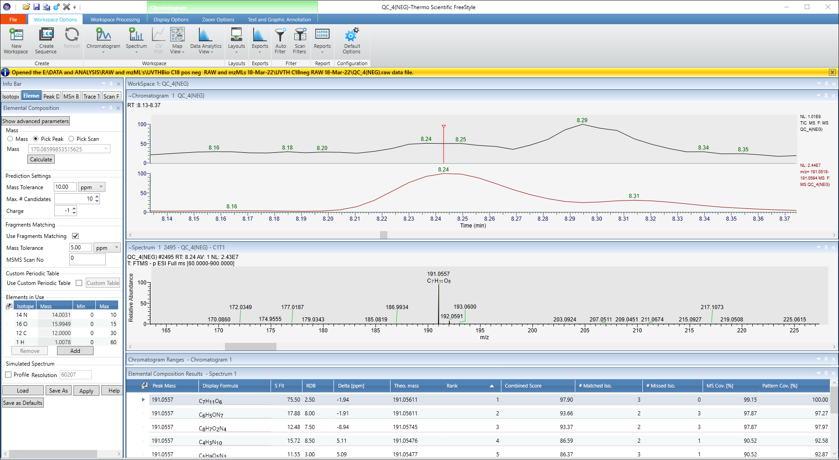
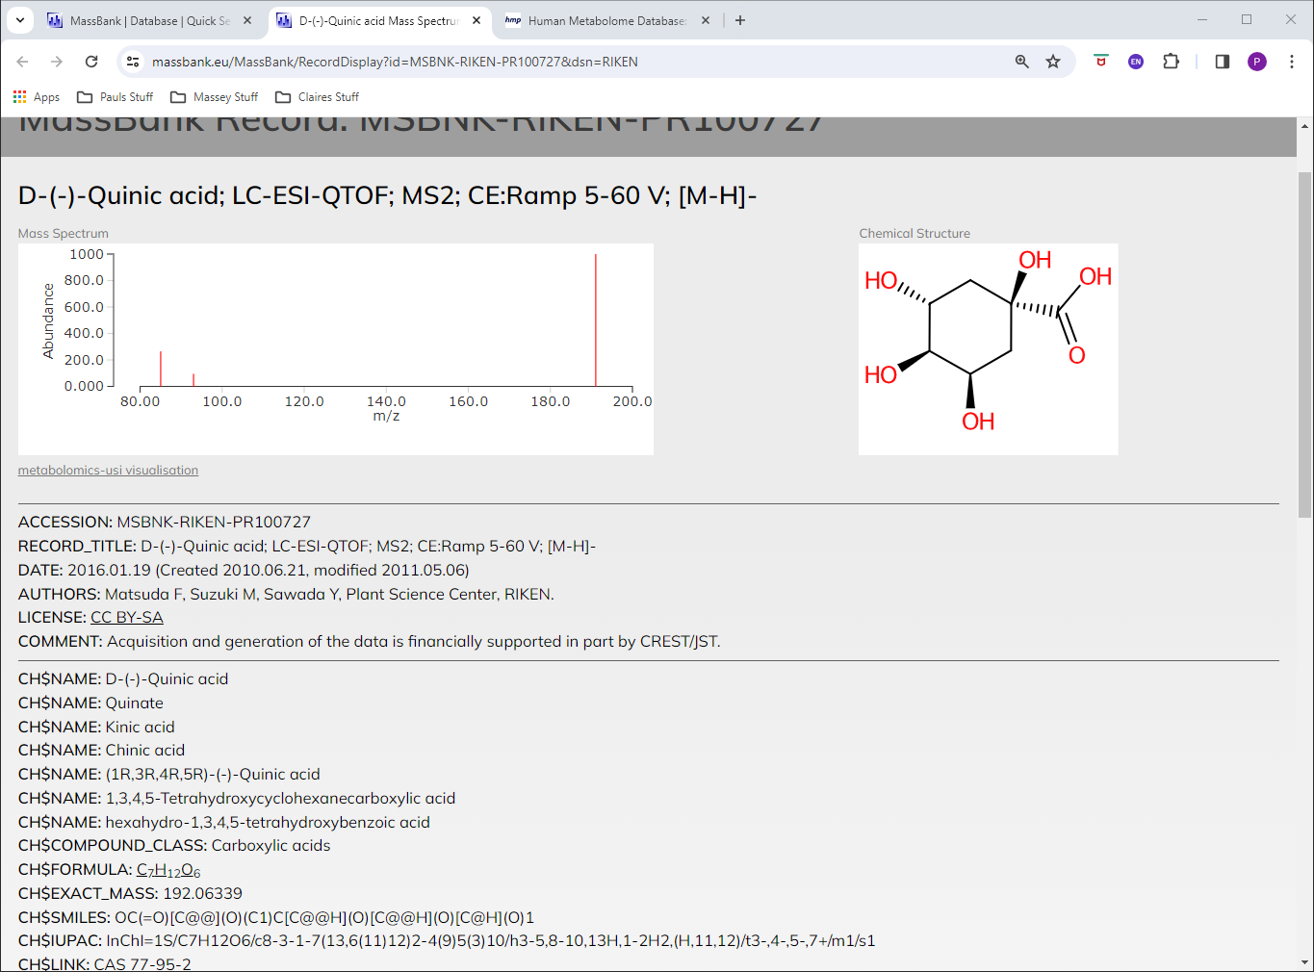
191.0556 / 8.24 Quinic acid

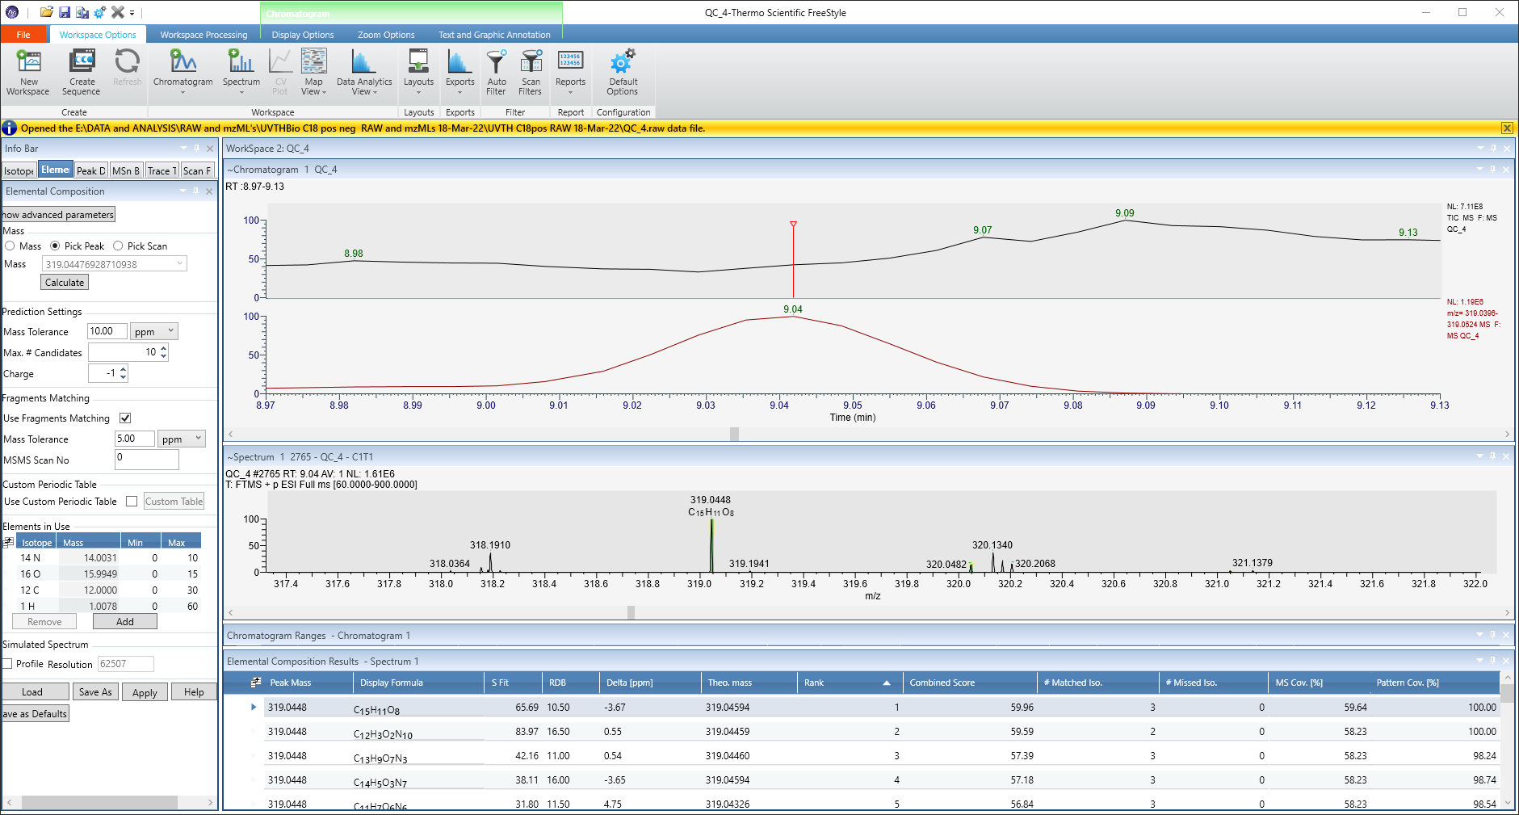
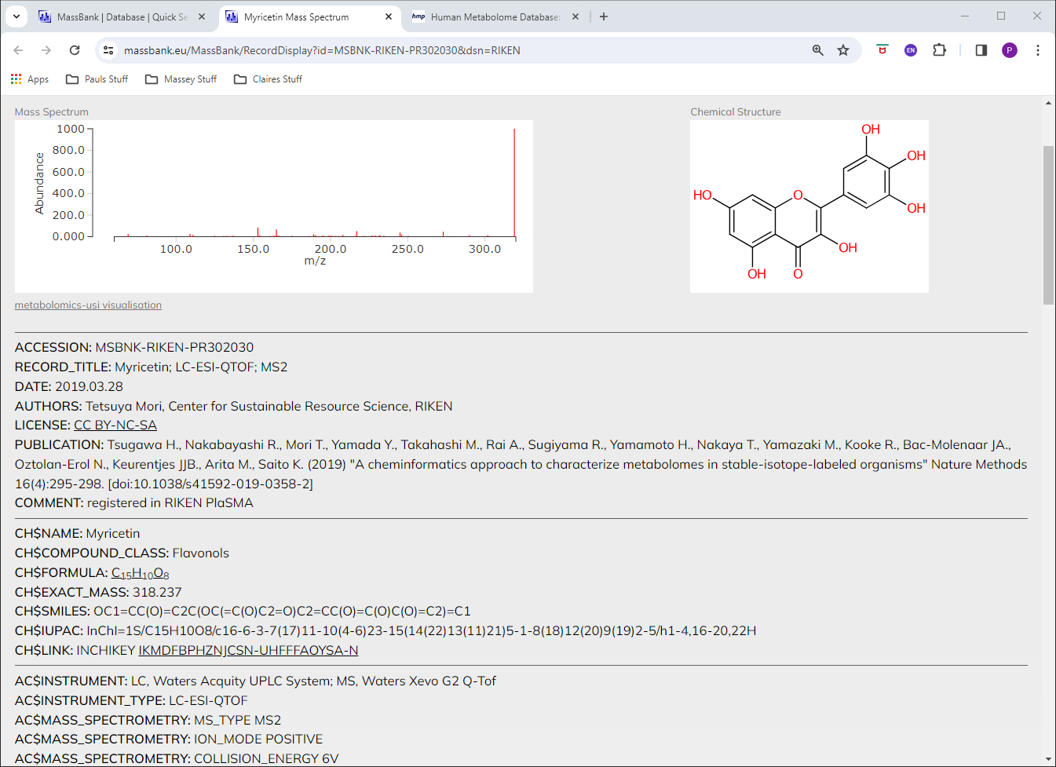
319.0446 / 9.03 Myricetin

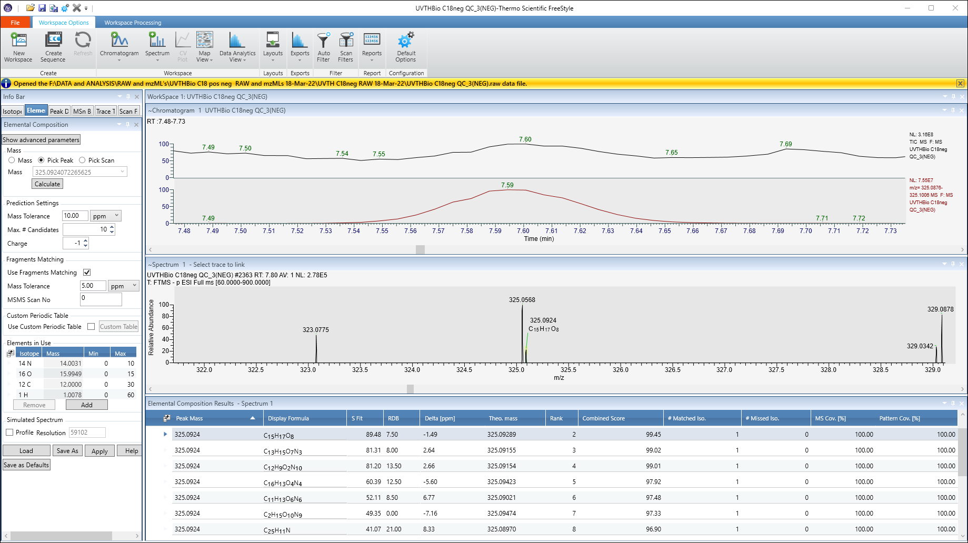
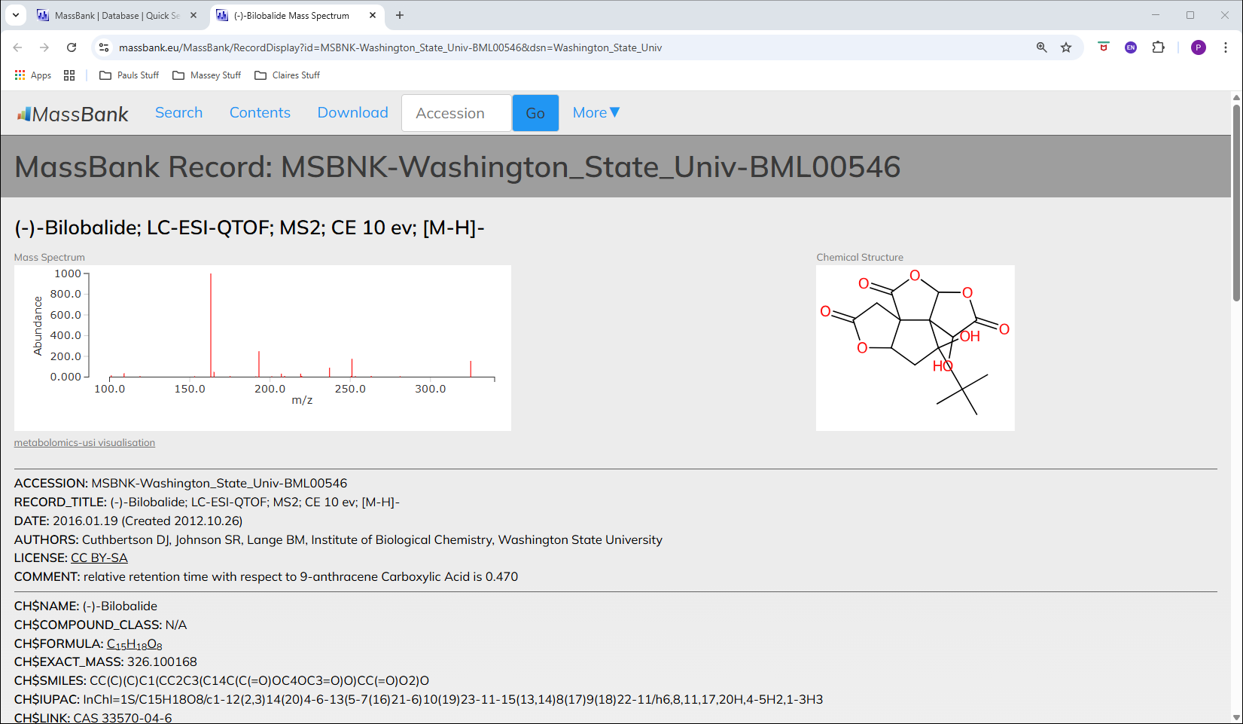
325.0932 / 7.59 Bilobalidae

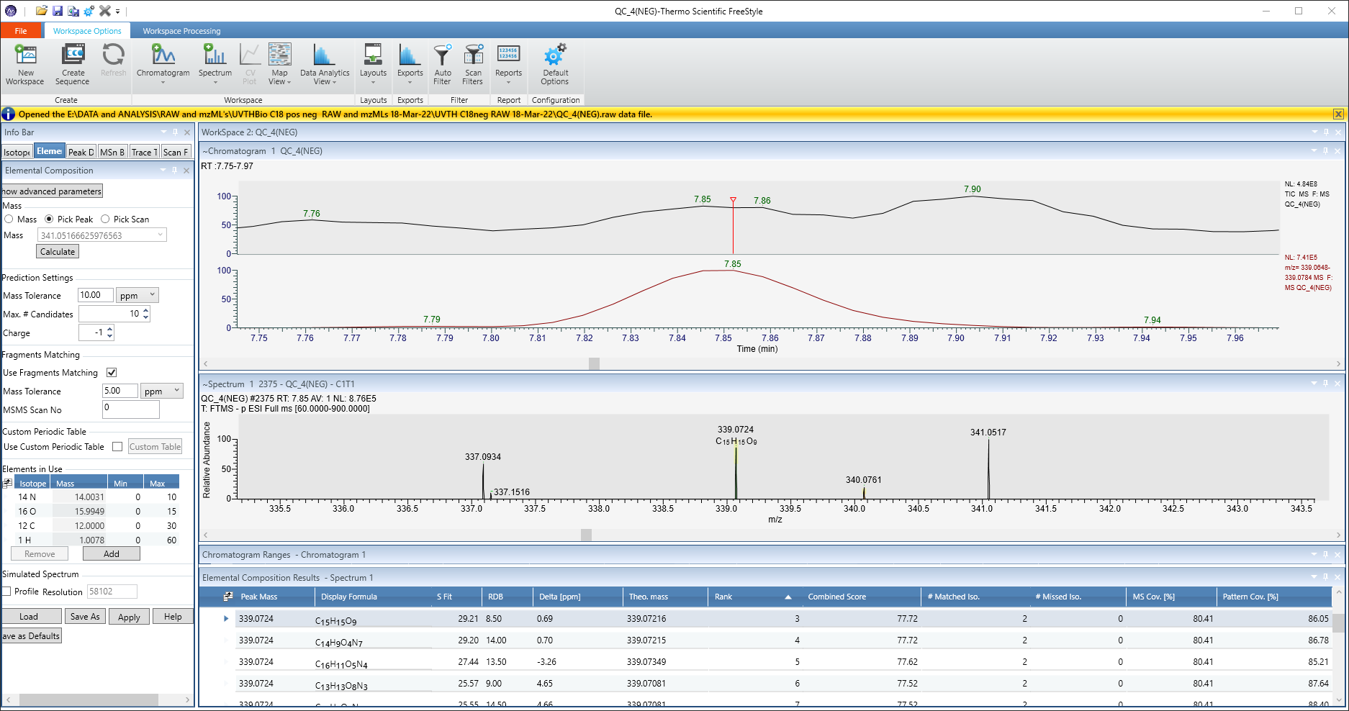
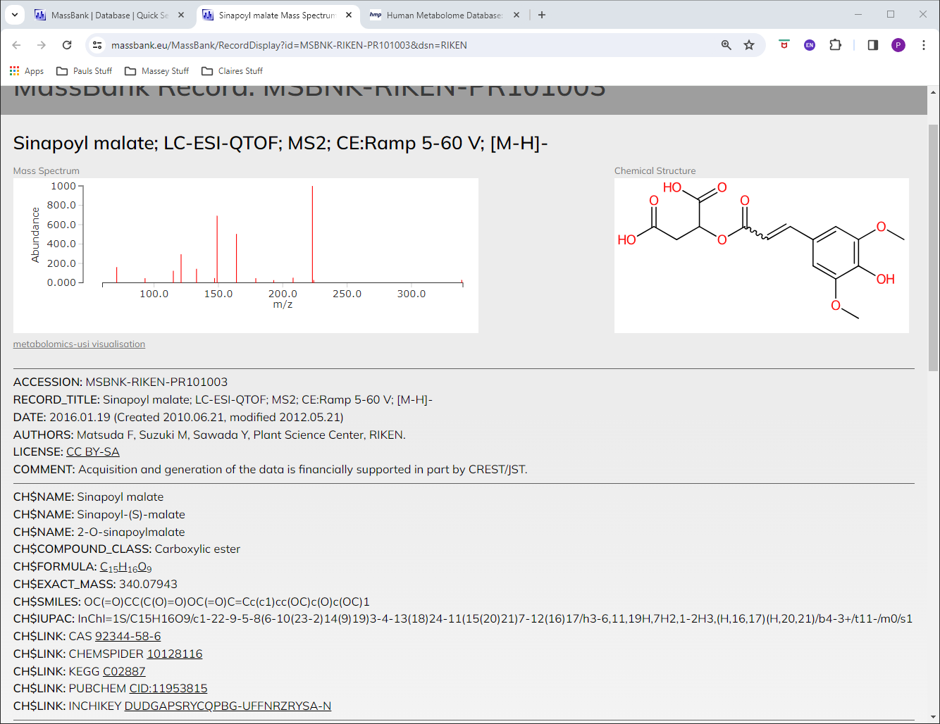
339.0721 / 7.85 Sinapoyl malate

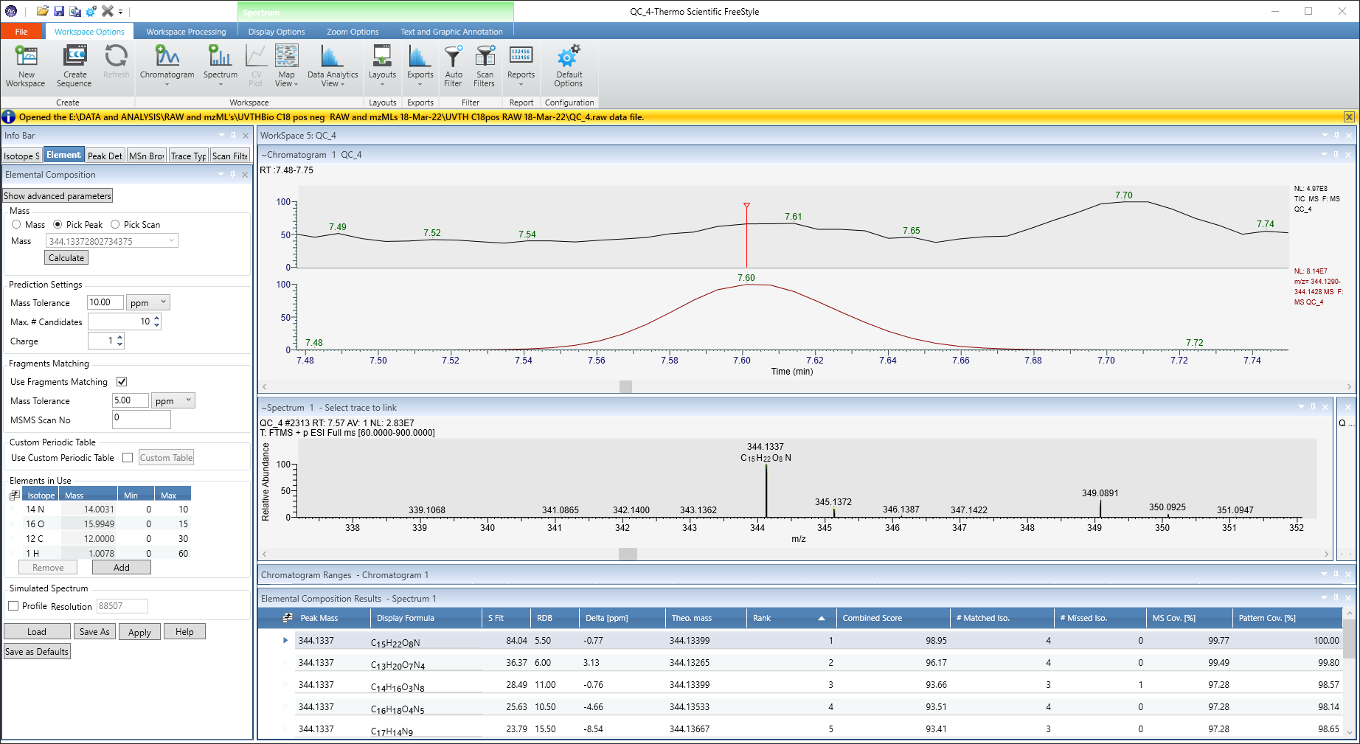
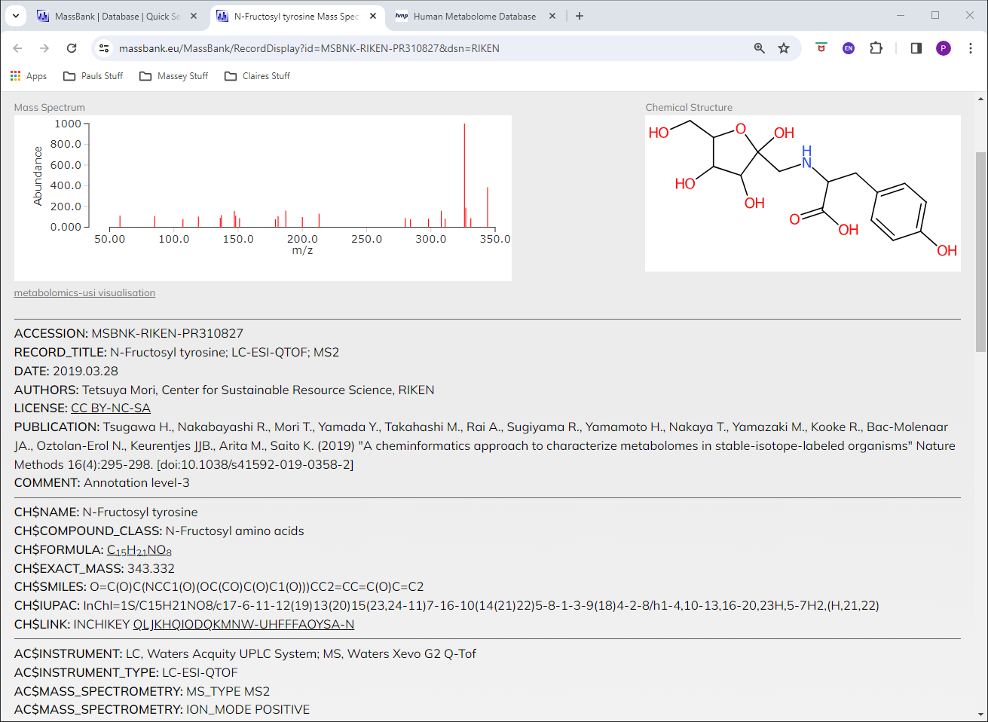
344.1338 / 7.61 N-Fructosyl Tyrosine
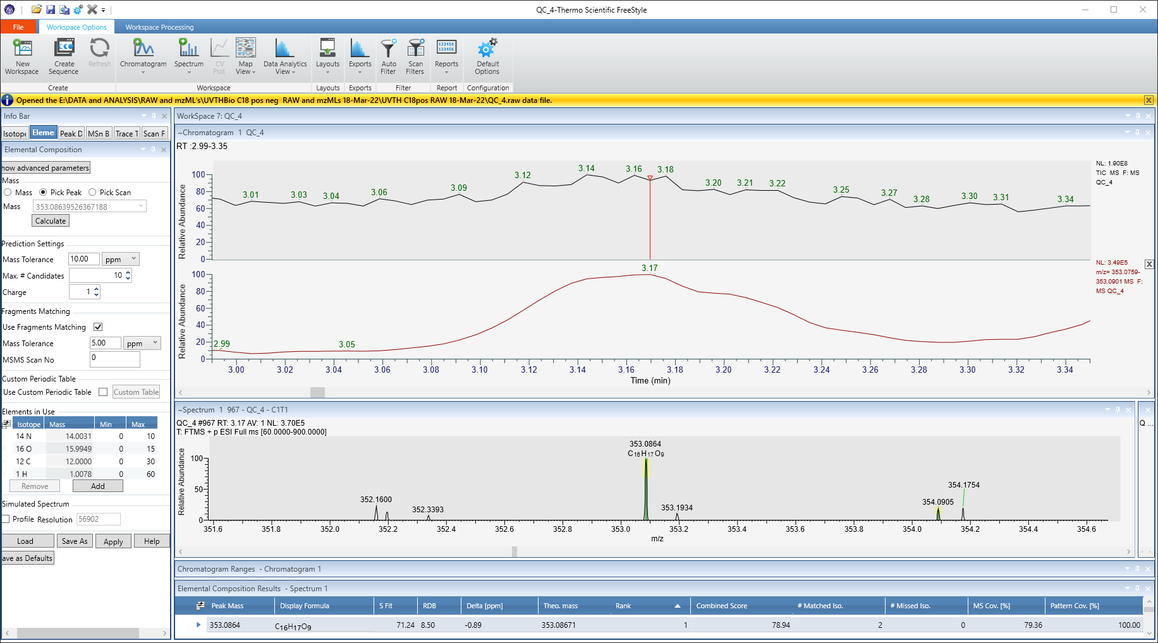
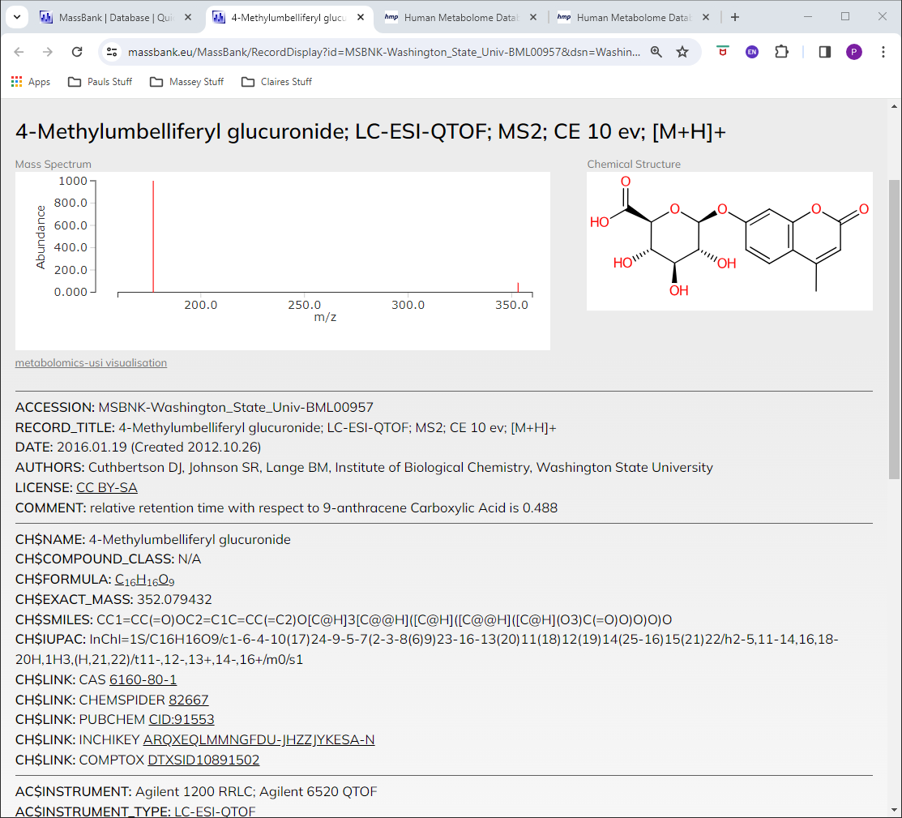
353.0865 / 3.17 4-Methylumbelliferyl glucuronide
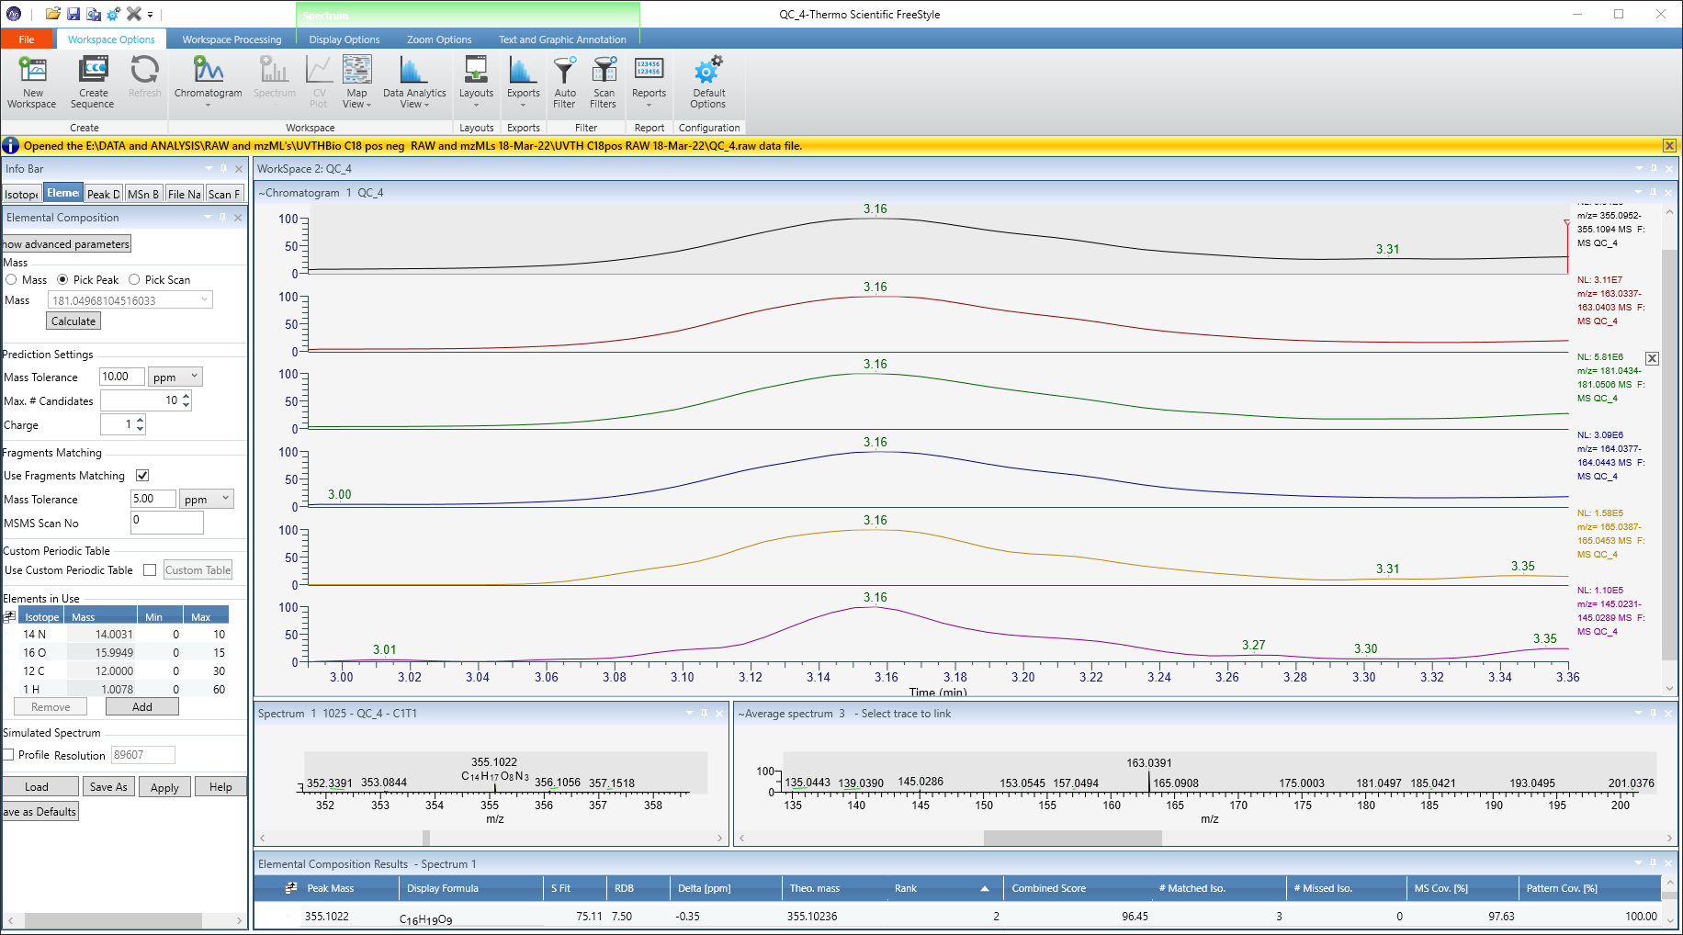
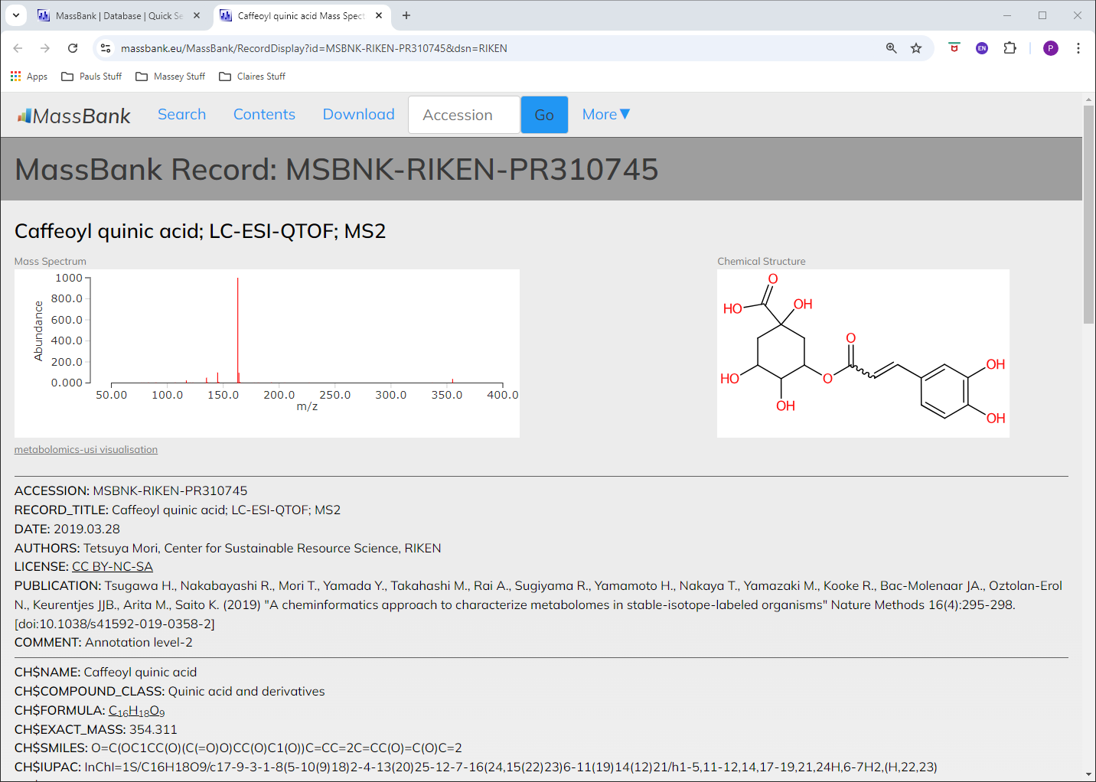
355.1021 / 3.16 Chlorogenic acid

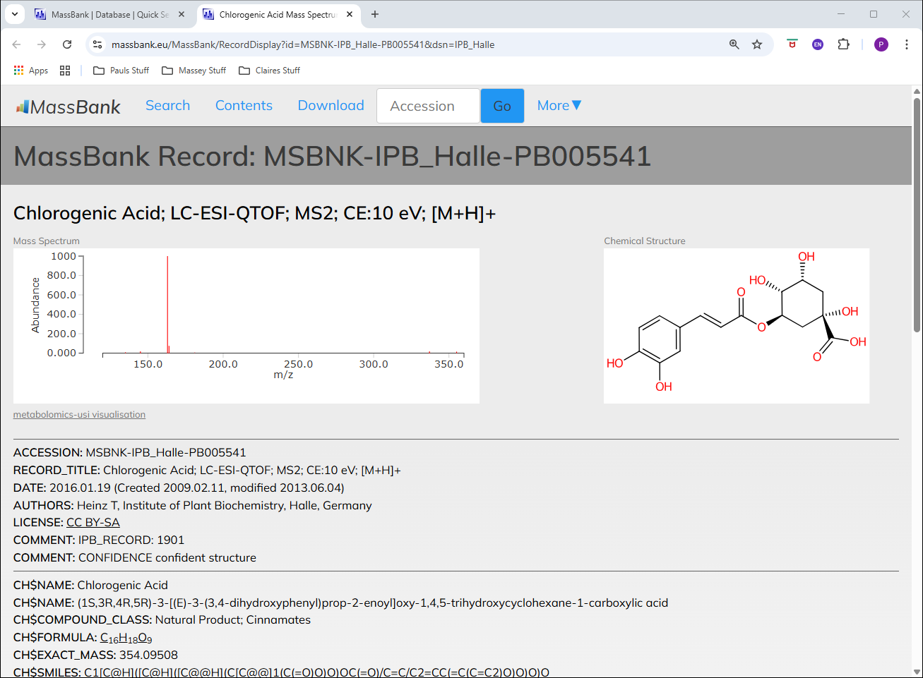
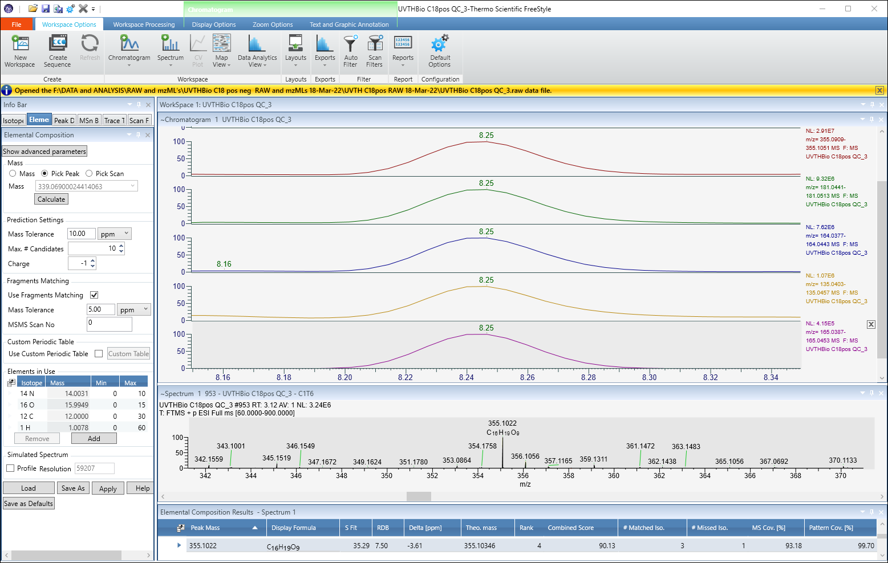
355.1021 / 8.25 Caffeoylquinic acid

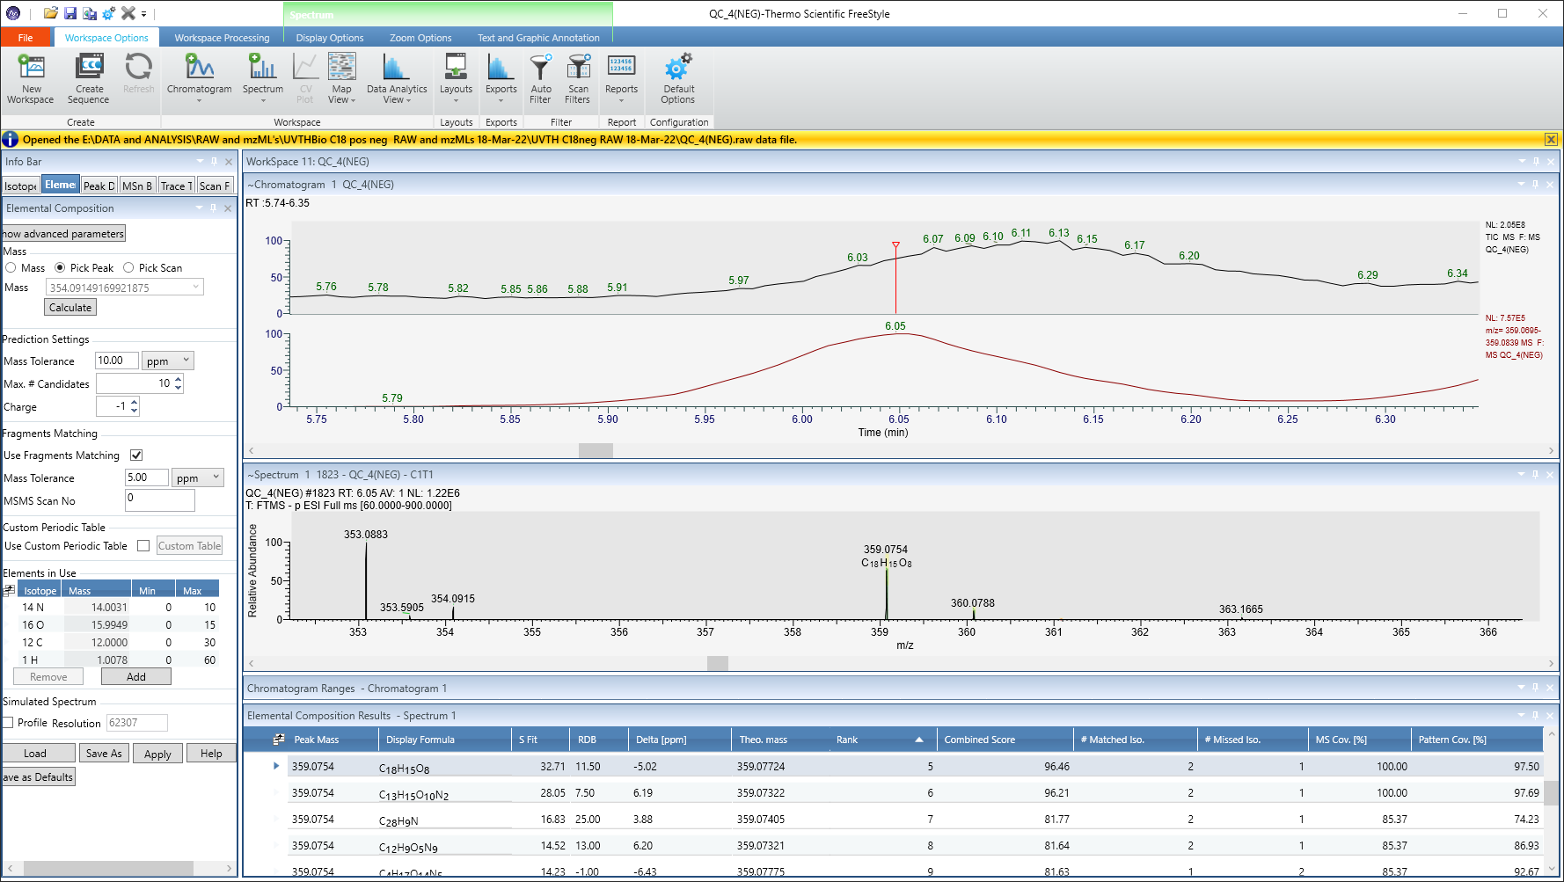
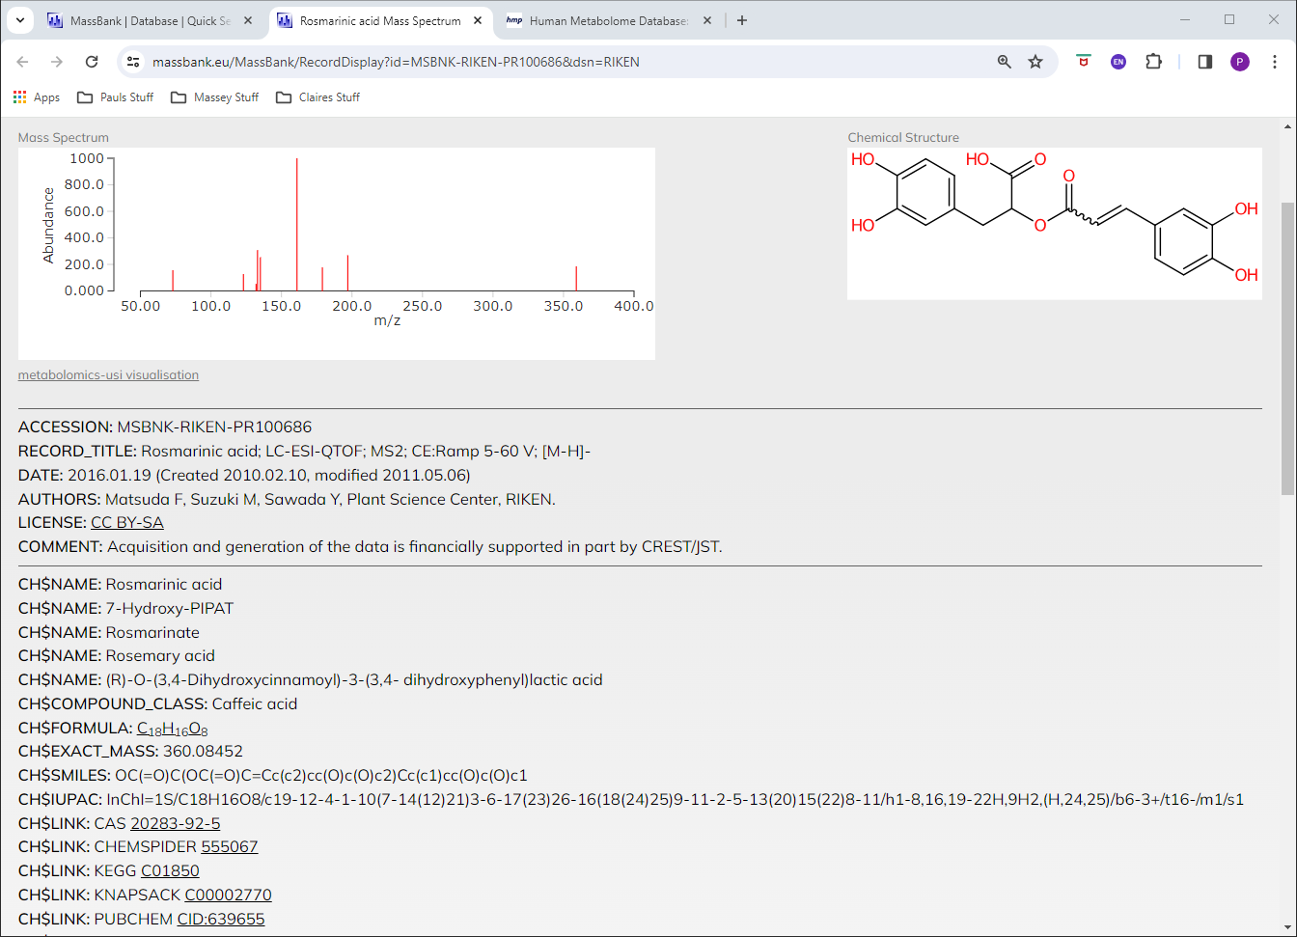
359.0752 / 6.04 Rosmarinic acid

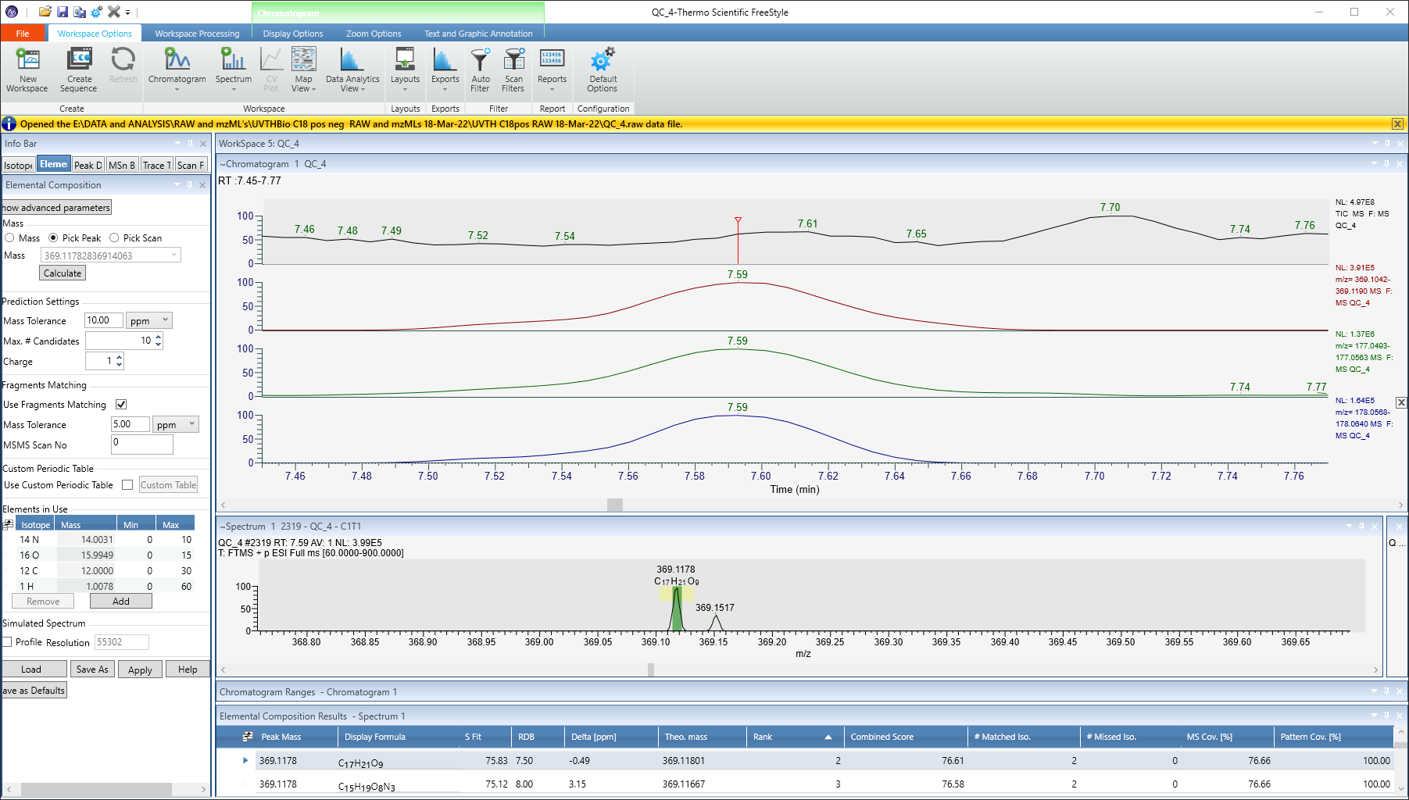
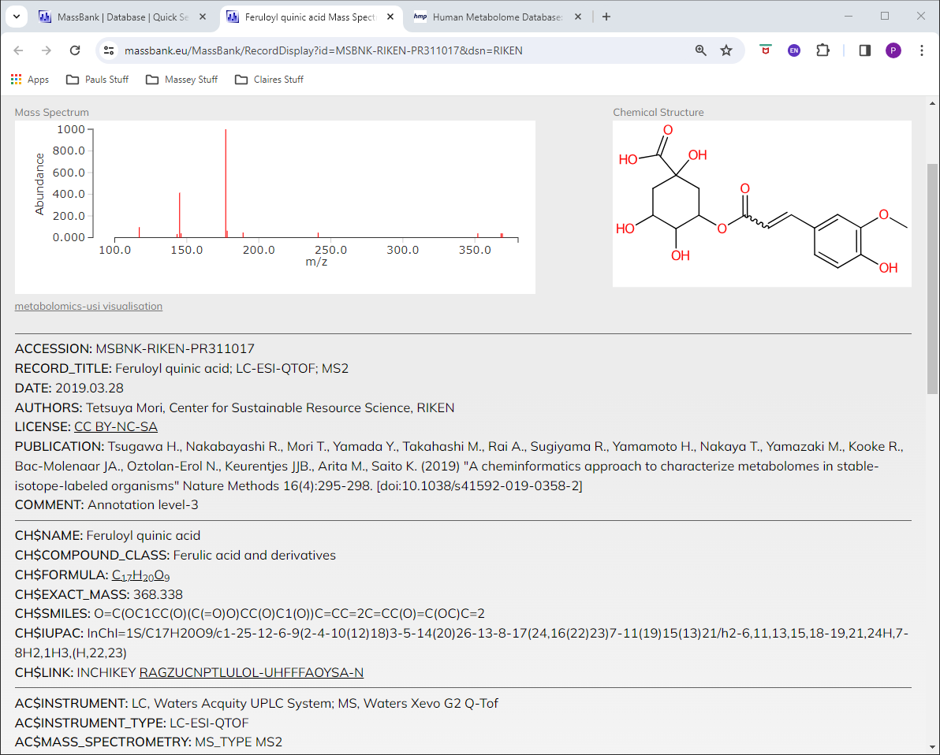
369.1177 / 7.59 3-Feruloylquinic acid

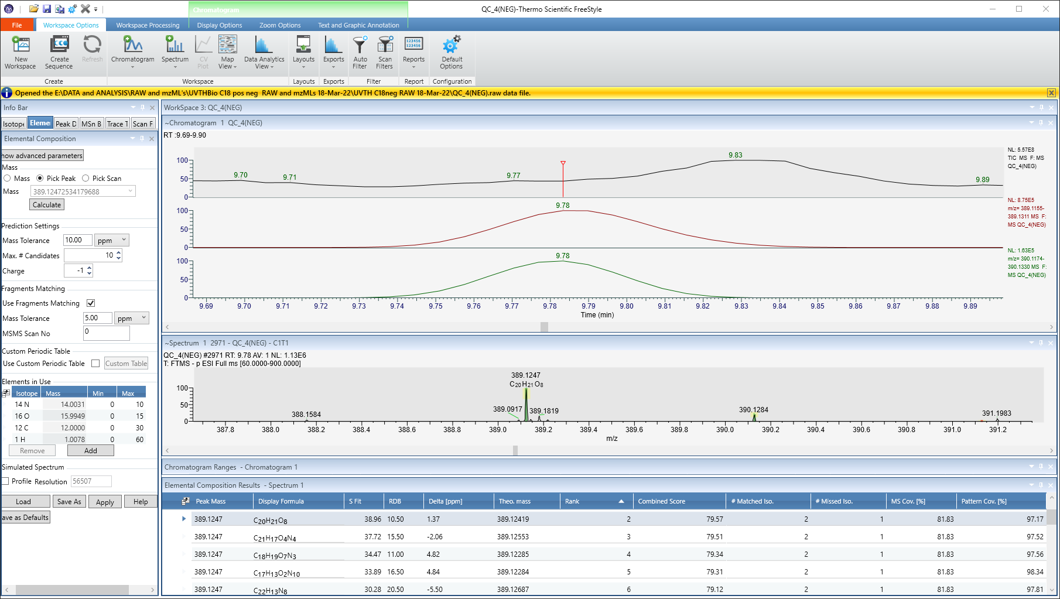
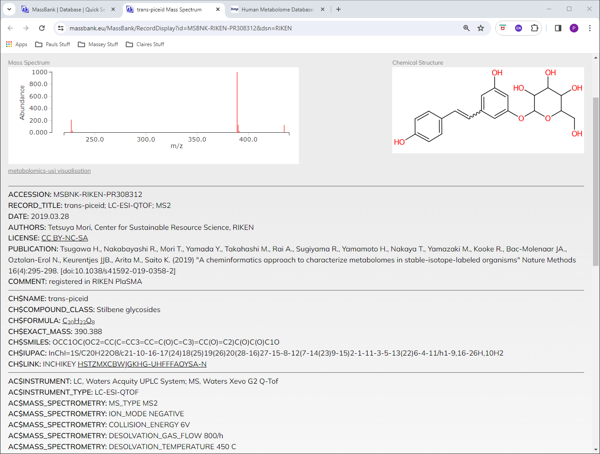
389.1246 / 9.78 3,4',5-Trihydroxystilbene-3-beta-D-glucoside (Resveratrol)

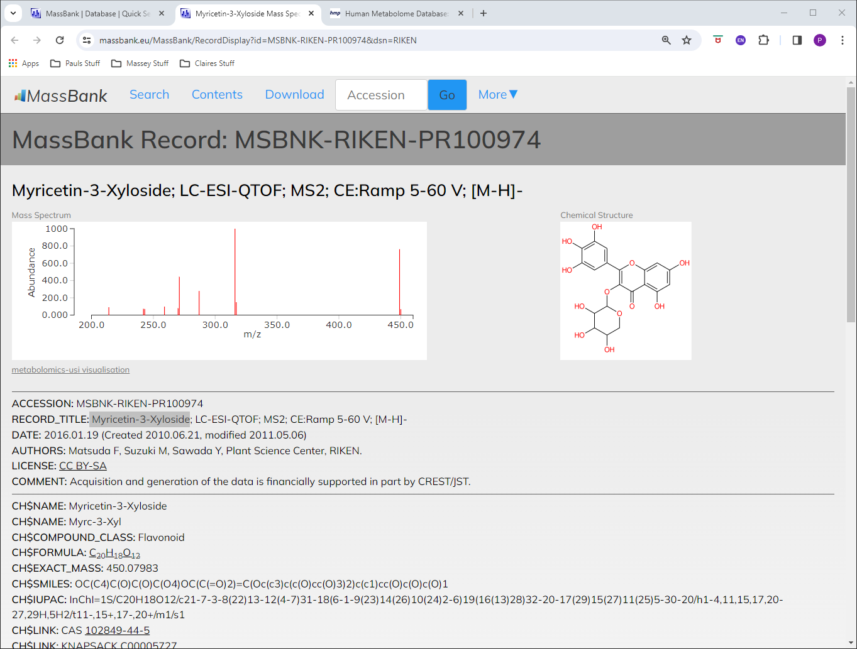
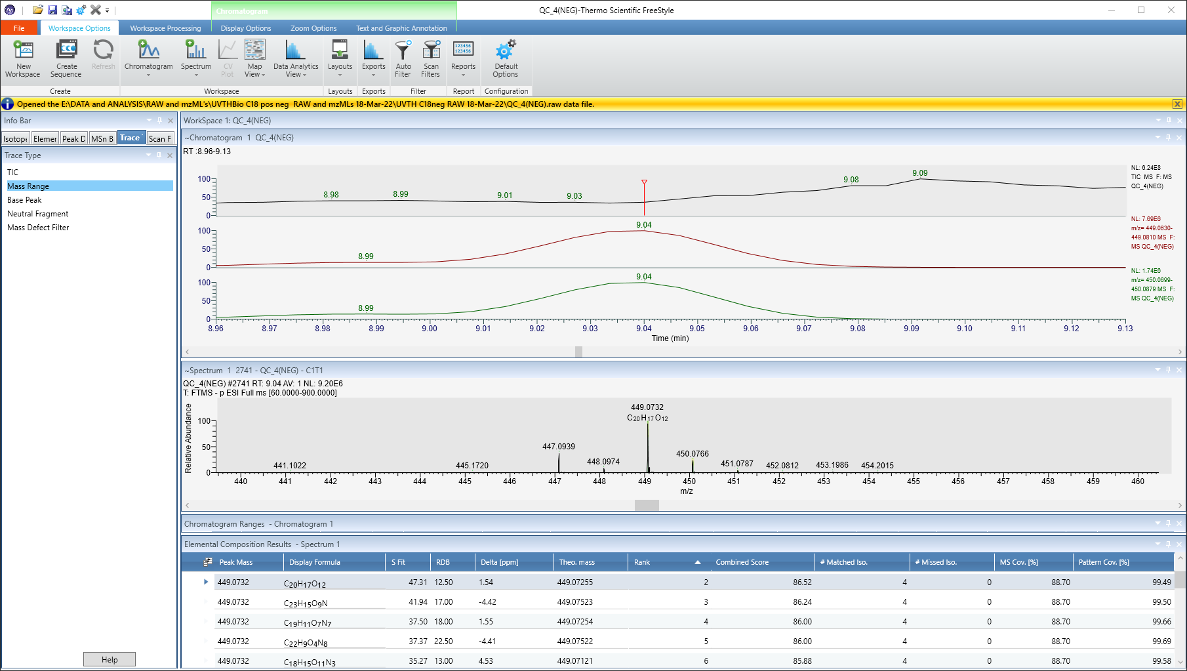
449.0733 / 9.04 Myricetin-3-Xyloside

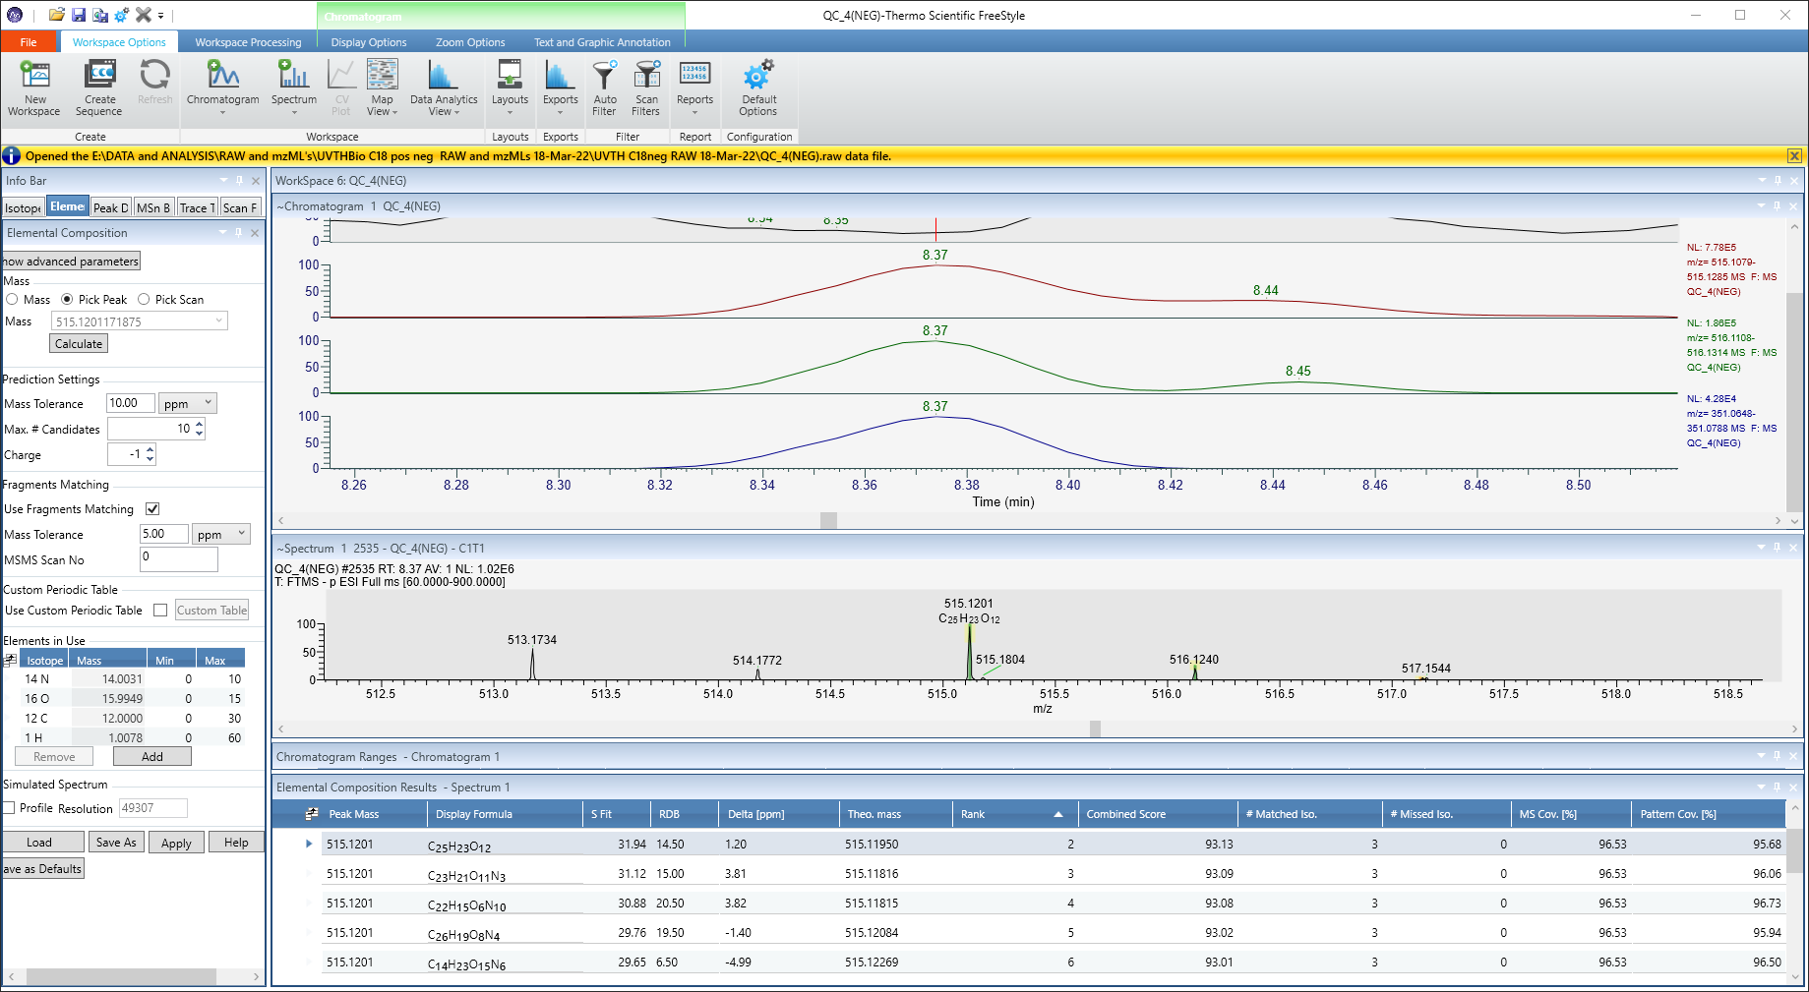
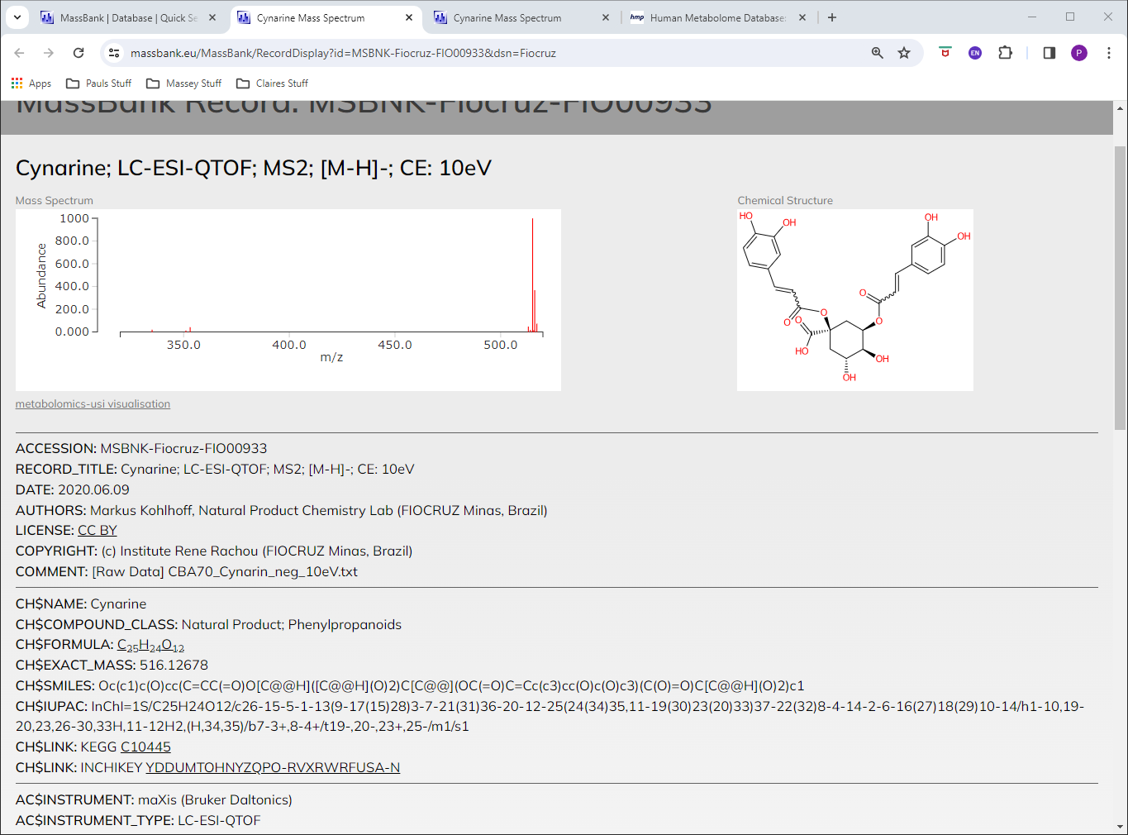
515.12 / 8.37 1,5-Dicaffeoylquinic acid

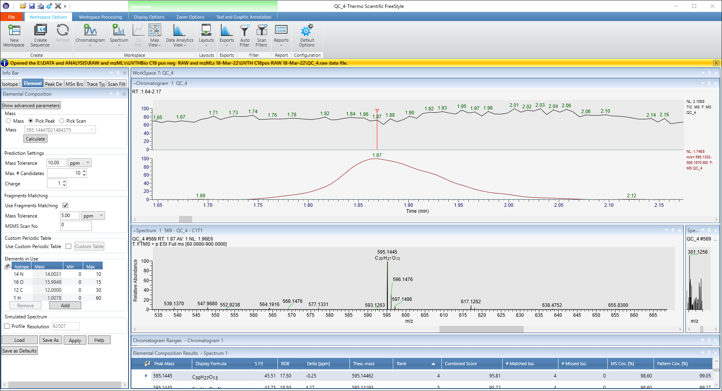
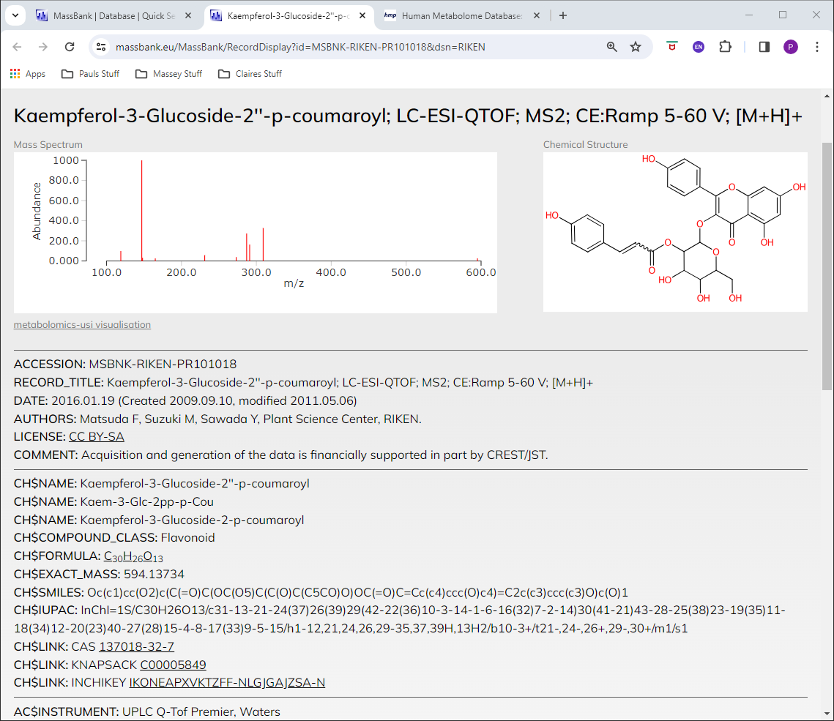
595.1444 / 1.87 Kaempferol-3-Glucoside-2''-p-coumaroyl

