SUPPLEMENTARY INFORMATION

The western corn rootworm is strongly attracted to floral (E)-p-methoxycinnamaldehyde, but not or weakly to other compounds of the oil pumpkin

Martin Schlager^{1,2}, Stephan Manhalter³, Katharina Wechselberger³, Zsolt Kárpáti⁴, Stefan Dötterl^{1,*}

¹Department of Environment & Biodiversity, University of Salzburg, Hellbrunnerstrasse 34, 5020 Salzburg, Austria
²Audorf 44, 4802 Ebensee am Traunsee, Austria
³Österreichische Agentur für Gesundheit und Ernährungssicherheit GmbH, Spargelfeldstrasse 191, 1120 Wien, Austria
⁴Department of Chemical Ecology, Plant Protection Institute, Centre of Agricultural Research, HUN-REN, 1116 Budapest, Hungary

* Corresponding author: stefan.doetterl@plus.ac.at

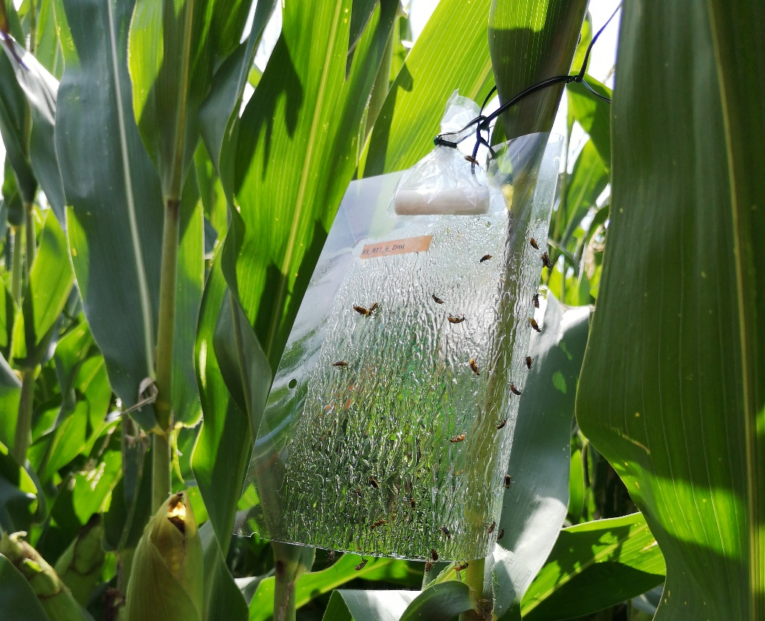
Fig. S1 Transparent PAL-sticky sheet in a maize field, equipped with a scent lure (cotton roll impregnated with synthetic scent in an perforated oven bag). Several Western corn rootworm beetles were successfully trapped.

