Household Earnings and Income Volatility in the UK, 2009-2017
Silvia Avram, Mike Brewer, Paul Fisher and Laura Fumagalli

Supplementary appendix

Figure A1: Volatility of individual and household labour and private incomes (equivalised and unequivalised), 2009-2017
A: Working age individuals (25-59)
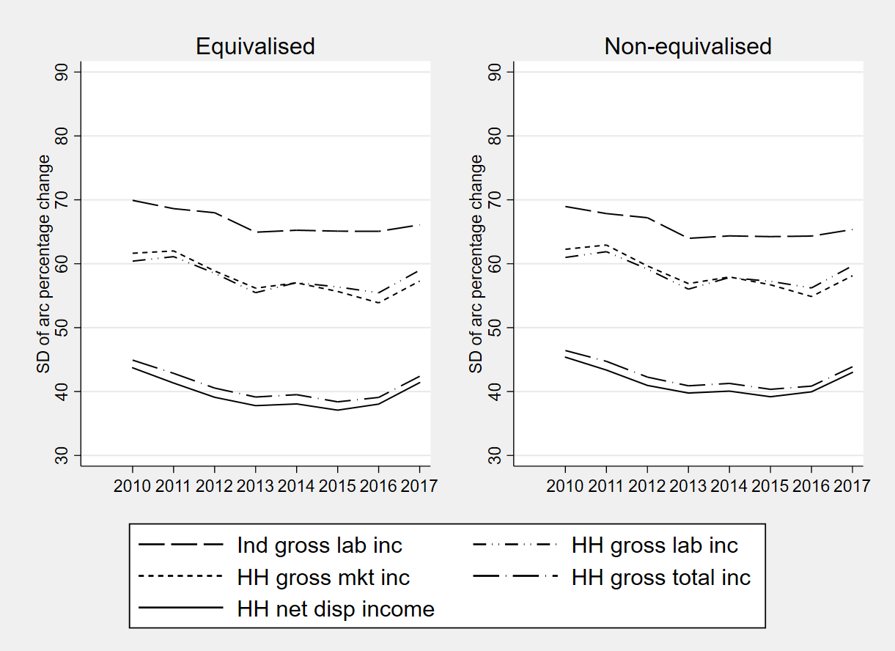

B: Older age individuals (60+)
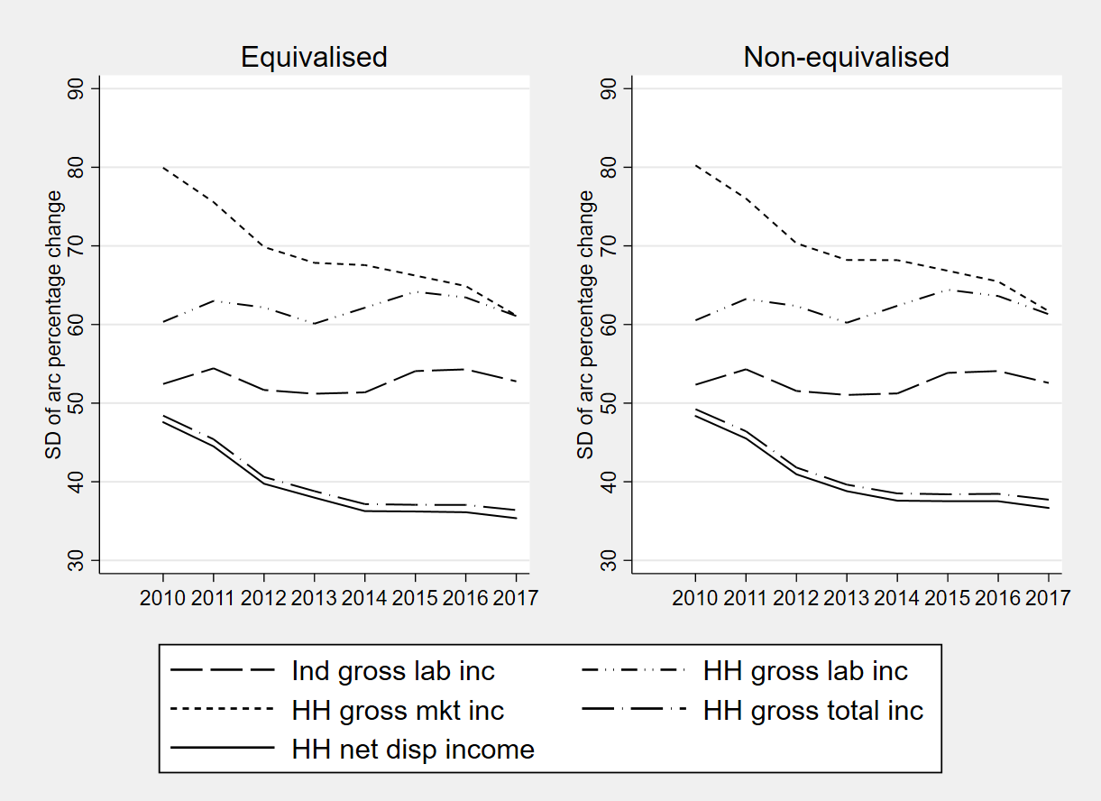
Note: Ind gross lab inc’=individual gross labour earnings;’ HH gross lab inc’= household gross labour earnings; ‘HH mkt inc’=household private income; ‘HH tot inc’=household total gross incomes; HH disp inc=household disposable income. Incomes are equivalised using the ‘modified’ OECD scale.
Source: Authors calculations based on UKHLS 2009-2017
Figure A2: Demographic trends
A. Share of individuals living in households of different types

B. Share of individuals with children of different ages
Source: Authors calculations based on UKHLS 2009-2017
Figure A3: Unweighted and weighted (for demographic change) volatility estimates: Working age individuals (25-59)

A. Standard UKHLS longitudinal weight
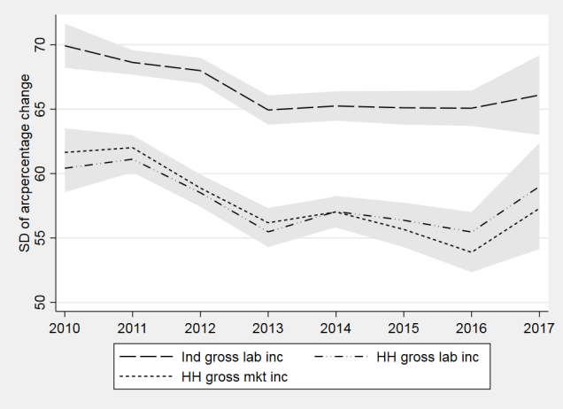
B. Re-weighted using the DFL method
Note: ‘Ind gross lab inc’=individual gross labour earnings;’ HH gross lab inc’= household gross labour earnings; ‘HH gross mkt inc’=Household gross private income; All incomes are equivalised using the modified OECD scale
Source: Authors calculations based on UKHLS 2009-2017
Figure A4: Unweighted and weighted (for demographic change) volatility estimates: Older age individuals (60+)
A. Standard UKHLS longitudinal weight
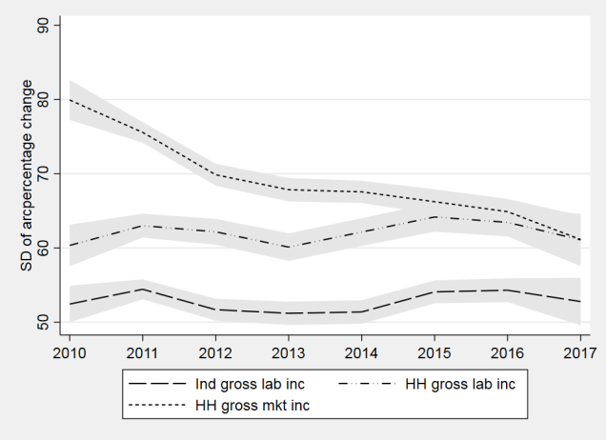

B. Re-weighted using the DFL method
Note: ‘Ind gross lab inc’=individual gross labour earnings;’ HH gross lab inc’= household gross labour earnings; ‘HH gross mkt inc’=Household gross private income; All incomes are equivalised using the modified OECD scale.
Source: Authors calculations based on UKHLS 2009-2017

Figure A5: Weighted (for demographic change) and unweighted volatility estimates (working age, 25-59), 2010-2017
A: Standard UKHLS longitudinal weight
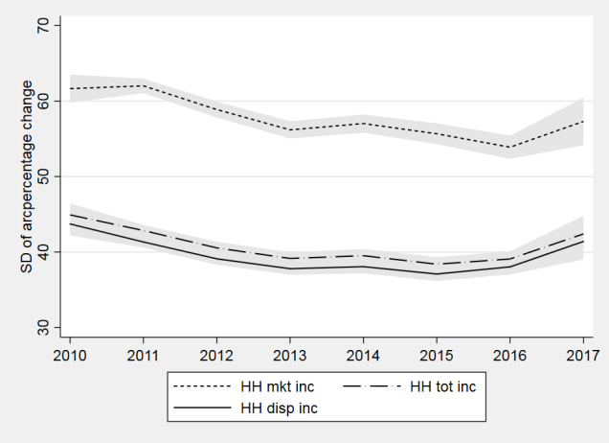

B: Re-weighted using the DFL method
Note: ‘HH mkt inc’=household private income; ‘HH tot inc’=household total gross incomes; HH disp inc=household disposable income. All incomes are equivalised using the ‘modified’ OECD scale.
Source: Authors calculations based on UKHLS 2009-2017

Figure A6: Weighted (for demographic change) and unweighted volatility estimates (older age, 25-60), 2010-2017
A: Standard UKHLS longitudinal weight
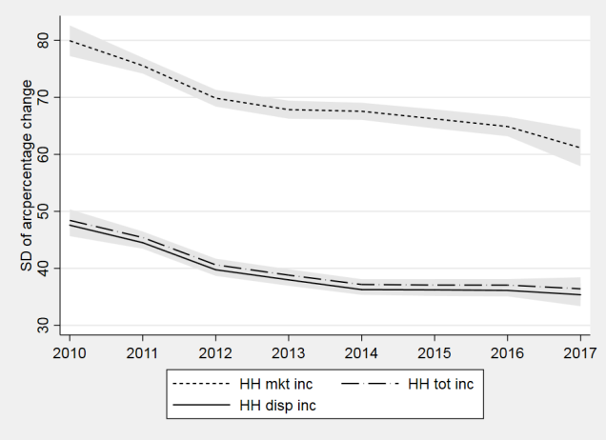
B: Re-weighted using the DFL method
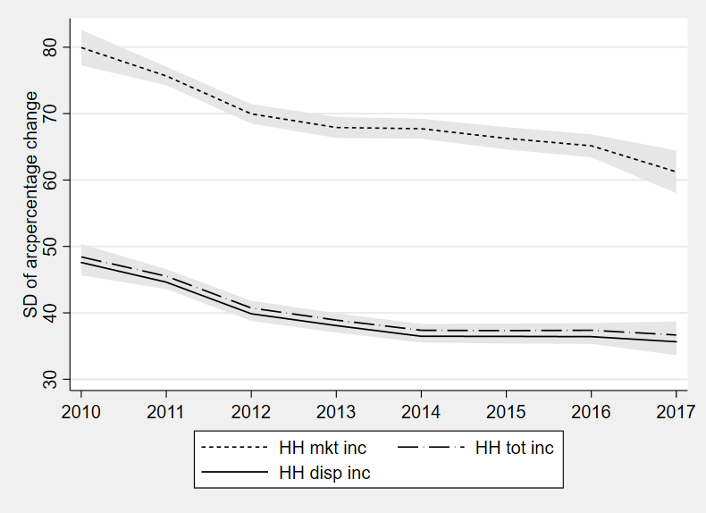
Note: ‘HH mkt inc’=household private income; ‘HH tot inc’=household total gross incomes; HH disp inc=household disposable income. All incomes are equivalised using the ‘modified’ OECD scale.
Source: Authors calculations based on UKHLS 2009-2017
Figure A7: Volatility estimates for after housing costs income
A. Working age (25-59)

B. Older age (60+)
Note: ‘HH mkt inc’=household private income; ‘HH tot inc’=household total gross incomes; HH disp inc=household disposable income. ‘AHC disp inc’= household disposable income after housing costs. All incomes are equivalised using the ‘modified’ OECD scale.
Source: Authors calculations based on UKHLS 2009-2017

Figure A8: FTSE 2007-2017

Source: Yahoo! Finance

Figure A9: Volatility estimates: continuous workers and workers employed at consecutive waves
A. FT, FY Employment

B. Employment at both waves
Note: ‘Ind gross lab inc’=individual gross labour earnings;’ HH gross lab inc’= household gross labour earnings; ‘HH gross mkt inc’=Household gross private income; All incomes are equivalised using the modified OECD scale
Source: Authors calculations based on UKHLS 2009-2017
Table A1: Share of missing data by wave and decile for main income components
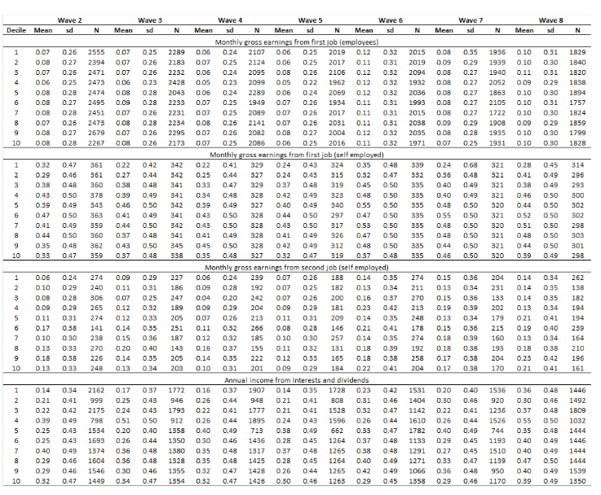
Note: Replication of table 10 from Fisher et al. (2019)

