ONLINE APPENDICES

Appendix 1: List of Countries Included in the Analysis 2
Appendix 2: Trends in Economic Globalization 3
Figure A1: Trends in Economic Globalization 4
Appendix 3: Descriptive Statistics and Data Sources 5
Appendix 4: Additional Results 7
Table A1 – First-Stage Estimates: Globalization and Growth 7
Table A2 – Sample Split: Low vs. High Globalization 8
Figure A2 – Sample Split, Coefficient Plot 8
Table A3 – First-Stage Estimates: Globalization and Inequality 9
Table A4 – Income Growth by Decile Group 10
Figure A3 – Income Growth by Decile Group, Coefficient Plot 10
Appendix 5: Robustness Tests 11
Figure A4: Plausibly Exogenous 15
Table A5: Robustness, GDP Figures from Penn World Tables 16
Table A6: Robustness, Gini Indices from PovcalNet and All the Ginis 17
Table A7: Robustness, Gini indices from the World Inequality Database 18
Table A8 – Globalization and Income Growth by Decile Group 19
Figure A5 – Relative Income Shares: Coefficient Plot 19
Table A9: Robustness, Growth, Old KOF Index 20
Table A10: Robustness, Inequality, Old KOF index 21
Table A11: Robustness, Relative Income Shares, Old KOF index 22
Table A12: Robustness, Income Growth by Decile Group, Old KOF index 23
Table A13: Additional Robustness Tests of Growth Regressions 24
Table A14: Additional Robustness Tests of Inequality Regressions 25
Figure A6: Globalization and Growth: Sensitivity of Coefficients (Jackknife Test) 26
Figure A7: Globalization and Inequality: Sensitivity of Coefficients (Jackknife Test) 27
Appendix 6: Suggestive Evidence on the Role of Redistribution 28
Figure A8: Globalization and Redistribution 29
Table A15: Net Inequality vs. Market Inequality 30
Appendix 7: Theoretical Corollary: The Role of Initial Conditions 31
Figure A9 – The Role of Initial Conditions 31
Table A16 – Initial Conditions 32
Figure A10 – The Effect of Globalization on Growth Depends on Initial Inequality 33
Appendix 8: Trade Globalization vs. Financial Globalization 34
Table A17 – Trade Globalization vs. Financial Globalization 35

Appendix 1: List of Countries Included in the Analysis

Afghanistan, Albania, Algeria, Angola, Argentina, Armenia, Australia, Austria, Azerbaijan, Bahrain, Bangladesh, Belarus, Belgium, Benin, Bhutan, Bolivia, Bosnia and Herzegovina, Botswana, Brazil, Bulgaria, Burkina Faso, Burundi, Cambodia, Cameroon, Canada, Central African Republic, Chad, Chile, China, Colombia, Congo, Dem. Rep., Congo, Rep., Costa Rica, Cote d'Ivoire, Croatia, Cyprus, Czech Republic, Denmark, Dominican Republic, Ecuador, Egypt, El Salvador, Estonia, Ethiopia, Fiji, Finland, France, Gabon, Gambia, Georgia, Germany, Ghana, Greece, Guatemala, Guinea, Guinea-Bissau, Guyana, Haiti, Honduras, Hungary, India, Indonesia, Iran, Ireland, Israel, Italy, Jamaica, Japan, Jordan, Kazakhstan, Kenya, Korea, Republic of, Kuwait, Kyrgyz Republic, Latvia, Lebanon, Lesotho, Libya, Lithuania, Macedonia, FYR, Madagascar, Malawi, Malaysia, Mali, Mauritania, Mauritius, Mexico, Moldova, Mongolia, Montenegro, Morocco, Mozambique, Myanmar, Namibia, Nepal, Netherlands, New Zealand, Nicaragua, Niger, Nigeria, Norway, Oman, Pakistan, Panama, Papua New Guinea, Paraguay, Peru, Philippines, Poland, Portugal, Qatar, Romania, Russian Federation, Rwanda, Saudi Arabia, Senegal, Serbia, Sierra Leone, Singapore, Slovakia, Slovenia, South Africa, Spain, Sri Lanka, Sudan, Swaziland, Sweden, Switzerland, Tajikistan, Tanzania, Thailand, Timor-Leste, Togo, Trinidad and Tobago, Tunisia, Turkey, Uganda, Ukraine, United Arab Emirates, United Kingdom, United States, Uruguay, Venezuela, Vietnam, Yemen, Republic of, Zambia, Zimbabwe

Appendix 2: Trends in Economic Globalization

Figure A1 depicts trends in the unweighted cross-country average of the KOF index of economic globalization and its two sub-indices for the four income groups of the World Bank’s classification.
Several stylized facts emerge. First, at all times over the past half century richer countries were more globalized than poorer countries. There appears to be distinct association between income levels and economic integration. Second, countries of all income classifications have, on average, experienced processes of strong economic globalization. Countries that are HICs today have started the integration process earlier than MICs and LICs. For HICs we see strong increases in both sub-dimensions already in the 1970s; for the average MIC the significant lifting of economic restrictions to cross-border flows began in the early 1990s and the flows themselves increased shortly after; the average LIC followed suit in the mid-1990s. Third, when focusing on the most recent years it becomes visible that HICs reached the highest level of globalization in the late 2000s and are currently experiencing stagnation or even a decline; this trend appears to be particularly driven by decreasing de jure openness. To a slightly lesser extent the same is also true for UMICs and LMICs. LICs on the other hand still appear to be in a process of strongly globalizing. A fourth observation based on Figure 1 is that the de jure and de facto dimensions of economic integration are correlated. The dynamics of the two sub-indices within income groups are similar.

Figure A1: Trends in Economic Globalization
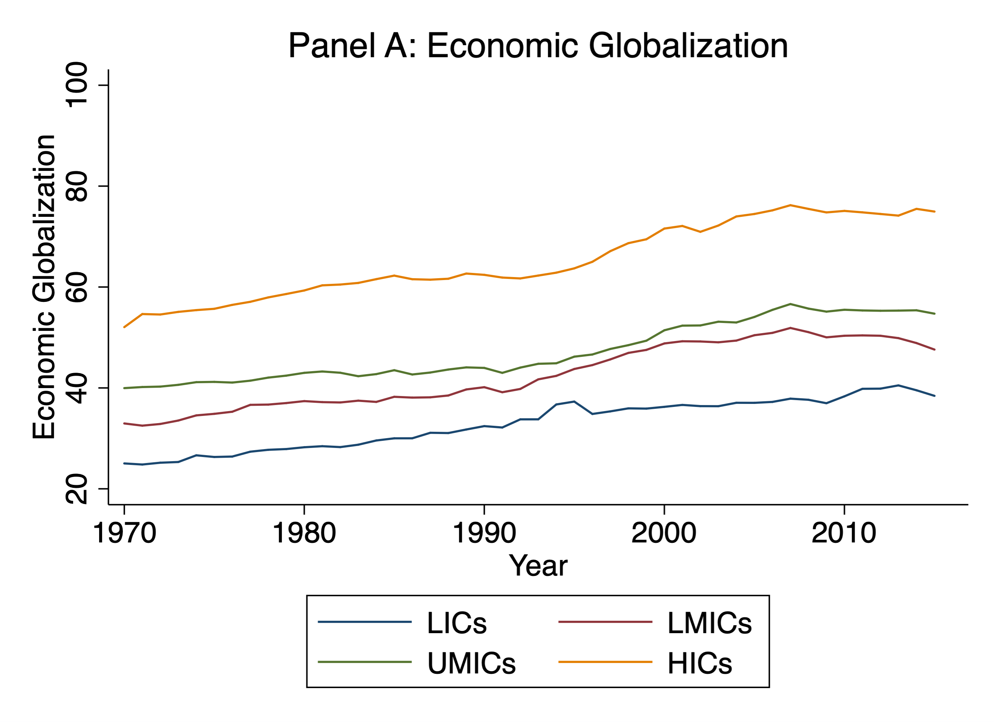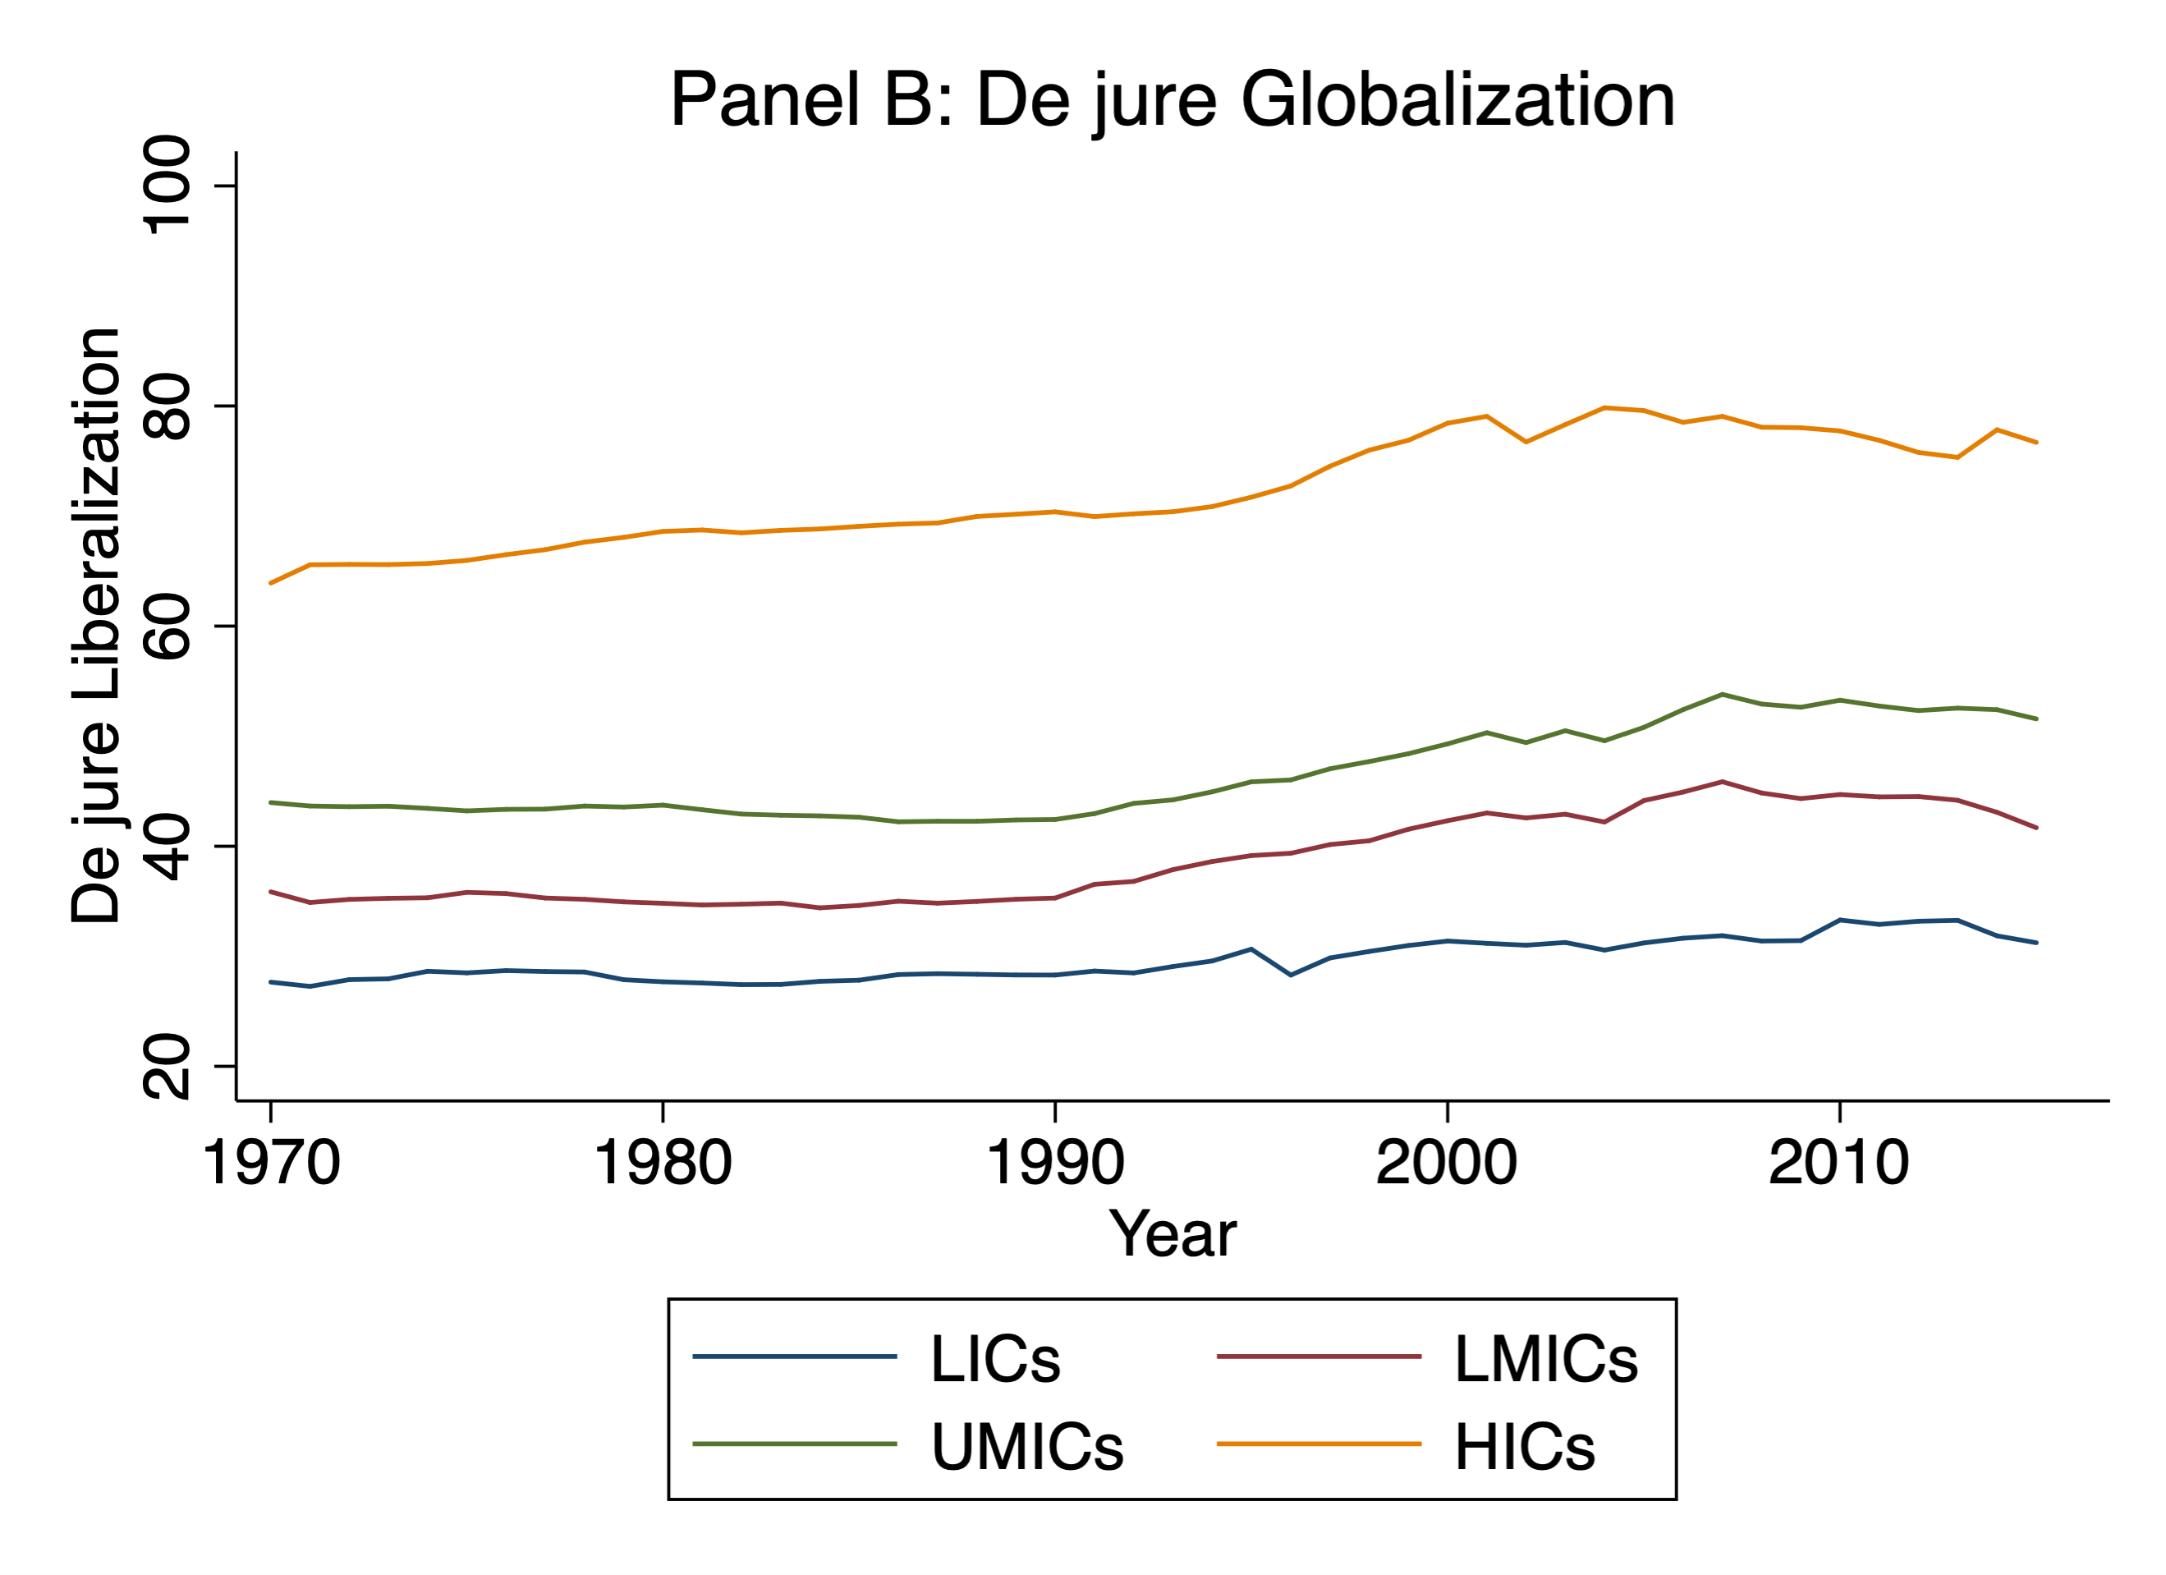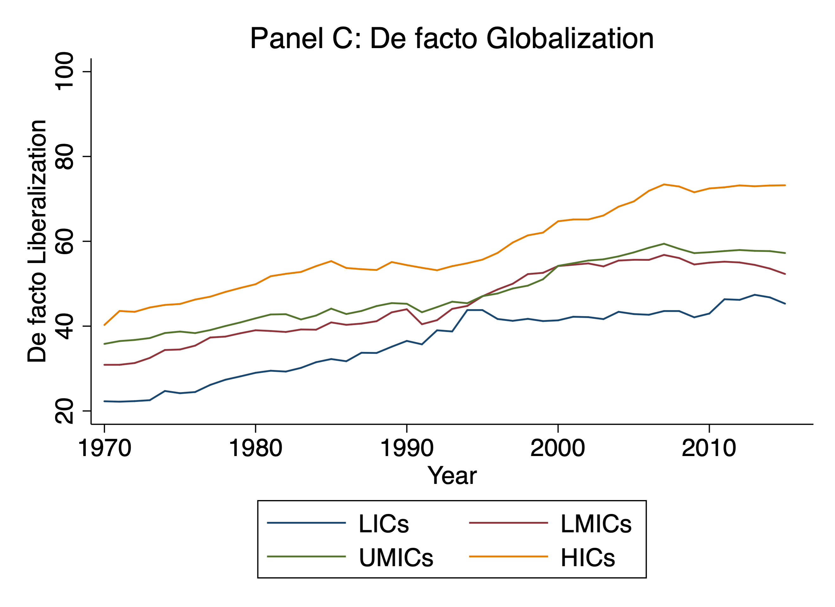
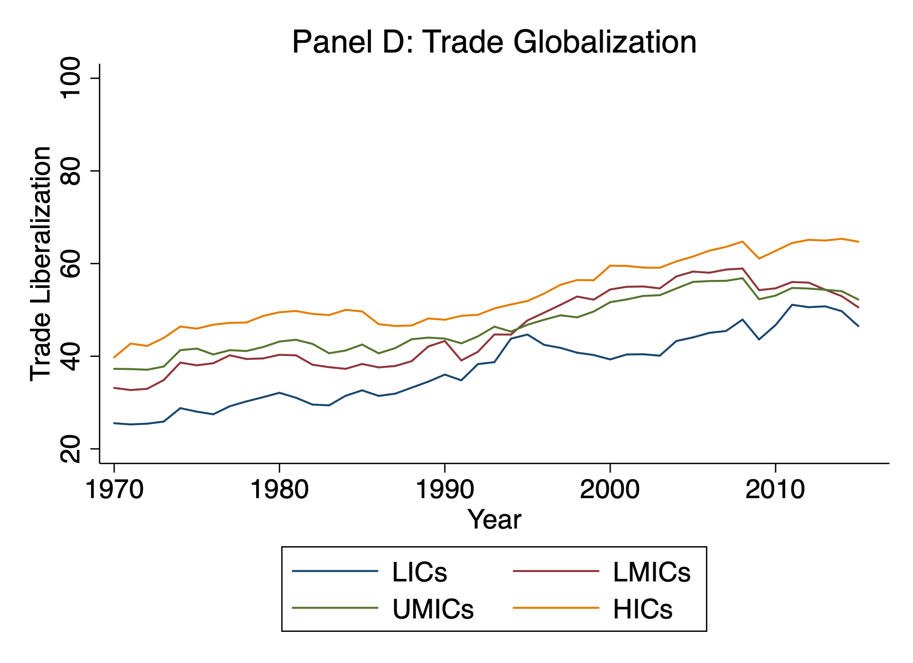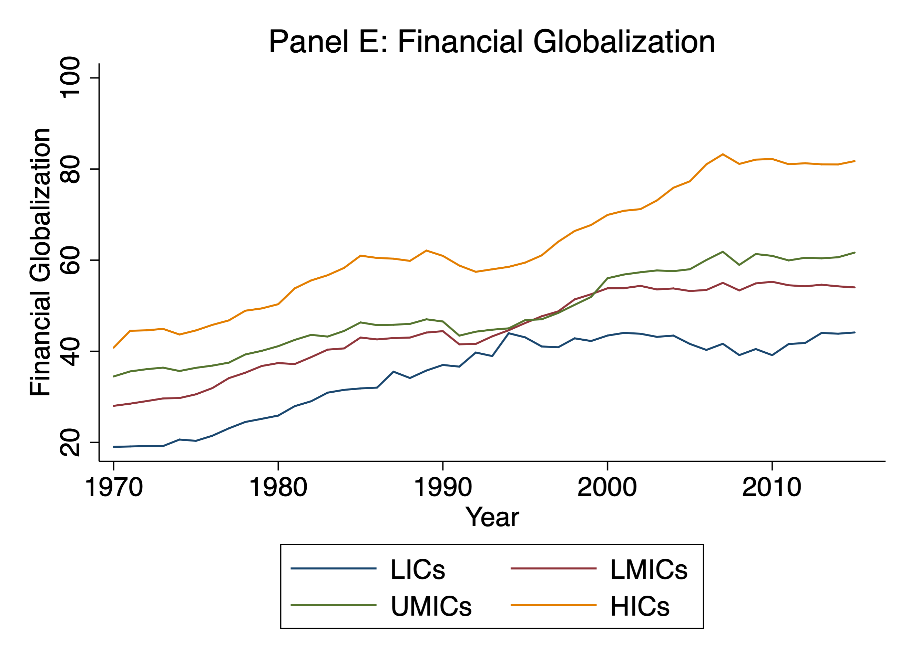

Note: unweighted means of the respective measure of globalization across the four income classifications over time

Appendix 3: Descriptive Statistics and Data Sources
 | Mean | S. D. | Min | Max | Source
Economic Globalization | 50.65 | 17.19 | 12.63 | 93.15 | KOF (2018)
Neighborhood Liberalization | 40.81 | 8.04 | 23.11 | 62.93 | Own calculations based on Mayer and Zignago (2011) and KOF (2018)
GDP/Capita Growth (WDI) | 0.09 | 0.16 | -1.41 | 1.08 | World Bank (2017a)
GDP/Capita (ln, WDI) | 8.17 | 1.57 | 5.02 | 11.52 | World Bank (2017a)
GDP/Capita Growth (PWT) | 0.09 | 0.16 | -1.10 | 1.00 | Feenstra et al. (2015)
GDP/Capita (ln, PWT) | 8.83 | 1.25 | 5.71 | 12.10 | Feenstra et al. (2015)
Gini (Net Income) | 38.20 | 8.89 | 18.15 | 63.90 | Solt (2016)
Gini (Market Income) | 46.34 | 7.21 | 23.00 | 73.42 | Solt (2016)
Gini (ATG & PovcalNet) | 39.92 | 9.37 | 17.50 | 69.70 | Milanovic (2014) and World Bank (2017b) (combined)
Population Growth | 1.77 | 1.44 | -3.77 | 15.53 | World Bank (2017a)
Education | 6.55 | 3.07 | 0.45 | 13.18 | Barro and Lee (2013)
Democracy (Polity IV) | 2.45 | 6.96 | -10.00 | 10.00 | Marshall et al. (2011)
Life Expectancy | 65.32 | 10.82 | 29.27 | 83.54 | World Bank (2017a)
Investment (% GDP) | 23.10 | 7.35 | 3.58 | 58.97 | World Bank (2017a)
Debt (% GDP) | 78.99 | 107.06 | 1.38 | 1095.70 | World Bank (2017a)
Government Expenditure (% GDP) | 15.64 | 6.53 | 0.00 | 88.43 | World Bank (2017a)
Education Expenditure (% GDP) | 4.22 | 2.27 | 0.00 | 36.39 | World Bank (2017a) and  IMF (2017) (combined)
Mean Income of Decile Group 1 (ln) | 5.78 | 1.61 | 2.09 | 8.98 | Lahoti et al. (2016)
Mean Income of Decile Group 2 (ln) | 6.36 | 1.49 | 3.26 | 9.34 | Lahoti et al. (2016)
Mean Income of Decile Group 3 (ln) | 6.69 | 1.43 | 3.90 | 9.54 | Lahoti et al. (2016)
Mean Income of Decile Group 4 (ln) | 6.95 | 1.38 | 4.25 | 9.68 | Lahoti et al. (2016)
Mean Income of Decile Group 5 (ln) | 7.18 | 1.34 | 4.55 | 9.80 | Lahoti et al. (2016)
Mean Income of Decile Group 6 (ln) | 7.39 | 1.30 | 4.84 | 9.91 | Lahoti et al. (2016)
Mean Income of Decile Group 7 (ln) | 7.61 | 1.26 | 5.11 | 10.09 | Lahoti et al. (2016)
Mean Income of Decile Group 8 (ln) | 7.86 | 1.21 | 5.41 | 10.28 | Lahoti et al. (2016)
Mean Income of Decile Group 9 (ln) | 8.19 | 1.15 | 5.81 | 10.54 | Lahoti et al. (2016)
Mean Income of Decile Group 10 (ln) | 9.10 | 0.96 | 6.42 | 11.50 | Lahoti et al. (2016)
Mean Income at 95th Percentile (ln) | 8.71 | 1.07 | 5.84 | 11.13 | Lahoti et al. (2016)
Mean Income at 99th Percentile (ln) | 11.20 | 1.07 | 8.32 | 13.61 | Lahoti et al. (2016)
Income Share of Decile Group 1 | 1.65 | 1.01 | 0.06 | 4.84 | Lahoti et al. (2016)
Income Share of Decile Group 2 | 2.73 | 1.27 | 0.28 | 6.19 | Lahoti et al. (2016)
Income Share of Decile Group 3 | 3.69 | 1.43 | 0.65 | 7.21 | Lahoti et al. (2016)
Income Share of Decile Group 4 | 4.67 | 1.52 | 1.18 | 8.10 | Lahoti et al. (2016)
Income Share of Decile Group 5 | 5.76 | 1.54 | 1.96 | 8.95 | Lahoti et al. (2016)
Income Share of Decile Group 6 | 7.04 | 1.50 | 2.95 | 9.92 | Lahoti et al. (2016)
Income Share of Decile Group 7 | 8.68 | 1.39 | 4.27 | 11.99 | Lahoti et al. (2016)
Income Share of Decile Group 8 | 11.03 | 1.15 | 6.53 | 14.71 | Lahoti et al. (2016)
Income Share of Decile Group 9 | 15.24 | 0.96 | 11.35 | 18.15 | Lahoti et al. (2016)
Income Share of Decile Group 10 | 39.51 | 10.65 | 18.48 | 69.55 | Lahoti et al. (2016)
Income Share of Top 1 Percent | 13.90 | 8.05 | 2.29 | 43.75 | Lahoti et al. (2016)
Income Share of Top 5 Percent | 28.64 | 10.37 | 10.21 | 60.62 | Lahoti et al. (2016)

Appendix 4: Additional Results

Table A1 – First-Stage Estimates: Globalization and Growth
 | (1) | (2) | (3) | (4)
First stage estimates  of specification … , Table 3 | 3 | 4 | 6 | 6
Dependent variable | Economic globalization _{t-1} | Economic globalization _{t-1} | Economic globalization _{t-1} | Economic globalization _{t-1} ²
Neighborhood Liberalization _{t-2} | 0.9269*** | 0.9536*** | 1.3386** | 29.7125
 | (0.1563) | (0.1556) | (0.5821) | (60.6076)
Neighborhood Liberalization _{t-2} ² |  |  | -0.0038 | 1.0756*
 |  |  | (0.0054) | (0.5776)
GDP/capita (ln) _{t-1} | 3.0319 | 3.3551* | 3.3795 | 277.4731
 | (2.0453) | (1.9703) | (2.1598) | (230.4244)
Population Growth (%) _{t-1} |  | 0.0575 | 0.0976 | 43.2742
 |  | (0.2392) | (0.2636) | (28.9518)
Education _{t-1} |  | -0.4038 | -0.3741 | -41.1119
 |  | (0.6239) | (0.6891) | (78.5094)
Democracy _{t-1} |  | 0.1597** | 0.1575** | 7.0521
 |  | (0.0730) | (0.0801) | (7.8094)
Life Expectancy _{t-1} |  | 0.1320 | 0.1255 | -1.1092
 |  | (0.1107) | (0.1227) | (13.4350)
Period FE and Country FE | Yes | Yes | Yes | Yes
Observations | 786 | 786 | 787 | 787
K-P underidentification (p) | 0.000 | 0.000 | 0.000 | 0.000
K-P weak identification (F) | 35.166 | 37.554 | 7.132 | 7.132
Note: First-stage estimates corresponding to Table 3.

Table A2 – Sample Split: Low vs. High Globalization
 | (1) | (2)
 | low globalization | high globalization
Economic Globalization _{t-1} | 0.0399*** | -0.0035
 | (0.0119) | (0.0025)
First Stage:
Neighborhood Liberalization _{t-2} | 0.8403*** | 0.9377***
 | (0.2849) | (0.1706)
Controls | Yes | Yes
Period and Country FE | Yes | Yes
Observations | 383 | 385
K-P weak indentification test (F) | 8.697 | 30.227
Note: Sample split at the median of Economic Globalization_{t-1} of the baseline sample (Table 1, column 4).

Figure A2 – Sample Split, Coefficient Plot

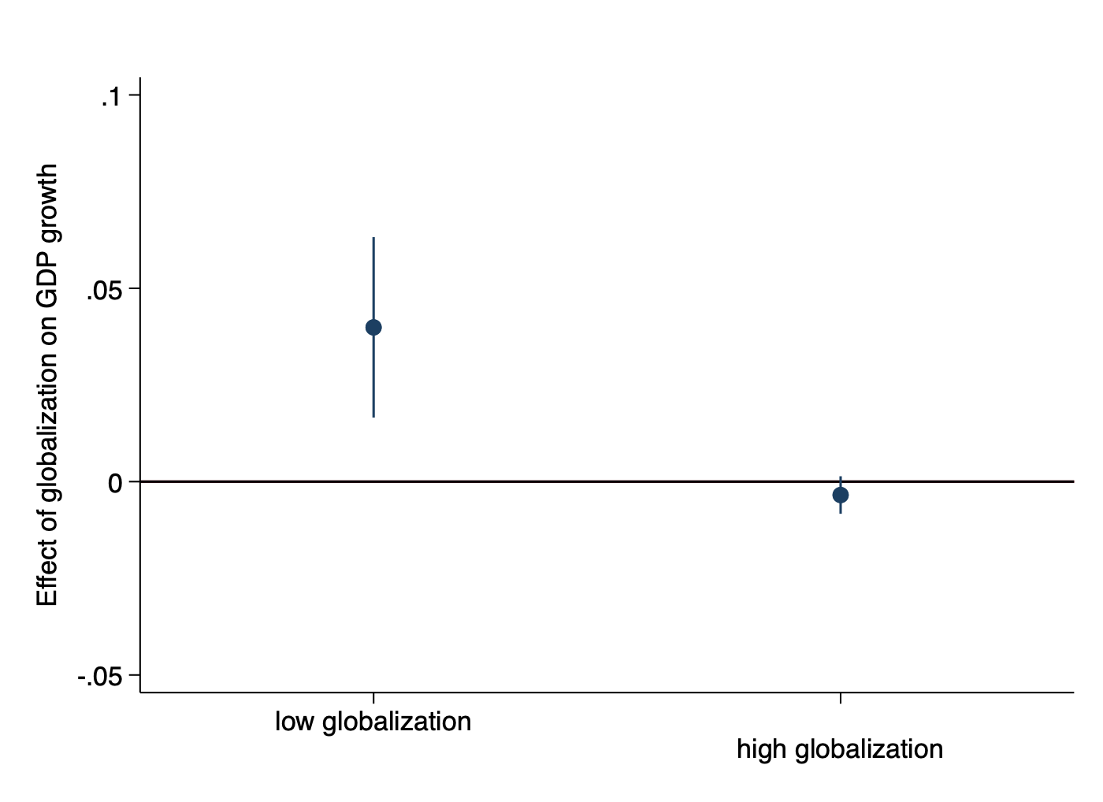
Note: coefficient plot corresponding to Table A2. 95% confidence intervals.

Table A3 – First-Stage Estimates: Globalization and Inequality
 | (1) | (2) | (3) | (4)
First stage estimates  of specification … of Table 4 | 3 | 4 | 6 | 6
Dependent variable | Economic globalization _{t-1} | Economic globalization _{t-1} | Economic globalization _{t-1} | Economic globalization _{t-1} ²
Neighborhood Liberalization _{t-2} | 0.807*** | 0.827*** | 1.530** | 77.274
 | (0.173) | (0.176) | (0.597) | (59.310)
Neighborhood Liberalization _{t-2} ² |  |  | -0.007 | 0.326
 |  |  | (0.005) | (0.553)
GDP/capita (ln) _{t-1} | 7.131 | 5.047 | 2.735 | -1682.025**
 | (6.822) | (6.969) | (7.054) | (766.357)
 | -0.070 | 0.078 | 0.229 | 144.060***
 | (0.450) | (0.452) | (0.456) | (49.441)
Population Growth (%) _{t-1} |  | -0.248 | -0.188 | 8.332
 |  | (0.408) | (0.404) | (40.859)
Education _{t-1} |  | -0.451 | -0.398 | -71.193
 |  | (0.632) | (0.633) | (67.964)
Democracy _{t-1} |  | 0.086 | 0.085 | 5.244
 |  | (0.084) | (0.086) | (7.904)
Life Expectancy _{t-1} |  | 0.072 | 0.059 | -1.590
 |  | (0.125) | (0.127) | (12.510)
Period FE and Country FE | Yes | Yes | Yes | Yes
Observations | 612 | 612 | 612 | 612
K-P underidentification (p) | 0.000 | 0.000 | 0.000 | 0.000
K-P weak identification (F) | 21.804 | 22.152 | 6.176 | 6.176
Note: First-stage estimates corresponding to Table 4.

Table A4 – Income Growth by Decile Group
 | (1) | (2) | (3) | (4) | (5) | (6) | (7) | (8) | (9) | (10)
Dependent Variable: Growth of Mean Income of Decile Group: | 1 | 2 | 3 | 4 | 5 | 6 | 7 | 8 | 9 | 10
Economic Globalization | 0.004 | 0.006 | 0.006 | 0.007 | 0.007 | 0.007 | 0.008 | 0.008* | 0.009* | 0.011**
Economic Globalization | (0.008) | (0.006) | (0.006) | (0.005) | (0.005) | (0.005) | (0.005) | (0.005) | (0.005) | (0.005)
Observations | 657 | 657 | 657 | 657 | 657 | 657 | 657 | 657 | 657 | 657
First-Stage Estimates
Neighborhood Liberalization _{t-2} | 0.823*** | 0.811*** | 0.809*** | 0.810*** | 0.814*** | 0.819*** | 0.824*** | 0.830*** | 0.837*** | 0.844***
Neighborhood Liberalization _{t-2} | (0.169) | (0.170) | (0.171) | (0.171) | (0.171) | (0.171) | (0.171) | (0.170) | (0.170) | (0.170)
K-P weak id. test (F) | 23.629 | 22.706 | 22.444 | 22.474 | 22.668 | 22.962 | 23.322 | 23.730 | 24.177 | 24.619
Note: 2SLS fixed effects regressions. Averages of 5-year-periods. All explanatory variables are lagged by one period. Standard errors clustered at the country-level in parentheses, significance levels: * p<.10, ** p<.05, *** p<.01. All regressions include country FE, period FE, the lagged baseline control variables and the lagged income level of the respective income quantile.
A multivariate two-sided Wald-test rejects the null hypothesis that all ten coefficients of the second-stage are zero with p = 0.0001. A regression that uses the mean income growth across all decile groups as the dependent variable yields a coefficient of 0.0094, with a standard error of 0.0046 and a p-value of 0.045.

Figure A3 – Income Growth by Decile Group, Coefficient Plot
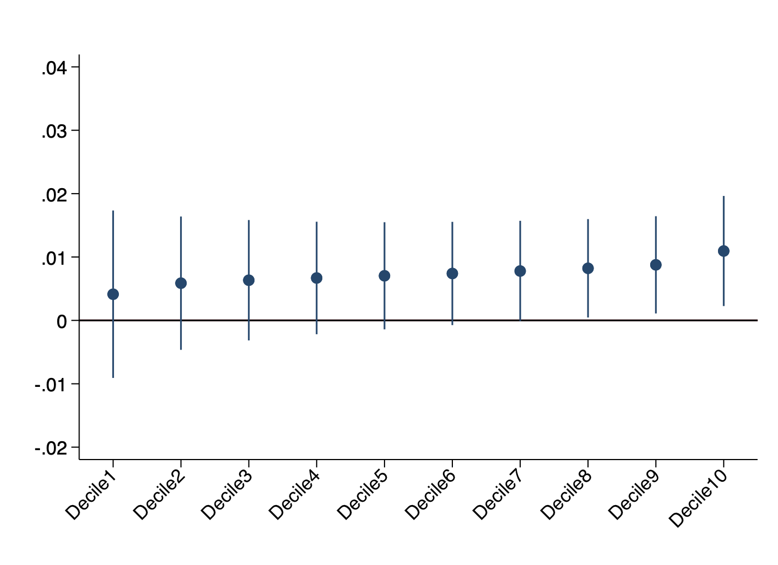

Note: point estimates and 90 percent confidence intervals of the coefficients on economic globalization in the regressions of decile-group-specific income growth, reported in Table A3, columns 1-10

Appendix 5: Robustness Tests

Identification strategy. Initially, it is important to note that all baseline results presented above are robust to both OLS and IV estimation as well as to the inclusion and exclusion of standard control variables. In the following, we further challenge the IV estimation, our preferred specification.
First, we relax the exclusion restriction the IV is based on. So far, we applied the standard assumption of ‘strict exogeneity’ for the IV. This means that in the model

$$y_{i,t} = { IV}_{i,t-2}+ β g_{i,t-1} + {X'}_{i,t-1}δ + μ_{i} + ϑ_{t} +{ ε}_{i,t}$$ | (11)
where $g$ is endogenous, we assumed that = 0. We argued above why we expect that this assumption holds. However, we acknowledge that in macroeconomic settings like ours it might, as an alternative, be reasonable to assume that is close to 0 but not exactly equal to 0. Such an assumption corresponds to what Conley et al. (2012) define as “plausibly exogenous.” Consider the following example: If a country $j$ that is geographically close to country $i$ implements liberalization policies, this could lead to increasing income opportunities for individuals in country $i$. In order for these increasing income opportunities to have an effect on incomes in country $i$, we would expect the globalization score $g$ of country $i$ to be affected, because economic flows between countries $i$ and $j$ would increase. In this case, would be exactly equal to 0 because there would be no direct effect that is independent of the endogenous variable $g$. If, however, the globalization score did not adequately capture these increasing flows, because, e.g., individuals from country $i$ derive income from commuting to informal employments in country $j$, there would be a direct effect of globalization in country $j$ on incomes in country i. In such a case would be close to 0 but not exactly 0. To account for such unobserved channels, we employ Conley et al.’s (2012) method and re-estimate our results for different values of . We consider it reasonable to use values of that are smaller than $\hat{β}$, as country $i$’s economy will have a stronger effect on incomes in country $i$ than economies of other countries. We focus on the inequality regressions and plot results for different values of in Figure A4 in the Appendix. The results indicate that in order to reduce the point estimate to zero the instrumental variable (i.e., $NeighborhoodLiberalization in countries j≠i$) would need to have a direct effect on inequality in country $i$ without affecting globalization in country $i$ that is equivalent to more than 80 percent of globalization’s estimated effect. We consider this to be highly unlikely.
Alternative Data. Next, we change the datasets used to measure all key concepts (growth, inequality, income shares, globalization). In Table A5 we, first, use GDP data from the Penn World Tables and replicate the baseline growth regressions reported in Table 3. The coefficients and significance levels are barely affected by this modification and inferences do not change. Second, in Table A5 we use Gini indices from other data sources to replicate the inequality regressions reported in Table 4. As discussed above, some scholars criticize the SWIID’s approach and recommend refraining from using imputed and interpolated values of Gini indices. In this robustness exercise, we follow this advice and use Gini indices from All the Ginis and PovcalNet instead of the SWIID. As these Gini indices are not standardized and based on different concepts (income and consumption, household and individual, gross and net), we use only Gini indices based on a single underlying concept for each country. More precisely, we check for each country which concept was used most frequently in the observation period and drop all observations that are based on other concepts. As country fixed effects are absorbed in all regressions, it is unproblematic that different countries use different concepts. It is important to note that the sample we can use for these regressions is substantially smaller than the baseline sample. Nevertheless, the results are remarkably similar. Next, we also use the Gini indices provided by the Distributional National Accounts (DINA) data from the World Inequality database (Alvaredo et al. 2020) in Table A7. These are based on different data sources and methods, but again, the results are very similar as in the baseline. Third, we use data on decile-group-specific income shares from GCIP to test the robustness of the decile-group-specific results and find very similar results as with the WDI data (Table A8). Fourth, we use an alternative measure of globalization. Instead of the new KOF index developed by Gygli et al. (2019) we use the old version developed by Dreher (2006) and re-estimate all baseline regressions. The two indices are based on different indicators (8 new indicators in the revised version), different numbers of indicators (14 vs. 8), and different aggregation methods (different restrictions on weights, different sub-indices). Despite these substantial differences in the way that these two indices measure globalization all results hold (Tables A9-A12).
Alternative Specifications. Then, we test the robustness of our main estimates to several additional modifications of the econometric specifications. We conduct the same robustness tests for both the growth regressions (Table A13) and the inequality regressions (Table A14). First, we add investment, debt, and government expenditure (all as a share of GDP) as additional control variables to the baseline OLS and IV regressions. Second, we remove all control variables. Coefficients and significance levels are barely affected by these changes. Third, we refrain from lagging the variable of interest and look at the contemporaneous effect of economic globalization on growth and inequality. In the growth regressions the point estimates remain statistically significant and become slightly smaller, suggesting that it takes some time for globalization to take full effect. The coefficients in the inequality regressions are only negligibly affected. Fourth, as IV regressions are known to be sensitive to outliers (Young 2019), we demonstrate that our results are not driven by influential observations. On the one hand, we “winsorize” the variable of interest, the outcome variable and the instrumental variable at the 1st and the 99th percentile and virtually find the same results. On the other hand, we follow Young (2017) and test the sensitivity of our coefficients of interest to dropping individual countries. Figure A6 plots the coefficients on economic globalization and its square in regressions in which each country is left out once. Figure A7 reports the results of the analogous exercise for the inequality baseline regression. It is visible that point estimates and confidence intervals are not sensitive to the exclusion of any single country. Fifth, in the last column of Tables A13 and A14, we modify the instrumental variable by using the simple distance between two countries’ largest agglomerations instead of the distance between all their major agglomerations weighted by population. While, as could be expected, instrument relevance slightly decreases, the IV still passes the relevant tests and second-stage estimates are not affected.

Figure A4: Plausibly Exogenous
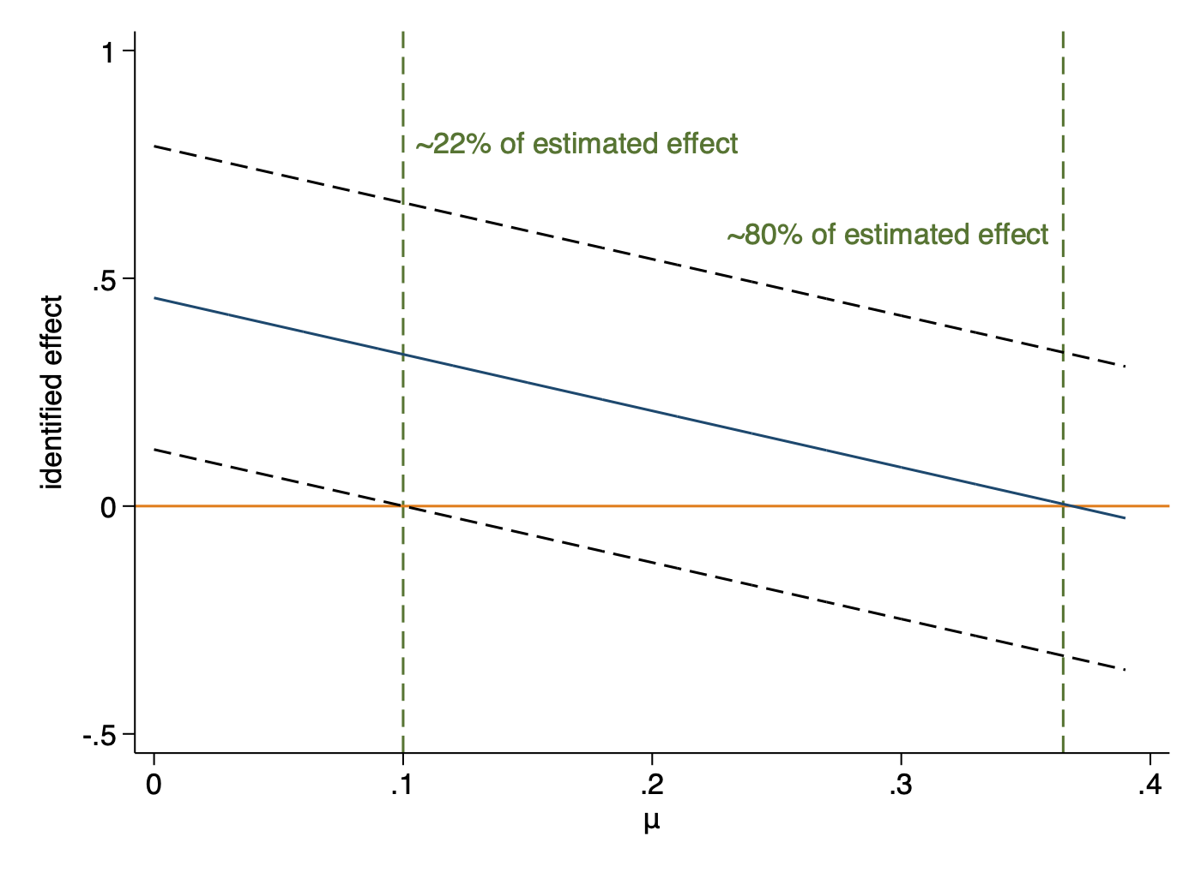
Note: The graph is the result of applying the “plausibly exogenous” method proposed by Conley et al. (2012). It visualizes the estimated effect of globalization on the Gini index of market income for various parameter values of $μ$. The estimates show that the estimated effect remains positive for values of $μ$ < 0.36 and statistically significant at the ten percent level for values of $μ$ < 0.10. This suggests that the direct positive effect of the IV on the Gini index would have be equivalent to 80% of the estimated effect of globalization in order for the true effect to be 0. For details see section 4.5 and Conley et al. (2012).

Table A5: Robustness, GDP Figures from Penn World Tables
 | (1) | (2) | (3) | (4) | (5) | (6)
Estimation Method | OLS | OLS | IV | IV | OLS | IV
Economic Globalization | 0.0040*** | 0.0034*** | 0.0050 | 0.0049 | 0.0129*** | 0.0512***
 | (0.0013) | (0.0013) | (0.0038) | (0.0036) | (0.0037) | (0.0124)
Economic Globalization² |  |  |  |  | -0.0001*** | -0.0003***
 |  |  |  |  | (0.0000) | (0.0001)
GDP/capita (ln, PWT) | -0.2485*** | -0.2432*** | -0.3157*** | -0.3171*** | -0.2442*** | -0.3855***
 | (0.0334) | (0.0345) | (0.0458) | (0.0458) | (0.0334) | (0.0524)
Population Growth (%) |  | -0.0073 |  | -0.0070 | -0.0045 | 0.0058
 |  | (0.0115) |  | (0.0117) | (0.0117) | (0.0128)
Education |  | -0.0147 |  | -0.0117 | -0.0123 | -0.0020
 |  | (0.0108) |  | (0.0124) | (0.0099) | (0.0148)
Democracy (Polity IV) |  | 0.0008 |  | 0.0016 | -0.0002 | -0.0039
 |  | (0.0014) |  | (0.0016) | (0.0014) | (0.0025)
Life Expectancy |  | 0.0067*** |  | 0.0080*** | 0.0051** | 0.0008
 |  | (0.0022) |  | (0.0022) | (0.0023) | (0.0034)
Period FE and Country FE | Yes | Yes | Yes | Yes | Yes | Yes
Observations | 924 | 924 | 817 | 817 | 924 | 817
K-P underid. (p) | 0.268 | 0.286 | 0.307 | 0.331 | 0.301 | 0.287
K-P weak id. (F) |  |  | 0.000 | 0.000 |  | 0.000
Note: Dependent Variable GDP/capita growth (Penn World Tables). Averages of 5-year periods. All explanatory variables are lagged by one period. OLS and 2SLS fixed effects regressions, standard errors clustered at the country-level in parentheses, significance levels: * p<.10, ** p<.05, *** p<.01.

Table A6: Robustness, Gini Indices from PovcalNet and All the Ginis
 | (1) | (2) | (3) | (4) | (5) | (6)
 | OLS | OLS | IV | IV | OLS | IV
Economic Globalization | 0.129** | 0.083 | 0.342* | 0.446** | 0.128 | -0.228
 | (0.054) | (0.053) | (0.191) | (0.226) | (0.178) | (0.391)
Economic Globalization² |  |  |  |  | -0.000 | 0.005
 |  |  |  |  | (0.002) | (0.003)
GDP/capita (ln, WDI) | 1.015 | 0.393 | 1.153 | 2.158 | -0.668 | 12.606
 | (6.320) | (6.808) | (7.123) | (7.832) | (8.126) | (10.229)
GDP/capita (ln, squared, WDI) | -0.012 | 0.106 | -0.112 | -0.195 | 0.176 | -0.777
 | (0.375) | (0.433) | (0.439) | (0.527) | (0.499) | (0.650)
Population Growth (%, WDI) |  | -0.711 |  | -0.271 | -0.688 | -0.731
 |  | (0.604) |  | (0.668) | (0.618) | (0.675)
Education |  | -0.468 |  | -0.506 | -0.457 | -0.548
 |  | (0.394) |  | (0.474) | (0.397) | (0.422)
Democracy (Polity IV) |  | -0.016 |  | -0.043 | -0.019 | -0.011
 |  | (0.106) |  | (0.105) | (0.107) | (0.108)
Life Expectancy |  | 0.010 |  | -0.002 | 0.008 | 0.025
 |  | (0.156) |  | (0.148) | (0.158) | (0.152)
Period FE and Country FE | Yes | Yes | Yes | Yes | Yes | Yes
Observations | 575 | 516 | 540 | 488 | 516 | 488
K-P underidentification test (p) |  |  | 0.000 | 0.002 |  | 0.000
K-P weak identification test (F) |  |  | 14.944 | 10.828 |  | 6.206
Note: Dependent variable: Gini indices from PovcalNet and All the Ginis. OLS and 2SLS regressions. Averages of five-year periods. All explanatory variables are lagged by one period. Standard errors clustered at the country-level in parentheses, significance levels: * p<.10, ** p<.05, *** p<.01
The difference to Table 3 is in the dependent variable. Instead of data from the SWIID, in this table Gini indices from All the Ginis supplemented with Gini indices from PovcalNet are used. For each country we use only Gini indices that use the same underlying concepts (income vs. consumption, household vs. individual, gross vs. net). If Ginis based on various concepts are reported for one country, we drop all observations except those based on the most frequently used concept.

Table A7: Robustness, Gini indices from the World Inequality Database
 | (1) | (2) | (3) | (4) | (5) | (6)
 | OLS | OLS | IV | IV | OLS | IV
Economic Globalization | 0.120*** | 0.136*** | 0.310*** | 0.300*** | 0.265* | 0.398
 | (0.036) | (0.040) | (0.094) | (0.105) | (0.134) | (0.277)
Economic Globalization² |  |  |  |  | -0.001 | -0.001
 |  |  |  |  | (0.001) | (0.002)
GDP/capita (ln, WDI) | -2.242 | 0.533 | -0.680 | 1.904 | -1.886 | 1.014
 | (4.283) | (4.558) | (4.239) | (4.586) | (4.427) | (5.610)
GDP/capita (ln, squared, WDI) | 0.313 | 0.130 | 0.165 | -0.010 | 0.286 | 0.040
 | (0.252) | (0.267) | (0.270) | (0.295) | (0.263) | (0.360)
Population Growth (%, WDI) |  | 0.058 |  | 0.098 | 0.086 | 0.121
 |  | (0.133) |  | (0.125) | (0.142) | (0.142)
Education |  | 0.549 |  | 0.614* | 0.573 | 0.632*
 |  | (0.360) |  | (0.359) | (0.363) | (0.370)
Democracy (Polity IV) |  | -0.112* |  | -0.131** | -0.124* | -0.140**
 |  | (0.066) |  | (0.060) | (0.069) | (0.064)
Life Expectancy |  | -0.043 |  | -0.089 | -0.052 | -0.100
 |  | (0.097) |  | (0.095) | (0.097) | (0.099)
Period FE and Country FE | Yes | Yes | Yes | Yes | Yes | Yes
Observations | 915 | 789 | 901 | 779 | 789 | 779
K-P underidentification test (p) |  |  | 0.000 | 0.000 |  | 0.000
K-P weak identification test (F) |  |  | 31.975 | 26.087 |  | 8.644
Note: Dependent variable: Gini indices from the World Inequality Database (WID.world).
OLS and 2SLS regressions. Averages of five-year periods. All explanatory variables are lagged by one period. Standard errors clustered at the country-level in parentheses, significance levels: * p<.10, ** p<.05, *** p<.01
The difference to Table 3 is in the dependent variable. Instead of data from the SWIID, in this table Gini indices from the World Inequality Database (Alvaredo et al. 2020) are used.

Table A8 – Globalization and Income Growth by Decile Group
Outcome Variable:  Income Share of Decile Group: | 1 | 2 | 3 | 4 | 5 | 6 | 7 | 8 | 9 | 10 | top 5% | top 1%
Economic Globalization | -0.022 | -0.019 | -0.021 | -0.025 | -0.029* | -0.031** | -0.031** | -0.024* | -0.001 | 0.233** | 0.217** | 0.127*
Economic Globalization | (0.016) | (0.015) | (0.016) | (0.016) | (0.016) | (0.015) | (0.014) | (0.013) | (0.018) | (0.104) | (0.095) | (0.076)
Observations | 657 | 657 | 657 | 657 | 657 | 657 | 657 | 657 | 657 | 657 | 657 | 657
First-stage Estimates
Neighborhood Liberalization _{t-2} | 0.823*** | 0.811*** | 0.809*** | 0.810*** | 0.814*** | 0.819*** | 0.824*** | 0.830*** | 0.837*** | 0.844*** | 0.836*** | 0.836***
Neighborhood Liberalization _{t-2} | (0.169) | (0.170) | (0.171) | (0.171) | (0.171) | (0.171) | (0.171) | (0.170) | (0.170) | (0.170) | (0.171) | (0.171)
K-P weak identif. (F) | 23.629 | 22.706 | 22.444 | 22.474 | 22.668 | 22.962 | 23.322 | 23.730 | 24.177 | 24.619 | 23.954 | 23.953
Note: 2SLS regressions. Averages of five-year periods. All explanatory variables are lagged by one period. Standard errors clustered at the country-level in parentheses, significance levels: * p<.10, ** p<.05, *** p<.01. All regressions include country FE, period FE, the lagged baseline control variables and the lagged income level of the respective income quantile.

Figure A5 – Relative Income Shares: Coefficient Plot
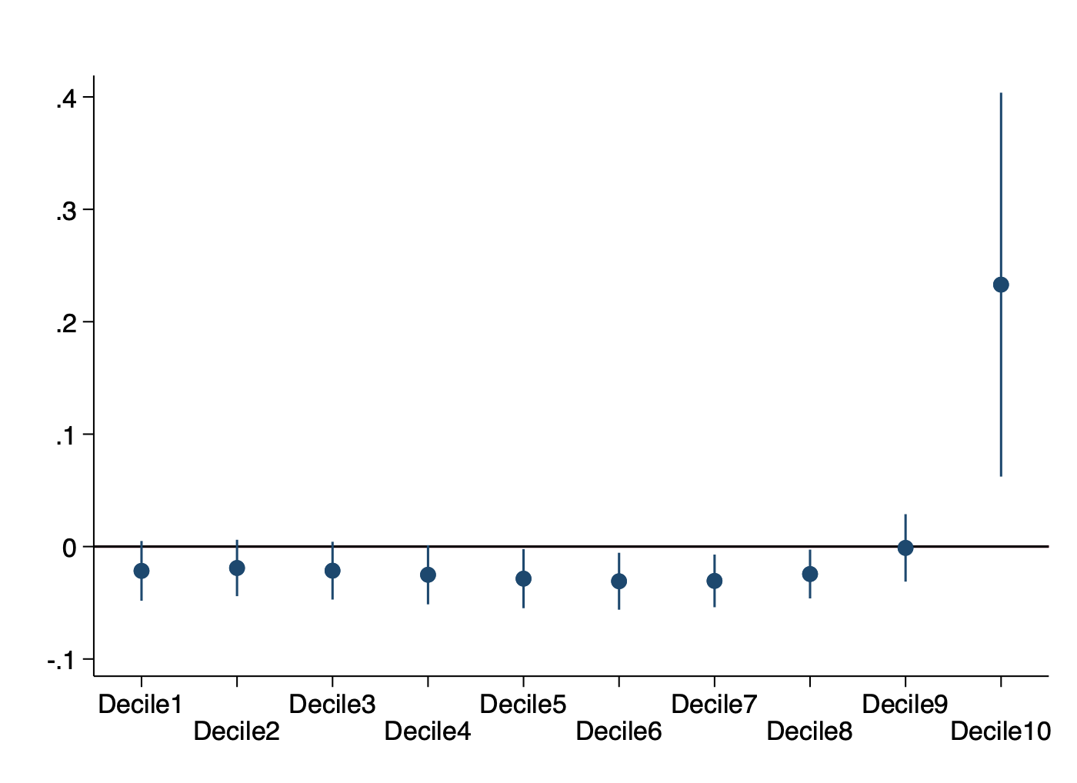
Note: visualization of results reported in Table 5: coefficients on economic globalization with 90 percent confidence intervals

Table A9: Robustness, Growth, Old KOF Index

 | (1) | (2) | (3) | (4) | (5) | (6)
Estimation Method | OLS | OLS | IV | IV | OLS | IV
Economic Globalization | 0.0033*** | 0.0031*** | 0.0017 | 0.0016 | 0.0101*** | 0.0495***
 | (0.0009) | (0.0009) | (0.0041) | (0.0038) | (0.0025) | (0.0133)
Economic Globalization² |  |  |  |  | -0.0001*** | -0.0003***
 |  |  |  |  | (0.0000) | (0.0001)
GDP/capita (ln) | -0.1958*** | -0.1892*** | -0.2417*** | -0.2361*** | -0.1839*** | -0.3515***
 | (0.0422) | (0.0413) | (0.0615) | (0.0595) | (0.0389) | (0.0666)
Population Growth (%) |  | -0.0199** |  | -0.0188** | -0.0151** | 0.0005
 |  | (0.0081) |  | (0.0075) | (0.0075) | (0.0090)
Education |  | -0.0133 |  | -0.0123 | -0.0121 | -0.0006
 |  | (0.0092) |  | (0.0105) | (0.0087) | (0.0150)
Democracy (Polity IV) |  | 0.0010 |  | 0.0024* | 0.0000 | -0.0040
 |  | (0.0013) |  | (0.0014) | (0.0013) | (0.0029)
Life Expectancy |  | 0.0048*** |  | 0.0068*** | 0.0030* | -0.0040
 |  | (0.0017) |  | (0.0020) | (0.0017) | (0.0045)
Period FE and Country FE | Yes | Yes | Yes | Yes | Yes | Yes
Sample | Full | Full | Full | Full | Full | Full
Observations | 852 | 852 | 767 | 767 | 852 | 767
R² | 0.225 | 0.249 |  |  | 0.269
K-P underidentification test (p) |  |  | 0.000 | 0.000 |  | 0.000
K-P weak identification test (F) |  |  | 34.462 | 37.656 |  | 14.888
Note: Dependent variable: GDP/capita growth. Averages of five-year periods. All explanatory variables are lagged by one period. OLS and 2SLS fixed effects regressions, standard errors clustered at the country-level in parentheses, significance levels: * p<.10, ** p<.05, *** p<.01.

Table A10: Robustness, Inequality, Old KOF index

 | (1) | (2) | (3) | (4) | (5) | (6)
 | OLS | OLS | IV | IV | OLS | IV
Economic Globalization | 0.175*** | 0.169*** | 0.456** | 0.440** | 0.242 | 0.064
 | (0.048) | (0.045) | (0.188) | (0.178) | (0.165) | (0.551)
Economic Globalization² |  |  |  |  | -0.001 | 0.002
 |  |  |  |  | (0.001) | (0.004)
GDP/capita (ln, WDI) | -6.162 | -1.899 | -4.459 | -0.545 | -3.972 | 8.097
 | (9.199) | (9.141) | (8.705) | (8.689) | (11.145) | (16.810)
GDP/capita (ln, squared) | 0.620 | 0.365 | 0.465 | 0.218 | 0.499 | -0.305
 | (0.479) | (0.494) | (0.475) | (0.491) | (0.618) | (1.011)
Population Growth (%) |  | 0.151 |  | 0.272 | 0.178 | 0.211
 |  | (0.382) |  | (0.385) | (0.388) | (0.387)
Education |  | -1.034** |  | -0.379 | -1.046** | -0.373
 |  | (0.435) |  | (0.390) | (0.437) | (0.381)
Democracy (Polity IV) |  | -0.167* |  | -0.143 | -0.171* | -0.137
 |  | (0.094) |  | (0.097) | (0.096) | (0.096)
Life Expectancy |  | -0.079 |  | -0.074 | -0.093 | -0.013
 |  | (0.130) |  | (0.132) | (0.134) | (0.157)
Period FE and Country FE | Yes | Yes | Yes | Yes | Yes | Yes
Sample | Full | Full | Full | Full | Full | Full
Observations | 658 | 658 | 608 | 608 | 658 | 608
R² | 0.148 | 0.179 | 0.017 | 0.049 | 0.180 | 0.108
K-P underidentification test (p) |  |  | 0.001 | 0.002 |  | 0.005
K-P weak identification test (F) |  |  | 24.927 | 25.442 |  | 8.702
Note: Dependent variable: Gini index of net income. Averages of five-year periods. All explanatory variables are lagged by one period. OLS and 2SLS fixed effects regressions, standard errors clustered at the country-level in parentheses, significance levels: * p<.10,
** p<.05, *** p<.01

Table A11: Robustness, Relative Income Shares, Old KOF index

Dependent Variable:  Income Share of Decile Group: | 1 | 2 | 3 | 4 | 5 | 6 | 7 | 8 | 9 | 10 | top 5% | top 1%
Economic Globalization | -0.023 | -0.021 | -0.024 | -0.029* | -0.033** | -0.035** | -0.034** | -0.026* | 0.001 | 0.248*** | 0.236*** | 0.134*
Economic Globalization | (0.015) | (0.014) | (0.015) | (0.016) | (0.016) | (0.015) | (0.015) | (0.014) | (0.019) | (0.091) | (0.091) | (0.078)
 | Yes | Yes | Yes | Yes | Yes | Yes | Yes | Yes | Yes | Yes | Yes | Yes
Observations | 645 | 645 | 645 | 645 | 645 | 645 | 645 | 645 | 645 | 645 | 645 | 645
K-P underid. test (p) | 0.000 | 0.000 | 0.000 | 0.000 | 0.000 | 0.000 | 0.000 | 0.000 | 0.000 | 0.000 | 0.000 | 0.000
K-P weak id. test (F) | 32.232 | 30.118 | 28.924 | 28.369 | 28.303 | 28.636 | 29.328 | 30.392 | 31.951 | 34.500 | 31.676 | 31.676
Note: 2SLS regressions. Averages of five-year periods. All explanatory variables are lagged by one period. Standard errors clustered at the country-level in parentheses, significance levels: * p<.10, ** p<.05, *** p<.01. All regressions include country FE, period FE, the lagged baseline control variables and the lagged income level of the respective income quantile.

Table A12: Robustness, Income Growth by Decile Group, Old KOF index

 | (1) | (2) | (3) | (4) | (5) | (6) | (7) | (8) | (9) | (10) | (11) | (12)
Dependent Variable: Income Growth of Decile Group: | 1 | 2 | 3 | 4 | 5 | 6 | 7 | 8 | 9 | 10 | top 5% | top 1%
Economic Globalization | 0.003 | 0.005 | 0.006 | 0.007 | 0.007 | 0.008 | 0.008 | 0.009* | 0.009* | 0.011** | 0.008 | 0.008
Economic Globalization | (0.008) | (0.007) | (0.006) | (0.006) | (0.006) | (0.005) | (0.005) | (0.005) | (0.005) | (0.005) | (0.006) | (0.006)
 | Yes | Yes | Yes | Yes | Yes | Yes | Yes | Yes | Yes | Yes | Yes | Yes
Observations | 645 | 645 | 645 | 645 | 645 | 645 | 645 | 645 | 645 | 645 | 645 | 645
K-P underid. test (p) | 0.000 | 0.000 | 0.000 | 0.000 | 0.000 | 0.000 | 0.000 | 0.000 | 0.000 | 0.000 | 0.000 | 0.000
K-P weak id. test (F) | 32.232 | 30.118 | 28.924 | 28.369 | 28.303 | 28.636 | 29.328 | 30.392 | 31.951 | 34.500 | 31.675 | 31.676
Note: 2SLS fixed effects regressions. Averages of 5-year-periods. All explanatory variables are lagged by one period. Standard errors clustered at the country-level in parentheses, significance levels: * p<.10, ** p<.05, *** p<.01. All regressions include country FE, period FE, the lagged baseline control variables and the lagged income level of the respective income quantile.

Table A13: Additional Robustness Tests of Growth Regressions
 | no controls |  | more controls |  | no lag |  | winsorized  variables |  | simple distance
 | (1) | (2) | (3) | (4) | (5) | (6) | (7) | (8) | (9)
 | OLS | IV | OLS | IV | OLS | IV | OLS | IV | IV
Economic Globalization  (t-1) | 0.016*** | 0.070*** | 0.012*** | 0.045*** |  |  | 0.013*** | 0.052*** | 0.061***
Economic Globalization  (t-1) | (0.003) | (0.017) | (0.004) | (0.013) |  |  | (0.003) | (0.011) | (0.015)
Economic Globalization²  (t-1) | -0.000*** | -0.001*** | -0.000*** | -0.000*** |  |  | -0.000*** | -0.000*** | -0.000***
Economic Globalization²  (t-1) | (0.000) | (0.000) | (0.000) | (0.000) |  |  | (0.000) | (0.000) | (0.000)
Economic Globalization  (t) |  |  |  |  | 0.012*** | 0.035**
Economic Globalization  (t) |  |  |  |  | (0.003) | (0.014)
Economic Globalization²  (t) |  |  |  |  | -0.000*** | -0.000***
Economic Globalization²  (t) |  |  |  |  | (0.000) | (0.000)
GDP/capita (ln, t-1) |  |  | -0.231*** | -0.335*** | -0.182*** | -0.216*** | -0.165*** | -0.278*** | -0.330***
 |  |  | (0.029) | (0.046) | (0.030) | (0.038) | (0.027) | (0.048) | (0.052)
Population Growth (%, t-1) |  |  | -0.009 | 0.003 | -0.003 | 0.004 | -0.007 | 0.005 | 0.014
 |  |  | (0.007) | (0.009) | (0.014) | (0.014) | (0.009) | (0.008) | (0.014)
Education (t-1) |  |  | -0.003 | -0.000 | -0.012 | -0.008 | -0.012 | -0.004 | -0.001
 |  |  | (0.008) | (0.011) | (0.009) | (0.010) | (0.009) | (0.011) | (0.014)
Democracy (Polity IV, t-1) |  |  | -0.001 | -0.002 | 0.000 | -0.003 | -0.000 | -0.003 | -0.004
 |  |  | (0.001) | (0.002) | (0.001) | (0.002) | (0.001) | (0.002) | (0.003)
Life Expectancy (t-1) |  |  | 0.003 | 0.002 | 0.004** | -0.000 | 0.003* | -0.000 | -0.002
 |  |  | (0.002) | (0.003) | (0.002) | (0.003) | (0.002) | (0.003) | (0.004)
Investment (% GDP, t-1) |  |  | 0.000 | -0.003*
 |  |  | (0.001) | (0.002)
Debt (% GDP, t-1) |  |  | -0.000* | -0.000
 |  |  | (0.000) | (0.000)
Government Exp.  (% GDP, t-1) |  |  | -0.002 | -0.004*
Government Exp.  (% GDP, t-1) |  |  | (0.002) | (0.002)
Observations | 1015 | 915 | 813 | 737 | 875 | 874 | 873 | 787 | 787
K-P underid. (p) |  | 0.000 |  | 0.000 |  | 0.003 |  | 0.000 | 0.000
K-P weak id. (F) |  | 7.981 |  | 6.806 |  | 3.823 |  | 8.878 | 3.766
Note: Dependent variable: GDP/capita growth. Averages of five-year periods. OLS and 2SLS fixed effects regressions, standard errors clustered at the country-level in parentheses, significance levels: * p<.10, ** p<.05, *** p<.01.

Table A14: Additional Robustness Tests of Inequality Regressions
 | no controls |  | more controls |  | no lag |  | winsorized  variables |  | simple distance
 | (1) | (2) | (3) | (4) | (5) | (6) | (7) | (8) | (9)
 | OLS | IV | OLS | IV | OLS | IV | OLS | IV | IV
Economic Globalization (t-1) | 0.181*** | 0.255** | 0.155*** | 0.367** |  |  | 0.139*** | 0.398** | 0.446**
 | (0.053) | (0.102) | (0.049) | (0.157) |  |  | (0.048) | (0.173) | (0.204)
Economic Globalization (t) |  |  |  |  | 0.184*** | 0.618***
 |  |  |  |  | (0.053) | (0.237)
GDP/capita (ln, t-1) |  |  | -1.661 | 6.283 | -0.898 | 1.474 | -0.971 | 4.042 | 4.462
 |  |  | (8.245) | (8.301) | (8.747) | (9.164) | (9.013) | (8.325) | (8.451)
GDP/capita (ln, squared, t-1) |  |  | 0.297 | -0.227 | 0.286 | -0.043 | 0.303 | -0.096 | -0.137
 |  |  | (0.462) | (0.485) | (0.484) | (0.558) | (0.492) | (0.491) | (0.505)
Population Growth (%, t-1) |  |  | 0.273 | 0.482 | 0.221 | 0.441 | 0.149 | 0.372 | 0.406
 |  |  | (0.375) | (0.378) | (0.406) | (0.429) | (0.375) | (0.376) | (0.386)
Education (t-1) |  |  | -1.124*** | -0.558 | -1.105** | -0.963** | -1.171*** | -0.581 | -0.536
 |  |  | (0.419) | (0.375) | (0.438) | (0.430) | (0.444) | (0.390) | (0.393)
Democracy (Polity IV, t-1) |  |  | -0.194** | -0.203** | -0.183* | -0.208** | -0.181** | -0.171* | -0.168*
 |  |  | (0.096) | (0.093) | (0.094) | (0.097) | (0.091) | (0.090) | (0.093)
Life Expectancy (t-1) |  |  | -0.001 | -0.008 | -0.108 | -0.220 | -0.077 | -0.058 | -0.064
 |  |  | (0.128) | (0.122) | (0.130) | (0.144) | (0.128) | (0.126) | (0.129)
Investment (% GDP) |  |  | -0.044 | -0.060
 |  |  | (0.069) | (0.070)
Debt (% GDP) |  |  | 0.418 | 0.487
 |  |  | (0.432) | (0.525)
Government Exp. (% GDP) |  |  | 0.122 | 0.080
 |  |  | (0.095) | (0.095)
Observations | 790 | 733 | 645 | 602 | 664 | 663 | 663 | 612 | 612
K-P underid. (p) |  | 0.000 |  | 0.000 |  | 0.001 |  | 0.000 | 0.000
K-P weak id. (F) |  | 32.516 |  | 17.356 |  | 11.714 |  | 22.723 | 14.475
Note: Dependent variable: Gini index of net income. Averages of five-year periods. OLS and 2SLS fixed effects regressions, standard errors clustered at the country-level in parentheses, significance levels: * p<.10, ** p<.05, *** p<.01

Figure A6: Globalization and Growth: Sensitivity of Coefficients (Jackknife Test)

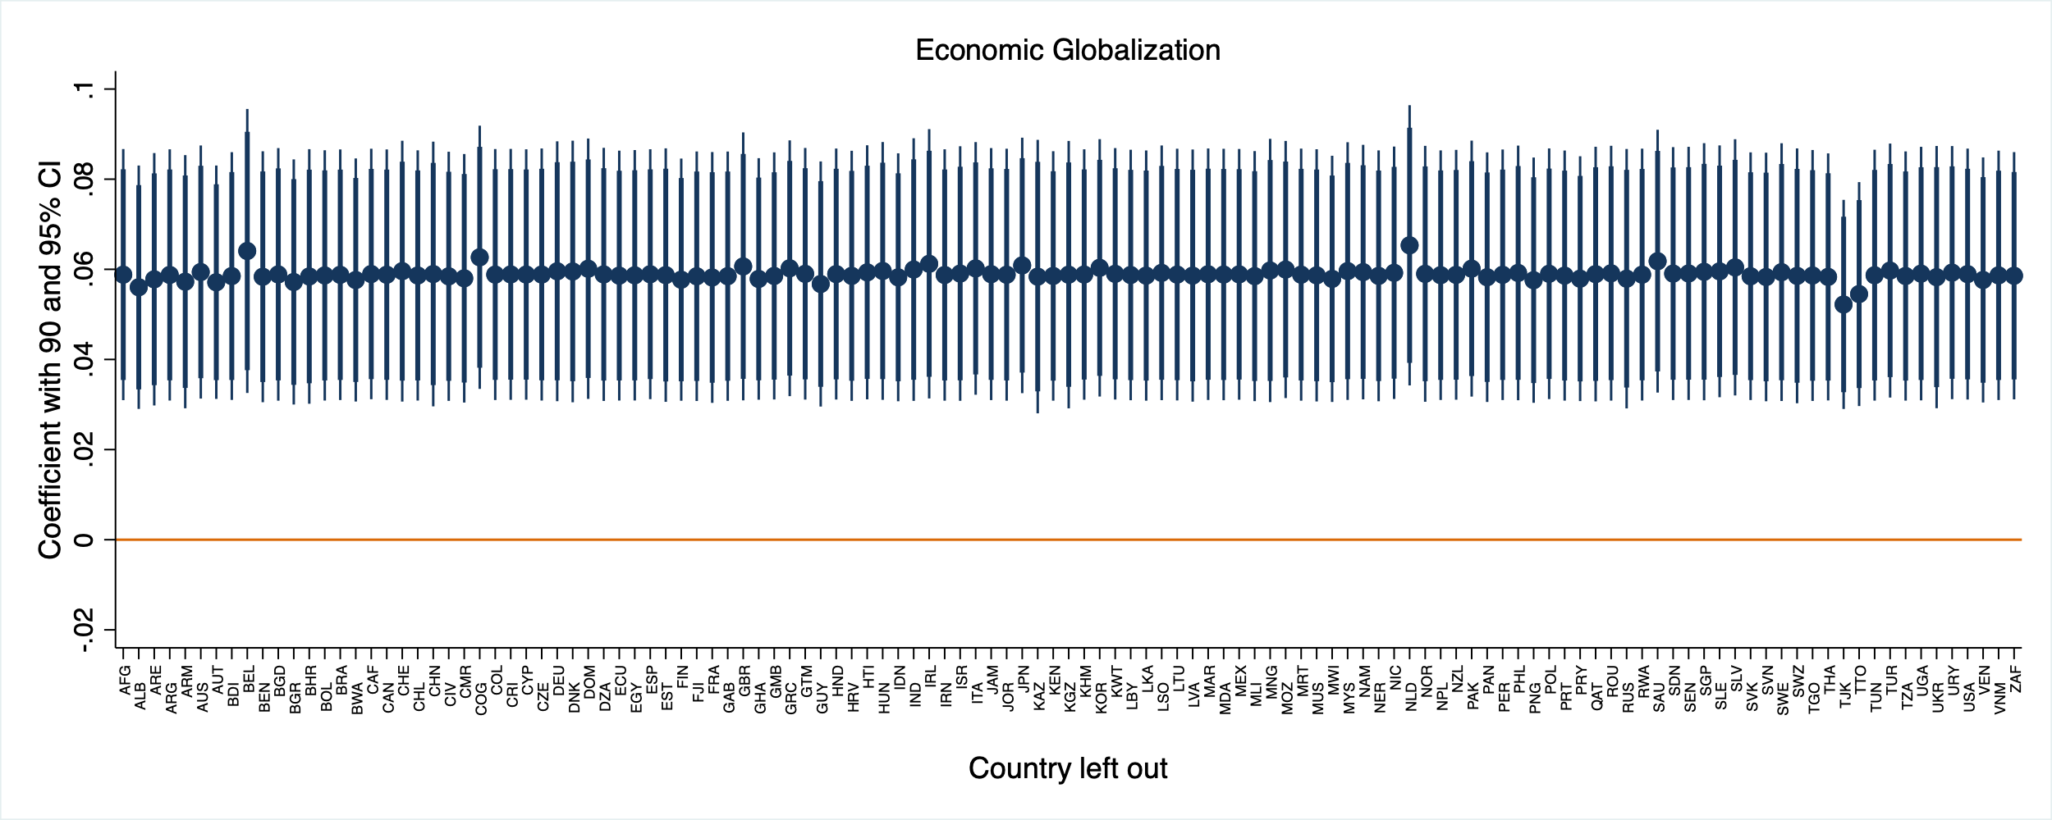
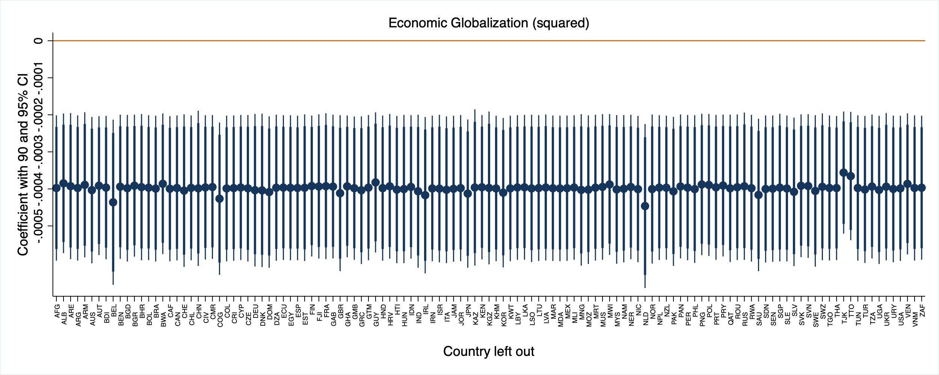
Note: coefficients with 95 (and 90) percent confidence intervals of globalization and globalization squared of the baseline growth regression (Table 2, column 6) when the country listed on the x-axis is left out

Figure A7: Globalization and Inequality: Sensitivity of Coefficients (Jackknife Test)
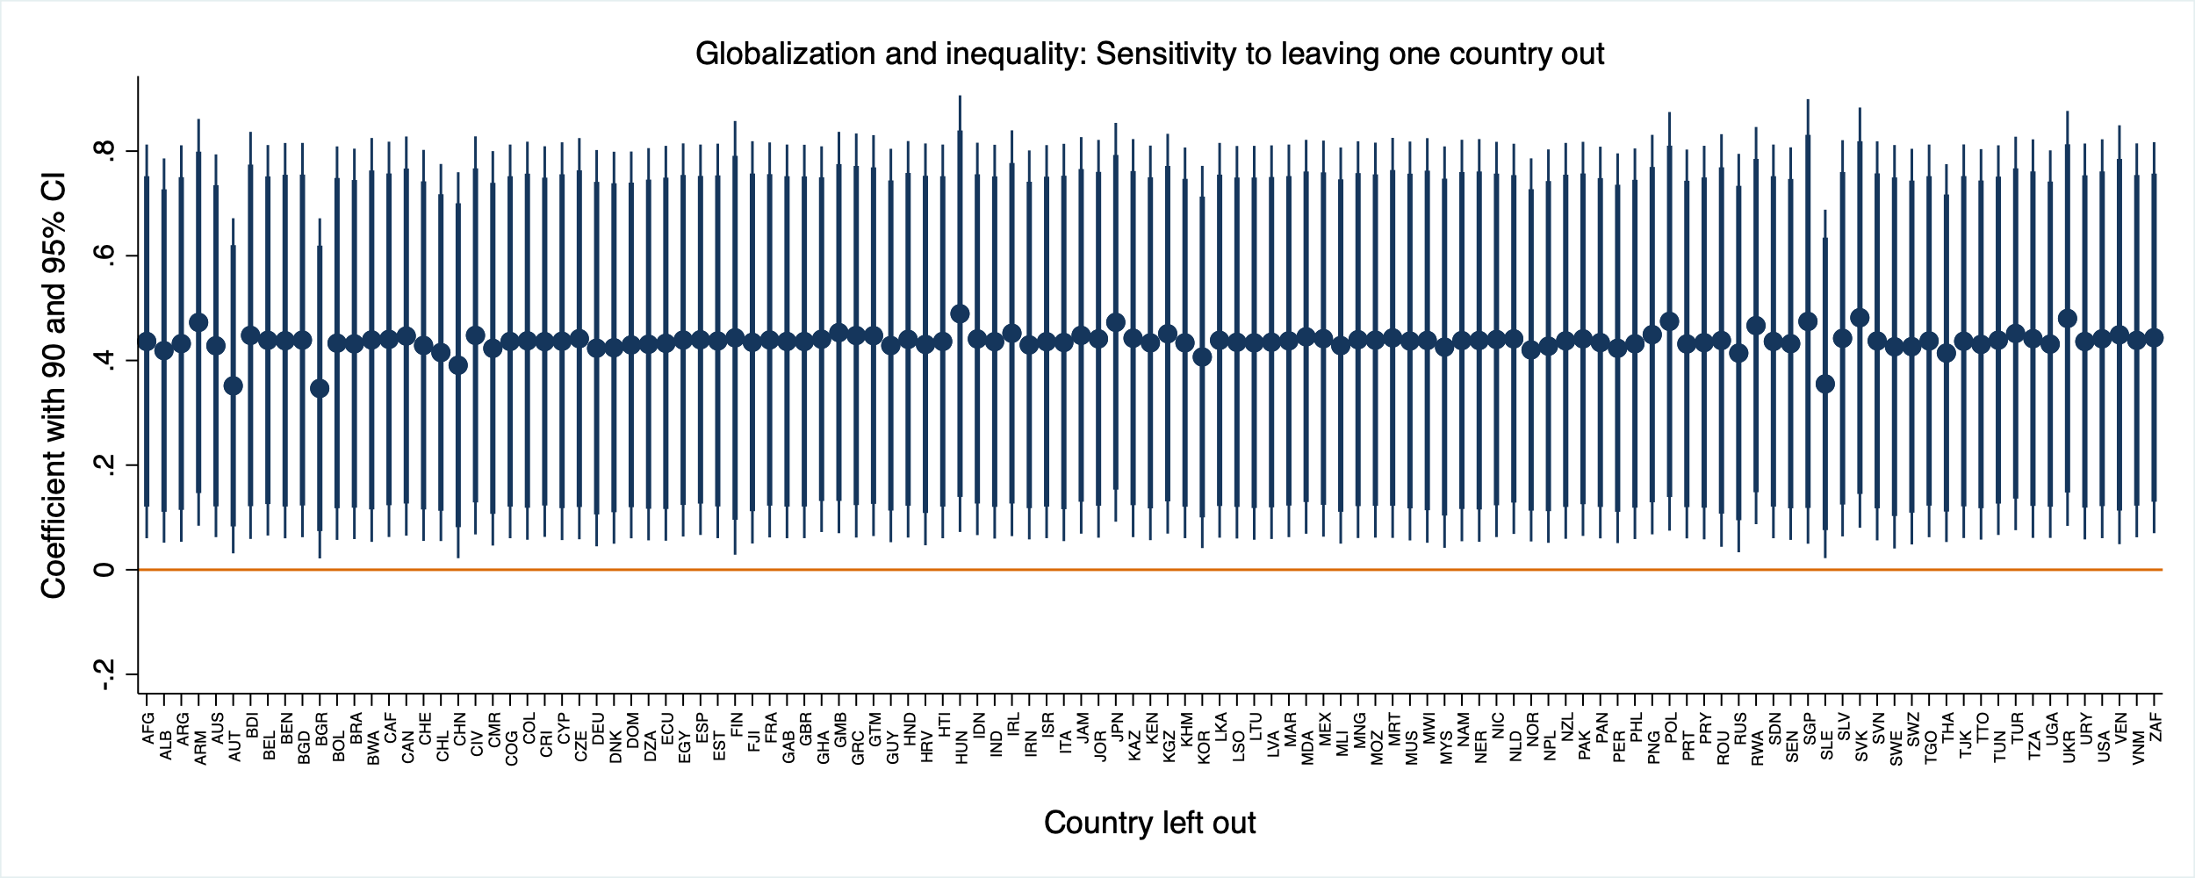
Note: coefficients with 95 (and 90) percent confidence intervals of globalization of the baseline inequality regression (Table 3, column 4) when the country listed on the x-axis is left out

Appendix 6: Suggestive Evidence on the Role of Redistribution
As our results suggests that economic globalization increases both average incomes and income inequality, it stands to reason that governments may want to combine the process of globalization with policies that spread the gains from globalization across society. In general, governments can affect the distribution of gains from globalization via two main channels: they can implement policies that alter the distribution of market income or they can redistribute market income by means of taxes and transfers. In this appendix we provide some suggestive evidence on the effectiveness of redistributive policies for mitigating the distributional effects of globalization.
Initially, the top panel of Figure A6 again presents the graph presented above showing that today’s more globalized countries are more unequal in terms of market income before taxes and transfers. This stands in an interesting contrast to the pattern that is visible in the middle panel: In countries with high levels of economic globalization net income is distributed more equally. Highly globalized countries appear to mitigate globalization’s inequality-increasing effects. The bottom panel makes this more explicit. It visualizes the relationship between current levels of globalization and redistribution and shows that more globalized economies tend to redistribute more. This is a prominent finding in the political economy literature, and is often interpreted as an indication for governments’ attempts to compensate those who are hurt by economic openness (Adsera and Boix 2002; Cameron 1978; Rodrik 1998; Ruggie 1982; Walter 2010). What the figure illustrates very clearly, however, is that this association in the cross-section is almost exclusively driven by (European) high-income countries. The extent of redistribution in these countries, which have highly developed welfare states, is an order of magnitude larger than in all other countries. Once high-income countries are excluded, the association is substantially weaker (see the dashed lines).

Figure A8: Globalization and Redistribution
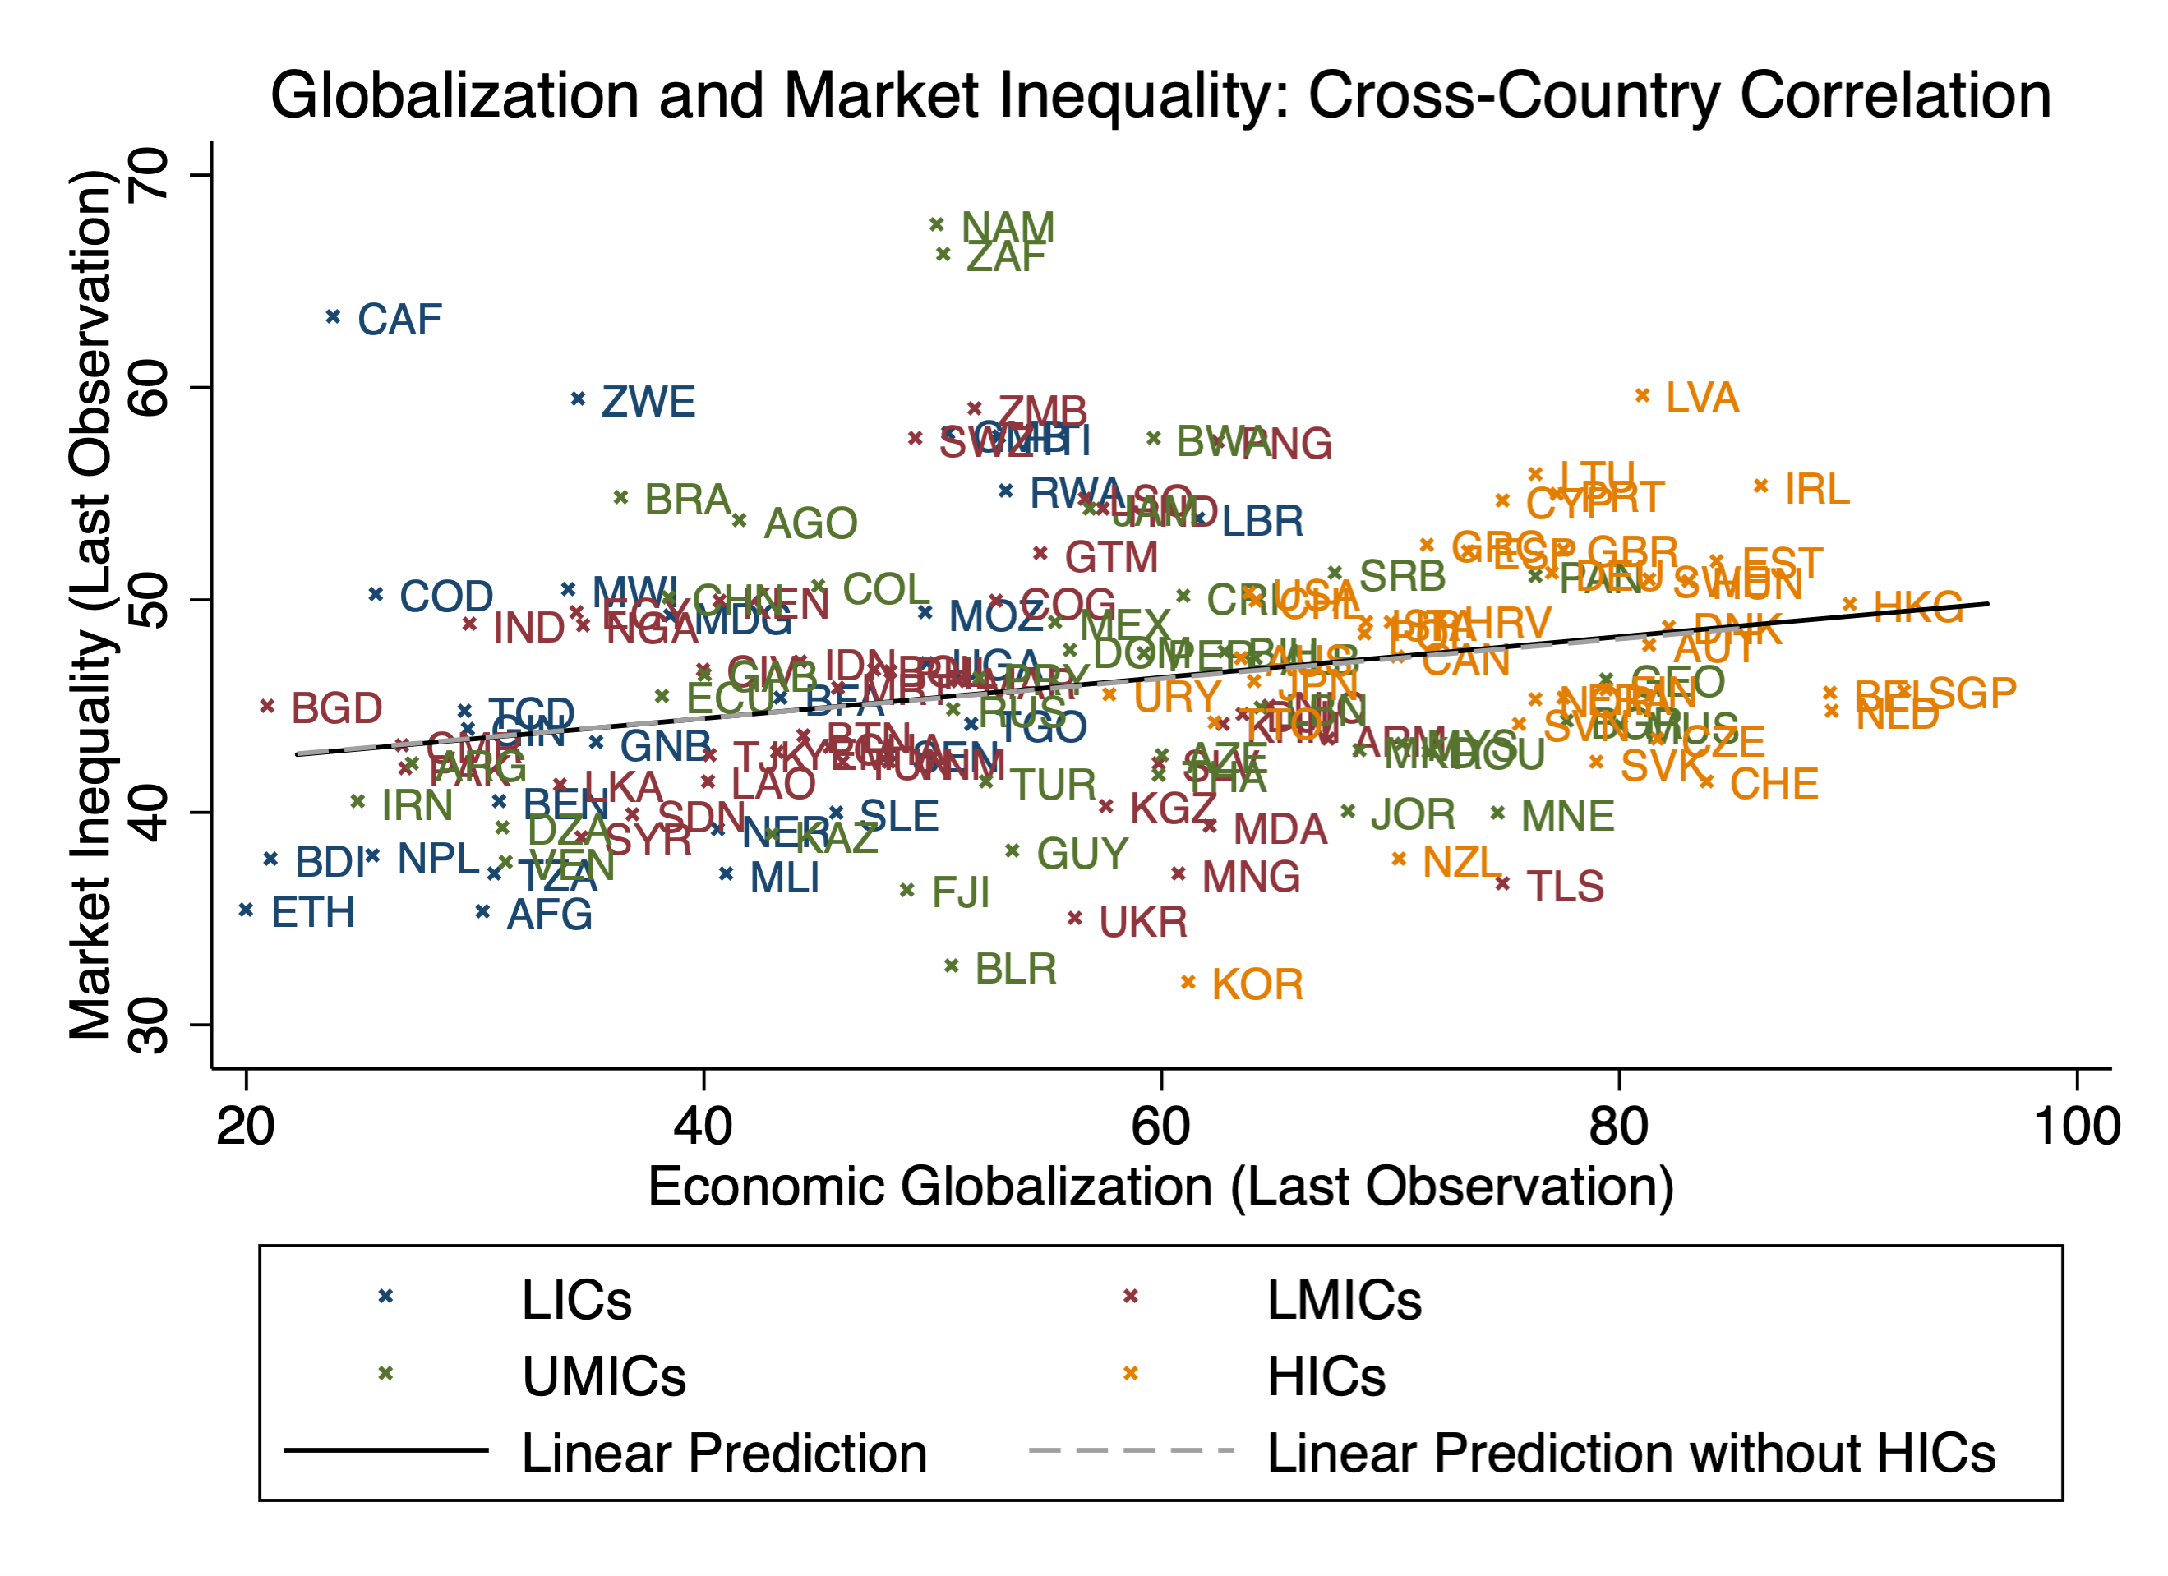
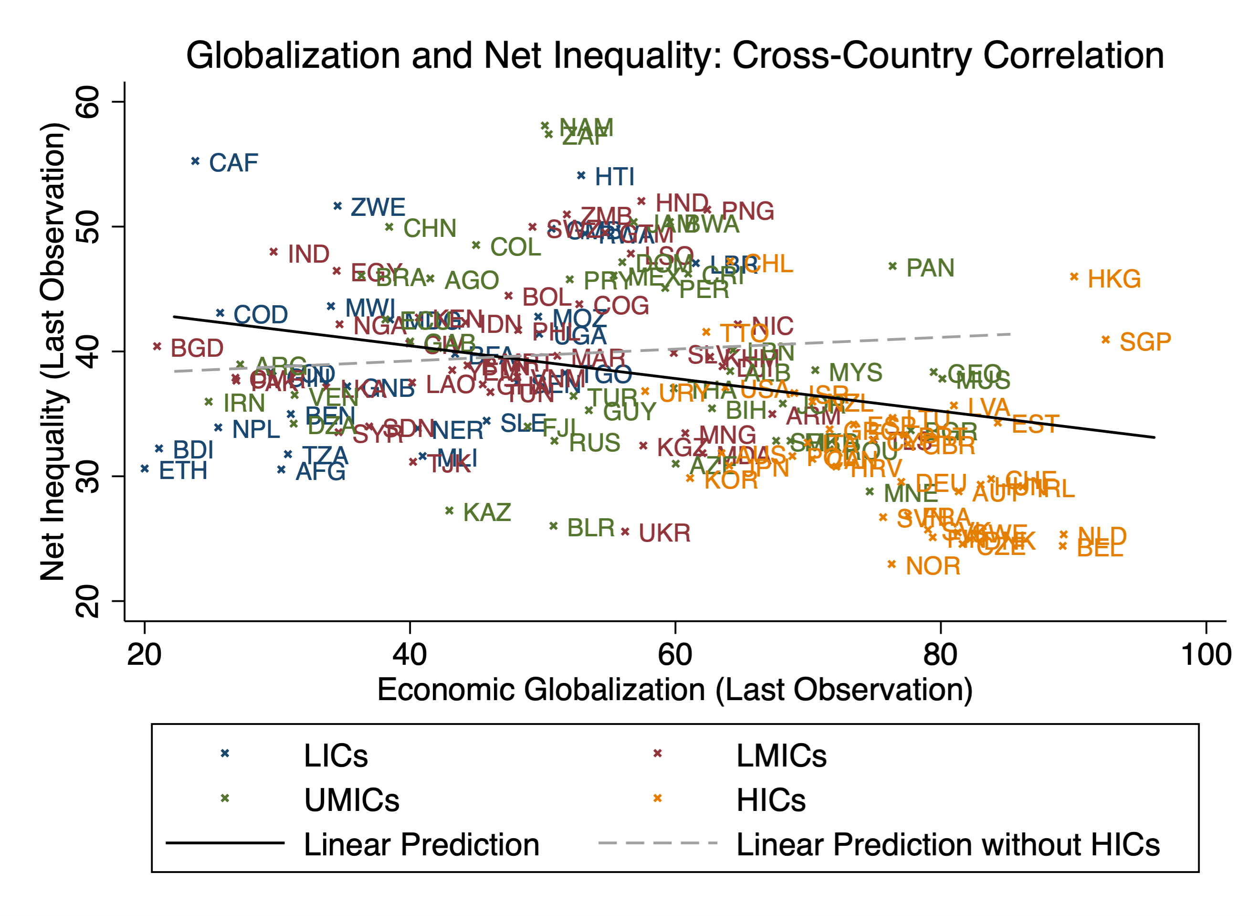
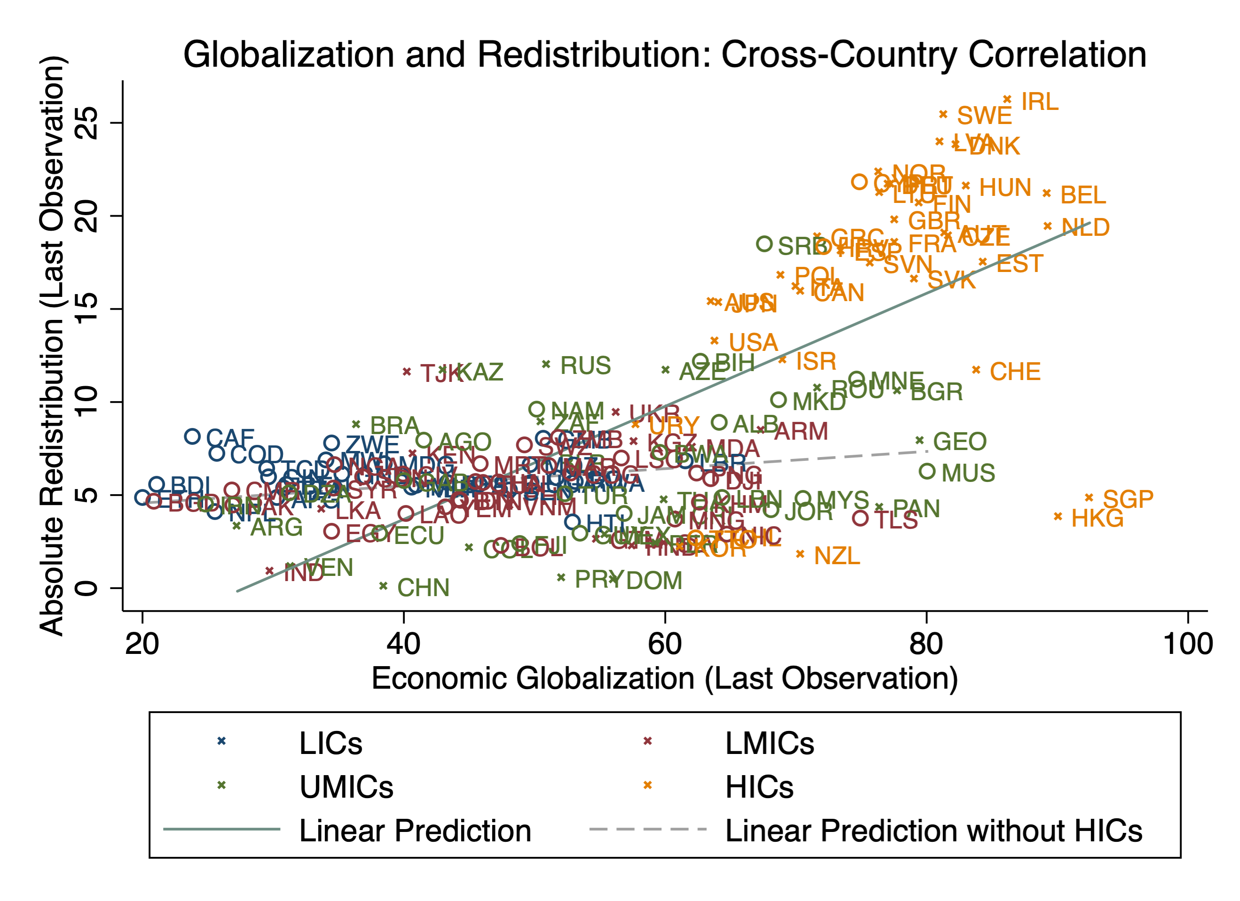
While these descriptive statistics suggest that redistribution is able to counteract some of the adverse distributional effects of globalization, our regression results show that the extent of redistribution is too small to offset the entire rise in inequality caused by globalization. In Table A10 we repeat the baseline inequality regressions but use the Gini index of net income – i.e., income after taxes and transfers – as the outcome variable (columns 1-2). Globalization’s effect on the inequality of net incomes is slightly smaller than on inequality of market incomes (repeated in columns 3-4), but these differences are not statistically significant. Hence, while taxes and transfers counter some of the inequality-increasing effect of globalization (see Figure A6), such redistributive policies – at least in their current shape – do not offset the entire rise in inequality resulting from economic globalization.

Table A15: Net Inequality vs. Market Inequality

 | (1) | (2) | (3) | (4)
Outcome Variable | Net  inequality | Net  inequality | Market  inequality | Market  inequality
 | OLS | IV | OLS | IV
Economic Globalization | 0.113*** | 0.327** | 0.127** | 0.436**
 | (0.038) | (0.141) | (0.049) | (0.192)
Period and Country FE | Yes | Yes | Yes | Yes
Controls | Yes | Yes | Yes | Yes
Observations | 618 | 618 | 618 | 618
K-P underidentification (p-value) |  | 0.000 |  | 0.000
K-P weak identification (F-statistic) |  | 22.152 |  | 22.152
Note: Dependent Variable: Gini index of market income. Averages of five-year periods. All explanatory variables are lagged by one period. OLS and 2SLS fixed effects regressions. Standard errors clustered at the country-level in parentheses, significance levels: * p<.10, ** p<.05, *** p<.01

Appendix 7: Theoretical Corollary: The Role of Initial Conditions

As an additional exercise of the quantitative analysis, we examine how different initial inequality levels affect this result. We find that countries with lower inequality levels benefit more from globalization because a larger share of the population participates in trade in these countries. To illustrate this result, we simulate the impact of globalization on both the share of exporters and on output growth in two economies: the benchmark economy and an alternative economy with a lower initial level of inequality. To ensure that these two economies are comparable, we increase the variance and reduce the mean of the ability distribution in order to model two economies with the same average ability level. We also adjust the iceberg cost to ensure that they start with the same share of exports over GDP. Figure 3 plots the results and indicates that the economy with a low level of inequality benefits more from globalization than the benchmark economy. Participation is larger in the low-inequality economy and, as a result, a reduction in trade cost leads to greater diversity of tasks in the low inequality economy thereby generating larger productivity gains.

Figure A9 – The Role of Initial Conditions
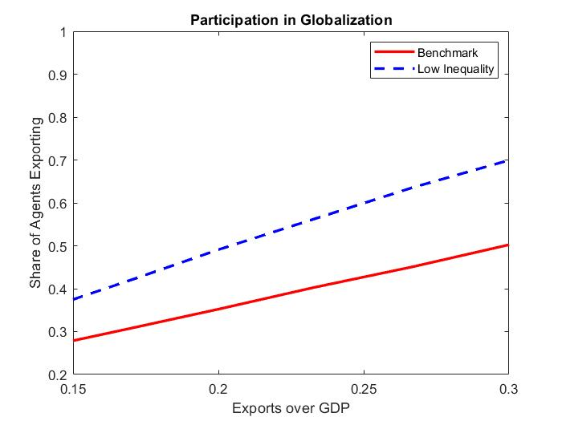 | 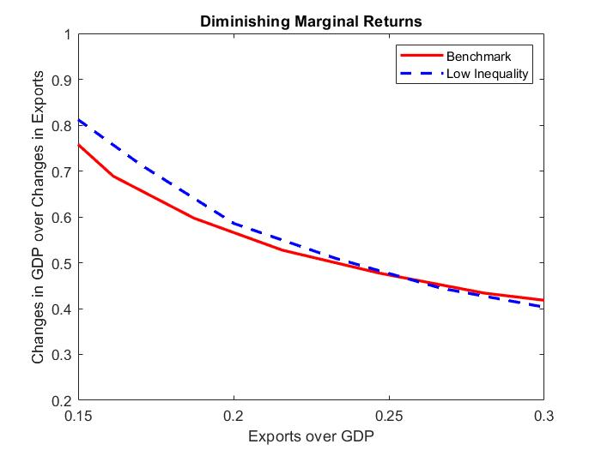
Note: The graph on the left-hand side plots the change of the share of exporting agents when exports increase for the benchmark and a low-inequality economy. The graph on the right-hand side plots the change in GDP relative to the change in exports for the same two economies.

Having presented an illustrative theoretical framework under which the distribution of gains from globalization across and within countries can be studied, we now turn to our main analysis and examine the question from an empirical perspective. While the model, in order to remain simple, abstracts from many elements of globalization’s effect on global inequality, the empirical analysis is less abstract along several dimensions: It uses data for a large panel of countries (N=141) over a long period of time (1970-2015), takes the country-year-decile as the unit of observation, and identifies the effect of economic globalization when understood as a multidimensional process.
As a next step, we bring this additional prediction of our model to the data. The model suggests that the effect of globalization on growth depends on the initial level of inequality in an economy and predicts lower gains from globalizing for more unequal countries. We test this by adding an interaction term of globalization and the level of inequality to the baseline regression (Table 6). This interaction term enters with a statistically significant, negative sign and thus suggests that the association of globalization with inequality gets more negative the more unequal a country is. Adding control variables does not affect this result (column 2).
Figure 9 plots the marginal effects of the full model and points to a significantly positive association of globalization with growth only for countries with a Gini index below 45. Above this inequality level, the association is not statistically significant at conventional levels. This supports the corollary of the model that the total gains from globalization are larger in more equal countries because in such economies more agents will participate in globalization.

Table A16 – Initial Conditions
 | (1) | (2)
Economic Globalization | 0.0175*** | 0.0163***
 | (0.0046) | (0.0050)
Gini index | 0.0172*** | 0.0164***
 | (0.0055) | (0.0058)
Economic Globalization x Gini index | -0.0003*** | -0.0003***
 | (0.0001) | (0.0001)
Country and period FE | Yes | Yes
Controls | No | Yes
Observations | 598 | 598
R² | 0.348 | 0.370
Note. Dependent variable: Economic growth. OLS-FE regressions with country FE and period FE. Averages of 5-year periods. All explanatory variables are lagged by one period. Standard errors clustered at the country-level in parentheses. Significance levels: * p<.10, ** p<.05, *** p<.01

Figure A10 – The Effect of Globalization on Growth Depends on Initial Inequality
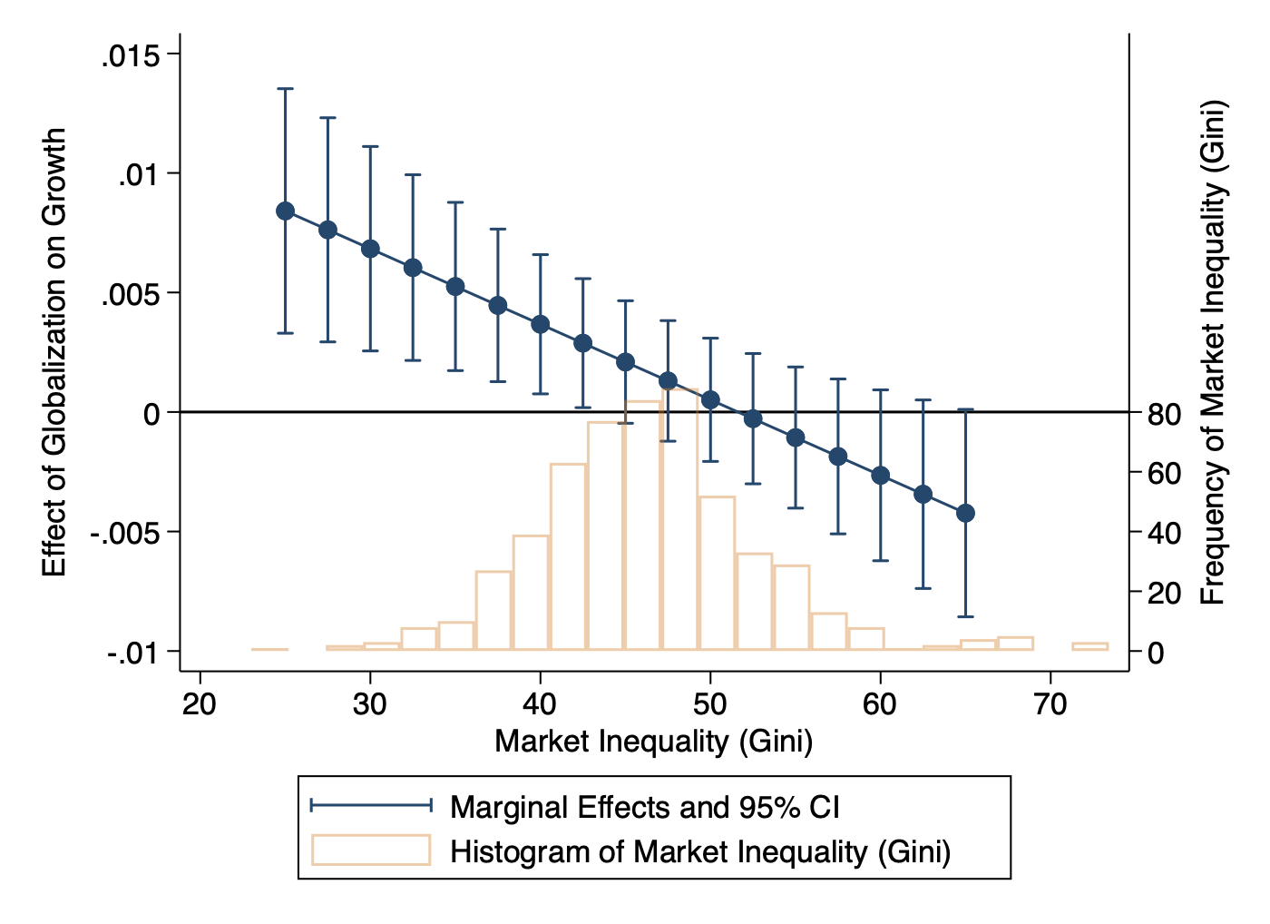
The figure visualizes the result of the growth regression reported in Table 6, column 2. The blue line depicts the marginal effect (and 95 percent confidence intervals) of a one-point-increase in economic globalization depending on a given level of initial inequality. A histogram of the distribution of inequality levels across the sample is shown in orange.

Appendix 8: Trade Globalization vs. Financial Globalization

A question that our main analysis does not answer is whether the trade dimension or the financial dimension of economic globalization drive its distributional effects. In this Appendix, we provide some suggestive evidence on this question.
To study the trade dimension, we use the “de facto trade globalization” sub-index of the KOF index as the endogenous variable and construct the instrumental variable “neighborhood trade liberalization” from the “de jure trade globalization” sub-index of the KOF index of other countries. For financial globalization we proceed analogously and use the “de facto financial globalization” sub-index of the KOF index as the endogenous variable and construct the instrumental variable “neighborhood financial liberalization” from the “de jure financial globalization” sub-index of the KOF index of other countries. Otherwise, we proceed as in the main analysis.
The results of this exercise are presented in Table A17. The estimations yield positive coefficients for both the trade dimension and the financial dimension. Substantively, the coefficients are both smaller than the coefficient for the aggregate globalization index, which is reported again for comparison in column 1 of this table. For trade globalization the coefficient is statistically significant at the ten percent level (p= 0.053) and for financial globalization the coefficient is not statistically significant at conventional levels (p=0.150). Arguably, these results are consistent with the following interpretation: Both the trade and the financial dimension of globalization contribute to its distributional effects. When considered in isolation, the individual effects of the two sub-indices are relatively weak. When considered in conjunction with each other, effects are stronger. This may explain why our results on distributional effects are somewhat stronger than results in related research that focuses on trade openness (e.g., Dorn et al. 2021).
As our identification strategy is not explicitly tailored to studying this differentiation, this evidence should be considered as merely suggestive. Future research could study the differences between trade and financial globalization in more detail.

Table A17 – Trade Globalization vs. Financial Globalization
 | (1) | (2) | (3)
 | IV | IV | IV
Economic Globalization (t-1) | 0.436**
 | (0.192)
Trade Globalization (t-1) |  | 0.262*
 |  | (0.135)
Financial Globalization (t-1) |  |  | 0.109
 |  |  | (0.076)
Period FE | Yes | Yes | Yes
Country FE | Yes | Yes | Yes
Controls | Yes | Yes | Yes
Observations | 612 | 612 | 612
K-P underidentification test (p) | 0.000 | 0.000 | 0.000
K-P weak identification test (F) | 22.152 | 12.200 | 30.515
First Stage:
Neighborhood Liberalization (t-2) | 1.474***
 | (0.247)
Neighborhood Trade Liberalization (t-2) |  | 0.764***
 |  | (0.219)
Neighborhood Financial Liberalization (t-2) |  |  | 1.419***
 |  |  | (0.257)
Note: Dependent Variable is Gini index of market income. IV regressions. Averages of 5-year-periods. Standard errors clustered at the country-level in parentheses.
Significance levels: * p<.10, ** p<.05, *** p<.01.

Note that for the observations plotted as circles (rather than crosses) the data on the extent of redistribution is less reliable. Here the difference between market and net Ginis rather than the SWIID’s measure of “absolute redistribution” is plotted. See Solt (2016: 1274-5) for details. While these data points should be treated with caution, the figure looks very similar if these observations are omitted.
A prominent explanation for this finding is that more intensive exposure to global markets and the risks and volatilities associated with it leads to increased political pressure for insurances and redistribution (Walter 2010). See Potrafke (2009, 2013) for related evidence.
We use the OLS model rather than the IV model because we are not aware of an exogenous source of variation in inequality that could be exploited in this model. Note, however, that IV and OLS results are similar in the baseline.

