Supplementary material
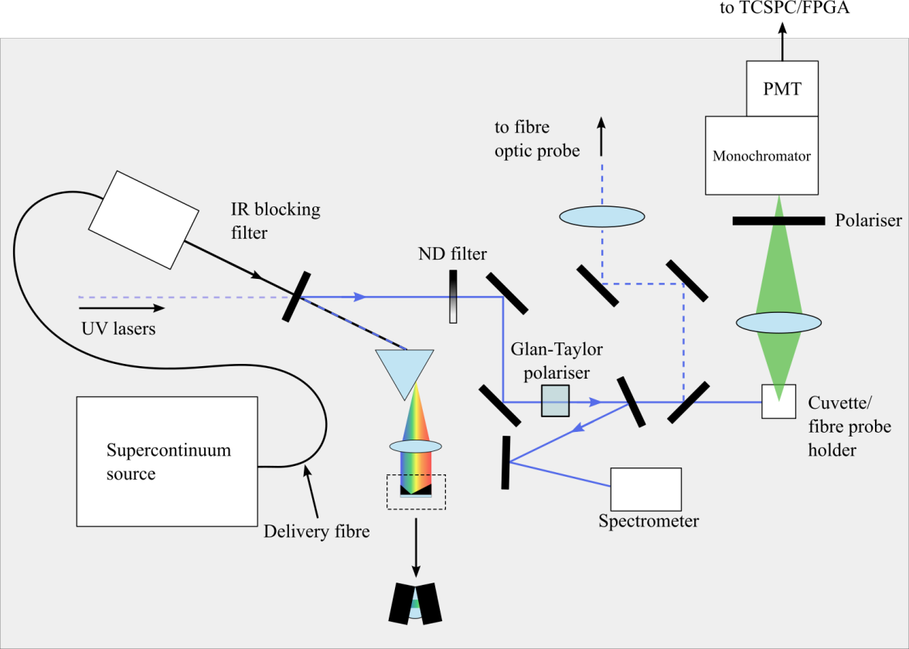
Figure 1A. Optical layout of the cuvette-based time-resolved spectrofluorometer used to compare our low-cost instrument against a TCSPC system

