A Nitronaphthalimide Probe for Fluorescence Imaging of Hypoxia in Cancer Cells

Rashmi Kumari¹, Vasumathy R², Dhanya Sunil^{1*}, Raghumani Singh Ningthoujam^{3,7}, Badri Narain Pandey^{2,7}, Suresh D Kulkarni⁴, Thivaharan Varadavenkatesan⁵, Ganesh Venkatachalam⁶, Anil Kumar N V ¹
¹Department of Chemistry, Manipal Institute of Technology, Manipal Academy of Higher Education, Manipal-576104, Karnataka, India
²Radiation Biology & Health Sciences Division, Bhabha Atomic Research Centre, Mumbai-400085, Maharashtra, India
³Chemistry Division, Bhabha Atomic Research Centre, Mumbai-400085, Maharashtra, India
⁴Department of Atomic and Molecular Physics, Manipal Academy of Higher Education, Manipal-576104, Karnataka, India
⁵Department of Biotechnology, Manipal Institute of Technology, Manipal Academy of Higher Education, Manipal-576104, Karnataka, India
⁶Electrodics and Electrocatalysis (EEC) Division, CSIR – Central Electrochemical Research Institute (CSIR-CECRI), Karaikudi-630003, Tamil Nadu, India
⁷Homi Bhabha National Institute, Anushakti Nagar, Mumbai-400094, India

* Corresponding author
Dr. Dhanya Sunil,
Senior Associate Professor,
Department of Chemistry,
Manipal Institute of Technology,
Manipal, Karnataka, India.
E-mail: dhanya.s@manipal.edu

Supplementary data
Supplementary figures
Sl. No | Figure number | Figure caption
1 | S1 | Electronic spectra of 1 × 10⁻⁴ M solutions of NIB and NIB-red in DMSO
2 | S2 | Emission spectrum of 1 × 10⁻⁴ M solutions of A) NIB and B) NIB-red in DMSO. C) The fluorescence of 1 × 10⁻⁴ M solutions of NIB and NIB-red in DMSO observed under UV lamp (λ_{exc}.: 365 nm).
3 | S3 | FT-IR spectrum of NIB
4 | S4 | ¹H NMR spectrum of NIB
5 | S5 | ¹³C NMR spectrum of NIB
6 | S6 | FT-IR spectrum of NIB-red
7 | S7 | ¹H NMR spectrum of NIB-red
8 | S8 | Fluorescence images of MCF-7 cells incubated with 6 µM NIB under normoxic (20% O₂) and hypoxic (1% O₂) conditions, after 6 h of NIB incubation before washing
9 | S9 | Fluorescence images of MCF-7 cells incubated with 6 µM NIB under normoxic (20% O₂) and hypoxic (1% O₂) conditions, after 6 h of NIB incubation imaged after washing

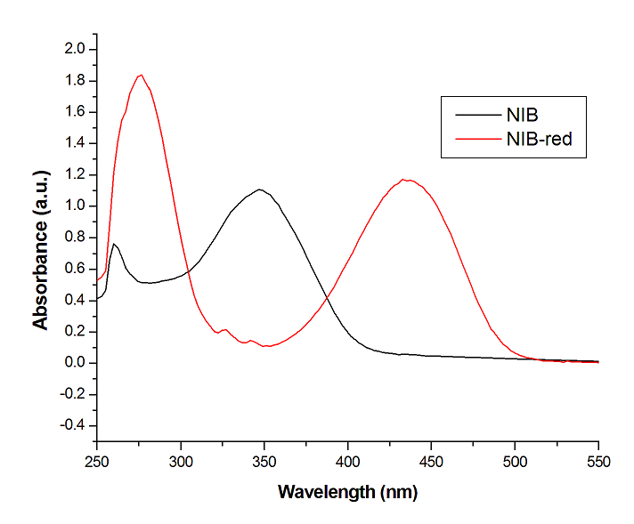
Fig. S1 Electronic spectra of 1 × 10⁻⁴ M solutions of NIB and NIB-red in DMSO

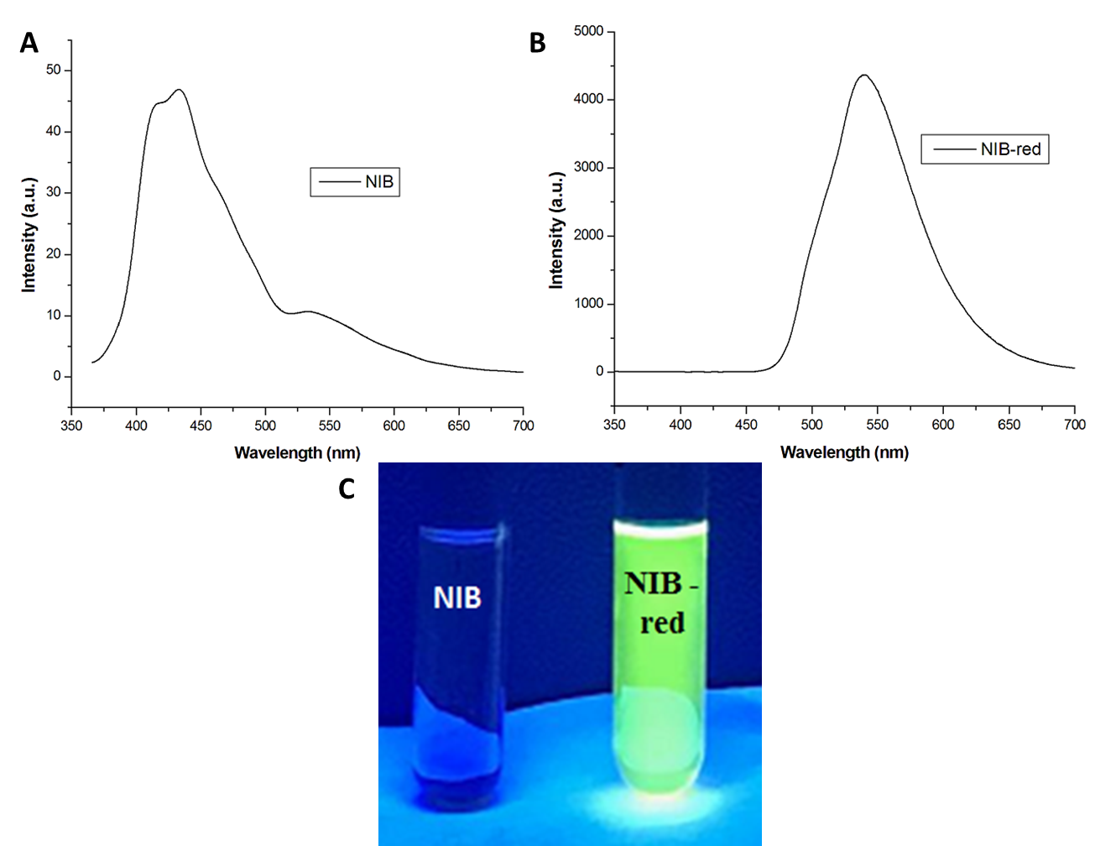
Fig. S2 Emission spectrum of 1 × 10⁻⁴ M solutions of A) NIB and B) NIB-red in DMSO. C) The fluorescence of 1 × 10⁻⁴ M solutions of NIB and NIB-red in DMSO observed under UV lamp (λ_{exc}.: 365 nm).

Fig. S3 FT-IR spectrum of NIB

Fig. S4 ¹H NMR spectrum of NIB

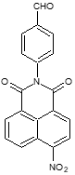
Fig. S5 ¹³C NMR spectrum of NIB

Fig. S6 FT-IR spectrum of NIB-red

Fig. S7 ¹H NMR spectrum of NIB-red

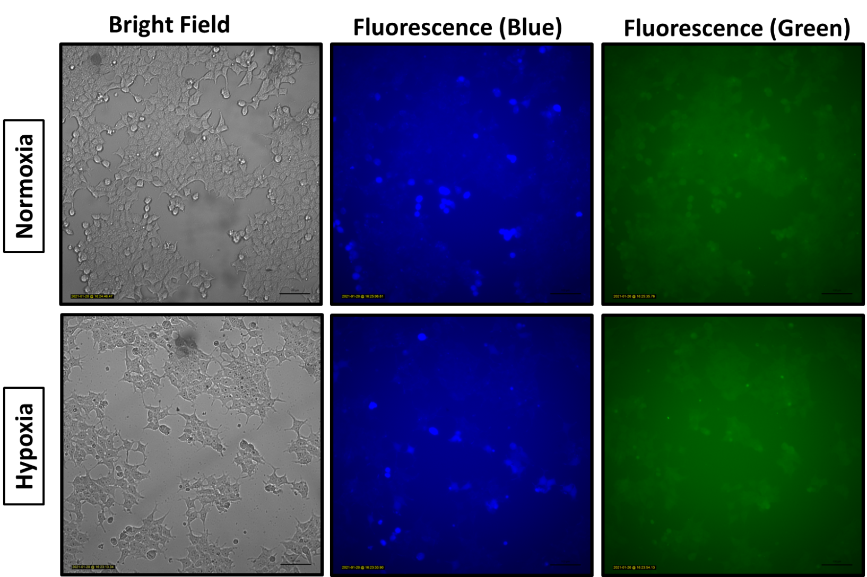
Fig. S8 Fluorescence images of MCF-7 cells incubated with 6 µM NIB under normoxic (20% O₂) and hypoxic (1 % O₂) conditions, after 6 h of NIB incubation imaged before washing for bright and blue/green fluorescence (blue: excitation 370-410 nm; emission 429-462 nm; green: excitation 473-491 nm; emission 502-561 nm). Scale bar: 100 µm.

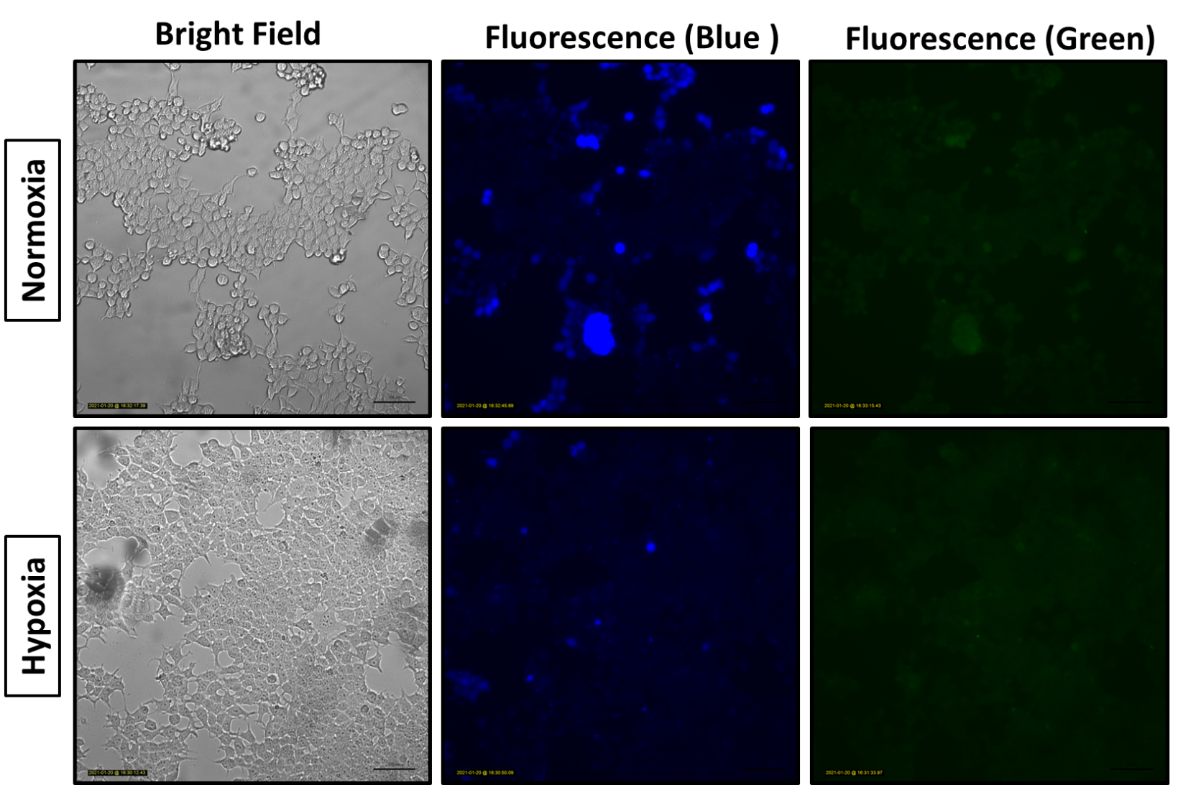
Fig. S9 Fluorescence images of MCF-7 cells incubated with 6 µM NIB under normoxic (20% O₂) and hypoxic (1% O₂) conditions, after 6 h of NIB incubation imaged after washing for bright and blue/green fluorescence (blue: excitation 370-410 nm; emission 429-462 nm; green: excitation 473-491 nm; emission 502-561 nm). Scale bar: 100 µm.

