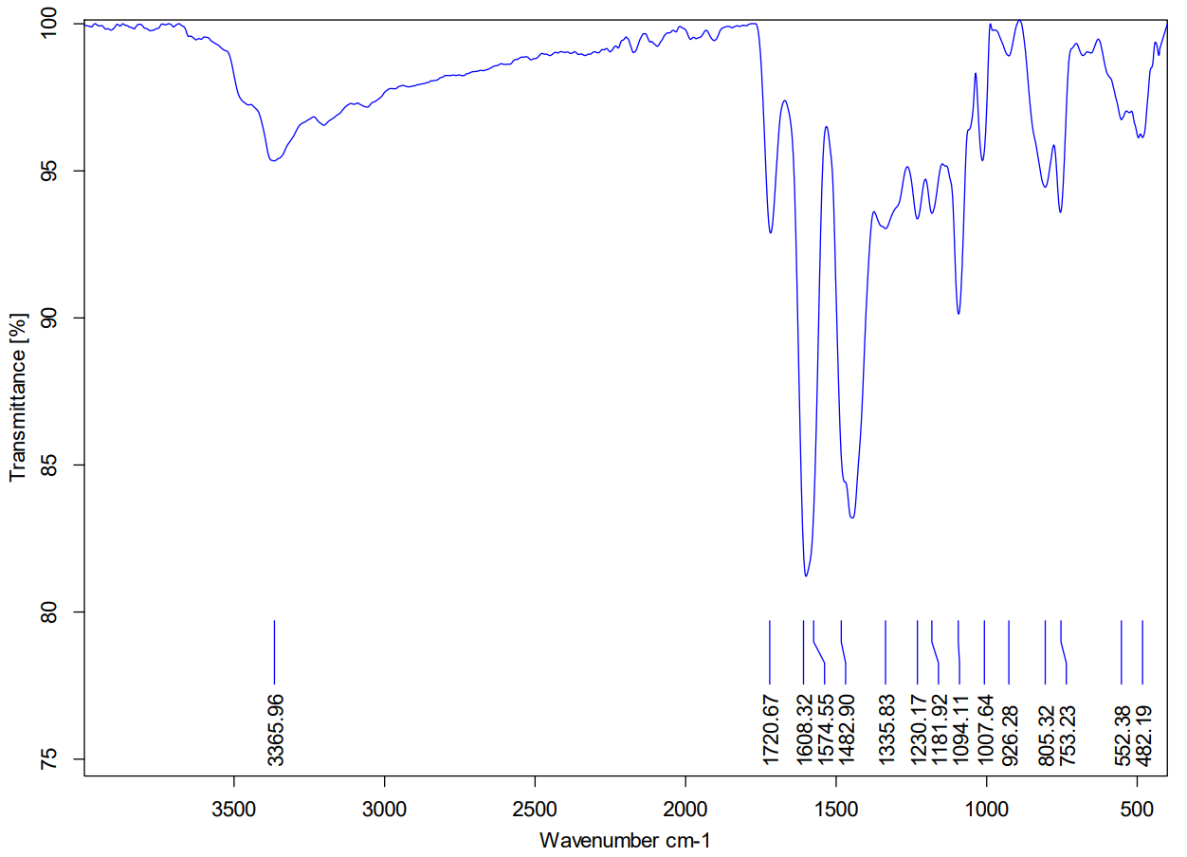
SI: Fig. 1: FT-IR spectrum of the CBAPI sensor

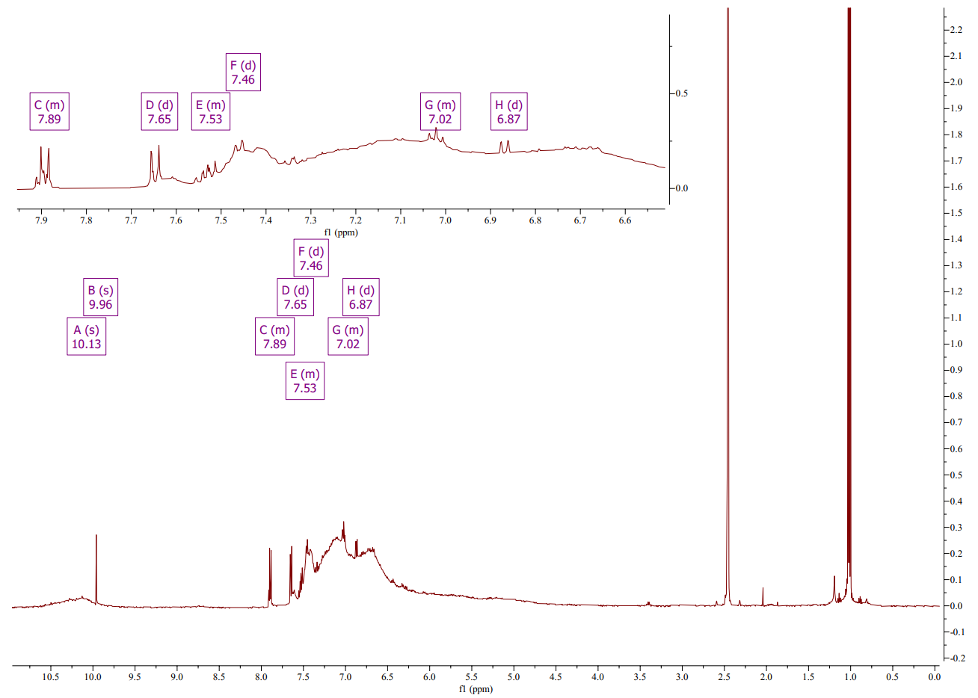
SI: Fig. 2: ¹H-NMR spectrum of the CBAPI sensor

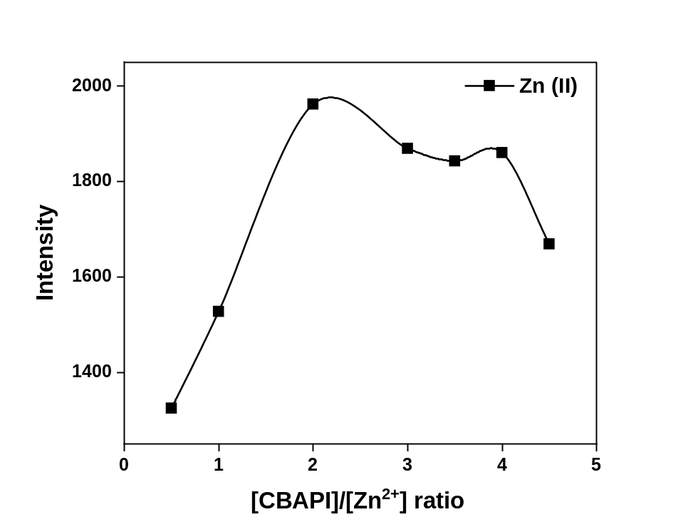
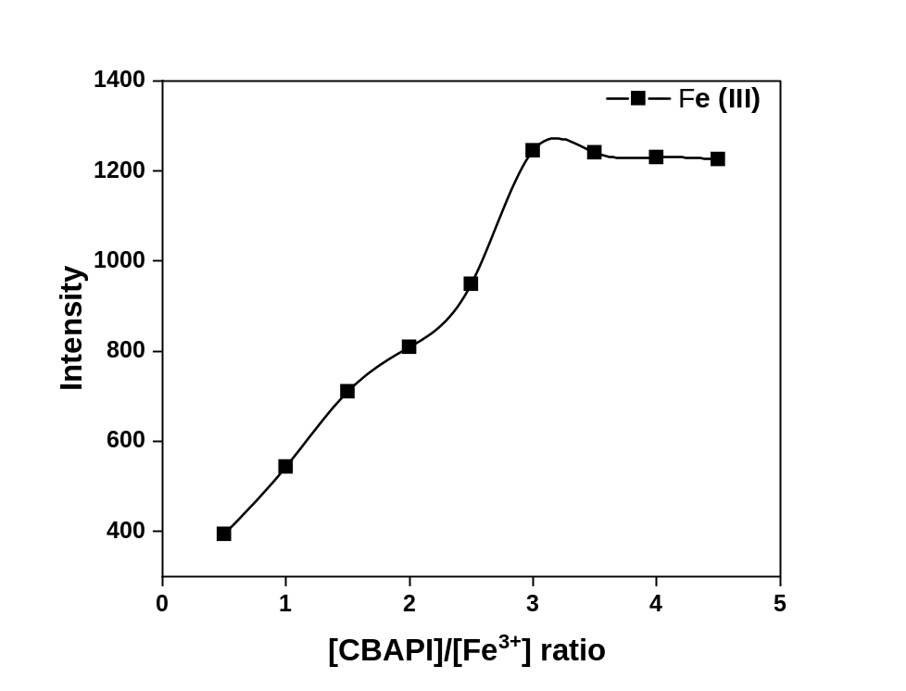
SI: Fig. 3: Molar ratio plot for Zn/CBAPI and Fe/CBAPI complexes at λ_{ex}= 335 nm, λ_{em}= 408 nm and at pH 6.0.

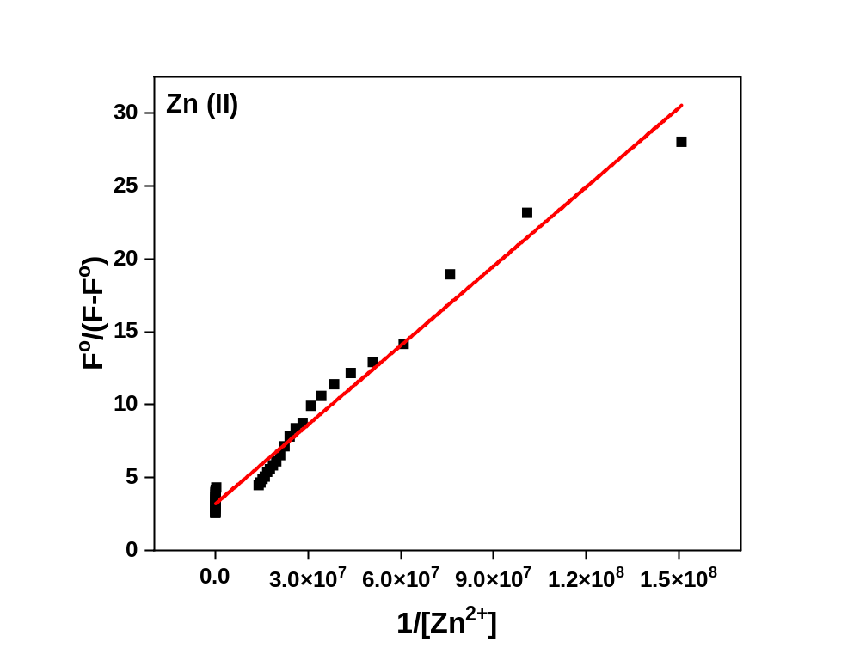
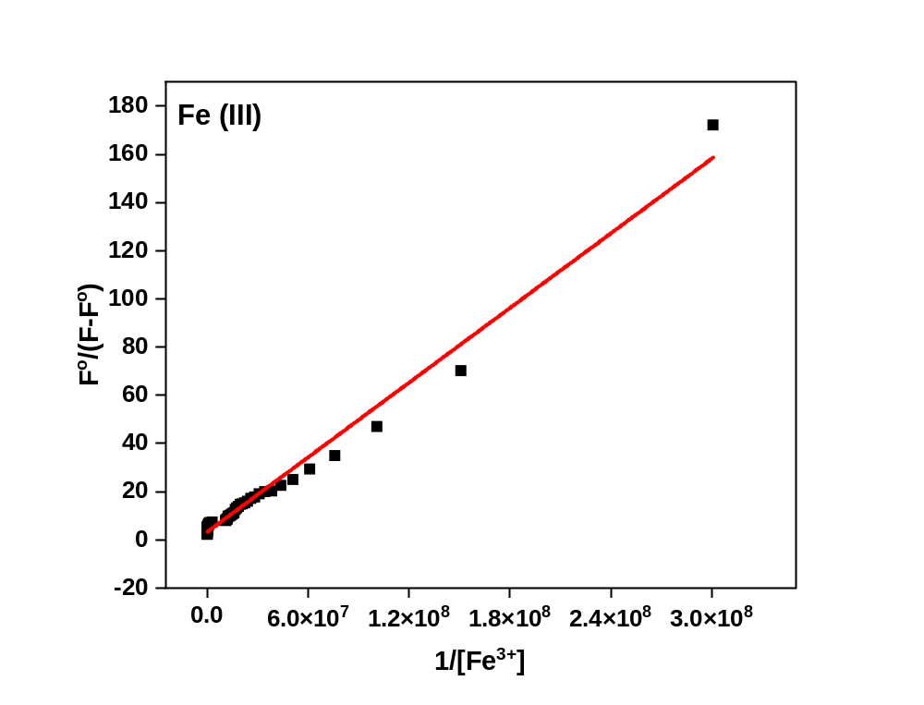
SI: Fig. 4: Benesi-Hildebrand relation for the interaction of different concentrations of Zn²⁺ or Fe³⁺ ions with the CBAPI sensor at λ_{exc} 335 nm, λ_{em} 408 nm in acetate buffer (pH = 6.0).
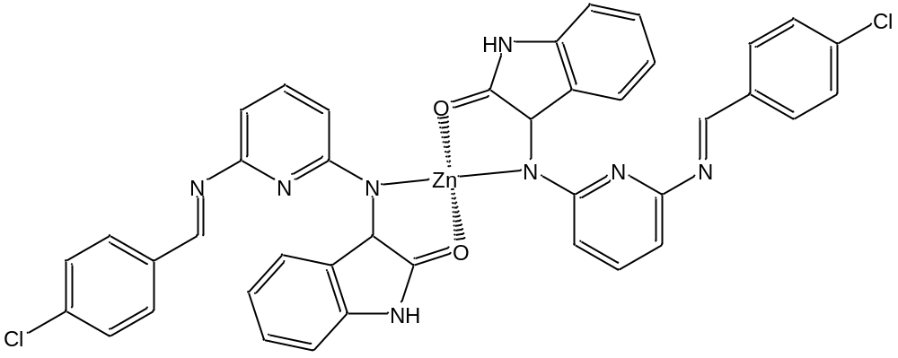

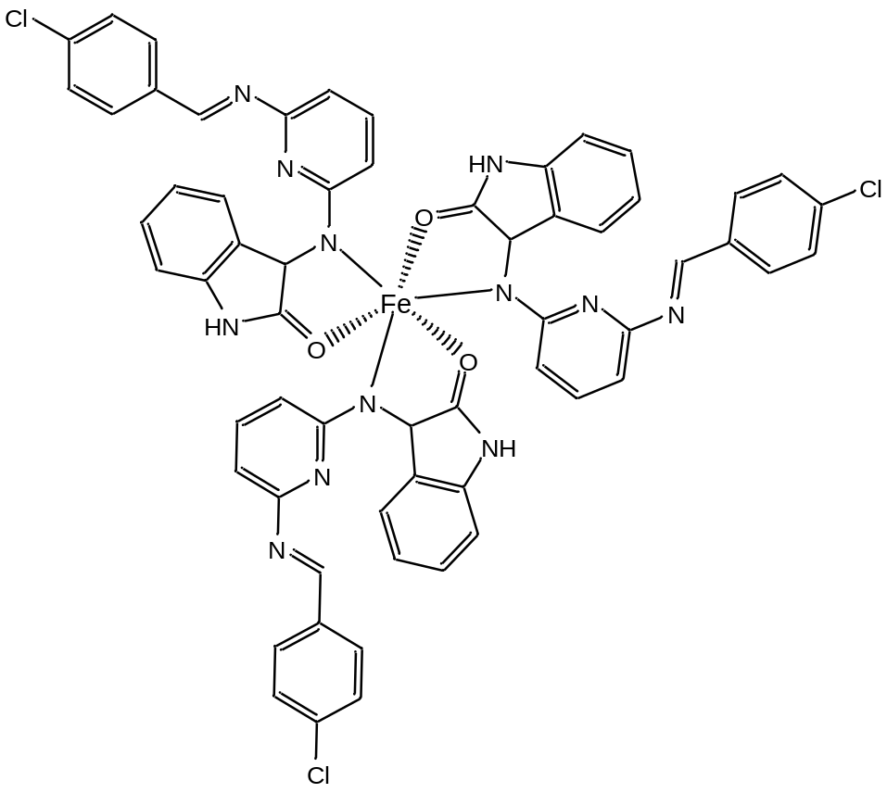
SI: Scheme 1: Predicted structures of Zn/CBAPI and Fe/CBAPI complexes

Instrumental Section
Buffer solutions (pH 2.0, 4.0, 6.0, 8.0, 10.0 and 12.0) was prepared using (KCl- HCl), (sodium acetate tri-hydrate - acetic acid), (HCl - disodium hydrogen phosphate), (NaOH - disodium hydrogen phosphate), and (KCl- NaOH) respectively.
The infrared spectra were recorded on a Bruker ALPHA II FT-IR spectrophotometer using the potassium bromide disc technique. Proton magnetic resonance ¹H NMR spectra were recorded on a Bruker 400 MHz-NMR spectrometer with DMSO-d₆ as the solvent.

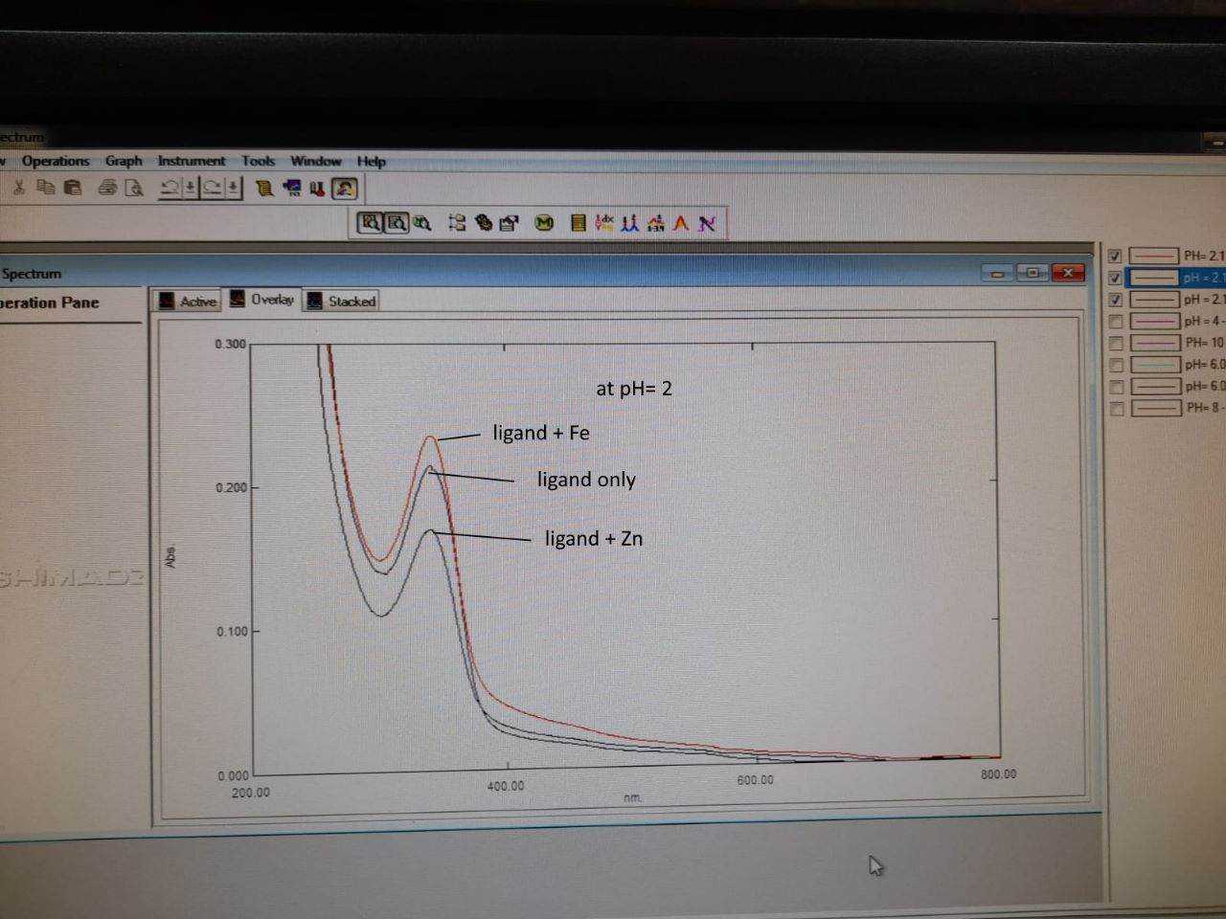
The absorption spectrum of 2x10⁻⁵ mol/L CBAPI only and in presence of 1 x10⁻⁵ mol /L Fe(III) or Zn(II) ions at pH 6.0.

