Development of Graphene Quantum Dot-Based Gold-Nickel Micromotors for Sensitive Detection of Ferric Ions
Gozde Karaca¹
¹ Department of Medical Services and Techniques, Isparta Health Services Vocational School, Suleyman Demirel University 32260 Isparta, Turkey
SI Figure Captions
SI Figure 1. The mapping analysis of the GQD-Au-Ni micromotors a) GQD-Au-Ni micromotors b) Green İndicates Carbon element c) Blue indicates Oxygen elements d) Red indicates Nickel elements e) Yellow indicates Gold element
SI Figure 2. EIS results for the bare SPE electrode and the GQD-Au-Ni/SPCE electrode
SI Figure 3. Micromotor speeds after incubation 10⁻⁵ M Fe³⁺ with different durations
SI Figure 4. Optical microscopy images of different ferric ion incubated GQD-Au-Ni micromotor a) 10⁻¹² M b) 10⁻¹¹ M c) 10⁻¹⁰ M d) 10⁻⁹ M e) 10⁻⁸ M f) 10⁻⁷ M g) 10⁻⁶ M h) 10⁻⁵ M

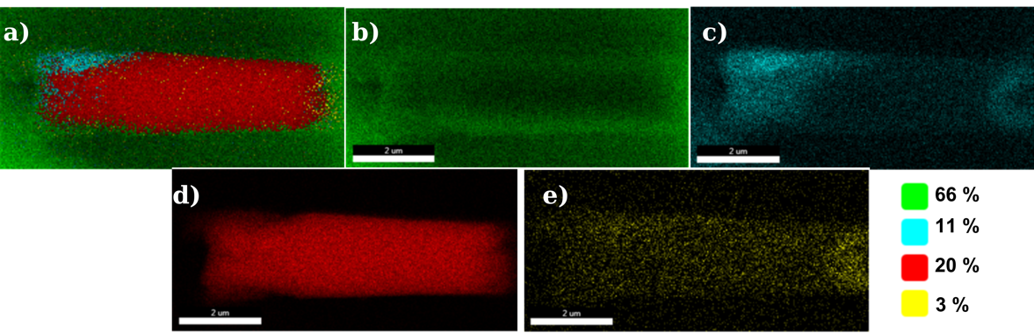
SI Figure 1. The mapping analysis of the GQD-Au-Ni micromotors a) GQD-Au-Ni micromotors b) Green İndicates Carbon element c) Blue indicates Oxygen elements d) Red indicates Nickel elements e) Yellow indicates Gold element

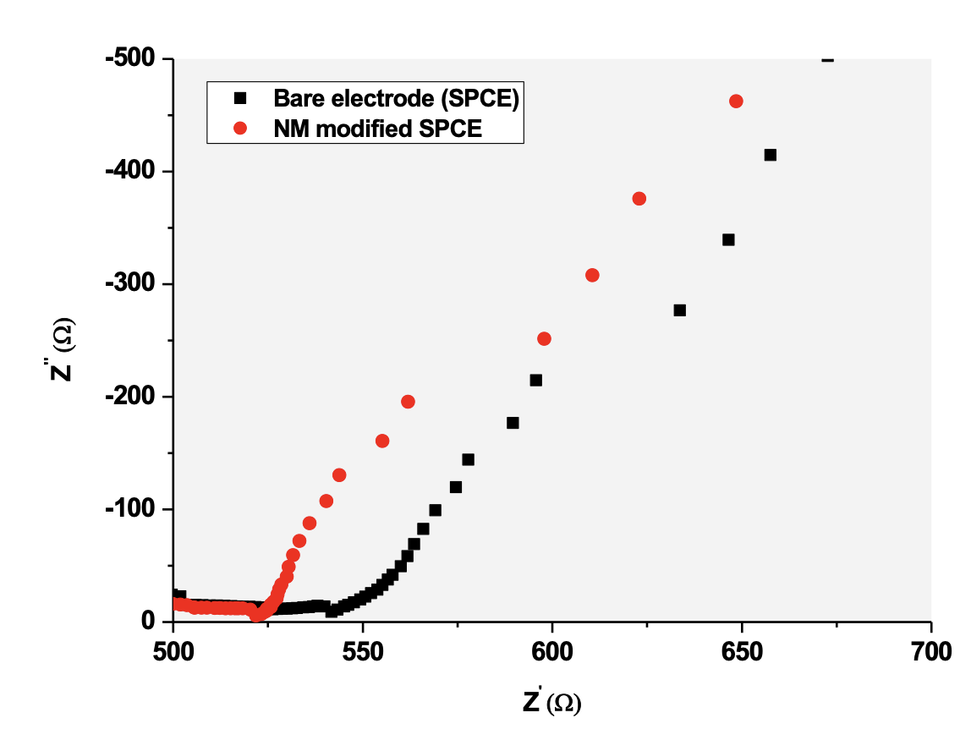
SI Figure 2. EIS results for the bare SPE electrode and the GQD-Au-Ni/SPCE electrode

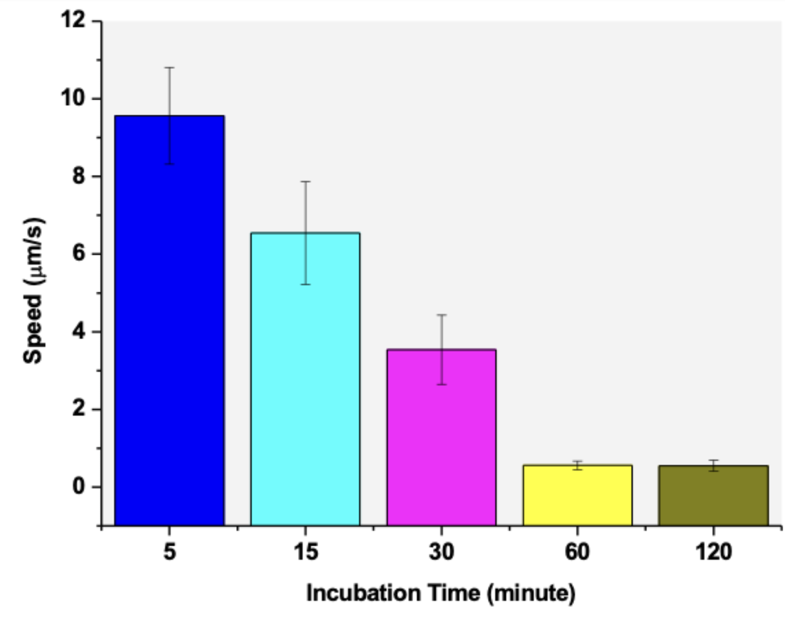
SI Figure 3. Micromotor speeds after incubation 10⁻⁵ M Fe³⁺ with different durations
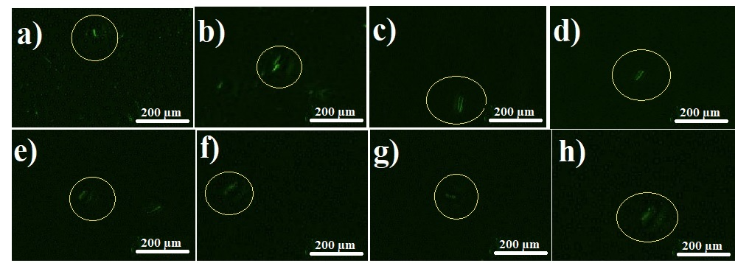
SI Figure 4. Optical microscopy images of different ferric ion incubated GQD-Au-Ni micromotor a) 10⁻¹² M b) 10⁻¹¹ M c) 10⁻¹⁰ M d) 10⁻⁹ M e) 10⁻⁸ M f) 10⁻⁷ M g) 10⁻⁶ M h) 10⁻⁵ M

