Supporting Information

D‑Penicillamine‑Stabilized Gold Nanoclusters as a Selective Fluorescent Sensor for Tetracyclines

Luis Marco-Sabater, Elena Zaballos-García, Jorge Escorihuela* and Julia Pérez-Prieto*

1. Experimental details.

1.1. Materials.
All the chemicals and solvents used in this thesis degree were of analytical grade and used without any additional purification. Gold(III) chloride (HAuCl₄·3H₂O), sodium chloride (NaCl), potassium chloride (KCl), magnesium chloride (MgCl₂), calcium chloride (CaCl₂), aluminum chloride (AlCl₃), sodium nitrate (NaNO₃), sodium carbonate (Na₂CO₃), copper sulphate (CuSO₄), L-phenylalanine (L-Phe), L-valine (L-Val), L-histidine (L-His), tetracyclines and ampicillin were purchased from Sigma-Aldrich. D-penicillamine was purchased from BLD Pharmatech. For all aqueous solutions, high purity deionized water from a Millipore system was used.

1.2. Equipment.
The following technical instruments were used for analysis and characterization. Centrifugation was performed on a Beckman Coulter's Microfuge 16 benchtop centrifuge. UV-vis absorption spectra were recorded on a PerkinElmer 1050+ UV/vis/NIR spectrometer. All the measurements were performed using 1cm×1cm path length quartz cuvettes. Fluorescence spectra were recorded on a FLS1000 photoluminescence spectrometer from Edinburgh Instruments. The quantum yield was measured with a Hamamatsu C9920-02 absolute PL Quantum Yield Measurement System. The pH measurements were carried out by using a Crison GLP 21 pH meter. Transmission electron microscopy (TEM) images were acquired using a HITACHI HT7800 microscope with a filament of LaB6 operating at 100 kV. Fourier transform infrared (FT-IR) spectra were recorded on a Thermo Scientific Nicolet iS10. X-ray photoelectron spectroscopy (XPS) spectra were acquired with VG-Microtech Multilab 3000 equipment. The ¹H spectrum were registered at room temperature in a Bruker AvanceIII 300 spectrometer, with a 300 MHz Bruker magnet. The chemical shifts (δ) are reported in ppm using deuterium oxide, 99.9% atom (D₂O) as solvent.

1.3. Procedures.

1.3.1. Preparation of AuNC@D-Pen.
A freshly prepared aqueous solution of HAuCl₄ (50 µL, 50 mM) was diluted in water (1 mL), and an aqueous solution of D-penicillamine (53µL, 1 M) was added. The mixture was set for 5 days at room temperature, obtaining a white precipitated (fluorescent under UV-light) and a colourless solution. The precipitate was isolated by centrifugation at 10000 rev/min for 15 min. The supernatant was slowly removed without disturbing the precipitate, which had been washed two times by dispersion in water and precipitation by centrifugation at 10000 rev/min for 15min. The centrifugation and washing cycles were repeated until no detectable free ligand remained in the supernatant. After purification, the AuNC@D-Pen were dispersed in water.

1.3.2. Fluorescence detection of tetracycline.
Fluorescence experiments were conducted at room temperature using an excitation wavelength of 310 nm. TC solutions of varying concentrations were freshly prepared and sequentially added to 3 mL of AuNC@D-Pen solution (pH 4.3, with an absorbance of 0.4 at 305 nm). Photoluminescence spectra were recorded at room temperature immediately after each addition of tetracycline. The concentration of tetracycline was plotted on the x-axis, while the corresponding PL intensity was plotted on the y-axis. Finally, a linear correlation curve was generated to determine the concentration of tetracycline.

1.3.3. Selectivity studies of AuNC@D-Pen.
To evaluate the selectivity of the prepared AuNC@D-Pen, a series of selective experiments were performed. Initially, 5 μL of a 0.05 M TC solution was added to a solution of AuNC@D-Pen to establish the baseline photoluminescence (PL) intensity as a control. Subsequently, 5 μL of 0.05 M solutions of different potential interfering analytes, such as common anions and cations (NaCl, KCl, MgCl₂, AlCl₃, Na₂CO₃, CaCl₂, and MgSO₄), amino acids (L-Phe, L-Val, and L-His), and ampicillin, were added to the AuNC@D-Pen solution. Fluorescence intensity values were measured after an incubation time of 5 minutes at room temperature.

1.3.4. Selectivity studies of AuNC@D-Pen.
We performed recovery experiments using both tap water and lake water. Tap water was tested for TC without pretreatment. For TC detection in lake water, the sample was initially centrifuged to remove suspended particles. Next, water samples were adjusted at pH around 4.0 by adding HCl solution. Known concentrations of TC (0.8, 1.2, 2.5, and 5.0 µM) were added to each water sample, and the resulting solutions were analysed under the same optimized conditions used for the calibration curve. For each concentration level, three independent measurements were carried out, allowing the calculation of both the recovery percentage and the corresponding relative standard deviation (RSD).

1.4 Additional figures.

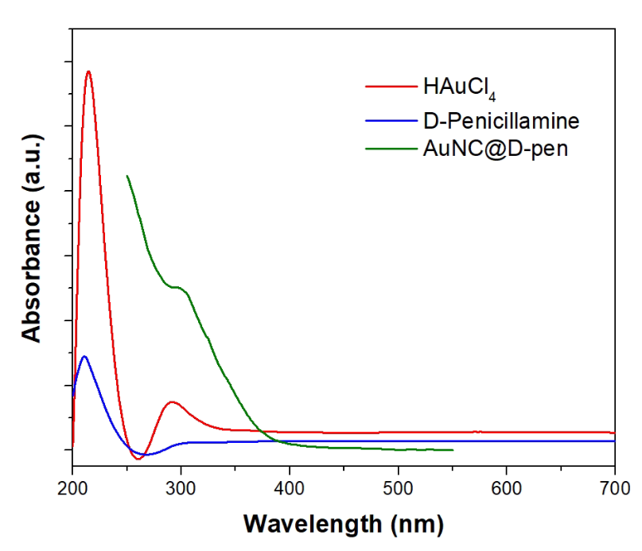
Figure S1. UV-Vis spectra of HAuCl₄, D-Penicillamine AuNC@D-Pen in water.

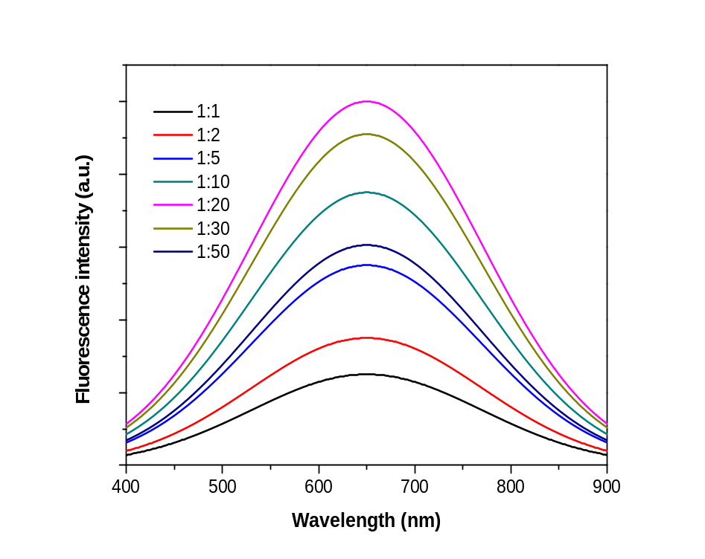
Figure S2. HAuCl₄/D-Pen molar ratio effect on the fluorescence of AuNC@D-Pen.

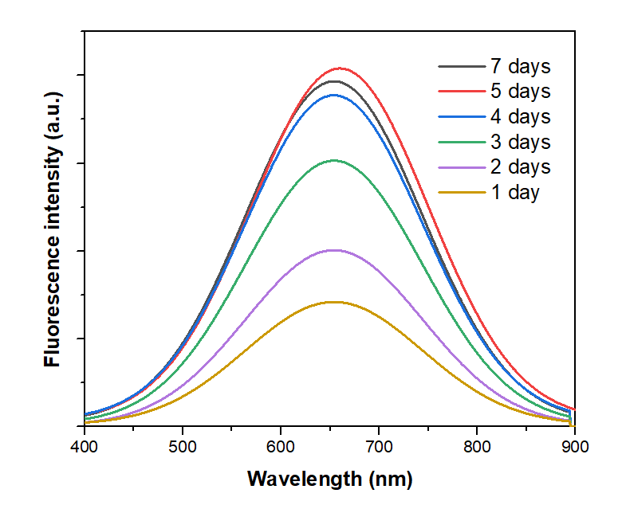
Figure S3. Reaction time effect on the fluorescence intensity of AuNC@D-Pen.

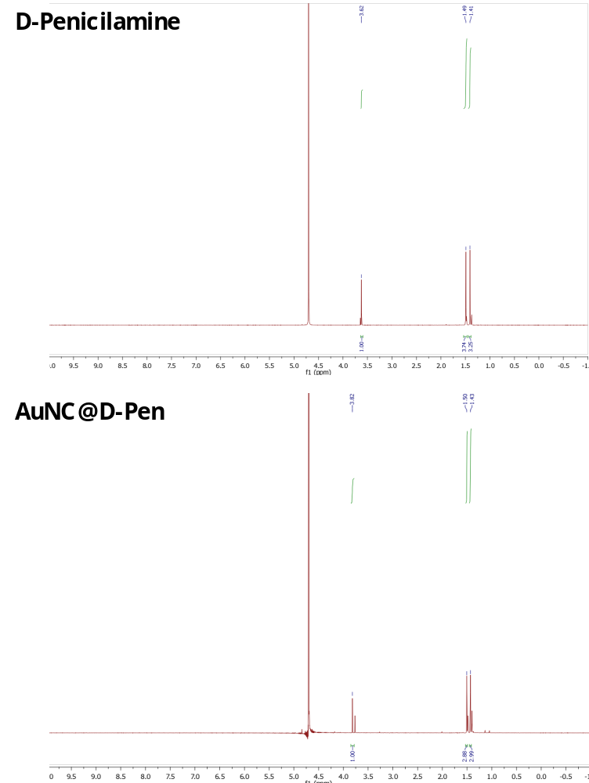
Figure S4. ¹H NMR (300 Mz, D₂O) of D-Penicillamine (top) and D-Penicillamine and HAuCl₄ (AuNC@D-Pen) (bottom).

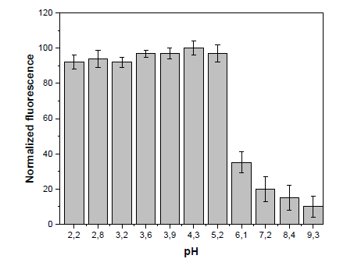
Figure S5. pH effect on the fluorescence intensity of AuNC@D-Pen.

1.5. Computational details.
DFT calculations were performed at the B3LYP-D3/def2TZVP (SDD for Au) level of theory using Gaussian 16. To this end, a model consisting of 18 gold atoms and 14 D-penicillamine ligands was modeled.

1.5.1. Cartesian coordinates of optimized structure

79 0.241805000 -0.673956000 1.653161000
79 -2.257242000 0.928007000 0.383311000
79 0.691109000 1.641077000 0.107229000
79 1.100526000 -1.004837000 -1.055552000
79 -2.986748000 -1.780430000 2.528374000
79 -1.749724000 -1.647886000 -0.531926000
79 -1.198754000 0.578617000 -2.167480000
79 -0.604419000 2.634307000 2.807478000
79 0.601400000 -3.997344000 0.782606000
79 -1.986206000 3.537804000 -1.542843000
79 2.909327000 -1.607299000 1.075347000
79 3.413898000 0.671608000 -0.439024000
79 1.896376000 1.912711000 -3.318935000
79 4.363176000 -1.869320000 -2.112081000
79 2.863827000 1.069737000 2.438293000
79 -4.818733000 -1.916877000 -0.812376000
79 -4.471415000 1.002174000 -2.713708000
79 5.813920000 -0.902296000 0.962772000
16 2.263750000 -1.779664000 -3.205028000
16 -1.122076000 -0.917789000 3.701225000
16 -1.213742000 -4.082869000 -0.727348000
16 -2.885280000 2.051472000 2.493058000
16 0.291046000 3.856484000 -0.957498000
16 2.478882000 -3.778151000 2.193837000
16 -0.324223000 1.859147000 -4.138656000
16 4.095705000 2.018573000 -2.424664000
16 1.689572000 3.183118000 3.068675000
16 -4.698185000 -2.869983000 1.337053000
16 -4.282281000 3.254226000 -2.057391000
16 6.445330000 -2.086301000 -1.003780000
16 5.012598000 -0.178732000 3.063970000
16 -4.837024000 -1.311839000 -3.109878000
6 4.498627000 3.848486000 -2.015436000
6 3.726661000 4.731188000 -3.048235000
6 7.812480000 -1.175277000 -1.972229000
6 7.738412000 -1.722185000 -3.432942000
6 3.689845000 -5.220662000 1.898634000
6 4.687706000 -5.148428000 3.102870000
6 6.309740000 0.899193000 3.962943000
6 6.307034000 2.332838000 3.359871000
6 1.927793000 -3.539646000 -3.880831000
6 0.565662000 -3.511538000 -4.642350000
6 -0.323719000 1.218586000 -5.937983000
6 -1.750723000 0.649129000 -6.226426000
6 -6.591424000 -1.496248000 -3.878570000
6 -6.953814000 -3.016170000 -3.838412000
6 -4.912933000 4.451115000 -3.387378000
6 -4.953256000 5.872394000 -2.709138000
6 -3.968064000 3.626201000 2.380915000
6 -5.205396000 3.227075000 1.517728000
6 -6.366430000 -2.877827000 2.247543000
6 -6.140768000 -3.836009000 3.462184000
6 0.323702000 5.175433000 0.340446000
1 1.382513000 5.356211000 0.545330000
1 -0.130568000 4.796604000 1.252970000
6 -0.376059000 6.470030000 -0.074558000
6 -0.562438000 -2.205998000 5.003506000
6 -1.283979000 -1.758896000 6.320595000
6 -2.503875000 -5.265047000 -0.095553000
1 -3.162759000 -4.742163000 0.593080000
1 -1.969919000 -6.032103000 0.464046000
6 -3.338399000 -5.936217000 -1.209767000
6 1.842449000 3.940898000 4.810640000
6 1.018384000 3.148187000 5.866056000
1 4.130631000 -5.434966000 4.003768000
1 5.314931000 2.759299000 3.545693000
1 6.765127000 -1.423696000 -3.841142000
1 -2.977423000 -6.952713000 -1.386968000
1 0.040338000 2.939331000 5.409748000
1 -4.836857000 2.960523000 0.524017000
1 -5.454355000 -3.331240000 4.152900000
1 -0.810425000 -0.823465000 6.644376000
1 -1.429398000 6.251786000 -0.282014000
1 -5.188187000 5.719685000 -1.647315000
1 -6.121876000 -3.570477000 -4.289933000
1 -2.467445000 1.463233000 -6.063954000
1 2.660749000 4.509875000 -2.925464000
1 0.736046000 -3.088553000 -5.635215000
6 5.841173000 -6.195584000 2.987617000
8 5.723239000 -7.297782000 2.500973000
8 6.985708000 -5.760667000 3.523208000
6 7.298457000 3.316839000 4.052169000
8 7.641127000 3.256407000 5.210637000
8 7.691782000 4.310402000 3.243467000
6 8.808034000 -1.033925000 -4.319852000
8 8.672848000 0.081096000 -4.769536000
8 9.898988000 -1.781006000 -4.527224000
6 -4.880349000 -6.003838000 -0.851819000
8 -5.624609000 -5.833324000 -1.867644000
8 -5.173537000 -6.199109000 0.334828000
6 1.566588000 1.755914000 6.250665000
8 1.137257000 1.348937000 7.451324000
8 2.263274000 1.057570000 5.545192000
6 -6.165800000 4.423366000 1.299124000
8 -5.975528000 5.300199000 0.478995000
8 -7.249765000 4.391343000 2.077185000
6 -7.456007000 -4.047252000 4.284881000
8 -7.684446000 -5.327135000 4.554188000
8 -8.171857000 -3.141381000 4.657938000
6 -1.055974000 -2.749801000 7.505627000
8 -2.073463000 -2.756263000 8.373719000
8 -0.060811000 -3.419163000 7.666279000
6 -0.388298000 7.433442000 1.145037000
8 -0.162923000 8.695757000 0.812810000
8 -0.614510000 7.057171000 2.281128000
6 -3.617540000 6.659206000 -2.718652000
8 -3.790310000 7.973891000 -2.775823000
8 -2.509907000 6.155904000 -2.638516000
6 -8.188833000 -3.301623000 -4.756323000
8 -8.138451000 -3.263804000 -5.964990000
8 -9.290280000 -3.593766000 -4.066588000
6 -1.895397000 0.263787000 -7.713780000
8 -1.723120000 -1.045885000 -7.988042000
8 -2.141949000 1.068780000 -8.577223000
6 3.882929000 6.236728000 -2.739768000
8 3.210184000 6.824383000 -1.916164000
8 4.830732000 6.838488000 -3.460727000
6 -0.088818000 -4.954284000 -4.822258000
8 -1.293754000 -4.991260000 -4.366454000
8 0.579288000 -5.829739000 -5.354266000
7 4.216769000 4.517989000 -4.421471000
1 5.131331000 6.153893000 -4.107942000
1 3.488844000 4.749022000 -5.093462000
7 -5.979700000 6.796426000 -3.223937000
1 -6.883002000 6.637714000 -2.791325000
1 -6.091084000 6.734129000 -4.232416000
7 -5.991174000 2.148537000 2.147957000
1 -7.189718000 3.523428000 2.550824000
1 -5.394882000 1.521010000 2.681264000
7 -5.594492000 -5.163544000 3.143878000
1 -6.918978000 -5.797114000 4.116272000
1 -4.612609000 -5.233536000 3.385150000
7 6.532023000 2.438846000 1.911085000
1 7.314364000 4.094660000 2.359549000
1 5.715079000 2.118360000 1.400928000
7 7.971722000 -3.175290000 -3.494675000
1 9.695041000 -2.656508000 -4.124022000
1 7.505516000 -3.575721000 -4.304534000
7 -3.308925000 -5.257754000 -2.549570000
1 -3.292638000 -4.241693000 -2.437932000
1 -4.282507000 -5.501458000 -2.882991000
7 -7.286670000 -3.512927000 -2.497977000
1 -6.970623000 -2.889754000 -1.761074000
1 -6.855905000 -4.423433000 -2.302729000
7 -2.055487000 -0.530078000 -5.390757000
1 -1.998639000 -0.239269000 -4.411231000
1 -1.587641000 -1.517181000 -7.147050000
7 -0.518266000 -2.705866000 -3.991110000
1 -0.256726000 -2.288374000 -3.093519000
1 -1.237169000 -3.500084000 -3.879561000
7 5.305163000 -3.845743000 3.388828000
1 5.539680000 -3.336795000 2.539292000
1 6.789828000 -4.832627000 3.808543000
1 7.606013000 -3.652353000 -2.674594000
1 4.693792000 -3.240987000 3.928426000
1 7.313998000 1.857591000 1.617278000
1 -4.774627000 8.086390000 -2.886987000
1 4.460203000 3.542836000 -4.578474000
1 -2.530121000 -5.502440000 -3.196660000
1 -0.908188000 -1.966484000 -4.599123000
1 -3.033706000 -0.793192000 -5.511840000
1 -6.442878000 1.581328000 1.435237000
1 -5.670346000 -5.433362000 2.159997000
1 -8.969533000 -3.658609000 -3.125795000
6 5.836560000 0.867431000 5.426533000
1 4.801979000 1.202077000 5.528448000
1 5.884942000 -0.156438000 5.809132000
1 6.486873000 1.505044000 6.027482000
6 7.679834000 0.221128000 3.837354000
1 7.635683000 -0.810093000 4.196296000
1 8.048651000 0.194861000 2.806422000
1 8.400068000 0.768443000 4.454321000
6 4.070791000 4.173673000 -0.583355000
1 2.999642000 4.033162000 -0.445592000
1 4.597931000 3.524484000 0.117650000
1 4.318875000 5.209761000 -0.336253000
6 6.024037000 3.984868000 -2.155328000
1 6.383523000 3.718959000 -3.151329000
1 6.322401000 5.018684000 -1.947416000
1 6.526972000 3.340892000 -1.429497000
6 9.135571000 -1.541940000 -1.278948000
1 9.138038000 -1.180330000 -0.247003000
1 9.315275000 -2.619185000 -1.261446000
1 9.969612000 -1.065744000 -1.805252000
6 7.581125000 0.336421000 -1.933330000
1 8.376808000 0.852312000 -2.476041000
1 6.627917000 0.612307000 -2.387612000
1 7.582881000 0.681174000 -0.894843000
6 2.857505000 -6.511022000 1.972121000
1 2.150603000 -6.557906000 1.138512000
1 3.532449000 -7.367977000 1.923626000
1 2.289665000 -6.565960000 2.906273000
6 4.399544000 -5.105424000 0.549633000
1 5.047653000 -5.975886000 0.408765000
1 3.670022000 -5.083089000 -0.262067000
1 5.011123000 -4.201918000 0.475649000
6 1.973415000 -4.581820000 -2.762510000
1 1.204035000 -4.419426000 -2.007121000
1 1.833643000 -5.577509000 -3.193191000
1 2.947589000 -4.545786000 -2.269902000
6 3.022599000 -3.838611000 -4.918910000
1 3.995018000 -3.941982000 -4.429550000
1 2.765726000 -4.778751000 -5.417246000
1 3.094645000 -3.047354000 -5.671372000
6 -6.351741000 3.979352000 -3.671809000
1 -6.812173000 4.588706000 -4.456066000
1 -6.339348000 2.945519000 -4.026800000
1 -6.981320000 4.027085000 -2.778348000
6 -4.076418000 4.404613000 -4.669207000
1 -3.024617000 4.616251000 -4.475479000
1 -4.158717000 3.420736000 -5.139706000
1 -4.452858000 5.145300000 -5.388323000
6 -4.356894000 3.963151000 3.831538000
1 -4.869159000 3.140473000 4.335639000
1 -3.464672000 4.217391000 4.409585000
1 -5.020718000 4.835221000 3.839994000
6 -3.202397000 4.794345000 1.763595000
1 -2.325411000 5.043689000 2.363962000
1 -2.876611000 4.560746000 0.746724000
1 -3.841102000 5.680302000 1.716485000
6 0.788283000 0.197429000 -6.192377000
1 0.724620000 -0.666125000 -5.531312000
1 0.753900000 -0.147439000 -7.232517000
1 1.764901000 0.656524000 -6.021393000
6 -0.079147000 2.483057000 -6.780759000
1 0.880495000 2.928669000 -6.505696000
1 -0.056118000 2.231846000 -7.844517000
1 -0.862067000 3.229724000 -6.627066000
6 -6.409830000 -0.985985000 -5.318170000
1 -5.707341000 -1.605274000 -5.882386000
1 -7.360972000 -1.017644000 -5.851816000
1 -6.047115000 0.046118000 -5.302557000
6 -7.624443000 -0.637844000 -3.138861000
1 -8.611014000 -0.787555000 -3.591865000
1 -7.700562000 -0.883186000 -2.077105000
1 -7.366730000 0.421470000 -3.218441000
6 -7.415682000 -3.446889000 1.281225000
1 -7.584839000 -2.754875000 0.451696000
1 -7.128252000 -4.416689000 0.866551000
1 -8.366058000 -3.555008000 1.814453000
6 -6.735942000 -1.457491000 2.684156000
1 -5.976425000 -1.040227000 3.352937000
1 -6.816398000 -0.813549000 1.802963000
1 -7.687676000 -1.472450000 3.217866000
7 0.732260000 3.855908000 7.128566000
1 1.561323000 4.315226000 7.499449000
1 0.685673000 2.138965000 7.839090000
1 0.018173000 4.565698000 7.004688000
7 -2.730432000 -1.490697000 6.248426000
1 -2.909134000 -0.587272000 5.821150000
1 -2.750902000 -2.155623000 7.981075000
6 -0.945181000 -3.629372000 4.588095000
1 -0.507320000 -3.880284000 3.619133000
1 -0.563269000 -4.332712000 5.334253000
1 -2.030028000 -3.760456000 4.506589000
6 0.954140000 -2.058121000 5.162073000
1 1.241429000 -1.035772000 5.416237000
1 1.284736000 -2.720250000 5.965276000
1 1.463522000 -2.339991000 4.240410000
1 -3.204440000 -2.183030000 5.672471000
6 3.326702000 4.047614000 5.174901000
1 3.444967000 4.557069000 6.139906000
1 3.796148000 3.067743000 5.249408000
1 3.859583000 4.649513000 4.433202000
6 1.245815000 5.351336000 4.644626000
1 0.183045000 5.328150000 4.389042000
1 1.372637000 5.930388000 5.566258000
1 1.753496000 5.892180000 3.843893000
7 0.157920000 7.183189000 -1.235894000
1 0.017224000 8.649336000 -0.166426000
1 -0.409693000 7.002731000 -2.058944000
1 1.137624000 6.976731000 -1.427173000

