Supplementary Figure 1: Main Random Effects Analysis (Forest Plot)
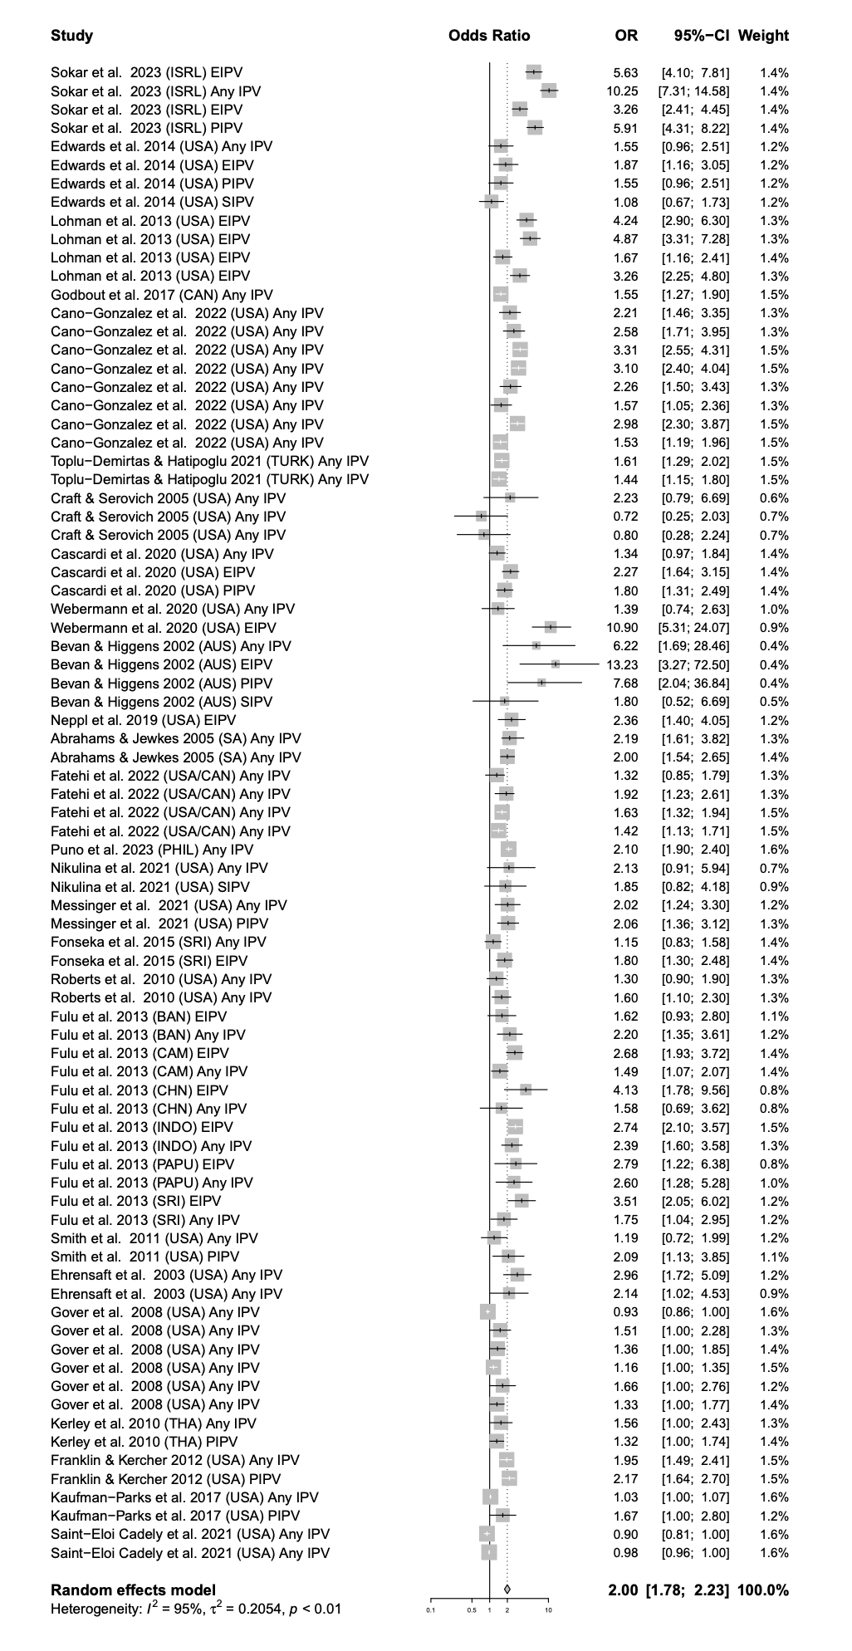

Supplementary Figure 2: Association between type of IPV* in childhood and perpetration of coercive control in adulthood

*Note. Abbreviation: EIPV = Emotional Intimate Partner Violence; PIPV = Physical IPV;

Supplementary Figure 3: Association between any IPV in childhood and perpetration of coercive control in adulthood

