Supplementary Information
Effects of Audiovisual Cues on Game Immersion during Simulated Slot Machine Gambling
Fiza Arshad ^{1, 2*} , MSc; Mario A. Ferrari ² , PhD; W. Spencer Murch ³ , PhD; Mariya V. Cherkasova ⁴ , PhD; Eve H. Limbrick-Oldfield ² , PhD; Catharine A. Winstanley ¹ , PhD; Luke Clark ^{1, 2 ,} PhD
¹Djavad Mowafaghian Centre for Brain Health, Graduate Program in Neuroscience, University of British Columbia, Vancouver, BC, Canada;
²Centre for Gambling Research at UBC, Department of Psychology, University of British Columbia, Vancouver, BC, Canada;
³Department of Anthropology and Sociology, Concordia University, Montreal, QC, Canada;
⁴Department of Psychology, West Virginia University, Morgantown, WV, US
*corresponding author email: fiza.arshad.ali@gmail.com

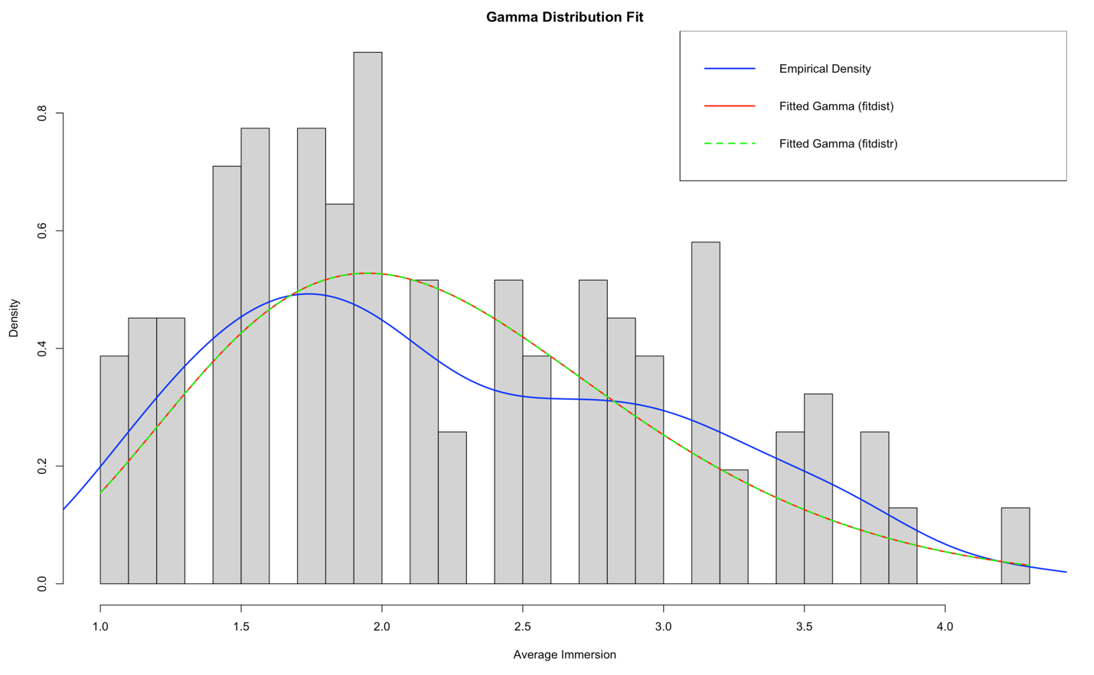
Supplementary Figure 1: Density plot displaying gamma distribution fit using two different fitting models (red and green) for the dependent variable, average immersion scores, against the empirical data (blue).

Table 1: Features of the audiovisual cues experienced across the three audiovisual cue conditions: Plus, Intermediate, and Minus.

Plus | Sound | - A ‘clunk’ sound and cash register bell both play when a spin starts  - Reels make a whirr sound as they spin  - Reel stops are accompanied by a ‘ding’  - Variable and layered winning sounds:  - 3 symbols: 1 second jingle and coins sound  - 4 symbols: 1.5 second jingle (cascades up) and coins sound  - 5 symbols: 4 second orchestra clip and longer coins sound
Plus | Visual | - A line and blue square highlight winning line combinations  - Symbol matches spin and zoom:  - 3 symbols: 1 second spin  - 4 symbols: 1.5 second enlarged animation  - 5 symbols: 4 second enlarge animation (greater)
Plus | Credit | - Credits display and win display both animate or ‘roll’ up during the feedback period
Intermediate | Sound | - Only a ‘clunk’ sound plays when a spin starts and a ‘ding’ as the reels stop  - Reels make a whirr sound as they spin  - Winning sounds are not variable and not layered:  - All symbol matches: 1 second jingle
Intermediate | Visual | - A line and blue square highlight winning line combinations  - Blue squares highlight the matching symbols  - Symbols matches only linger on screen:  - 3 symbols: 1 second  - 4 symbols: 1.5 seconds  - 5 symbols: 4 seconds
Intermediate | Credit | - Credits display and win display both animate or ‘roll’ up during the feedback period
Minus | Sound | - No sounds play when a spin starts or stops  - Reels make a whirr sound as they spin  - No winning sounds
Minus | Visual | - A line highlights winning line combinations  - Symbols matches only linger on screen:  - 3 symbols: 1 second  - 4 symbols: 1.5 seconds  - 5 symbols: 4 seconds
Minus | Credit | - Credits display and win display are not animated during the feedback period

