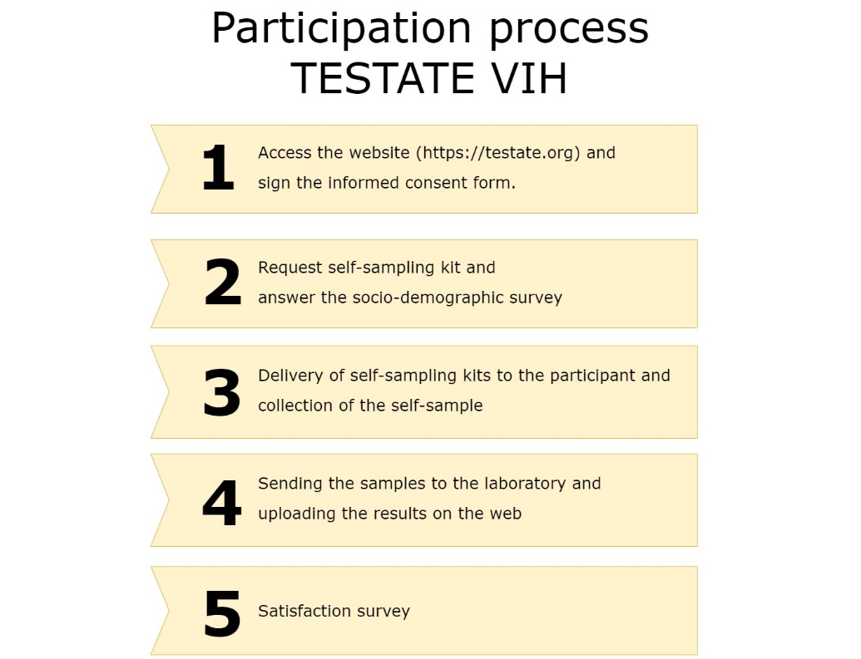

Supplementary figure 1. TESTATE HIV participation process

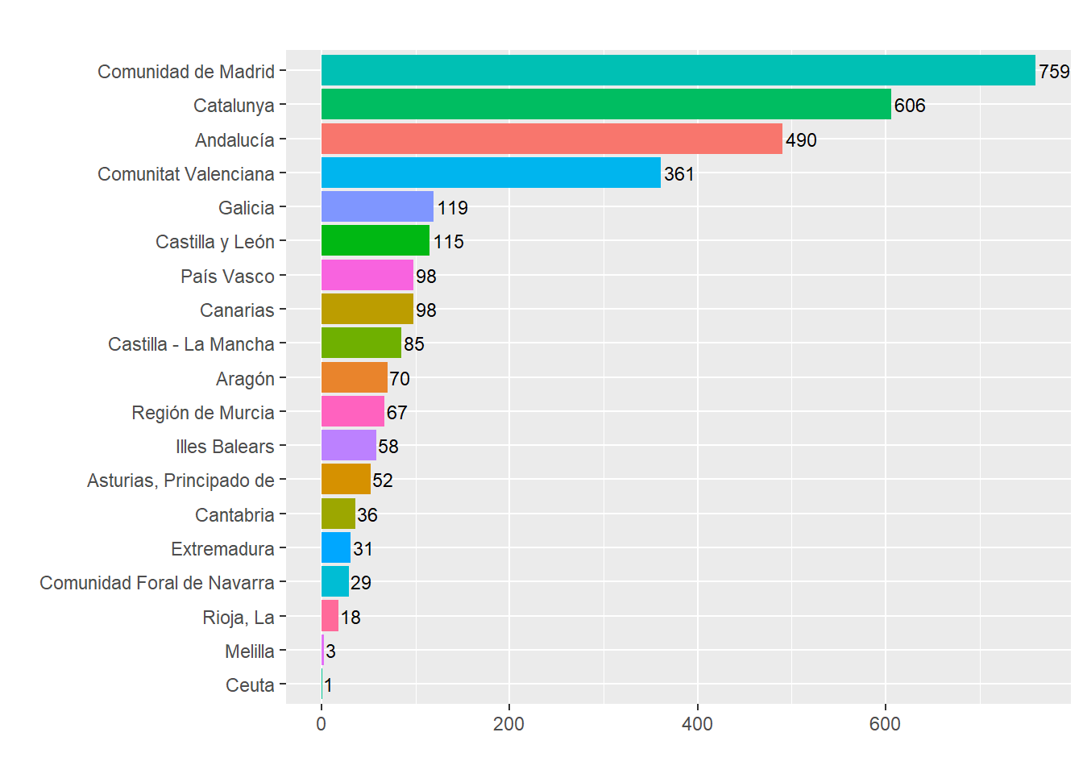
Supplementary figure 2. Number of TESTATE HIV participants by autonomous community
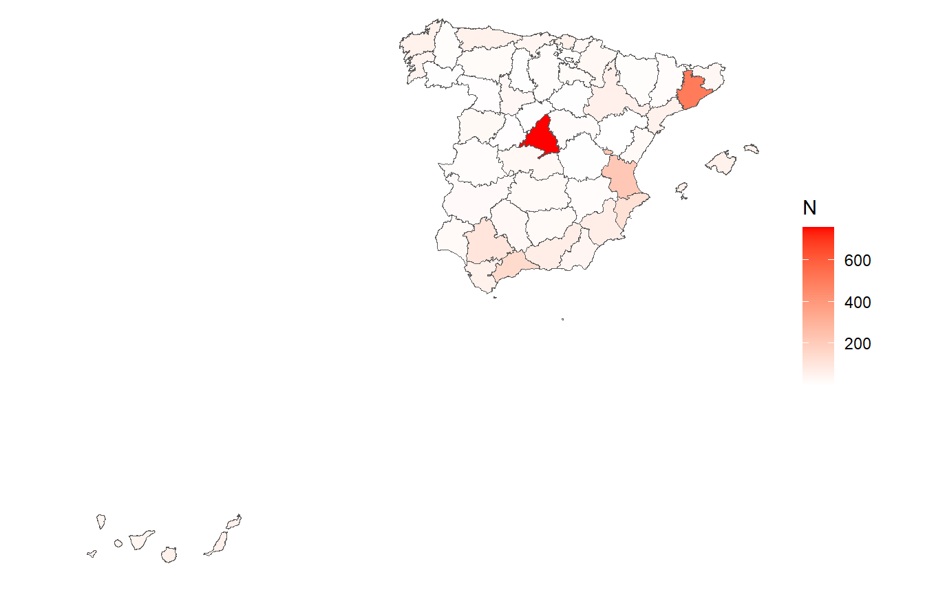
Supplementary figure 3. Map of TESTATE HIV participation by province in Spain

