Supplementary Figure 1a. Kaplan-Meier Survival Curves for One-ª and Two^{b}-Year Survival by Categories of Travel Distance to Initial Dialysis Facility^{c}, 2010-2021: Sensitivity Analysis 1 (Outliers Included)
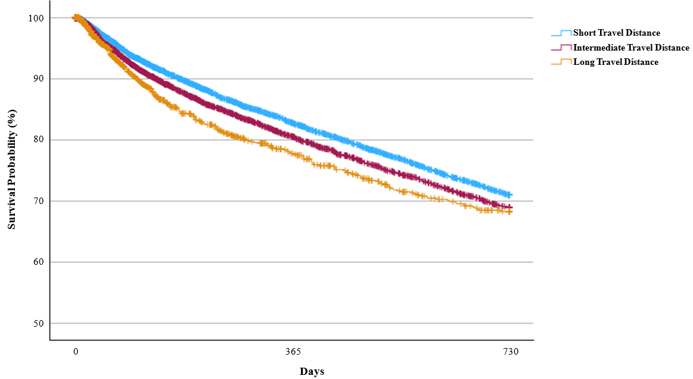

ªOne-Year Survival Probability (%, 95% Confidence Interval):
- Short travel distance: 82.80% (81.85%, 83.70%)
- Intermediate travel distance: 80.54% (79.30%, 81.71%)
- Long travel distance: 77.76% (74.77%, 80.44%)
- Log-rank test: p<.001

^{b}Two-Year Survival Probability (%, 95% Confidence Interval):
- Short travel distance: 70.95% (69.79%, 72.08%)
- Intermediate travel distance: 68.95% (67.45%, 70.39%)
- Long travel distance: 68.26% (64.73%, 71.53%)
- Log-rank test: p=0.002

^{c}Travel distance categories were classified based on the 50th (6.95 km) and 90th (27.83 km) percentiles.

Supplementary Figure 1b. Kaplan-Meier Survival Curves for One-ª and Two^{b}-Year Survival by Categories of Travel Distance to Initial Dialysis Facility^{c}: Sensitivity Analysis 2 (Cohort 2018-2021)
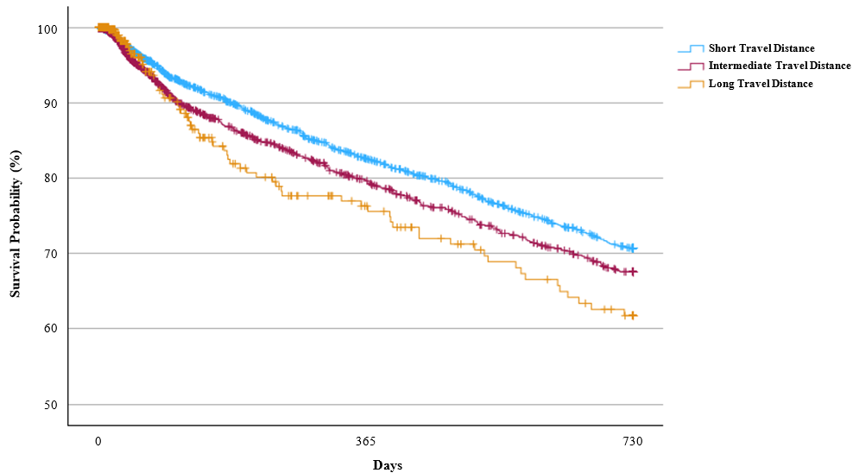
ªOne-Year Survival Probability (%, 95% Confidence Interval):
- Short travel distance: 82.62% (80.86%, 84.24%)
- Intermediate travel distance: 79.64% (77.04%, 81.99%)
- Long travel distance: 76.30% (69.50%, 81.79%)
- Log-rank test: p=0.016

^{b}Two-Year Survival Probability (%, 95% Confidence Interval):
- Short travel distance: 70.72% (68.56%, 72.76%)
- Intermediate travel distance: 67.57% (64.43%, 70.51%)
- Long travel distance: 61.76% (53.56%, 68.94%)
- Log-rank test: p=0.010

^{c}Travel distance categories were classified based on the 50th (8.13 km) and 90th (29.43 km) percentiles.

Supplementary Figure 1c. Kaplan-Meier Survival Curves for One-ª and Two^{b}-Year Survival by Categories of Travel Distance to Initial Dialysis Facility^{c}, 2010-2021: Sensitivity Analysis 3 (Quartiles-Based Classification)
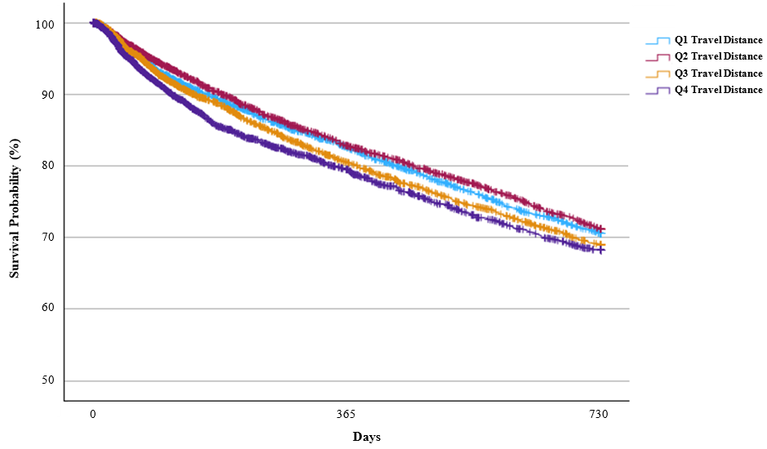
ªOne-Year Survival Probability (%, 95% Confidence Interval):
- Q1 travel distance: 82.61% (81.27%, 83.86%)
- Q2 travel distance: 82.82% (81.44%, 84.11%)
- Q3 travel distance: 80.50% (78.98%, 81.92%)
- Q4 travel distance: 79.49% (77.74%, 81.12%)
- Log-rank test: p<.001

^{b}Two-Year Survival Probability (%, 95% Confidence Interval):
- Q1 travel distance: 70.60% (68.96%, 72.17%)
- Q2 travel distance: 71.20% (69.50%, 72.82%)
- Q3 travel distance: 69.01% (67.19%, 70.75%)
- Q4 travel distance: 68.26% (66.13%, 71.29%)
- Log-rank test: p=0.005

^{c}Travel distance categories were classified based on quartiles (3.44 km, 6.80 km, 15.08 km).

