Supplementary Materials
Jach, Sun, Loton, Chin, & Waters, 2016
Strengths and Subjective Wellbeing in Adolescence:
Strength Based Parenting and the Moderating Effect of Mindset

Exploratory Factor Analysis of Strength-Based Parenting Items
The strength-based parenting scale was adapted from Govindji and Linley’s (2007) strengths knowledge and strengths use scales. Strength-based parenting (SBP) is conceptualised as being comprised of two modules – SBP-knowledge and SBP-use – which then feed into the higher-level SBP construct. SBP has been analysed with the knowledge and use items considered separately (Waters, 2015a) and also with the knowledge and use items considered together (Waters, 2015b). However, thus far, no study has conducted an analysis on the underlying factor structure to see whether one approach would be more empirically supported. In the following appendix we present such a factor analysis. Our hypothesis was that, while there might be considerable correlations between strength knowledge and use (as reported in Govindji & Linley, 2007) two factors should emerge that support the proposed distinction between these modules.
Kaiser’s measure of sampling adequacy produced a value of .96, clearly indicating that this data was factorisable (Cerny & Kaiser, 1977). The scree plot and parallel analysis suggested 1 factor (Figure 1), while the MAP test and Kaiser method suggested 2 factors (Ruscio & Roche, 2012). As results were conflicted, we decided to test both a 1-factor and 2-factor solution and observe the differences in factor loadings. Table 1 depicts the factor loadings from a direct oblimin rotated factor analysis using ordinary least squares; while Table 2 displays the model fit indices for each solution.
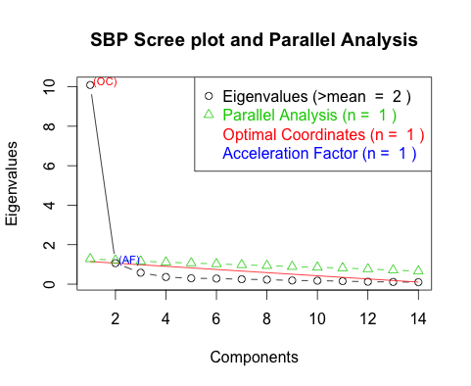
Figure 1. Scree plot, depicting the change in eigenvalues with the addition of more components. Optimal coordinates and acceleration factor are objective measures of interpreting the scree plot.

Table 1.
Factor Loadings for a One- or Two-Factor Solution
Two factors One factor .

Item 1 2 1
1. My parents see the strengths (personality, abilities, talents, and skills) that I have. | .870 |  | .885
2. My parents don’t know what my strengths are. | .702 | -.123 | .575
3. My parents know what I do best. | .919 |  | .859
4. My parents are aware of my strengths | .864 |  | .906
5. My parents know the things I am good at doing. | .984 |  | .883
6. My parents know my strengths well. | .815 | .139 | .921
7. My parents see the things I do best. | .787 | .137 | .892
8. My parents give me opportunities to regularly do what I do best. | .365 | .514 | .827
9. My parents encourage me to always play to my strengths. | .225 | .647 | .808
10. My parents encourage me to do what I’m good at. | .358 | .537 | .839
11. My parents suggest I should use my strengths every day. | -.114 | .986 | .780
12. My parents give me lots of opportunities to use my strengths | .240 | .683 | .885
13. My parents help me think of ways to use my strengths. |  | .935 | .833
14. My parents show me how to use my strengths in different situations. |  | .853 | .792

Table 2.
Fit Indices for the 1- or 2-Factor Model
Fix index | 1 factor | 2 factors
RMSEA | .165 (95% CI: .153, .173) | .079 (95% CI: .066, .09)
TLI | .847 | .965
BIC | 364.61 | -171.55
Note. RMSEA = , Root Mean Square Error of Approximation (RMSEA) RMSE = Root-mean-square error, TLI = Tucker Lewis Index of factoring reliability, BIC = Bayesian Information Criterion.

Adopting a cut-off value of .50 for a primary loading, we can see in Table 1 that in the 2-factor solution, items load correctly onto their hypothesised factor. In the 1-factor solution, all items load acceptably on the single factor. Meanwhile, in Table 2, the two-factor solution offers a better model by some fit indices.
For these reasons, in addition to the previously-mentioned theoretical interpretation of strength knowledge and strength use as separate, though interrelated, constructs, we will consider SBP as two factors.

Hierarchical Regression Using Observed Variables
Table 3 depicts a hierarchical regression testing incremental validity of strengths processes using observed variables. This is designed as a companion to Table 2 in-text, where the regression is presented with latent variables. In both versions of this table, SBP and strengths use remained significant predictors of subjective wellbeing. However, in contrast to the latent version, personality results were flipped: Extraversion remained a significant predictor throughout, while Neuroticism ceased to be significant. Westfall and Yarkoni (2016) argue that measurement unreliability can artificially inflate results when analysed with observed variables, and this is what appears to have happened here. These results lend strong support to the argument for using latent rather than observed variables in tests of incremental validity.

Table 3.
Hierarchical Regression Using Observed Variables
Observed Predictors | b | Std. error | t | p-value | R² | Adjusted R²
Step 1 |  |  |  |  | .13 | .13
Extraversion | 0.24 | 0.04 | 6.22 | <.001
Neuroticism | -0.06 | 0.03 | -1.95 | .052
Step 2 |  |  |  |  | .28 | .27
Extraversion | 0.13 | 0.04 | 3.36 | .001
Neuroticism | 0.04 | 0.03 | 1.14 | .256
+ Strength Use | 0.22 | 0.03 | 8.60 | <.001
Step 3 |  |  |  |  | .32 | .31
Extraversion | 0.11 | 0.04 | 3.08 | .002
Neuroticism | 0.04 | 0.03 | 1.15 | .252
Strength Use | 0.15 | 0.03 | 5.15 | <.001
+ SBP | 0.10 | 0.02 | 4.55 | <.001
Step 4 |  |  |  |  | .32 | .31
Extraversion | 0.11 | 0.04 | 3.10 | .002
Neuroticism | 0.03 | 0.03 | 1.06 | .290
Strength Use | 0.15 | 0.03 | 5.01 | <.001
SBP | 0.10 | 0.02 | 4.51 | <.001
+ mindset (implicit person) | -0.01 | 0.02 | -0.60 | .548
OR + Strength mindset | -0.02 | 0.02 | -1.44 | .150
Note. SBP = strength-based parenting. Note that the values for Extraversion, Neuroticism, strengths use, and SBP have been omitted when considering strengths mindset, as they were almost identical to results obtained when considering mindset (implicit person).

