Appendix S1. Details on the Bayesian multilevel Item Response Theory approach used for the obtention of the health scores.
A Bayesian multilevel Item Response Theory (IRT) approach was used in order to obtain the health scores of each individual at each time point in which they participated. A set of four IRT models with increasing complexity were computed in order to select the model with best fit to the data. The resulting expected a posteriory (EAP) was extracted from the model with the best fit (lowest Deviance Information Criterion, DIC). Essential unidimensionality of the responses was assumed to be met based on the previous work by Caballero et al. (2017) with the same dataset. Item and person parameters were estimated simultaneously for all waves using a Markov Chain Monte Carlo (MCMC) estimation method (Fox & Glas, 2001), which allows the latent scores to be based on different sets of items across waves while keeping comparability. A set of four Bayesian multilevel IRT models were computed in order to select the model with the best fit to the data: model 1) item-wise difficulties (b_{i}); model 2) item-wise difficulties and slopes (b_{i} and a_{i}); model 3) model 2, but allowing for variations of item difficulties across occasions; a joint standard deviation of all item difficulties is estimated (σ_{b}); and model 4) model 2 + item-specific standard deviation of item difficulties (σ_{bi}). Models with additional specifications of the standard deviation of the item slopes were explored but discarded due to lack of convergence. The MCMC estimation in each of these models was run considering 7,000 iterations, discarding the 100 first ones (burn-in). The resulting models were compared based on their Deviance Information Criterion (DIC) and expected a posteriori (EAP) reliability (Brown & Croudace, 2014; Spiegelhalter et al., 2002). The model with the best fit (lowest DIC) was selected, and the corresponding EAP scores were extracted for subsequent analyses.
Additional references:
Brown, A., & Croudace, T. J. (2014). Scoring and Estimating Score Precision Using Multidimensional IRT Models. In S. P. Reise & D. A. Revicki (Eds.), Handbook of item response theory modeling: Applications to typical performance assessment (pp. 307-333). Routledge.
Fox, J.-P., & Glas, C. A. W. (2001). Bayesian estimation of a multilevel IRT model using gibbs sampling. Psychometrika, 66(2), 271-288. https://doi.org/10.1007/BF02294839
Spiegelhalter, D. J., Best, N. G., Carlin, B. P., & Van Der Linde, A. (2002). Bayesian measures of model complexity and fit. Journal of the Royal Statistical Society: Series B (Statistical Methodology), 64(4), 583-639. https://doi.org/10.1111/1467-9868.00353
Appendix S2. Details on the procedure used to assess the equivalence in terms of rank-ordering of individuals between the raw sum scores and the longitudinally invariant factor scores of the Satisfaction With Life Scale.
Although the raw sum scores of the Satisfaction With Life Scale (SWLS) were used in the study, we assessed the correlation between these and the factor scores predicted from a model with an adequate level of longitudinal invariance as a way to assess the equivalence between these scores in terms of the rank-ordering of individuals. A model with metric (or weak) longitudinal invariance (see below) was deemed sufficient considering that the focus of the study is on the relationships between variables rather than on the mean scores over time (Mulder & Hamaker, 2020).
In order to test whether the SWLS was metrically invariant over time, two confirmatory factor analysis (CFA) models were computed (Meredith, 1993). The first model, the configural invariance model, assessed whether the model specification (i.e., all five items load on the same single latent factor) adequately reproduced the data across waves. Due to the within-person dependencies introduced by the longitudinal design, we freed the residual covariances of the items across waves. We used the cut-off criteria proposed by Hu and Bentler (1999) to assess goodness-of-fit (i.e., CFI and TLI > 0.95 and RMSEA < 0.06). Provided a good fit of the model, we computed an additional model, the metric invariance model, where factor loadings were constrained to be equal across waves. The metric invariance model tests whether the different items contribute similarly over time to the latent variable under study (in this case, life satisfaction). The fit of this model was then compared to the fit of the less restrictive configural model. If the absolute difference between the CFIs was smaller than 0.010, and the absolute difference between the RMSEAs was smaller than 0.015 (Chen, 2007; Cheung & Rensvold, 2002), the more restrictive metric invariance model was considered to adequately reproduce the data.
The factor scores were then estimated from the metric invariance model, and the correlations between raw sum scores and factor scores computed to assess the equivalence between these scores in terms of rank-ordering of individuals.
Additional references:

Chen, F. F. (2007). Sensitivity of Goodness of Fit Indexes to Lack of Measurement Invariance. Structural equation modeling, 14(3), 464-504. doi:10.1080/10705510701301834
Cheung, G. W., & Rensvold, R. B. (2002). Evaluating goodness-of-fit indexes for testing measurement invariance. Structural equation modeling, 9(2), 233-255. doi:10.1207/s15328007sem0902_5
Hu, L. t., & Bentler, P. M. (1999). Cutoff criteria for fit indexes in covariance structure analysis: Conventional criteria versus new alternatives. Structural equation modeling: a multidisciplinary journal, 6(1), 1-55. doi:10.1080/10705519909540118
Meredith, W. (1993). Measurement invariance, factor analysis and factorial invariance. Psychometrika, 58(4), 525-543. doi:10.1007/BF02294825
Mulder, J. D., & Hamaker, E. L. (2020). Three Extensions of the Random Intercept Cross-Lagged Panel Model. Structural equation modeling: a multidisciplinary journal, 1-11. doi:10.1080/10705511.2020.1784738

Table S1. Health-related items included in the operationalisation of health status.
Item name | Content | W4 | W5 | W6 | W7 | W8
cfani | Verbal fluency (measured test) | x | x |  | x | x
cfdscr | Orientation in time (measured test) | x | x |  | x | x
cflisd | Delayed recall (measured test) | x | x | x | x | x
cflisen | Immediate recall (measured test) | x | x | x | x | x
cfmetm | How would you rate your memory at the present time? | x |  |  | x | x
cfmscr | Numeracy test (measured test) | x |  | x | x | x
headlba | Difficulty bathing or showering | x | x | x | x | x
headlbe | Difficulty getting in and out of bed | x | x | x | x | x
headldr | Difficulty dressing, including putting on shoes and socks | x | x | x | x | x
headlea | Difficulty eating, such as cutting up food | x | x | x | x | x
headlho | Difficulty doing work around house and garden | x | x | x | x | x
headlma | Difficulty using map to figure out how to get around strange place | x | x | x | x | x
headlme | Difficulty taking medications | x | x | x | x | x
headlmo | Difficulty managing money, e.g., paying bills, keeping track expenses | x | x | x | x | x
headlpr | Difficulty preparing a hot meal | x | x | x | x | x
headlsh | Difficulty shopping for groceries | x | x | x | x | x
headlte * | Difficulty making telephone calls | x | x | x | x | x
headlwa | Difficulty walking across a room | x | x | x | x | x
headlwc | Difficulty using the toilet, including getting up or down | x | x | x | x | x
hebal | How often do you have problems with keeping your balance when you are walking on a level surface? | x |  |  | x
hediz | How often do you have problems with dizziness when you are walking on a level surface? | x |  |  | x
heeye | Is your eyesight (using glasses or corrective lens) as usual? | x | x | x | x | x
hefrnd | How good is your eyesight for seeing things at a distance, like recognising a friend across the street (using glasses or corrective lens as usual)? | x | x | x | x | x
hefunc | By yourself and without using any special equipment, how much difficulty do you have walking for a quarter of a mile? | x | x | x | x | x
hehear | Is your hearing (using a hearing aid) as usual? | x | x | x | x | x
hehra | Do you find it difficult to follow a conversation if there is background noise, such as TV, radio or children playing (using a hearing aid as usual)? | x | x | x | x | x
heinct | During the last 12 months, have you lost any amount of urine beyond your control? | x | x | x | x
hemobch | Difficulty getting up from chair after sitting long periods | x | x | x | x | x
hemobcl | Difficulty climbing one flight stairs without resting | x | x | x | x | x
hemobcs | Difficulty climbing several flights stairs without resting | x | x | x | x | x
hemobli | Difficulty lifting or carrying weights over 10 pounds | x | x | x | x | x
hemobpi | Difficulty picking up 5p coin from table | x | x | x | x | x
hemobpu | Difficulty pulling or pushing large objects | x | x | x | x | x
hemobre | Difficulty reaching or extending arms above shoulder level | x | x | x | x | x
hemobsi | Difficulty sitting 2 hours | x | x | x | x | x
hemobst | Difficulty stopping, kneeling or crouching | x | x | x | x | x
hemobwa | Difficulty walking 100 yards | x | x | x | x | x
hepain | Are you often troubled with pain? | x | x | x | x | x
hepap | How good is your eyesight for seeing things up close, like reading ordinary newspaper print (using glasses or corrective lens as usual)? | x | x | x | x | x
ncorrect | Processing speed (measured test) | x | x
pscedb | Much of the time during the past week, have you felt that everything you did was an effort? | x | x | x | x | x
pscedc | Much of the time during the past week, has your sleep been restless? | x | x | x | x | x
pscedh | Much of the time during the past week, could you not get going? | x | x | x | x | x
scqolo | I feel full of energy these days | x | x | x | x | x
walking_speed ** | Walking speed (measured test) | x | x | x | x | x
Note. W4: wave 4 (2008); W5: wave 5 (2010); W6: wave 6 (2012); W7: wave 7 (2014); W8: wave 8 (2016); * also named headlph; ** computed as the mean of the two walking speed trials (mmwlka and mmwlkb). Item names refer to the names of the variables in the English Longitudinal Study of Ageing datasets, which are publicly available.

Table S2. Distribution of the health and life satisfaction scores across waves in the sample.
Variable | Wave | Observations | M | SD
Satisfaction With Life Scale (SWLS) | 4 | 8,748 | 25.34 | 6.22
Satisfaction With Life Scale (SWLS) | 5 | 8,428 | 25.69 | 6.39
Satisfaction With Life Scale (SWLS) | 6 | 8,332 | 25.25 | 6.50
Satisfaction With Life Scale (SWLS) | 7 | 7,496 | 25.80 | 6.29
Satisfaction With Life Scale (SWLS) | 8 | 6,660 | 25.83 | 6.21
Item Response Theory (IRT)-based health measure | 4 | 10,740 | 83.10 | 17.33
Item Response Theory (IRT)-based health measure | 5 | 9,983 | 82.95 | 17.93
Item Response Theory (IRT)-based health measure | 6 | 10,226 | 83.48 | 17.77
Item Response Theory (IRT)-based health measure | 7 | 9,277 | 83.35 | 17.68
Item Response Theory (IRT)-based health measure | 8 | 8,118 | 83.38 | 17.59
Self-reported health measure | 4 | 10,328 | 3.20 | 1.12
Self-reported health measure | 5 | 9,469 | 3.19 | 1.11
Self-reported health measure | 6 | 9,659 | 3.17 | 1.12
Self-reported health measure | 7 | 8,730 | 3.18 | 1.10
Self-reported health measure | 8 | 7,689 | 3.16 | 1.11
Note. M: mean; SD: standard deviation.

Table S3. Goodness-of-fit indices of the confirmatory factor analysis models computed to assess the longitudinal invariance of the Satisfaction With Life Scale (SWLS).
Model | χ² (df) | CFI | TLI | RMSEA (90% CI) | ΔCFI | ΔRMSEA
Configural | 2403 (215) | 0.981 | 0.974 | 0.036 (0.034, 0.037)
Metric | 2437 (231) | 0.981 | 0.976 | 0.035 (0.033, 0.036) | <0.001 | 0.001
Note. CFI: Comparative Fit Index; CI: Confidence Interval; TLI: Tucker-Lewis Index; df: degrees of freedom; RMSEA: Root Mean Square Error of Approximation.
MLR estimator employed. The residual covariances across the same items over time were freely estimated in all models.

Figure S1. Standard cross-lagged model between life satisfaction and the self-reported health measure (n = 11,322).
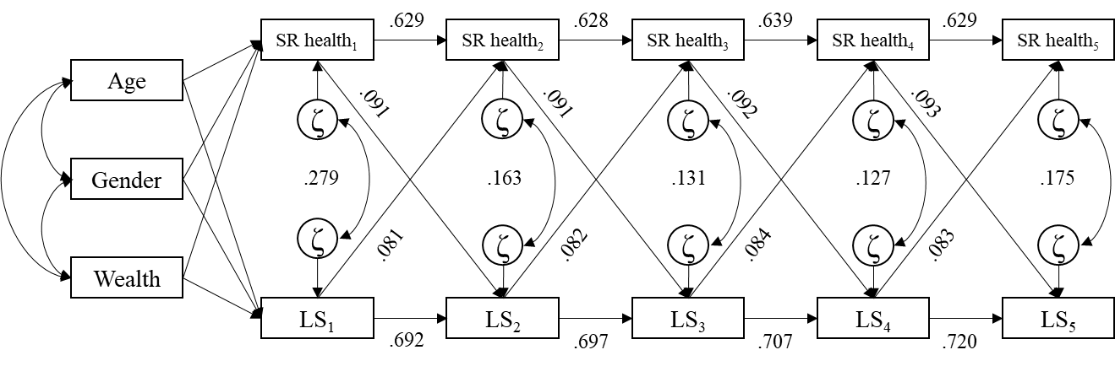

Note. ζ: residuals; LS: life satisfaction; SR: self-reported. All coefficients are standardised. The effects of the exogenous variables (i.e. age, gender, and wealth) on health and life satisfaction on later time points (Health₂ and LS₂ and onwards) are not depicted for the sake of clarity.
Figure S2. Within-person stability cross-lagged model between life satisfaction and the self-reported health measure (n = 11,322).
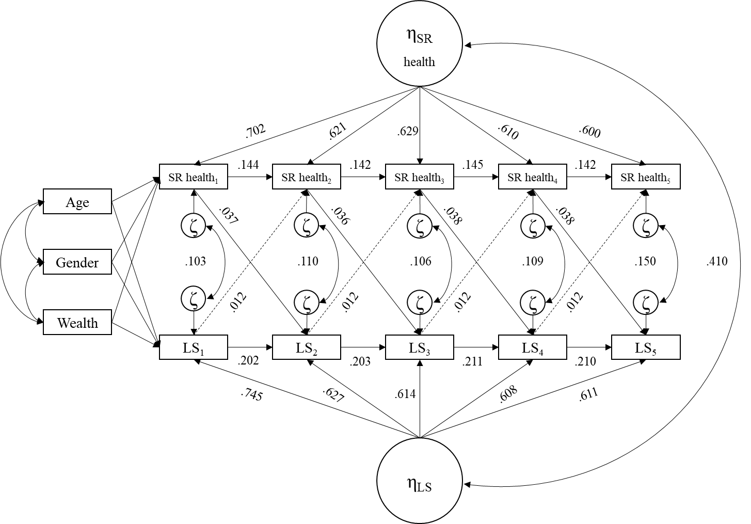
Note. η: within-person stability factors; ζ: residuals; LS: life satisfaction; SR: self-reported. All coefficients are standardised. The effects of the exogenous variables (i.e. age, gender, and wealth) on health and life satisfaction on later time points (SR health₂ and LS₂ and onwards) are not depicted for the sake of clarity. The dashed lines represent non-significant effects.

Figure S3. Standard cross-lagged model between life satisfaction and the item response theory-based health measure without adjusting for wealth (n = 13,233).
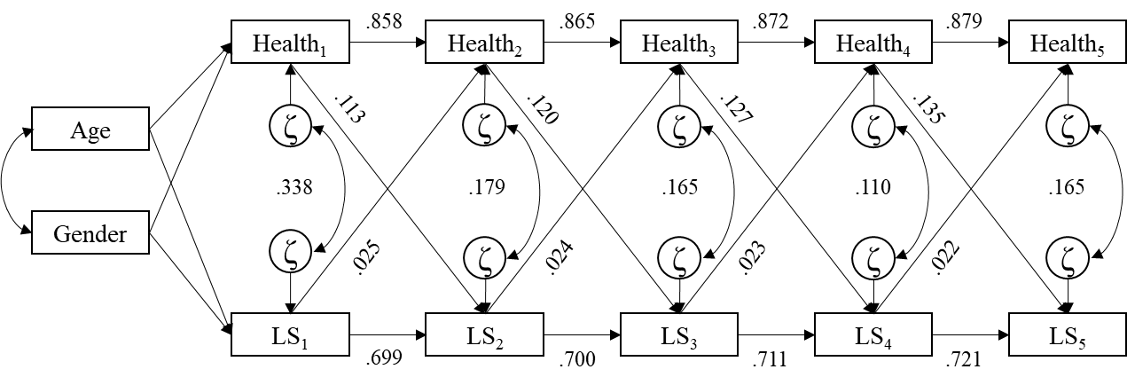
Note. ζ: residuals; LS: life satisfaction; SR: self-reported. All coefficients are standardised. The effects of the exogenous variables (i.e. age and gender) on health and life satisfaction on later time points (Health₂ and LS₂ and onwards) are not depicted for the sake of clarity.

Figure S4. Within-person stability cross-lagged model between life satisfaction and the item response theory-based health measure without adjusting for wealth (n = 13,233).
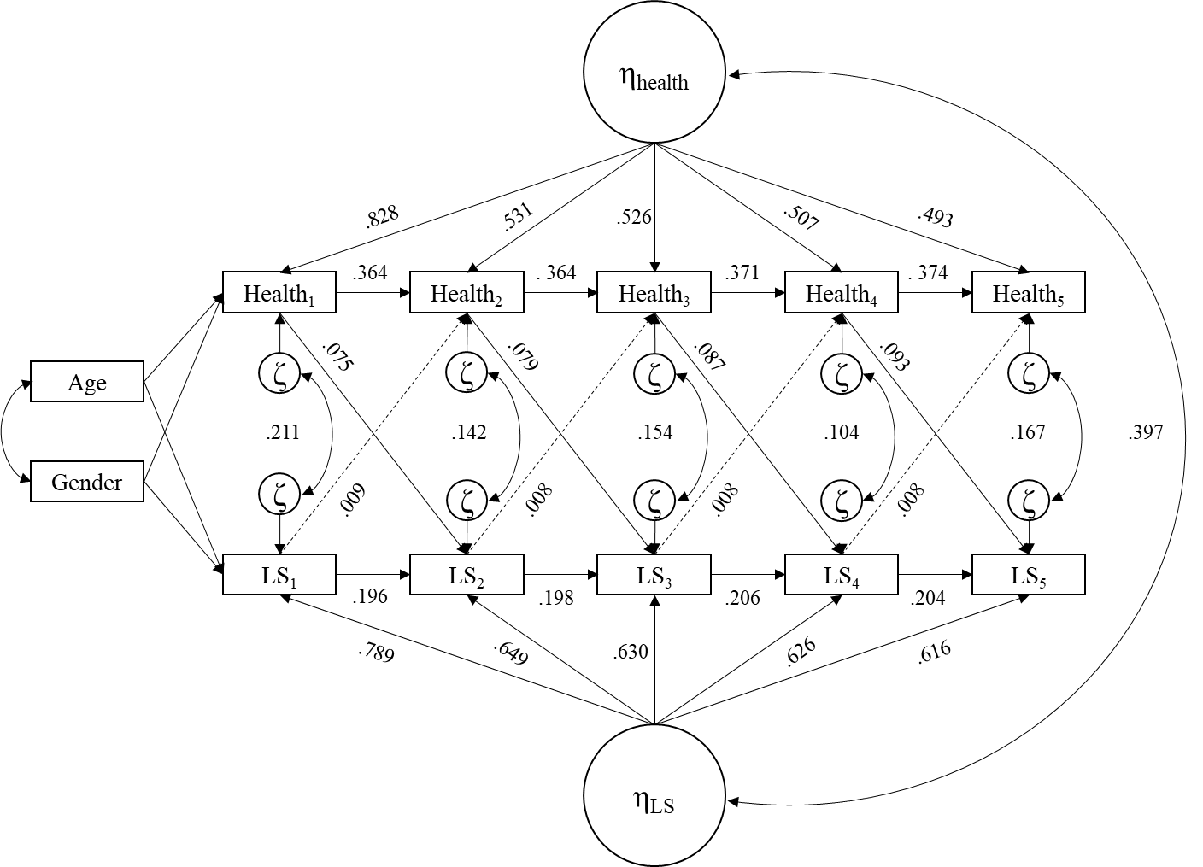
Note. η: within-person stability factors; ζ: residuals; LS: life satisfaction; SR: self-reported. All coefficients are standardised. The effects of the exogenous variables (i.e. age and gender) on health and life satisfaction on later time points (Health₂ and LS₂ and onwards) are not depicted for the sake of clarity. The dashed lines represent non-significant effects.

